The status of copper Rockfish (*Sebastes caurinus*) in U.S. waters off the coast of California south of Point Conception in 2021 using catch and length data

by Chantel R. Wetzel1 Brian J. Langseth1 Jason M. Cope1 John E. Budrick2

1Northwest Fisheries Science Center, U.S. Department of Commerce, National Oceanic and Atmospheric Administration, National Marine Fisheries Service, 2725 Montlake Boulevard East, Seattle, Washington 98112

2California Department of Fish and Wildlife, 350 Harbor Boulevard, Belmont, California

94002

May 2021

© Pacific Fisheries Management Council, 2021

Correct citation for this publication:

Wetzel, C.R., B.J. Langseth, J.M. Cope, J.E. Budrick. 2021. The status of copper Rockfish (*Sebastes caurinus*) in U.S. waters off the coast of California south of Point Conception in 2021 using catch and length data. Pacific Fisheries Management Council, Portland, Oregon. 137 p.

**Contents**

#### Disclaimer i

1. Introduction 1
   1. Basic Information 1
   2. Historical and Current Fishery Information 1
   3. Summary of Management History and Performance 3
2. Data 4
   1. Fishery-Dependent Data 4
      1. Commercial Fishery 4
      2. Recreational Fishery 5
   2. Fishery-Independent Data 6
      1. NWFSC Hook and Line Survey 6
      2. NWFSC West Coast Groundfish Bottom Trawl Survey 7
      3. Remotely Operated Vehicle Observations 8
   3. Biological Data 8
      1. Natural Mortality 8
      2. Length-Weight Relationship 9
      3. Growth (Length-at-Age) 9
      4. Maturation and Fecundity 10
      5. Sex Ratio 10
3. Assessment Model 11
   1. Summary of Previous Assessments 11
      1. Bridging Analysis 11
   2. Model Structure and Assumptions 12
      1. Modeling Platform and Structure 13
      2. Priors 13
      3. Data Weighting 13
      4. Estimated and Fixed Parameters 14
   3. Model Selection and Evaluation 14
   4. Base Model Results 14
      1. Parameter Estimates 14
      2. Fits to the Data 15
      3. Population Trajectory 16
   5. Model Diagnostics 17
      1. Convergence 17
      2. Sensitivity Analyses 17
      3. Area-Based Sensitivity Analyses 18
      4. Likelihood Profiles 19
      5. Length-Based Spawner Recruit Analysis 20
      6. Retrospective Analysis 20
4. Management 20
   1. Reference Points 20
   2. Harvest Projections and Decision Tables 21
   3. Evaluation of Scientific Uncertainty 21
   4. Future Research and Data Needs 21
5. Acknowledgments 22
6. References 23
7. Tables 26
8. Figures 51
9. Appendix A 125
   1. Annual Length Composition Data 125
   2. Detailed Fit to Length Composition Data 131
   3. Implied Fit to Commercial ‘Ghost’ Fleet Length Data 137

**Disclaimer**

##### *These materials do not constitute a formal publication and are for information* only. They are in a pre-review, pre-decisional state and should not be formally cited or reproduced. They are to be considered provisional and do not represent any determination or policy of NOAA or the Department of Commerce.

# Introduction

## Basic Information

This assessment reports the status of copper rockfish (*Sebastes caurinus*) off the California coast, south of Point Conception, using data through 2020.

Copper rockfish is a medium- to large-sized nearshore rockfish found from Mexico to Alaska. The core range is comparatively large, from northern Baja Mexico to the Gulf of Alaska, as well as in Puget Sound. Copper rockfish have historically been a part of both commercial (mainly in the live-fish fishery in recent years) and recreational fisheries throughout its range.

Copper rockfish are commonly found in waters less than 130 meters in depth in nearshore kelp forests and rocky habitat (Love 1996). The diets of copper rockfish consist primarily of crustaceans, mollusks, and fish (Lea, McAllister, and VenTresca 1999; Bizzarro, Yoklavich, and Wakefield 2017). The body coloring of copper rockfish varies across the coast with northern fish often exhibiting dark brown to olive with southern fish exhibiting yellow to olive-pink variations in color (Miller and Lea 1972) which initially led to them being designated as two separate species (*S. caurinus* and *S. vexillaris*).

Numerous genetic studies have been performed looking for genetic variation in copper rockfish with variable outcomes. Genetic work has revealed significant differences between Puget Sound and coastal stocks of copper rockfish (Dick, Shurin, and Taylor 2014). Stocks along the West Coast have not been determined to be genetically distinct populations but significant population sub division has been detected, indicating limited oceanographic exchange among geographically proximate locations (Buonaccorsi et al. 2002; Johansson et al. 2008). A specific study examining copper rockfish populations off the coast of Santa Barbara and Monterrey California identified a genetic break between the north and south with moderate differentiation (Sivasundar and Palumbi 2010).

Copper rockfish is a relatively long-lived rockfish and are estimated to live at least 50 years (Love 1996). Copper rockfish was determined to have the highest vulnerability (V = 2.27) of any West Coast groundfish stock evaluated in a productivity susceptibility analysis (Cope et al. 2011). This analysis calculated species specific vulnerability scores based on two dimensions: productivity characterized by the life history, and susceptibility characterized by how the stock is likely affected by the fishery in question.

## Historical and Current Fishery Information

Off the coast of California south of Point Conception copper rockfish is caught in both commercial and recreational fisheries. Recreational removals have been the largest source of fishing mortality of copper rockfish across all years (Table 1 and Figure 1). The recreational

fishery is comprised of individual recreational fishers and charter recreational private vessels which take groups of individuals out for day fishing trips. Across both types of recreational fishing the majority of effort occurs around rocky reefs that can be accessed via a day-trips.

The California recreational fisher in the early part of the 20th century was focused on nearshore waters near ports, but expanded further from port and into deeper depths over time (Miller et al. 2014). Prior to the rebuilding period for overfished species after the groundfish fishery disaster was declared in 2000, there was access to all depths and year-round seasons for groundfish. Access to deeper depths during this period spread effort over a larger area and filled bag limits with a greater diversity of species on the shelf as well as the nearshore. This resulted in lower catch of nearshore rockfish relative to the period after 2000 when 20 to 60 fm depth restrictions were put in place in various management area delineations along the state, shifting effort onto the nearshore, concomitantly increasing catch nearshore rockfish including copper rockfish. After rebuilding of overfished groundfish species other than yelloweye rockfish by 2019, deeper depth restrictions were offered in the Southern Management area allowing resumed access to shelf rockfish in less than 75 fm, though north of Point Conception constraints persist and effort remains focused on the nearshore in 30 to 50 fm depending on the management area. As yelloweye rockfish continues to rebuild, incremental increases in access to deeper depths are expected to continue, reducing the focus of effort on nearshore waters where copper rockfish is most prevalent.

Prior to development of the live-fish market in the 1980s, commercial catch of copper rockfish was relatively low and were often landed dead for a relatively low ex-vessel price per pound. Most fish were caught using hook and line gear, though some were caught using traps, gill nets and in some instances with trawl gear. Whether from directed effort in the nearshore or as bycatch while targeting other more valuable stocks such as lingcod, catches by the commercial fishery of copper rockfish were relatively low.

In the late 1980s and early 1990s a market for live landed fish arose out of Los Angeles and the Bay area, driven by demand from Asian restaurants and markets. The growth of the live fish market was driven by consumers willingness to pay a higher price for live fish, ideally plate-sized (12 - 14 inches or 30.5 - 35.6 cm). Live fish landed for the restaurant market lump fish into two categories, small (1 - 3 lbs. or 0.5 - 1.4 kgs.) or large (3 - 6 lbs. or 1.4

- 2.7 kgs.), with small fish fetching higher prices at market ranging between $5 -7 per fish (Bill James, personal communication). The proportion of copper rockfish being landed live vs. dead since 2000 by California commercial fleets ranges between 50 to greater than 70 percent in the southern and northern areas, respectively. Copper rockfish is one of the many rockfish species that is included in the commercial live fish fishery but also are included in the traditional dead fish fishery off the coast of California.

With the development and expansion of the nearshore live-fish fishery during the 1980s and 1990s, new entrants in this open access fishery were drawn by premium ex-vessel price per pound for live fish resulting in over-capitalization of the fishery. Since 2002, the California Department of Fish and Wildlife (CDFW) has managed 19 nearshore species in accordance with Nearshore Fisheries Management Plan (Wilson-Vandenberg, Larinto, and Key 2014). In 2003, the CDFW implemented a Nearshore Restricted Access Permit system, including

requirement of a Deeper Nearshore Fishery Species Permit to retain copper rockfish, with the overall goal of reducing the number of participants to a more sustainable level, with permit issuance based on historical landings history by the retrospective qualifying date. The result was reduction in permits issued from 1,127 in 1999 to 505 in 2003, greatly reducing catch levels. In addition, reduced trip limits, season closures in March and April and depth restrictions were implemented to address bycatch of overfished species and associated constraints from their low catch limits.

As overfished shelf rockfish have rebuilt, resumed access to deeper depths has been allowed for Nearshore Permit holders as well as open access fisheries. While deeper depth restrictions of 75 fm were implemented in 2019 south of Point Conception where yelloweye rockfish are uncommon, it still constrains depth restrictions north of Point Conception where depth restrictions are 30 to 40 fm since 2015 depending on the management area. As open access fisheries allowed to retain shelf rockfish species co-occurring with nearshore rockfish species within the open depths, there is growing concern regarding increased encounters by non-permit holders and greater discard mortality from bycatch in deeper depths as discard mortality is 100 percent in depths greater than 30 fm. This is of particular concern considering increased trip limits for shelf rockfish species in combination with increased depth restrictions allowing access to these species, driving increased participation in the open access fishery exacerbating discard mortality. In addition, sampling rates for observers from the West Coast Observer Program (WCGOP) on small vessels participating in these fisheries provide limited data to inform bycatch rates. Under National Standard 8, reduction of bycatch is a priority and increased observer rates would improve data on discards as the open access fishery for shelf rockfish expands.

The population of copper rockfish south of Point Conception to the U.S./Mexico border is assessed here as a separate stock. This decision was made based on oceanographic conditions and previous assessments of copper rockfish. The stock split in California waters at Point Conception accounts for water circulation patterns that create a natural barrier between nearshore rockfish population north and south of the area.

## Summary of Management History and Performance

Copper rockfish is managed by the Pacific Fishery Management Council (PFMC) as a part of the Nearshore Rockfish North and Nearshore Rockfish South complexes. The North and South areas are split at N. 40∘ 10’ Lat. N. off the West Coast. The complex is managed based on a complex level overfishing limit (OFL) and annual catch limit (ACL). The OFL and ACL values for the complex are determined by summing the species specific contributions for all stock managed in the complexes. Removals for species within the Nearshore complex are managed and tracked against the complex total OFL and ACL, rather than on a species by species basis.

Copper rockfish was most recently assessed in 2013 as two stocks, one south of Point Conception in California and one north of Point Conception to the Washington/Canadian border. The 2013 assessment estimated the substocks in each area to be above the management

target, 40 percent of unfished, with the southern area being assessed at 75 percent of unfished and the northern population at 48 percent of unfished. The estimated OFLs and the ACLs from the south and north assessments were modified to match the management boundary of North and South of N. 40∘ 10’ Lat. N.

Although, management defines OFLs and ACLs north and south of 40∘ 10’ Lat. N. man- agement areas, copper rockfish in California are managed based on the portion of OFL and ACL allocated to California. The OFLs and ACLs for south of 40∘ 10’ Lat. N. and recent removals for the California area south of Point Conception are shown in Table 2.

# Data

A description of each data source is provided below (Figure 2).

## Fishery-Dependent Data

### Commercial Fishery

* + - 1. **Landings**

The commercial removals for copper rockfish were combined into a single fleet by aggregating across gear types (Table 1 and Figure 1). Commercial landings prior to 1969 were pulled from the SWFSC catch reconstruction database for estimates from the California Catch Reconstruction (Ralston et al. 2010). Landings in this database are divided into trawl, ‘non-trawl’, and ‘unknown’ gear categories. Regions 7 and 8 as defined by Ralston et al. (2010) were assigned to Southern California. Region 6 in Ralston et al. (2010) includes Santa Barbara County (mainly south of Point Conception), plus some major ports north of Point Conception. To allocate catches from Region 6 to the areas north and south of Point Conception, we followed an approach used by Dick et al. (2007) for the assessment of cowcod. Specifically, port-specific landings of total rockfish from the CDFW Fish Bulletin series were used to determine the annual fraction of landings in Region 6 that was south of Point Conception (Table 3). Rockfish landings at that time were not reported at the species level. Although the use of total rockfish landings to partition catch in Region 6 is not ideal, we see this as the best available option in the absence of port-specific species composition data. Years with no data were imputed using ratio estimates from adjacent years. Annual catches from unknown locations (Region 0) and unknown gear types were allocated proportional to the catches from known regions and gears. Catches from known regions, but unknown gears, were allocated proportional to catches by known gears within the same region. In this way, total annual removals in California were kept consistent with those reported by Ralston et al. (2010), and assigned to the assessment areas north and south of Point Conception.

In September 2005, the California Cooperative Groundfish Survey (CCGS) incorporated newly acquired commercial landings statistics from 1969-80 into the CALCOM database. The data consisted of landing receipts (“fish tickets”), including mixed species categories for rockfish. In order to assign rockfish landings to individual species, the earliest available species composition samples were applied to the fish ticket data by port, gear, and quarter. These ‘ratio estimator’ landings are coded (internally) as market category 977 in the CALCOM database, and are used in this and past assessments as the best available landings for the time period 1969-1980 for all port complexes. See Appendix A of Dick et al. (2007) for further details.

Commercial fishery landings from 1981-2020 were pulled from the PacFIN database (extracted 2/22/2021). Landings were separated for the area south of Point Conception based on port of landings. The input catches in the model represent total removals: landings plus discards. Discards totals for the commercial fleet from 2002-2019 were determined based on WCGOP data provided in the Groundfish Expanded Mortality Multiyear (GEMM) product. The total coastwide observed discards were allocated to state and area based on the total observed landings observed by WCGOP. The historical commercial discard mortality used to adjust the landings data to account for total removals was calculated based on the average coastwide discard rates from WCGOP of 4.4 percent.

* + - 1. **Length Compositions**

Length data for the commercial fleet were pulled from PacFIN Biological Data System (BDS) with samples for south of Point Conception beginning in 1983 (Table 4). The number of total lengths available was highly variable ranging from a low of 2 to 542 samples per year. The samples prior to 1995 were sparse and variable across sizes. During model explorations these low sample years appeared to have a disproportionate impact on selectivity estimates and the decision of removing these samples from the base model (treated as a ‘ghost’ fleet, see Appendix A for implied fits to these lengths).

The majority of lengths observed by the commercial fleet were between approximately 25 - 45 cm (Figure 3) with relatively low observations of fish larger than 45 cm (detailed length compositions by year can be found in Appendix A). The mean length observed by year ranged between 32 - 39 cm (Figure 4). The mean length across commercial lengths was the smallest in 2014 (around 32 cm) and has generally incrementally in the subsequent years.

The input sample sizes were calculated via the Stewart method (Ian Stewart, personal communication) based on a combination of trips and fish sampled:

Input effN = 𝑁trips + 0.138 ∗ 𝑁fish if 𝑁fish/𝑁trips is < 44 Input effN = 7.06 ∗ 𝑁trips if 𝑁fish/𝑁trips is ≥ 44

### Recreational Fishery

* + - 1. **Landings**

The recreational removals prior to 1980 were obtained from the historical reconstruction starting in 1928 (Ralston et al. 2010) which were available split north and south of Point Conception. Mortality estimates from 1980 to 2003 from the Marine Recreational Fisheries Statistical Survey (MRFSS) were downloaded from the Recreational Fisheries Information Network (RecFIN). The California Recreational Fisheries Survey (CRFS) provided estimates from 2004 to 2020, downloaded from RecFIN. Both data sources provide total mortality which combined observed landings plus discarded fish. The missing years between the MRFSS and RecFIN data years, 1990-1992, were assumed by applying a linear ramp in removals based on 1989 and 1992 values. For years prior to 1980 a historical discard rate of 3 percent was assumed based on Miller and Gotshall (1965).

The recreational fishery is the main source of exploitation of copper rockfish. The recreational catches of copper rockfish south of Point Conception in California waters peaked in the late 1970s and early 1980s. Removals declined in the 1990s and early 2000s. The removals remained relatively low until 2015 and after. The increase in removals in 2015 is likely due to new Annual Catch Limits being updated based on the 2013 assessment (Cope et al. 2013).

* + - 1. **Length Compositions**

Length data for retained catch from MRFSS (1980-2003) and CRFS (2004-2020) were downloaded from the RecFIN website. The lengths of fish measured by samplers onboard Commercial Passenger Fishing Vessels (CPFV) prior to being released (Type 3d data) from 2003 to 2020 were downloaded from the RecFIN website. Recreational length data was available starting in 1983 (Table 5). The total length samples per year was relatively low until 2004, the first year with 200+ samples, and increased substantially starting in 2012. The length data from the recreational fleet generally ranged between 25 to approximately 45 cm (Figure 5) with limited observations of fish greater than 45 cm. The annual mean length observed was relatively stable between 2004 and 2011, followed by a minor dip in mean size and slight increase in recent years (Figure 6). Detailed length compositions by year can be found in Appendix A.

The input sample sizes for the recreational length data were calculated equal to the number of length samples available by year.

## Fishery-Independent Data

### NWFSC Hook and Line Survey

Since 2004, the NWFSC has conducted an annual hook and line survey targeting shelf rockfish in the genus *Sebastes* at fixed stations (e.g., sites, Figure 7) in the Southern California Bight. Key species of rockfish targeted by the NWFSC Hook and Line Survey are bocaccio (*S. paucispinis*), cowcod (*S. levis*), greenspotted (*S. chlorostictus*), and vermilion (*S. miniatus*

and *S. crocotulus*) rockfishes, although a wide range of rockfish species have been observed by this survey. During each site visit, three deckhands simultaneously deploy 5-hook sampling rigs (this is referred to as a single drop) for a maximum of 5 minutes per line, but individual lines may be retrieved sooner at the angler’s discretion (e.g., to avoid losing fish). Five drops are attempted at each site for a maximum possible catch of 75 fish per site per year (3 anglers x 5 hooks x 5 drops). Further details regarding the sample frame, site selection, and survey methodology are described by Harms et al. (Harms, Benante, and Barnhart 2008).

Copper rockfish have been observed at multiple sampling sites by the NWFSC Hook and Line Survey each year between 2004 - 2019 (Table 6). Starting in 2014 the NWFSC Hook and Line Survey added sampling sites located within the cowcod conservation area (CCA). Copper rockfish have been observed both outside and inside the CCA (Figures 8 and 9). The number of observations limited the ability to determine whether the CCA impacted the frequency and sizes of copper rockfish compared to the other areas sampled. Copper rockfish were observed at sites with depth ranging between 40 - 120 m with only the largest sizes being observed at the greatest depths (Figure 10).

The NWFSC Hook and Line Survey generally observed copper rockfish between 30 - 50 cm of both sexes (Figure 11). The mean length observed by year was variable with appreciable drop in the mean sized observed in 2012 but has gradually increased in the subsequent years (Figure 12). Detailed length compositions by year can be found in Appendix A. The input sample sizes for the composition data were calculated equal to the number of length samples available by year.

An annual index of abundance was calculated from the NWFSC Hook and Line Survey data following the methods put forth in Harms et al. (2010) based on the AIC criterion. The index of abundance was calculated using a binomial generalized-linear model. The final index includes year, site, number of hooks, fisher, drop number, and swell height as covariates. The single index of abundance was calculated using observations outside and within the CCA (Table 7 and Figure 13). The diagnostics for the binomial generalized-linear model are shown in Figure 14.

### NWFSC West Coast Groundfish Bottom Trawl Survey

The NWFSC West Coast Groundfish Bottom Trawl Survey (WCGBTS) is based on a random- grid design; covering the coastal waters from a depth of 55-1,280 m (Bradburn, Keller, and Horness 2011). This design generally uses four industry-chartered vessels per year assigned to a roughly equal number of randomly selected grid cells and divided into two ‘passes’ of the coast. Two vessels fish from north to south during each pass between late May to early October. This design therefore incorporates both vessel-to-vessel differences in catchability, as well as variance associated with selecting a relatively small number (approximately 700) of possible cells from a very large set of possible cells spread from the Mexican to the Canadian borders.

The observations of copper rockfish by the WCGBTS were limited (Table 8). The WCGBTS uses trawl gear to sample sandy bottom areas off the West Coast and *apriori* it would not be expected to be an informative data source for copper rockfish which are closely associated with rock substrate. The WCGBTS had limited tows by year where copper rockfish were observed within this area, preventing the calculation of an index of abundance for copper rockfish. With limited length observations and in the absence of an index of abundance to link these data to, this data set was not used in the base model.

### Remotely Operated Vehicle Observations

Data collected by Remotely Operated Vehicle (ROV) fall outside the Terms of Reference (TOR) for catch and length based assessments and were not included in this assessment. However, data collected by ROV were preliminarly examined in order to gain insight in copper rockfish south of Point Conception which may provide additional understanding of the data from the commercial, recreational, and survey fleets that are being included in this assessment.

Length frequency distribution for copper rockfish sampled by the ROV in reference locations open to fishing south of Point Conception show the majority of observations occuring between 10 - 20 fathoms with with peak observations between 20 - 40 cm (Figure 15). The observations in closed areas, marine protected areas where retention is prohibited, had higher number of observations of copper rockfish across sizes and depths (Figure 16). Smaller sizes were observed in higher proportions across depth in open areas (Figure 17) versus closed areas (Figure 18).

## Biological Data

### Natural Mortality

The current method for developing a prior on natural mortality for West Coast groundfish stock assessments is based on Hamel (2015), a method for combining meta-analytic approaches relating the 𝑀 rate to other life-history parameters such as longevity, size, growth rate, and reproductive effort to provide a prior on 𝑀. This approach modifies work done by Then et al. (2015) who estimated 𝑀 and related life history parameters across a large number of fish species from which to develop an 𝑀 estimator for fish species in general. They concluded by recommending 𝑀 estimates be based on maximum age alone, based on an updated Hoenig non-linear least squares estimator 𝑀 = 4.899𝐴−m0a.x916. Hamel (2015) re-evaluated the data used by Then et al. (2015) by fitting the one-parameter 𝐴max model under a log-log transformation (such that the slope is forced to be -1 in the transformed space (Hamel 2015)), the point estimate and median of the prior for 𝑀 is:

𝑀 = 5.4

𝐴max

where 𝐴max is the maximum age. The prior is defined as a lognormal distribution with mean 𝑙𝑛(5.4/𝐴max) and standard error = 0.438. Using a maximum age of 50, the point estimate and median of the prior is 0.108 per year. The maximum age was selected based on available age data from all West Coast data sources and literature values. The oldest aged rockfish was 51 years with two observations, off the coast of Washington and Oregon in 2019. The maximum age in the model was set at 50 years. This selection was consistent with the literature examining the longevity of copper rockfish (Love 1996) and was supported by the observed ages which had multiple observations of fish between 44 and 51 years of age.

### Length-Weight Relationship

The length-weight relationship for copper rockfish was estimated outside the model using all coastwide biological data available from fishery-independent data from the WCGBTS and the NWFSC Hook and Line survey (Figure 19). The estimated length-weight for female fish was 9.56e-06𝐿3.19 and males at 1.08e-05𝐿3.15 where 𝐿 is length in cm (Figure 20).

### Growth (Length-at-Age)

The length-at-age was estimated for male and female copper rockfish south of Point Conception using data combined across multiple sources. Variable oceangraphic conditions north and south of Point Conception, differences in growth patterns in the same species among areas may occur. Ideally a full area specific growth curve would be estimated for both sexes (𝑘,

𝐿∞, 𝐿1, and 𝐿2 within SS) would be estimated based on a single age and growth study, however, given limitation in ageing capacity developing a targeted approach was applied. The Cooperative Ageing Program (CAP) selected a subsample of larger (greater then 35 cm) of copper rockfish observed by both the NWFSC Hook and Line Survey and the WCGBTS survey (Figure 21). These observations were combined with simulated data based on a growth study from the south of Point Conception area. A published growth study for copper rockfish by Lea (1999) had numerous observations of young fish and also reported the mean length, the number of observations, and the standard deviation of the length observations by age. These pieces of information were used to simulate length-at-age data that would be representative of the study’s data for fish less than 5 years of age. The simulated data for young fish appeared consistent with older fish observed in the survey data sources (Figure 22). This combined data set was used to estimate growth curves for male and female copper rockfish that were used in this assessment. The length-at-age observations from the survey collected fish shown minimal differences to those collected off the Oregon and Washington coast from fishery-dependent sources (Figure 23).

The estimated growth used in this assessment had female and males with similar growth. Sex-specific growth parameters were estimated at the following values:

Females 𝐿∞ = 47.4 cm; 𝑘 = 0.231 Males 𝐿∞ = 47.1 cm; 𝑘 = 0.238

These values were fixed within the base model for male and female copper rockfish. While the growth differences between sexes was limited for copper rockfish, sex-specific parameterization was selected in the anticipation of growth differences that were not observed. The coefficient of variation (CV) around young and old fish was fixed at a value of 0.10 for both sexes. The length-at-age curve with the CV around length-at-age by sex is shown in Figure 24.

In contrast, the length-at-age values cited in the 2013 data-moderate assessment (Cope et al. 2013) for copper rockfish (although not directly used by the data-moderate model) were from Lea (1999). The 𝐿∞ from the Lea study were quite a bit larger for both sexes than those estimated for this assessment. In the Lea (1999) young fish were well sampled; however, there were very few observations of fish older than 12 years of age (less than 5 total) which appears to have led to a poorly informed estimate of 𝐿∞.

### Maturation and Fecundity

Maturity-at-length was based on maturity reads conducted by Melissa Head at the NWFSC examining a total of 111 samples collected south of Point Conception by the NWFSC Hook and Line Survey and WCGBTS. The maturity-at-length curve is based on an estimate of functional maturity rather than biological maturity. Biological maturity can include multiple behaviors that Functional will exclude (i.e., abortive maturation and skip spawning). Biological maturity indicates that some energy reserves were used to create vitellogenin, but it does not mean that eggs will continue to develop and successfully spawn. This includes juvenile abortive maturation. Rockfish commonly do a dummy run the year before they reach actual spawning capability. This is most likely a factor related to their complicated reproductive process of releasing live young. A subset of oocyte will develop early yolk, and then get aborted during the spawning season. Biological maturity also does not account for the proportion of oocytes in atresia (cellular breakdown and reabsorption), which means that fish that were skipping spawning for the season could be listed as biologically mature and functionally immature (Melissa Head, personal communication, NWFSC, NOAA).

The 50 percent size-at-maturity was estimated at 34.3 cm and slope of -0.37 with maturity asymptoting to 1.0 for larger fish (Figure 25). This area specific maturity-at-length estimate is relatively similar to the the biological maturity curve assumed for copper rockfish north of Point Conception based on the work of Hannah (2014) which estimated the 50 percent size-at-maturity of 34.8 cm and slope of -0.60.

The fecundity-at-length was based on research Dick et al. (2017). The fecundity relationship for copper rockfish was estimated equal to 3.362e-07𝐿3.68 in millions of eggs where 𝐿 is length in cm. Fecundity-at-length is shown in Figure 26.

### Sex Ratio

There was limited sex specific observations by length or age for all biological data sources. The sex ratio of copper rockfish by length and age across all available data sources off the

West Coast are shown in Figures 27 and 28. The sex ratio of young fish was assumed to be 1:1.

# Assessment Model

## Summary of Previous Assessments

Copper rockfish was last assessed in 2013 (Cope et al. 2013). The stock was assessed using extended depletion-based stock reduction analysis (XDB-SRA), a data-moderate approach, which incorporated catch and index data with prior on select parameters (natural mortality, stock status in a specified year, productivity, and the relative status of maximum productivity). Copper rockfish was assessed as two separated stocks, split north and south of Point Conception. The 2013 assessment estimated the stock south of Point Conception at 75 percent of unfished spawning output north of Point Conception at 48 percent of unfished spawning output.

### Bridging Analysis

A bridging analysis was done to replicate the results from XDB-SRA. XDB-SRA is a delay- difference model that uses a production function to define biomass and dynamics of a stock. XDB-SRA does not explicitly parameterize weight-at-length or length-at-age. The bridge Stock Synthesis (SS) model assumed a structure similar to XDB-SRA: single-sex, deterministic recruitment, knife-edged selectivity equal to 50 percent maturity-at-length. The growth in the bridge SS model was based on the biology values provided in the 2013 assessment for copper rockfish (Cope et al. 2013), although the XDB-SRA does not explicitly define growth. The bridge model used the data from the XDB-SRA model: catches and indices, the median parameter values from XDB-SRA: depletion in the year 2000 and natural mortality, and productivity (parameterized via the 3-parameter Ricker Power stock-recruitment function).

The bridge model estimated stock status time series matched the estimate from XDB-SRA but estimated a reduced stock size across time compared to XDB-SRA (Figure 29, red line). This mis-match in scale alone implied a difference in the implied growth (all mature biomass assumed equal) within XD-SRA versus the weight-at-length parameterization for the SS bridge model. The female weight-at-length was adjusted within the bridge model to produce a stock trajectory that matched in scale the results from XDB-SRA (Figure 29 and 30).

Once the matching bridge structure was identified, the parameterization of the model was updated in a step-wise fashion by the following steps:

1. Remove the depletion ”survey” for the year 2000.
2. Update all biology to match those applied in the base model (natural mortality, length-weight, length-at-age, fecundity, and maturity).
3. Switch to a Beverton-Holt stock-recruitment relationship with a steepness value of 0.72, the value in the base model.
4. Update catches through 2012, lumped into a single fleet.
5. Add all lengths to the model through 2012, lumped into a single fleet. Allow for asymptotic selectivity estimation using the double normal selectivity parameterization.
6. Remove the indices of abundance used in the 2013 XDB-SRA model.
7. Add in the NWFSC Hook and Line index of abundance, length data, and fleet specific selectivity curve.
8. Separate catches and lengths into the fleet structure assumed in the base model. Allow for fleet specific selectivity estimation.
9. Turn on annual recruitment deviations.

Removing the depletion survey resulted in a shift upward in scale and stock status in 2013 (Figures 31 and 32). Updating the biology included changing the fecundity assumption from it being equal to spawning biomass to in terms of eggs and body size (spawning output). Figure 33 shows only the time series in terms of spawning output for ease of visibility. The comparable quantity, stock status, was more pessimistic relative to the 2013 XDB-SRA model (Figure 32). All subsequent changes or additions to the 2013 model resulted in a more pessimistic view of the stock (Figure 32). The largest changes resulted when the length composition data was added and the 2013 fishery-dependent indices removed. The fishery-dependent indices used in the 2013 copper rockfish south model were variable but had a slight increasing trend (see Figure 69 in Cope et al. (2013)). The length data from the recreational fishery, the main source of removals, has limited observation of larger copper rockfish with the peak of the length data distribution around 30 cm. The observed length distribution combined with an asymptotic selectivity assumption resulted in an extreme estimate of stock status.

The bridge model was modified from this point to determine the base model by extending the catches, the index of abundance, and fishery and survey lengths to 2020 along with updating and/or changing model assumptions based upon fits to the data.

## Model Structure and Assumptions

Copper rockfish south of Point Conception were assessed using a two-sex model with sex specific life history parameters. The model assumed two fishing fleets: 1) commercial and

2) recreational fleets with removals beginning in 1916 and one survey fleet, NWFSC Hook and Line Survey. Selectivity was specified for all fleets in the model using the double normal parameterization within SS. The selectivity for the commercial and recreational fleets were allowed to estimate dome-shaped selectivity and the NWFSC Hook and Line Survey selectivity was fixed to be asymptotic.

### Modeling Platform and Structure

The assessment was conducted used Stock Synthesis version 3.30.16 developed by Dr. Richard Methot at the NOAA, NWFSC (Methot and Wetzel 2013). This most recent version was used because it included improvements and corrections to older model versions. The R package [r4ss](https://github.com/r4ss/r4ss), version 1.38.0, along with R version 4.0.1 were used to investigate and plot model fits.

### Priors

Prior were used to determine fixed parameter values for natural mortality and steepness in the base model. The prior distribution for natural mortality was based on the Hamel (2015) meta-analytic approach with an assumed maximum age of 50 years. The prior assumed a log normal distribution for natural mortality. The log normal prior has a median of 0.108 and a standard error of 0.438.

The prior for steepness assumed a beta distribution with mean of 0.72 and standard error of 0.15. The prior parameters are based on the Thorson-Dorn rockfish prior (commonly used in past West Coast rockfish assessments) conducted by James Thorson (personal communication, NWFSC, NOAA) which was reviewed and endorsed by the Scientific and Statistical Committee (SSC) in 2017. However, this approach was subsequently rejected for future analysis in 2019 when the new meta-analysis resulted in a mean value of approximately

0.95. In the absence of a new method for generating a prior for steepness the default approach reverts to the previously endorsed method, the 2017 value.

### Data Weighting

Length composition data for the commercial fishery started with a sample size determined from the equation listed in Sections 2.1.1. The input sample size for the recreational fishery and NWFSC Hook and Line Survey length composition data were set equal to the number of length samples by year.

The base model was weighted using the “Francis method”, which was based on equation TA1.8 in Francis (2011). This formulation looks at the mean length or age and the variance of the mean to determine if across years, the variability is explained by the model. If the variability around the mean does not encompass the model predictions, then that data source should be down-weighted. This method accounts for correlation in the data (i.e., the multinomial distribution). Sensitivities were performed examining the difference in weighting using McAllister-Ianelli Harmonic Mean Weighting(1997) and the Dirichlet Multinomial Weighting (2017).

### Estimated and Fixed Parameters

There were 12 estimated parameters in the base model. These included 1 parameter for 𝑅0, 1 for estimated added variance for the NWFSC Hook and Line Survey index of abundance, and 10 parameters for selectivity (Table 10). The estimation of annual recruitment was explored but were not included in the base model due to correlation with high catches.

Fixed parameters in the model were as follows. Steepness was fixed at . Natural mortality was fixed at 0.108 yr-1 for females and males, which is the median of the prior. Annual recruitment was deterministic predicted from the stock-recruitment curve. Growth, maturity-at-length, and length-at-weight was fixed as described above in Section 2. Likelihood profiles were conducted across steepness, natural mortality, and growth parameters to examine the impact of the selected fixed values in the model.

Dome-shaped selectivity was explored for all fleets within the model. Older copper rockfish are often found in deeper waters and may move into areas that limit their availability to fishing gear. After explorations, the commercial and recreational fleets were both allowed to estimate dome-shaped selectivity due to extreme model estimates when forced to be asymptotic.

## Model Selection and Evaluation

The base assessment model for copper rockfish was developed to balance parsimony and realism, and the goal was to estimate a spawning output trajectory for the population of copper rockfish south of Point Conception. The model contains many assumptions to achieve parsimony and uses many different sources of data to estimate reality. A series of investigative model runs were done to achieve the final base model.

## Base Model Results

The base model parameter estimates along with approximate asymptotic standard errors are shown in Table 10 and the likelihood components are shown in Table 11. Estimates of derived reference points and approximate 95 percent asymptotic confidence intervals are shown in Table 16. Estimates of stock size and status over time are shown in Table 12.

### Parameter Estimates

Estimated parameter values are provided in Table 10. The 𝑅0 was estimated at 5.49. The selectivity curves for the commercial and recreational fleet are shown in Figure 34. The selectivity for both the commercial and recreational fleets were estimated to be dome-shaped,

with reduced selectivity for larger copper rockfish. A dome-shaped selectivity was not anticipated *apriori*; however, forcing one or both of the fleets to have asymptotic selectivity resulted in an extremely depleted stock status (3 percent when both fleets assumed asymptotic selectivity). The highly pessimistic stock status was deemed to have limited plausibility given the ongoing high removals of copper rockfish in recent years. Multiple sensitivities were performed to examine the assumption of dome-shaped selectivity in the base model.

The commercial fleet selectivity peaked at 35.6 cm and decreased to low selectivity rates for larger copper rockfish (Figure 34). The recreational fleet selectivity peaked at smaller sizes relative to the commercial fleet with full selectivity occurring at 29.5 cm. The peak selectivity for both the commercial and recreational fleets were less than the length-at-50 percent maturity (34.3 cm).

The NWFSC Hook and Line Survey was fixed to have asymptotic selectivity with full selection starting at 38.5 cm (Figure 34). The NWFSC Hook and Line Survey selectivity is markedly different compared to the commercial and recreational fleets. The reason for this difference was speculated to be possibly due to two factors: 1) the survey across years sampling deeper waters that until recently the recreational fishery did not have access to, and 2) many of the observations of large copper rockfish by the NWFSC Hook and Line Survey were around areas that would likely require 3/4 day trip if not a full-day or overnight trip (i.e., Santa Rosa Island, San Miguel Island) which would put them out of range of 1/2 day trip recreational fishing efforts (John Harms, personal communication, NOAA, NWFSC).

The stock-recruit curve resulting from a value of steepness fixed at 0.72 is shown in Figure

36. Annual recruitment deviations were not estimated in the base model due to confounding between recent high catches and estimated recruitment deviations. A rise in catches could be related to above average recruitment. However, when recruitment deviations were allowed to be estimated, the estimates of annual recruitment deviations were positively biased in recent years in order to maintain the population biomass greater than 0 (not extinct). This issue was identified by conducting a 20 year retrospective analysis combined with a plot that reflects the model estimated recruitment strength by year as data were removed. When all data were removed that would inform recent recruitment, the recruitment deviations did not decline to 0, but remained positive in order to keep the population biomass from hitting the lower bound of 0 when catches were high (Figure 35). The stock-recruit curve resulting from a value of steepness fixed at 0.72 is shown in Figure 36. Annual recruits estimated directly from the stock-recruitment curve are shown in Figure 37.

### Fits to the Data

Fits to the length data are shown based on the Pearson residuals-at-length, the annual mean lengths, and aggregated length composition data for the commercial, recreational, and NWFSC Hook and Line Survey fleets. Annual length composition fits are shown in Appendix A.

The Pearson residuals for the commercial fishery length data area shown in Figure 38. There are limited patterns in the Pearson residuals but there is potential evidence of an above average recruitment moving through the population in recent years. The mean length observed by year from the commercial fleet were uncertain but with a relatively stable mean size until 2014 when the mean length declined and then slowly increase in the subsequent years (Figure 39).

The Pearson residuals for the recreational length data are variable by year (Figure 40). Pearson residuals were positive, observations greater than expected, for larger fish prior to 2000. Adding a block in selectivity for this period was explored during model development but there was little support in the data for the added model complexity (i.e., similar fits to the data). In recent years there are residual patterns in the length data that likely indicate above average recruitments moving through the population which the model was unable to capture with deterministic recruitment. The mean length in the early period of data ranged between 28 - 38 cm, with a decline and stabilizing of the mean observed length in recent years around 30 cm (Figure 41).

The Pearson residuals for the NWFSC Hook and Line Survey were variable by year and by sex (Figure 42). Similar to the other data sources in the model there appears to be a pattern of observations greater than the model expectations moving through the population possibly supporting an above average recruitment event prior to 2011 and 2013. The mean length observed by year from the NWFSC Hook and Line Survey varied by year ranging between 35 - 40 cm (Figure 43).

Aggregate fits by fleet are shown in Figure 44. The model fits the aggregated lengths for both the commercial and recreational fleet length data generally well.

The fit to the NWFSC Hook and Line Survey index of abundance is shown in Figure 45. The index of abundance was relatively flat between 2004 - 2009, dropped in 2010, and then slow increases until 2015. The model was unable to capture theses trends in the index of abundance and estimated a slightly increasing stock until 2013 and then declining in the final years. The index of abundance had relatively high uncertainty intervals (uncertainty estimated in the index development) by years likely due to the limited observations of copper rockfish in the survey. In order to fit the index of abundance the base model estimated added variance (0.2) which is reflected by the thin bars on Figure 45. The catchability calculated for the NWFSC Hook and Line Survey was 6.24 × 10−5.

### Population Trajectory

The predicted spawning output (in millions of eggs) is given in Table 12 and plotted in Figure 46. The estimated spawning output decreases sharply in the mid-1970s reaching a low around 2000. The spawning output slowly increases between 2000 - 2013 and then begins declining in recent years due to an increase in removals starting in 2013. The estimate of total biomass shows a similar pattern over time (Figure 47). Estimates of the unavailable spawning output across time are shown in Figure 48.

The model estimates of spawning output relative the unfished equilibrium declined below the current management threshold limit of 25 percent around 1983 and remained below the limit until 2011, and then dropping below the limit once again in 2016 (Figure 49). The fraction unfised at the start of 2021 is estimated to be below the rockfish relative biomass target of 40 percent (0.18) and below the management threshold limit of 25 percent.

## Model Diagnostics

### Convergence

Proper convergence was determined by starting the minimization process from dispersed values of the maximum likelihood estimates to determine if the model found a better minimum. Starting parameters were jittered by 10 percent. This was repeated 100 times with 90 out of 100 runs returned to the base model likelihood. A better, lower negative log-likelihood, model fit was not found. The model did not experience convergence issues when provided reasonable starting values. Through the jittering done as explained and likelihood profiles, we are confident that the base model as presented represents the best fit to the data given the assumptions made. There were no difficulties in inverting the Hessian to obtain estimates of variability, although much of the early model investigation was done without attempting to estimate a Hessian.

### Sensitivity Analyses

A number of sensitivity analyses were conducted. The majority of the sensitivities conducted was a single exploration from the base model assumptions and/or data, and were not performed in a cumulative fashion.

1. Estimate female natural mortality.
2. Estimate the coefficient of variation for older fish by sex.
3. Estimate annual recruitment deviations.
4. Data weighting according to the McAllister-Ianelli method using the weighting values shown in Table 13.
5. Data weighting according to the Dirichlet method where the estimated parameters are shown in Table 13.
6. Fix selectivity for the commercial fleet to be asymptotic.
7. Fix selectivity for the recreational fleet to be asymptotic.
8. Fix selectivity for both the commercial and recreational fleets to be asymptotic.
9. Fit to the dockside RecFIN index of abundance abundance used in the 2013 assessment.
10. Fit to the onboard CPFV index of abundance used in the 2013 assessment.
11. Remove the NWFSC Hook and Line Survey length and index data.

Likelihood values and estimates of key parameters from each sensitivity are available in Tables 14 and 14. Plots of the estimated time series of spawning output and relative spawning output are shown in Figures 50 - 53. The majority of sensitivities estimated the final stock status to be below the management threshold limit of 25 percent of unfished spawning output, similar o the base model. Estimating annual recruitment deviations from the stock recruitment curve resulted in a more pessimistic final stock status relative to the base model (Figure 51). The sensitivity that estimated female natural mortality estimated a lower unfished spawning output but a similar final stock size to the base model (Figures 50 and 51).

The two sensitivities that examined alternative parameterization of the recreational selectivity (forced to be asymptotic) estimated a relative stock status of 3 percent in the final year of the model (Figure 53). Fixing the only the commercial selectivity to be asymptotic resulted in slightly more depleted stock relative to the base model (Figure 53). The sensitivity that included the onboard CPFV index of abundance from the 2013 assessment estimated a similar stock size and status relative to the base model (Figure 52 and 53). The sensitivity that included the dockside RecFIN index of abundance estimated a larger initial spawning output and higher relative biomass compared to the base model (Figure 52 and 53). Both sensitivities were allowed to estimate additional added variance for the input standard deviation for the index timeseries which is typical practice in West Coast groundfish stock assessments. The estimated added variance for the CPFV index was high (0.26), while little added variance was estimated in order to fit the RecFIN index of abundance (0.05).

The sensitivity of removing the NWFSC Hook and Line Survey length and index data is not shown due to the model estimating a 𝑙𝑜𝑔(𝑅0) value at the upper bound (20 in log-space). This is due to slight shifts in the recreational and commercial selectivity curves. Fixing the selectivity parameters at the values of the base model (estimating 𝑙𝑜𝑔(𝑅0) only) resulted in a similar estimate of the unfished spawning output but a more depleted final status in 2021 (0.17) relative to the base model.

### Area-Based Sensitivity Analyses

Along the coast of California, over the last couple of decades, a number of marine protected areas that prohibited retention have been created. During model development there was much discussion concerning the model results and whether they reflected the copper rockfish population south of Point Conception as a whole or only reflect the status of the stock in fished areas. In order to attempt to understand how the results could vary if a portion of the population was protected from fishing some simple area-based sensitivities were conducted. These sensitivities make some strong assumptions which likely do not match the real world system. The first major assumption is that the protected areas have experienced no fishing pressure across all model years. The second assumption is that annual recruitment by year is

pooled across both protected and fished areas with the proportion of recruitment settling to each area equal to the area protected (e.g., if 20 percent of the population is protected then 20 percent of annual recruitment settles in that area). Three sensitivities were conducted where the percent of protected area was either 10, 15, or 20 percent of the total population.

The estimated spawning output and fraction unfished for each sensitivity is shown in Figures 54 and 55. The sensitivities that assumed two-areas resulted in a lower initial spawning output relative to the base model. The estimated final year fraction of unfished spawning output was above and below the base model for the 10 and 20 percent area protected sensitivities (Figure 55) with the 15 percent protected area resulting in a similar status as the base model.

### Likelihood Profiles

Likelihood profiles were conducted for 𝑅0, steepness, female 𝐿∞, female natural mortality values, and female growth coefficient 𝑘 separately. These likelihood profiles were conducted by fixing the parameter at specific values and estimated the remaining parameters based on the fixed parameter value.

The log(𝑅0) negative log-likelihood was minimized at approximately log(𝑅0) of 5.49 (Figure 56). The likelihood component driving the estimate of the log(𝑅0) were the length data. The length data from recreational fleet was the most informative to the estimate of log(𝑅0). Assuming higher of lower values of 𝑅0 result in large fluctuations in the scale of the stock and final stock status (Figure 57 and 58). Values of log(𝑅0) lower than 5.25 resulted in a crash population and were not explored.

For steepness, values from approximately 0.50 to 0.80 were supported by the negative log- likelihood (Figure 59). The information content in the length data by source was variable with the NWFSC Hook and Line Survey data supporting higher steepness values and the commercial and recreational fleets supporting lower values. Assuming higher steepness values estimated lower initial spawning output and a lower stock status relative to the base model where values greater than 0.85 resulted in a crashed population (Figures 60 and 61).

The negative log-likelihood profile across female natural mortality supported a wide range of values, 0.095 - 0.14, compared to the fixed value in the base model 0.108 (Figure 62). The range of value explored in the profile resulted in large changed in the unfished stock size and but very similar stock status trajectories compared to the base model (Figure 63 and 64).

A profile across a range of female 𝐿∞ values was also conducted (Figure 65). The negative log-likelihood showed support for lower 𝐿∞ values. The 𝐿∞ value for female fish in the model was fixed at 47.36 based on external model estimates using length-at-age data. The stock scale and status was quite variable across alternative 𝐿∞ values where assuming the lowest value profiled, 44 cm, resulted in sharp increases status (Figure 66 and 67).

A profile across a range of female 𝑘 showed support for values from 0.16 - 0.24 (Figure 68). The 𝑘 value for female fish in the model was fixed at 0.231. The unfished spawning output decreased under lower 𝑘 values, however, the relative stock status were relatively similar across 𝑘 values (Figure 69 and 70).

### Length-Based Spawner Recruit Analysis

An exploratory length-based spawner-per-recruit analysis which assumes asymptotic selectiv- ity estimating year independent estimates of selectivity and spawner-per-recruit effort on the recreational lengths. This analysis indicated the copper rockfish were 50 percent selected size around 25 cm with full selection between 31 - 32 cm (Figure 71). For comparison, the size at 50 percent length-at-maturity was fixed at 34.3 cm south of Point Conception based on the maturity curve developed for this assessment. The LB-SPR estimate of the size at 50 percent selection assuming asymptotic selectivity was consistent with the base model estimates which estimated peak selectivity (although allowed to be domed) at sizes less than 50 percent maturity (Figure 34).

### Retrospective Analysis

A ten-year retrospective analysis was conducted by running the model using data only through 2010 - 2020 (e.g., Data -10 Year reflects data through 2010). A longer retrospective analysis was conducted to cover years prior to the last assessment in 2013. As years of data were removed the estimates of stock size in recent years declines relative to the base model with the retrospective runs with at least 3 years of removed data having similar stock trajectories (Figures 72 and 73).

# Management

## Reference Points

Reference points were calculated using the estimated selectivity and catch distributions among fleets in the most recent year of the model (2020, Table 16). Sustainable total yields were 51.78 mt when using an SPR50% reference harvest rate. The spawning output equivalent to 40 percent of the unfished spawning output (SB40%) was 103.68 millions of eggs.

The 2020 spawning output relative to unfished equilibrium spawning output is below the management threshold limit of 25 percent of unfished spawning output (Figure 49). The fishing intensity, 1 − SPR, has been above the harvest rate limit (SPR50%) in recent years,

except 2020 when overall removals declined due to impacts of COVID-19 which reduced recreational fishing effort (Table 12 and Figure 74). The stock is estimated to be below the management target with fishing intensity exceeding the target across recent years (Figure 75). Table 16 shows the full suite of estimated reference points for the base model and Figure 76 shows the equilibrium curve based on a steepness value fixed at 0.72.

## Harvest Projections and Decision Tables

A ten year projection of the base model with catches equal to the estimated Acceptable Biological Catch (ABC) based on the category 2 time-varying 𝜎 and 𝑃 ∗ = 0.45 for years 2023-2032 and the 40:10 harvest control rule (Table 17). Since the stock is estimated to be below the management target the buffer applied between the OFL and ABC incorporates both the harvest control rule adjustment and the default time-varying buffer. The removals in 2021 and 2022 were determine by first summing the adopted ACLs South of 40∘ 10’ Lat.

N. and the portion of the North of 40∘ 10’ Lat. N. allocated to California(25 percent - PFMC Groundfish Management Team pers. comm.). Once the total ACLs for California were determined the portion of the ACL allocated to the area south of Point Conception was based on the percentage of total removals in each area of California (north and south of Point Conception) from 2017 - 2019.

The decision table uncertainty axes and catch levels to be determined later.

## Evaluation of Scientific Uncertainty

The estimated uncertainty in the base model around the 2021 spawning output is 𝜎 = 0.33 and the uncertainty in the base model around the 2021 OFL is 𝜎 = 0.23. The estimated model uncertainty was less than the category 2 groundfish data moderate assessment default value of 𝜎 = 1.0.

## Future Research and Data Needs

There were some major sources of uncertainty within this assessment. To improve our understanding of the copper rockfish stock south of Point Conception the following research and data collection should be prioritized:

1. The commercial and recreational fisheries had limited observations of larger copper rockfish. It is unclear whether this was due to lack of access to larger individuals or a truncation of the length/age distribution due to fishing effort. Fishery-independent survey information via. hook and line or remotely operated vehicles (ROVs) targeted at areas that are subject to recreational and commercial fishing could improve our understanding the availability of of copper rockfish.
2. The assessment area appears to have a mixture of observations from areas experiencing variable fishing effort. In the region there are likely a mixture of areas: open access rocky reefs that are close to port that are heavily fished, open access rocky reefs that are inaccessible via day-trips that are fished but likely lower levels, and rocky reefs that fall within marine protect areas. A spatially explicit assessment model may be able to capture this complexity but will require data (indices of abundance and composition data) from each of the regions.
3. There are very limited age data for copper rockfish south of Point Conception. The NWFSC Hook and Line Survey was the main source of otoliths read for constructing a age-at-length curve for copper rockfish. Collection otoliths from the recreational fishery, a large source of mortality in the area, would support future assessments and would improve the understanding of the population structure and life history of copper rockfish.

# Acknowledgments

Many people were instrumental in the successful completion of this assessment and their contribution is greatly appreciated. We are very grateful to all the agers at WDFW, ODFW, and the CAP lab for their hard work reading numerous otoliths and availability to answer questions when needed. Jason Jannot and Kayleigh Sommers assisted with data from the WCGOP and entertained our many questions. We would like to acknowledge our survey team and their dedication to improving the assessments we do. Peter Frey and John Harms were incredibly helpful in helping the STAT team to understand the data and as to why and when each of our assessments either encounter or do not copper rockfish along the coast. Melissa Head provided an area specific maturity estimate for copper rockfish and provided insight in the complex biological processes that govern maturity processes.

All of the data moderate assessment assessments this year were greatly benefited by the numerous individuals who took the time to participate in the pre-assessment data webinar. Gerry Richter, Merit McCrea, Louis Zimm, Bill James, and Daniel Platt provided insight to the data and the complexities of the commercial and recreational fisheries off the West Coast of the U.S. which were essential in the production of all of the copper rockfish assessments conducted this year.

# References

Bizzarro, Joseph J., Mary M. Yoklavich, and W. Waldo Wakefield. 2017. “Diet Composition and Foraging Ecology of U.S. Pacific Coast Groundfishes with Applications for Fisheries Management.” *Environmental Biology of Fishes* 100 (4): 375–93. [https://doi.org/10.](https://doi.org/10.1007/s10641-016-0529-2) [1007/s10641-016-0529-2.](https://doi.org/10.1007/s10641-016-0529-2)

Bradburn, M. J., A. A Keller, and B. H. Horness. 2011. “The 2003 to 2008 US West Coast Bottom Trawl Surveys of Groundfish Resources Off Washington, Oregon, and California: Estimates of Distribution, Abundance, Length, and Age Composition.” US Department of Commerce, National Oceanic; Atmospheric Administration, National Marine Fisheries Service.

Buonaccorsi, Vincent P, Carol A Kimbrell, Eric A Lynn, and Russell D Vetter. 2002. “Population Structure of Copper Rockfish ( *Sebastes Caurinus* ) Reflects Postglacial Colonization and Contemporary Patterns of Larval Dispersal.” *Canadian Journal of Fisheries and Aquatic Sciences* 59 (8): 1374–84. [https://doi.org/10.1139/f02-101.](https://doi.org/10.1139/f02-101)

Cope, Jason, E. J. Dick, Alec MacCall, Melissa Monk, Braden Soper, and Chantel Wetzel. 2013. “Data-Moderate Stock Assessments for Brown, China, Copper, Sharpchin, Stripetail, and Yellowtail Rockfishes and English and Rex Soles in 2013.” 7700 Ambassador Place NE, Suite 200, Portland, OR: Pacific Fishery Management Council. [http://www.academia.](http://www.academia.edu/download/44999856/CopeetalDataModerate2013.pdf) [edu/download/44999856/CopeetalDataModerate2013.pdf.](http://www.academia.edu/download/44999856/CopeetalDataModerate2013.pdf)

Cope, Jason M., John DeVore, E. J. Dick, Kelly Ames, John Budrick, Daniel L. Erickson, Joanna Grebel, et al. 2011. “An Approach to Defining Stock Complexes for U.S. West Coast Groundfishes Using Vulnerabilities and Ecological Distributions.” *North American Journal of Fisheries Management* 31 (4): 589–604. [https://doi.org/10.1080/02755947.](https://doi.org/10.1080/02755947.2011.591264)

[2011.591264.](https://doi.org/10.1080/02755947.2011.591264)

Dick, E. J., Sabrina Beyer, Marc Mangel, and Stephen Ralston. 2017. “A Meta-Analysis of Fecundity in Rockfishes (Genus *Sebastes*).” *Fisheries Research* 187 (March): 73–85. [https://doi.org/10.1016/j.fishres.2016.11.009.](https://doi.org/10.1016/j.fishres.2016.11.009)

Dick, E. J., Stephen Ralston, and Don E. Pearson. 2007. “Status of Cowcod, *Sebastes Levis*, in the Southern California Bight.” Pacific Fishery Management Council, 7700 Ambassador Place NE, Suite 200, Portland, OR 97220.

Dick, S., J. B. Shurin, and E. B. Taylor. 2014. “Replicate Divergence Between and Within Sounds in a Marine Fish: The Copper Rockfish ( *Sebastes Caurinus* ).” *Molecular Ecology* 23 (3): 575–90. [https://doi.org/10.1111/mec.12630.](https://doi.org/10.1111/mec.12630)

Francis, R. I. C. Chris, and Ray Hilborn. 2011. “Data Weighting in Statistical Fisheries Stock Assessment Models.” *Canadian Journal of Fisheries and Aquatic Sciences* 68 (6): 1124–38. [https://doi.org/10.1139/f2011-025.](https://doi.org/10.1139/f2011-025)

Hamel, Owen S. 2015. “A Method for Calculating a Meta-Analytical Prior for the Natural Mortality Rate Using Multiple Life History Correlates.” *ICES Journal of Marine Science: Journal Du Conseil* 72 (1): 62–69. [https://doi.org/10.1093/icesjms/fsu131.](https://doi.org/10.1093/icesjms/fsu131)

Hannah, Robert W. 2014. “Length and Age at Maturity of Female Copper Rockfish (*Sebastes Caurinus*) from Oregon Waters Based on Histological Evaluation of Ovaries.” Information Reports 2014-04. Oregon Department of Fish; Wildlife.

Harms, John, James Benante, and R Matthew Barnhart. 2008. “NOAA Technical Mem- orandum NMFS-NWFSC-95. The 2004-2007 Hook and Line Survey of Shelf Rockfish

in the Southern California Bight: Estimates of Distribution, Abundance, and Length Composition,” 127.

Harms, John H., John R. Wallace, and Ian J. Stewart. 2010. “Analysis of Fishery-Independent Hook and Line-Based Data for Use in the Stock Assessment of Bocaccio Rockfish (Sebastes Paucispinis).” *Fisheries Research* 106 (3): 298–309. [https://doi.org/10.1016/j.fishres.](https://doi.org/10.1016/j.fishres.2010.08.010)

[2010.08.010.](https://doi.org/10.1016/j.fishres.2010.08.010)

Johansson, M. L., M. A. Banks, K. D. Glunt, H. M. Hassel-Finnegan, and V. P. Buonaccorsi. 2008. “Influence of Habitat Discontinuity, Geographical Distance, and Oceanography on Fine-Scale Population Genetic Structure of Copper Rockfish ( *Sebastes Caurinus* ).” *Molecular Ecology* 17 (13): 3051–61. [https://doi.org/10.1111/j.1365-294X.2008.03814.x.](https://doi.org/10.1111/j.1365-294X.2008.03814.x)

Lea, Robert N, Robert D McAllister, and David A VenTresca. 1999. “Biological Sspects of Nearshore Rockfishes of the Genus Sebastes from Central California with Notes on Ecologically Related Sport Fishes.” Fish Bulletin 177. State of California The Resources Agency Department of Fish; Game.

Love, Milton. 1996. *Probably More Than You Want to Know About the Fishes of the Pacific Coast*. Santa Barbara, California: Really Big Press.

McAllister, M. K., and J. N. Ianelli. 1997. “Bayesian Stock Assessment Using Catch-Age Data and the Sampling - Importance Resampling Algorithm.” *Canadian Journal of Fisheries and Aquatic Sciences* 54: 284–300.

Methot, R. D., and C. R. Wetzel. 2013. “Stock Synthesis: A Biological and Statistical Framework for Fish Stock Assessment and Fishery Management.” *Fisheries Research* 142 (May): 86–99. [https://doi.org/10.1016/j.fishres.2012.10.012.](https://doi.org/10.1016/j.fishres.2012.10.012)

Miller, Daniel J, and Daniel Gotshall. 1965. “Ocean Sportfish Catch and Effort from Oregon to Point Arguello, California July 1, 1957–June 30, 196.” Fish Bulletin 130. California Department of Fish; Game.

Miller, Daniel J, and Robert N Lea. 1972. “Guide to Coastal Marine Fishes of California.” Fish Bulletin 157. State of California Department of Fish; Game Bureau of Marine Fisheries.

Miller, Rebecca R., John C. Field, Jarrod A. Santora, Isaac D. Schroeder, David D. Huff, Meisha Key, Don E. Pearson, and Alec D. MacCall. 2014. “A Spatially Distinct History of the Development of California Groundfish Fisheries.” Edited by David Hyrenbach. *PLoS ONE* 9 (6): e99758. [https://doi.org/10.1371/journal.pone.0099758.](https://doi.org/10.1371/journal.pone.0099758)

Ralston, Stephen, Don E. Pearson, John C. Field, and Meisha Key. 2010. “Documentation of the California Catch Reconstruction Project.” US Department of Commerce, National Oceanic; Atmospheric Adminstration, National Marine.

Sivasundar, Arjun, and Stephen R. Palumbi. 2010. “Life History, Ecology and the Biogeog- raphy of Strong Genetic Breaks Among 15 Species of Pacific Rockfish, Sebastes.” *Marine Biology* 157 (7): 1433–52. [https://doi.org/10.1007/s00227-010-1419-3.](https://doi.org/10.1007/s00227-010-1419-3)

Then, A. Y., J. M. Hoenig, N. G. Hall, and D. A. Hewitt. 2015. “Evaluating the Predictive Performance of Empirical Estimators of Natural Mortality Rate Using Information on over 200 Fish Species.” *ICES Journal of Marine Science* 72 (1): 82–92. [https:](https://doi.org/10.1093/icesjms/fsu136)

[//doi.org/10.1093/icesjms/fsu136.](https://doi.org/10.1093/icesjms/fsu136)

Thorson, James T., Kelli F. Johnson, Richard D. Methot, and Ian G. Taylor. 2017. “Model- Based Estimates of Effective Sample Size in Stock Assessment Models Using the Dirichlet- Multinomial Distribution.” *Fisheries Research* 192: 84–93. [https://doi.org/10.1016/j.](https://doi.org/10.1016/j.fishres.2016.06.005) [fishres.2016.06.005.](https://doi.org/10.1016/j.fishres.2016.06.005)

Wilson-Vandenberg, Deb, Traci Larinto, and Meisha Key. 2014. “Implementing California’s Nearshore Fishery Management Plan — Twelve Years Later.” *California Department of Fish and Game* 100 (2): 32.

# Tables

**Table 1:** Catches (mt) by fleet for all years and total catches (mt) by year summed by year.

|  |  |  |  |
| --- | --- | --- | --- |
| Year | CA S  Commercial | CA S  Recreational | Total Catch |
| 1916 | 0.12 | 0.00 | 0.12 |
| 1917 | 0.20 | 0.00 | 0.20 |
| 1918 | 0.18 | 0.00 | 0.18 |
| 1919 | 0.11 | 0.00 | 0.11 |
| 1920 | 0.12 | 0.00 | 0.12 |
| 1921 | 0.10 | 0.00 | 0.10 |
| 1922 | 0.10 | 0.00 | 0.10 |
| 1923 | 0.13 | 0.00 | 0.13 |
| 1924 | 0.18 | 0.00 | 0.18 |
| 1925 | 0.20 | 0.00 | 0.20 |
| 1926 | 0.25 | 0.00 | 0.25 |
| 1927 | 0.20 | 0.00 | 0.20 |
| 1928 | 0.17 | 0.03 | 0.20 |
| 1929 | 0.18 | 0.05 | 0.23 |
| 1930 | 0.18 | 0.08 | 0.26 |
| 1931 | 0.15 | 0.10 | 0.25 |
| 1932 | 0.21 | 0.13 | 0.34 |
| 1933 | 0.05 | 0.15 | 0.20 |
| 1934 | 0.12 | 0.18 | 0.30 |
| 1935 | 0.39 | 0.21 | 0.60 |
| 1936 | 0.23 | 0.21 | 0.44 |
| 1937 | 0.93 | 0.27 | 1.20 |
| 1938 | 0.42 | 0.28 | 0.70 |
| 1939 | 0.23 | 0.25 | 0.48 |
| 1940 | 0.34 | 0.18 | 0.52 |
| 1941 | 0.41 | 0.16 | 0.57 |
| 1942 | 0.04 | 0.09 | 0.13 |
| 1943 | 0.10 | 0.08 | 0.18 |
| 1944 | 0.02 | 0.07 | 0.09 |
| 1945 | 0.07 | 0.09 | 0.16 |
| 1946 | 0.05 | 0.16 | 0.21 |
| 1947 | 0.03 | 0.72 | 0.75 |
| 1948 | 0.06 | 1.72 | 1.78 |
| 1949 | 0.16 | 2.17 | 2.33 |
| 1950 | 0.25 | 2.90 | 3.15 |
| 1951 | 3.53 | 2.19 | 5.72 |
| 1952 | 1.45 | 2.97 | 4.42 |
| 1953 | 0.44 | 3.67 | 4.11 |
| 1954 | 0.24 | 8.34 | 8.58 |
| 1955 | 0.03 | 16.74 | 16.77 |
| 1956 | 0.21 | 18.14 | 18.35 |
| 1957 | 0.43 | 10.41 | 10.84 |
| 1958 | 0.75 | 10.10 | 10.85 |
| 1959 | 0.52 | 5.38 | 5.90 |

**Table 1:** Catches (mt) by fleet for all years and total catches (mt) by year summed by year.

*(continued)*

|  |  |  |  |
| --- | --- | --- | --- |
| Year | CA S  Commercial | CA S  Recreational | Total Catch |
| 1960 | 0.78 | 5.99 | 6.77 |
| 1961 | 2.44 | 7.15 | 9.59 |
| 1962 | 1.37 | 5.14 | 6.51 |
| 1963 | 1.19 | 5.80 | 6.99 |
| 1964 | 0.63 | 11.16 | 11.79 |
| 1965 | 1.39 | 15.98 | 17.37 |
| 1966 | 1.11 | 42.75 | 43.86 |
| 1967 | 2.65 | 48.11 | 50.76 |
| 1968 | 1.44 | 57.91 | 59.35 |
| 1969 | 0.32 | 46.79 | 47.11 |
| 1970 | 0.21 | 69.55 | 69.76 |
| 1971 | 0.40 | 66.63 | 67.03 |
| 1972 | 0.50 | 91.97 | 92.47 |
| 1973 | 0.59 | 111.22 | 111.81 |
| 1974 | 0.80 | 137.75 | 138.55 |
| 1975 | 1.53 | 141.02 | 142.55 |
| 1976 | 2.02 | 115.23 | 117.25 |
| 1977 | 2.08 | 107.26 | 109.34 |
| 1978 | 2.75 | 105.57 | 108.32 |
| 1979 | 4.96 | 147.23 | 152.19 |
| 1980 | 4.44 | 143.93 | 148.37 |
| 1981 | 4.34 | 79.93 | 84.27 |
| 1982 | 5.57 | 151.18 | 156.75 |
| 1983 | 4.43 | 77.95 | 82.38 |
| 1984 | 3.70 | 87.75 | 91.45 |
| 1985 | 4.11 | 111.66 | 115.77 |
| 1986 | 4.05 | 96.85 | 100.90 |
| 1987 | 3.56 | 8.55 | 12.11 |
| 1988 | 4.95 | 49.76 | 54.71 |
| 1989 | 3.81 | 46.54 | 50.35 |
| 1990 | 2.82 | 38.96 | 41.78 |
| 1991 | 8.84 | 31.38 | 40.22 |
| 1992 | 3.44 | 23.80 | 27.24 |
| 1993 | 3.62 | 16.22 | 19.84 |
| 1994 | 7.39 | 55.16 | 62.55 |
| 1995 | 31.93 | 18.51 | 50.44 |
| 1996 | 36.33 | 61.21 | 97.54 |
| 1997 | 36.96 | 6.32 | 43.28 |
| 1998 | 28.65 | 26.60 | 55.25 |
| 1999 | 0.79 | 49.56 | 50.35 |
| 2000 | 4.85 | 22.42 | 27.27 |
| 2001 | 3.77 | 16.77 | 20.54 |
| 2002 | 4.23 | 10.11 | 14.34 |
| 2003 | 0.47 | 16.55 | 17.02 |

**Table 1:** Catches (mt) by fleet for all years and total catches (mt) by year summed by year.

*(continued)*

|  |  |  |  |
| --- | --- | --- | --- |
| Year | CA S  Commercial | CA S  Recreational | Total Catch |
| 2004 | 2.64 | 13.69 | 16.33 |
| 2005 | 1.61 | 28.14 | 29.75 |
| 2006 | 1.02 | 12.61 | 13.63 |
| 2007 | 0.69 | 31.45 | 32.14 |
| 2008 | 0.81 | 26.03 | 26.84 |
| 2009 | 1.89 | 22.95 | 24.84 |
| 2010 | 1.51 | 21.82 | 23.33 |
| 2011 | 1.33 | 43.40 | 44.73 |
| 2012 | 2.69 | 48.21 | 50.90 |
| 2013 | 3.87 | 75.61 | 79.48 |
| 2014 | 4.01 | 57.63 | 61.64 |
| 2015 | 5.86 | 75.97 | 81.83 |
| 2016 | 5.53 | 93.28 | 98.81 |
| 2017 | 4.47 | 82.30 | 86.77 |
| 2018 | 5.21 | 96.18 | 101.39 |
| 2019 | 5.61 | 74.91 | 80.52 |
| 2020 | 6.42 | 13.12 | 19.54 |

**Table 2:** The OFL and ACL for south of 40.10 Latitude N. and the total removals south of Point Conception.

|  |  |  |  |
| --- | --- | --- | --- |
| Year | OFL | ACL | Total Removals |
| 2011 | 155.96 | 130.15 | 44.73 |
| 2012 | 155.96 | 130.15 | 50.90 |
| 2013 | 141.50 | 118.01 | 79.48 |
| 2014 | 141.50 | 118.01 | 61.64 |
| 2015 | 301.11 | 274.91 | 81.83 |
| 2016 | 284.34 | 259.60 | 98.81 |
| 2017 | 310.86 | 283.83 | 86.77 |
| 2018 | 316.71 | 289.16 | 101.39 |
| 2019 | 322.09 | 294.07 | 80.52 |
| 2020 | 327.26 | 298.79 | 19.54 |

**Table 3:** Ratio estimates of total rockfish landings south of Point Conception. ”Ratio years” are the range of years over which ratio estimates were calculated. Sources include the NMFS SWFSC ERD Live Access Server and several volumes of the CDFG Fish Bulletin series. of years over which ratio estimates were calculated. Sources include the NMFS SWFSC ERD Ratio estimates of total rockfish landings south of Point Conception. ”Ratio years” are the range of years over which ratio estimates were calculated. Sources include the NMFS SWFSC ERD Live Access Server and several volumes of the CDFG Fish Bulletin series.

|  |  |  |
| --- | --- | --- |
| Year | Ratio | Ratio Years |
| 1916 | 0.33 | 1928-33 |
| 1917 | 0.33 | 1928-33 |
| 1918 | 0.33 | 1928-33 |
| 1919 | 0.33 | 1928-33 |
| 1920 | 0.33 | 1928-33 |
| 1921 | 0.33 | 1928-33 |
| 1922 | 0.33 | 1928-33 |
| 1923 | 0.33 | 1928-33 |
| 1924 | 0.33 | 1928-33 |
| 1925 | 0.33 | 1928-33 |
| 1926 | 0.33 | 1928-33 |
| 1927 | 0.33 | 1928-33 |
| 1928 | 0.33 | 1949-51 |
| 1929 | 0.33 | 1949-51 |
| 1930 | 0.33 | 1949-51 |
| 1931 | 0.33 | 1949-51 |
| 1932 | 0.33 | 1949-51 |
| 1933 | 0.33 | 1949-51 |
| 1934 | 0.33 | 1949-51 |
| 1935 | 0.33 | 1949-51 |
| 1936 | 0.33 | 1949-51 |
| 1937 | 0.33 | 1949-51 |
| 1938 | 0.33 | 1949-51 |
| 1939 | 0.33 | 1949-51 |
| 1940 | 0.33 | 1949-51 |
| 1941 | 0.33 | 1949-51 |
| 1942 | 0.33 | 1949-51 |
| 1943 | 0.33 | 1949-51 |
| 1944 | 0.33 | 1949-51 |
| 1945 | 0.33 | 1949-51 |
| 1946 | 0.33 | 1949-51 |
| 1947 | 0.33 | 1949-51 |
| 1948 | 0.33 | 1949-51 |
| 1949 | 0.30 | data |
| 1950 | 0.19 | data |
| 1951 | 0.44 | data |
| 1952 | 0.46 | 1949-51 |
| 1953 | 0.31 | 1954-57 |
| 1954 | 0.14 | data |
| 1955 | 0.01 | data |

**Table 3:** Ratio estimates of total rockfish landings south of Point Conception. ”Ratio years” are the range of years over which ratio estimates were calculated. Sources include the NMFS SWFSC ERD Live Access Server and several volumes of the CDFG Fish Bulletin seri *(continued)*

|  |  |  |
| --- | --- | --- |
| Year | Ratio | Ratio Years |
| 1956 | 0.06 | data |
| 1957 | 0.10 | data |
| 1958 | 0.14 | 1954-57 |
| 1959 | 0.24 | 1954-57 |
| 1960 | 0.23 | 1954-57 |
| 1961 | 0.44 | 1954-57 |
| 1962 | 0.28 | data |
| 1963 | 0.25 | data |
| 1964 | 0.19 | data |
| 1965 | 0.37 | data |
| 1966 | 0.27 | data |
| 1967 | 0.38 | data |
| 1968 | 0.46 | data |

**Table 4:** Summary of the commercial length samples by number of trips and lengths by sex per year.

|  |  |  |  |  |
| --- | --- | --- | --- | --- |
| Year | N Trips | N Fish Females | N Fish Males | N Fish Unsexed |
| 1983 | 1 | 0 | 0 | 2 |
| 1984 | 5 | 0 | 0 | 18 |
| 1985 | 5 | 0 | 0 | 27 |
| 1986 | 9 | 0 | 0 | 34 |
| 1987 | 5 | 0 | 0 | 20 |
| 1988 | 2 | 0 | 0 | 23 |
| 1989 | 6 | 0 | 0 | 24 |
| 1992 | 1 | 0 | 0 | 2 |
| 1994 | 3 | 0 | 0 | 12 |
| 1995 | 20 | 0 | 0 | 187 |
| 1996 | 16 | 0 | 0 | 116 |
| 1997 | 29 | 0 | 0 | 409 |
| 1998 | 41 | 0 | 0 | 542 |
| 1999 | 8 | 0 | 0 | 108 |
| 2000 | 1 | 0 | 0 | 21 |
| 2001 | 1 | 0 | 0 | 12 |
| 2002 | 4 | 0 | 0 | 47 |
| 2003 | 3 | 0 | 0 | 63 |
| 2006 | 1 | 0 | 0 | 15 |
| 2009 | 1 | 0 | 0 | 25 |
| 2010 | 2 | 0 | 0 | 51 |
| 2011 | 1 | 0 | 0 | 16 |
| 2012 | 4 | 0 | 0 | 11 |
| 2013 | 5 | 0 | 0 | 19 |
| 2014 | 10 | 0 | 0 | 56 |
| 2015 | 15 | 0 | 0 | 212 |
| 2016 | 13 | 0 | 0 | 218 |
| 2017 | 12 | 0 | 0 | 253 |
| 2018 | 6 | 0 | 0 | 68 |
| 2019 | 6 | 0 | 0 | 49 |
| 2020 | 2 | 0 | 0 | 4 |

**Table 5:** Summary of the recreational length samples used in the stock assessment.

|  |  |  |  |
| --- | --- | --- | --- |
| Year | All Fish | Sexed Fish | Unsexed Fish |
| 1980 | 265 | 0 | 265 |
| 1981 | 100 | 0 | 100 |
| 1982 | 178 | 0 | 178 |
| 1983 | 130 | 0 | 130 |
| 1984 | 102 | 0 | 102 |
| 1985 | 125 | 0 | 125 |
| 1986 | 82 | 0 | 82 |
| 1987 | 6 | 0 | 6 |
| 1988 | 31 | 0 | 31 |
| 1989 | 10 | 0 | 10 |
| 1993 | 38 | 0 | 38 |
| 1994 | 69 | 0 | 69 |
| 1995 | 19 | 0 | 19 |
| 1996 | 23 | 0 | 23 |
| 1997 | 9 | 0 | 9 |
| 1998 | 96 | 0 | 96 |
| 1999 | 193 | 0 | 193 |
| 2000 | 78 | 0 | 78 |
| 2001 | 27 | 0 | 27 |
| 2002 | 19 | 0 | 19 |
| 2003 | 37 | 0 | 37 |
| 2004 | 389 | 0 | 389 |
| 2005 | 804 | 0 | 804 |
| 2006 | 1211 | 1 | 1210 |
| 2007 | 1763 | 0 | 1763 |
| 2008 | 1742 | 0 | 1742 |
| 2009 | 1280 | 0 | 1280 |
| 2010 | 790 | 0 | 790 |
| 2011 | 1507 | 0 | 1507 |
| 2012 | 2494 | 0 | 2494 |
| 2013 | 3804 | 0 | 3804 |
| 2014 | 2188 | 0 | 2188 |
| 2015 | 2180 | 0 | 2180 |
| 2016 | 2138 | 0 | 2138 |
| 2017 | 1709 | 0 | 1709 |
| 2018 | 1590 | 0 | 1590 |
| 2019 | 1416 | 2 | 1414 |
| 2020 | 95 | 0 | 95 |

**Table 6:** Summary of the NWFSC Hook and Line length samples by number of sites and lengths by sex per year.

|  |  |  |  |  |
| --- | --- | --- | --- | --- |
| Year | Sites | All Fish | Sexed Fish | Unsexed Fish |
| 2004 | 11 | 33 | 33 | 0 |
| 2005 | 14 | 70 | 70 | 0 |
| 2006 | 12 | 58 | 58 | 0 |
| 2007 | 17 | 77 | 77 | 0 |
| 2008 | 22 | 67 | 67 | 0 |
| 2009 | 21 | 104 | 104 | 0 |
| 2010 | 14 | 24 | 24 | 0 |
| 2011 | 23 | 56 | 56 | 0 |
| 2012 | 22 | 63 | 63 | 0 |
| 2013 | 29 | 46 | 46 | 0 |
| 2014 | 29 | 53 | 52 | 1 |
| 2015 | 38 | 99 | 99 | 0 |
| 2016 | 39 | 109 | 108 | 1 |
| 2017 | 31 | 75 | 75 | 0 |
| 2018 | 30 | 108 | 108 | 0 |
| 2019 | 32 | 65 | 64 | 1 |

**Table 7:** Index of abundance values and standard error for the NWFS Hook and Line survey.

|  |  |  |
| --- | --- | --- |
| Year | Observation | Standard Error |
| 2004 | 0.03 | 0.33 |
| 2005 | 0.03 | 0.29 |
| 2006 | 0.03 | 0.36 |
| 2007 | 0.04 | 0.21 |
| 2008 | 0.03 | 0.22 |
| 2009 | 0.04 | 0.19 |
| 2010 | 0.01 | 0.29 |
| 2011 | 0.02 | 0.21 |
| 2012 | 0.03 | 0.20 |
| 2013 | 0.03 | 0.22 |
| 2014 | 0.03 | 0.21 |
| 2015 | 0.04 | 0.18 |
| 2016 | 0.05 | 0.17 |
| 2017 | 0.04 | 0.19 |
| 2018 | 0.05 | 0.19 |
| 2019 | 0.03 | 0.22 |

**Table 8:** Summary of the NWFSC WCGBTS length samples by number of trips and lengths by sex per year.

|  |  |  |  |  |  |
| --- | --- | --- | --- | --- | --- |
| Year | Tows | All Fish | Sexed Fish | Unsexed Fish | Sample Size |
| 2003 | 3 | 13 | 13 | 0 | 7 |
| 2004 | 1 | 22 | 22 | 0 | 2 |
| 2005 | 3 | 13 | 10 | 3 | 7 |
| 2006 | 1 | 3 | 3 | 0 | 2 |
| 2007 | 4 | 12 | 12 | 0 | 9 |
| 2008 | 5 | 18 | 18 | 0 | 11 |
| 2009 | 2 | 21 | 21 | 0 | 4 |
| 2010 | 4 | 6 | 6 | 0 | 6 |
| 2011 | 3 | 11 | 11 | 0 | 7 |
| 2012 | 16 | 237 | 230 | 7 | 38 |
| 2013 | 6 | 90 | 90 | 0 | 14 |
| 2014 | 7 | 17 | 17 | 0 | 16 |
| 2015 | 5 | 103 | 103 | 0 | 11 |
| 2016 | 8 | 94 | 51 | 43 | 19 |
| 2017 | 10 | 115 | 114 | 1 | 23 |
| 2018 | 6 | 50 | 50 | 0 | 14 |
| 2019 | 4 | 22 | 22 | 0 | 9 |

**Table 9:** Age, length, weight, maturity, and spawning output by age (product of maturity and fecundity) at the start of the year for female fish.

|  |  |  |  |  |
| --- | --- | --- | --- | --- |
| Age | Length (cm) | Weight (kg) | Maturity | Spawning Output |
| 0 | 4.00 | 0.00 | 0.00 | 0.00 |
| 1 | 11.68 | 0.03 | 0.00 | 0.00 |
| 2 | 19.04 | 0.12 | 0.00 | 0.00 |
| 3 | 24.88 | 0.28 | 0.04 | 0.00 |
| 4 | 29.52 | 0.48 | 0.19 | 0.02 |
| 5 | 33.20 | 0.70 | 0.42 | 0.07 |
| 6 | 36.12 | 0.92 | 0.62 | 0.13 |
| 7 | 38.44 | 1.12 | 0.75 | 0.20 |
| 8 | 40.28 | 1.31 | 0.83 | 0.25 |
| 9 | 41.74 | 1.46 | 0.88 | 0.30 |
| 10 | 42.90 | 1.60 | 0.91 | 0.34 |
| 11 | 43.82 | 1.71 | 0.93 | 0.37 |
| 12 | 44.55 | 1.80 | 0.94 | 0.40 |
| 13 | 45.13 | 1.88 | 0.95 | 0.42 |
| 14 | 45.59 | 1.94 | 0.95 | 0.44 |
| 15 | 45.95 | 1.99 | 0.96 | 0.45 |
| 16 | 46.24 | 2.03 | 0.96 | 0.46 |
| 17 | 46.47 | 2.06 | 0.96 | 0.47 |
| 18 | 46.66 | 2.09 | 0.97 | 0.48 |
| 19 | 46.80 | 2.11 | 0.97 | 0.48 |
| 20 | 46.92 | 2.12 | 0.97 | 0.49 |
| 21 | 47.01 | 2.14 | 0.97 | 0.49 |
| 22 | 47.08 | 2.15 | 0.97 | 0.49 |
| 23 | 47.14 | 2.16 | 0.97 | 0.50 |
| 24 | 47.18 | 2.16 | 0.97 | 0.50 |
| 25 | 47.22 | 2.17 | 0.97 | 0.50 |
| 26 | 47.25 | 2.17 | 0.97 | 0.50 |
| 27 | 47.27 | 2.18 | 0.97 | 0.50 |
| 28 | 47.29 | 2.18 | 0.97 | 0.50 |
| 29 | 47.30 | 2.18 | 0.97 | 0.50 |
| 30 | 47.32 | 2.18 | 0.97 | 0.50 |
| 31 | 47.33 | 2.18 | 0.97 | 0.50 |
| 32 | 47.33 | 2.18 | 0.97 | 0.51 |
| 33 | 47.34 | 2.18 | 0.97 | 0.51 |
| 34 | 47.34 | 2.19 | 0.97 | 0.51 |
| 35 | 47.35 | 2.19 | 0.97 | 0.51 |
| 36 | 47.35 | 2.19 | 0.97 | 0.51 |
| 37 | 47.35 | 2.19 | 0.97 | 0.51 |
| 38 | 47.35 | 2.19 | 0.97 | 0.51 |
| 39 | 47.35 | 2.19 | 0.97 | 0.51 |
| 40 | 47.36 | 2.19 | 0.97 | 0.51 |
| 41 | 47.36 | 2.19 | 0.97 | 0.51 |
| 42 | 47.36 | 2.19 | 0.97 | 0.51 |

**Table 9:** Age, length, weight, maturity, and spawning output by age (product of maturity and fecundity) at the start of the year for female fish. *(continued)*

|  |  |  |  |  |
| --- | --- | --- | --- | --- |
| Age | Length (cm) | Weight (kg) | Maturity | Spawning Output |
| 43 | 47.36 | 2.19 | 0.97 | 0.51 |
| 44 | 47.36 | 2.19 | 0.97 | 0.51 |
| 45 | 47.36 | 2.19 | 0.97 | 0.51 |
| 46 | 47.36 | 2.19 | 0.97 | 0.51 |
| 47 | 47.36 | 2.19 | 0.97 | 0.51 |
| 48 | 47.36 | 2.19 | 0.97 | 0.51 |
| 49 | 47.36 | 2.19 | 0.97 | 0.51 |
| 50 | 47.36 | 2.19 | 0.97 | 0.51 |

40

**Table 10:** List of parameters used in the base model, including estimated values and standard deviations (SD), bounds (minimum and maximum), estimation phase (negative values not estimated), status (indicates if parameters are near bounds), and prior type information (mean and SD).

|  |  |  |  |  |  |  |
| --- | --- | --- | --- | --- | --- | --- |
| Parameter | Value | Phase | Bounds | Status | SD | Prior (Exp.Val, SD) |
| NatM p 1 Fem GP 1 | 0.108 | -2 | (0.05, 0.4) | NA | NA | Log Norm (-2.2256, 0.48) |
| L at Amin Fem GP 1 | 11.680 | -2 | (3, 25) | NA | NA | None |
| L at Amax Fem GP 1 | 47.360 | -2 | (35, 60) | NA | NA | None |
| VonBert K Fem GP 1 | 0.231 | -2 | (0.03, 0.3) | NA | NA | None |
| CV young Fem GP 1 | 0.100 | -2 | (0.01, 1) | NA | NA | None |
| CV old Fem GP 1 | 0.100 | -2 | (0.01, 1) | NA | NA | None |
| Wtlen 1 Fem GP 1 | 0.000 | -9 | (0, 0.1) | NA | NA | None |
| Wtlen 2 Fem GP 1 | 3.190 | -9 | (2, 4) | NA | NA | None |
| Mat50Mat slope Fem GP 1 | -0.369 | -9 | (-1, 0) | NA | NA | None |
| Eggs scalar Fem GP 1 | 0.000 | -9 | (-3, 3) | NA | NA | None |
| Eggs exp len Fem GP 1 | 3.679 | -9 | (-3, 3) | NA | NA | None |
| NatM p 1 Mal GP 1 | 0.108 | -2 | (0.05, 0.4) | NA | NA | Log Norm (-2.2256, 0.48) |
| L at Amin Mal GP 1 | 11.390 | -2 | (3, 25) | NA | NA | None |
| L at Amax Mal GP 1 | 47.090 | -2 | (35, 60) | NA | NA | None |
| VonBert K Mal GP 1 | 0.238 | -2 | (0.03, 0.3) | NA | NA | None |
| CV young Mal GP 1 | 0.100 | -2 | (0.01, 1) | NA | NA | None |
| CV old Mal GP 1 | 0.100 | -2 | (0.01, 1) | NA | NA | None |
| Wtlen 1 Mal GP 1 | 0.000 | -9 | (0, 0.1) | NA | NA | None |
| Wtlen 2 Mal GP 1 | 3.150 | -9 | (2, 4) | NA | NA | None |
| CohortGrowDev | 1.000 | -9 | (0, 1) | NA | NA | None |
| FracFemale GP 1 | 0.500 | -9 | (0.01, 0.99) | NA | NA | None |
| SR LN(R0) | 5.493 | 1 | (2, 20) | OK | 0.0368311 | None |
| SR BH steep | 0.720 | -7 | (0.22, 1) | NA | NA | Full Beta (0.72, 0.16) |
| SR sigmaR | 0.600 | -99 | (0.15, 0.9) | NA | NA | None |
| SR regime | 0.000 | -99 | (-2, 2) | NA | NA | None |
| SR autocorr | 0.000 | -99 | (0, 0) | NA | NA | None |
| Late RecrDev 2018 | 0.000 | NA | (NA, NA) | NA | NA | dev (NA, NA) |
| Late RecrDev 2019 | 0.000 | NA | (NA, NA) | NA | NA | dev (NA, NA) |

41

**Table 10:** List of parameters used in the base model, including estimated values and standard deviations (SD), bounds (minimum and maximum), estimation phase (negative values not estimated), status (indicates if parameters are near bounds), and prior type information (mean and SD). *(continued)*

|  |  |  |  |  |  |  |
| --- | --- | --- | --- | --- | --- | --- |
| Parameter | Value | Phase | Bounds | Status | SD | Prior (Exp.Val, SD) |
| Late RecrDev 2020 | 0.000 | NA | (NA, NA) | NA | NA | dev (NA, NA) |
| LnQ base NWFSC HKL(3) | -9.683 | -1 | (-15, 15) | NA | NA | None |
| Q extraSD NWFSC HKL(3) | 0.204 | 4 | (0.001, 0.5) | OK | 0.0800703 | None |
| Size DblN peak CA S Commercial(1) | 35.550 | 1 | (15, 55) | OK | 1.2168300 | None |
| Size DblN top logit CA S Commercial(1) | -6.842 | -3 | (-7, 7) | NA | NA | None |
| Size DblN ascend se CA S Commercial(1) | 3.740 | 3 | (-10, 10) | OK | 0.2928140 | None |
| Size DblN descend se CA S Commercial(1) | 3.799 | 4 | (-10, 10) | OK | 0.7841580 | None |
| Size DblN start logit CA S Commercial(1) | -20.000 | -9 | (-20, 30) | NA | NA | None |
| Size DblN end logit CA S Commercial(1) | -2.074 | 4 | (-10, 10) | OK | 1.3306800 | None |
| Size DblN peak CA S Recreational(2) | 29.540 | 2 | (15, 55) | OK | 0.7576900 | None |
| Size DblN top logit CA S Recreational(2) | -6.935 | -3 | (-7, 7) | NA | NA | None |
| Size DblN ascend se CA S Recreational(2) | 3.682 | 3 | (-10, 10) | OK | 0.1935980 | None |
| Size DblN descend se CA S | 4.586 | 4 | (-10, 10) | OK | 0.2876780 | None |
| Recreational(2)  Size DblN start logit CA S Recreational(2) | -8.243 | -9 | (-20, 30) | NA | NA | None |
| Size DblN end logit CA S Recreational(2) | -2.596 | 4 | (-10, 10) | OK | 0.7909180 | None |
| Size DblN peak NWFSC HKL(3) | 38.537 | 2 | (15, 55) | OK | 1.7890100 | None |
| Size DblN top logit NWFSC HKL(3) | -6.891 | -3 | (-7, 7) | NA | NA | None |
| Size DblN ascend se NWFSC HKL(3) | 4.468 | 3 | (-10, 10) | OK | 0.2899110 | None |
| Size DblN descend se NWFSC HKL(3) | -9.703 | -4 | (-10, 10) | NA | NA | None |
| Size DblN start logit NWFSC HKL(3) | -20.000 | -9 | (-20, 30) | NA | NA | None |
| Size DblN end logit NWFSC HKL(3) | 10.000 | -4 | (-10, 10) | NA | NA | None |

**Table 11:** Likelihood components by source.

|  |  |
| --- | --- |
| Label | Total |
| TOTAL | 154.83 |
| Catch | 0.00 |
| Equil catch | 0.00 |
| Survey | -5.26 |
| Length comp | 160.09 |
| Recruitment | 0.00 |
| InitEQ Regime | 0.00 |
| Forecast Recruitment | 0.00 |
| Parm priors | 0.00 |
| Parm softbounds | 0.00 |
| Parm devs | 0.00 |
| Crash Pen | 0.00 |

**Table 12:** Time series of population estimates from the base model.

|  |  |  |  |  |  |  |  |  |
| --- | --- | --- | --- | --- | --- | --- | --- | --- |
| Year | Total Biomass (mt) | Spawn- ing Output | Total Biomass 3 (mt) | Frac- tion Un- fished | Age-0 Re- cruits | Total Catch (mt) | 1-SPR | Ex- ploita- tion Rate |
| 1916 | 2317.67 | 232.39 | 2288.55 | 1.00 | 243.04 | 0.12 | 0.00 | 0.00 |
| 1917 | 2317.54 | 232.38 | 2288.41 | 1.00 | 243.04 | 0.20 | 0.00 | 0.00 |
| 1918 | 2317.32 | 232.36 | 2288.19 | 1.00 | 243.03 | 0.18 | 0.00 | 0.00 |
| 1919 | 2317.13 | 232.34 | 2288.00 | 1.00 | 243.03 | 0.11 | 0.00 | 0.00 |
| 1920 | 2317.02 | 232.32 | 2287.90 | 1.00 | 243.03 | 0.12 | 0.00 | 0.00 |
| 1921 | 2316.92 | 232.31 | 2287.79 | 1.00 | 243.03 | 0.10 | 0.00 | 0.00 |
| 1922 | 2316.85 | 232.30 | 2287.72 | 1.00 | 243.03 | 0.10 | 0.00 | 0.00 |
| 1923 | 2316.78 | 232.29 | 2287.65 | 1.00 | 243.03 | 0.13 | 0.00 | 0.00 |
| 1924 | 2316.69 | 232.28 | 2287.56 | 1.00 | 243.03 | 0.18 | 0.00 | 0.00 |
| 1925 | 2316.55 | 232.27 | 2287.42 | 1.00 | 243.02 | 0.20 | 0.00 | 0.00 |
| 1926 | 2316.39 | 232.25 | 2287.27 | 1.00 | 243.02 | 0.25 | 0.00 | 0.00 |
| 1927 | 2316.19 | 232.23 | 2287.06 | 1.00 | 243.02 | 0.20 | 0.00 | 0.00 |
| 1928 | 2316.05 | 232.21 | 2286.92 | 1.00 | 243.02 | 0.20 | 0.00 | 0.00 |
| 1929 | 2315.92 | 232.20 | 2286.79 | 1.00 | 243.02 | 0.23 | 0.00 | 0.00 |
| 1930 | 2315.77 | 232.18 | 2286.64 | 1.00 | 243.02 | 0.26 | 0.00 | 0.00 |
| 1931 | 2315.58 | 232.16 | 2286.46 | 1.00 | 243.01 | 0.25 | 0.00 | 0.00 |
| 1932 | 2315.42 | 232.15 | 2286.29 | 1.00 | 243.01 | 0.34 | 0.00 | 0.00 |
| 1933 | 2315.16 | 232.12 | 2286.03 | 1.00 | 243.01 | 0.20 | 0.00 | 0.00 |
| 1934 | 2315.06 | 232.11 | 2285.94 | 1.00 | 243.01 | 0.30 | 0.00 | 0.00 |
| 1935 | 2314.86 | 232.09 | 2285.74 | 1.00 | 243.01 | 0.60 | 0.00 | 0.00 |
| 1936 | 2314.33 | 232.03 | 2285.20 | 1.00 | 243.00 | 0.44 | 0.00 | 0.00 |
| 1937 | 2313.99 | 232.00 | 2284.86 | 1.00 | 243.00 | 1.20 | 0.01 | 0.00 |
| 1938 | 2312.81 | 231.88 | 2283.69 | 1.00 | 242.98 | 0.70 | 0.01 | 0.00 |
| 1939 | 2312.23 | 231.81 | 2283.10 | 1.00 | 242.98 | 0.48 | 0.00 | 0.00 |
| 1940 | 2311.92 | 231.77 | 2282.80 | 1.00 | 242.97 | 0.52 | 0.00 | 0.00 |
| 1941 | 2311.61 | 231.74 | 2282.49 | 1.00 | 242.97 | 0.57 | 0.00 | 0.00 |
| 1942 | 2311.28 | 231.70 | 2282.16 | 1.00 | 242.97 | 0.13 | 0.00 | 0.00 |
| 1943 | 2311.48 | 231.71 | 2282.36 | 1.00 | 242.97 | 0.18 | 0.00 | 0.00 |
| 1944 | 2311.64 | 231.72 | 2282.52 | 1.00 | 242.97 | 0.09 | 0.00 | 0.00 |
| 1945 | 2311.92 | 231.75 | 2282.80 | 1.00 | 242.97 | 0.16 | 0.00 | 0.00 |
| 1946 | 2312.12 | 231.77 | 2283.00 | 1.00 | 242.97 | 0.21 | 0.00 | 0.00 |
| 1947 | 2312.26 | 231.79 | 2283.14 | 1.00 | 242.98 | 0.75 | 0.01 | 0.00 |
| 1948 | 2311.76 | 231.74 | 2282.64 | 1.00 | 242.97 | 1.78 | 0.01 | 0.00 |
| 1949 | 2310.03 | 231.59 | 2280.91 | 1.00 | 242.96 | 2.33 | 0.02 | 0.00 |
| 1950 | 2307.62 | 231.36 | 2278.50 | 1.00 | 242.93 | 3.15 | 0.03 | 0.00 |
| 1951 | 2304.26 | 231.03 | 2275.14 | 0.99 | 242.90 | 5.72 | 0.04 | 0.00 |
| 1952 | 2298.06 | 230.40 | 2268.95 | 0.99 | 242.83 | 4.42 | 0.04 | 0.00 |
| 1953 | 2293.46 | 229.91 | 2264.35 | 0.99 | 242.78 | 4.11 | 0.03 | 0.00 |
| 1954 | 2289.37 | 229.47 | 2260.27 | 0.99 | 242.74 | 8.58 | 0.07 | 0.00 |
| 1955 | 2280.22 | 228.57 | 2251.13 | 0.98 | 242.64 | 16.77 | 0.13 | 0.01 |
| 1956 | 2261.59 | 226.79 | 2232.50 | 0.98 | 242.46 | 18.35 | 0.15 | 0.01 |
| 1957 | 2241.08 | 224.76 | 2212.01 | 0.97 | 242.24 | 10.84 | 0.09 | 0.00 |

**Table 12:** Time series of population estimates from the base model. *(continued)*

|  |  |  |  |  |  |  |  |  |
| --- | --- | --- | --- | --- | --- | --- | --- | --- |
| Year | Total Biomass (mt) | Spawn- ing Output | Total Biomass 3 (mt) | Frac- tion Un- fished | Age-0 Re- cruits | Total Catch (mt) | 1-SPR | Ex- ploita- tion Rate |
| 1958 | 2229.63 | 223.46 | 2200.58 | 0.96 | 242.10 | 10.85 | 0.09 | 0.00 |
| 1959 | 2219.00 | 222.22 | 2189.97 | 0.96 | 241.96 | 5.90 | 0.05 | 0.00 |
| 1960 | 2214.97 | 221.60 | 2185.96 | 0.95 | 241.89 | 6.77 | 0.06 | 0.00 |
| 1961 | 2210.90 | 221.03 | 2181.90 | 0.95 | 241.83 | 9.59 | 0.08 | 0.00 |
| 1962 | 2204.35 | 220.27 | 2175.37 | 0.95 | 241.74 | 6.51 | 0.05 | 0.00 |
| 1963 | 2201.95 | 219.91 | 2172.97 | 0.95 | 241.71 | 6.99 | 0.06 | 0.00 |
| 1964 | 2199.54 | 219.59 | 2170.57 | 0.94 | 241.67 | 11.79 | 0.10 | 0.01 |
| 1965 | 2191.92 | 218.84 | 2162.95 | 0.94 | 241.58 | 17.37 | 0.14 | 0.01 |
| 1966 | 2177.95 | 217.48 | 2149.00 | 0.94 | 241.43 | 43.86 | 0.32 | 0.02 |
| 1967 | 2133.16 | 213.31 | 2104.23 | 0.92 | 240.94 | 50.76 | 0.37 | 0.02 |
| 1968 | 2079.89 | 208.12 | 2050.98 | 0.90 | 240.32 | 59.35 | 0.42 | 0.03 |
| 1969 | 2016.84 | 201.84 | 1988.00 | 0.87 | 239.52 | 47.11 | 0.36 | 0.02 |
| 1970 | 1968.92 | 196.72 | 1940.16 | 0.85 | 238.83 | 69.76 | 0.49 | 0.04 |
| 1971 | 1896.69 | 189.35 | 1868.03 | 0.81 | 237.79 | 67.03 | 0.49 | 0.04 |
| 1972 | 1829.32 | 182.27 | 1800.75 | 0.78 | 236.71 | 92.47 | 0.62 | 0.05 |
| 1973 | 1734.82 | 172.68 | 1706.40 | 0.74 | 235.14 | 111.81 | 0.70 | 0.07 |
| 1974 | 1619.87 | 161.08 | 1591.60 | 0.69 | 233.02 | 138.55 | 0.80 | 0.09 |
| 1975 | 1476.12 | 146.66 | 1448.07 | 0.63 | 229.98 | 142.55 | 0.83 | 0.10 |
| 1976 | 1330.23 | 131.73 | 1302.47 | 0.57 | 226.25 | 117.25 | 0.80 | 0.09 |
| 1977 | 1217.50 | 119.54 | 1190.10 | 0.51 | 222.63 | 109.34 | 0.80 | 0.09 |
| 1978 | 1119.49 | 108.75 | 1092.54 | 0.47 | 218.88 | 108.32 | 0.82 | 0.10 |
| 1979 | 1028.12 | 98.77 | 1001.61 | 0.42 | 214.82 | 152.19 | 0.92 | 0.15 |
| 1980 | 890.73 | 85.12 | 864.72 | 0.37 | 208.09 | 148.37 | 0.94 | 0.17 |
| 1981 | 759.10 | 71.88 | 733.65 | 0.31 | 199.75 | 84.27 | 0.85 | 0.11 |
| 1982 | 703.56 | 64.92 | 678.90 | 0.28 | 194.38 | 156.75 | 0.97 | 0.23 |
| 1983 | 570.81 | 52.32 | 547.17 | 0.23 | 182.21 | 82.38 | 0.90 | 0.15 |
| 1984 | 521.50 | 46.31 | 498.60 | 0.20 | 174.89 | 91.45 | 0.93 | 0.18 |
| 1985 | 466.31 | 40.40 | 444.76 | 0.17 | 166.38 | 115.77 | 0.97 | 0.26 |
| 1986 | 384.29 | 32.87 | 363.69 | 0.14 | 153.04 | 100.90 | 0.97 | 0.28 |
| 1987 | 316.15 | 26.40 | 296.69 | 0.11 | 138.46 | 12.11 | 0.43 | 0.04 |
| 1988 | 347.79 | 27.14 | 329.81 | 0.12 | 140.31 | 54.71 | 0.86 | 0.17 |
| 1989 | 339.20 | 26.13 | 322.62 | 0.11 | 137.77 | 50.35 | 0.83 | 0.16 |
| 1990 | 334.42 | 25.77 | 317.72 | 0.11 | 136.83 | 41.78 | 0.78 | 0.13 |
| 1991 | 338.50 | 26.11 | 322.05 | 0.11 | 137.71 | 40.22 | 0.76 | 0.12 |
| 1992 | 345.06 | 26.58 | 328.66 | 0.11 | 138.91 | 27.24 | 0.62 | 0.08 |
| 1993 | 366.89 | 28.31 | 350.37 | 0.12 | 143.11 | 19.84 | 0.48 | 0.06 |
| 1994 | 399.07 | 30.97 | 382.33 | 0.13 | 149.09 | 62.55 | 0.84 | 0.16 |
| 1995 | 384.78 | 30.38 | 367.54 | 0.13 | 147.83 | 50.44 | 0.78 | 0.14 |
| 1996 | 383.25 | 30.00 | 365.43 | 0.13 | 146.99 | 97.54 | 0.94 | 0.27 |
| 1997 | 329.62 | 25.64 | 312.00 | 0.11 | 136.50 | 43.28 | 0.78 | 0.14 |
| 1998 | 334.54 | 25.12 | 317.18 | 0.11 | 135.12 | 55.25 | 0.85 | 0.17 |
| 1999 | 329.02 | 24.40 | 312.72 | 0.11 | 133.18 | 50.35 | 0.83 | 0.16 |
| 2000 | 326.72 | 24.59 | 310.62 | 0.11 | 133.70 | 27.27 | 0.63 | 0.09 |

**Table 12:** Time series of population estimates from the base model. *(continued)*

|  |  |  |  |  |  |  |  |  |
| --- | --- | --- | --- | --- | --- | --- | --- | --- |
| Year | Total Biomass (mt) | Spawn- ing Output | Total Biomass 3 (mt) | Frac- tion Un- fished | Age-0 Re- cruits | Total Catch (mt) | 1-SPR | Ex- ploita- tion Rate |
| 2001 | 348.69 | 26.42 | 332.73 | 0.11 | 138.49 | 20.54 | 0.50 | 0.06 |
| 2002 | 379.69 | 29.08 | 363.56 | 0.13 | 144.92 | 14.34 | 0.36 | 0.04 |
| 2003 | 419.69 | 32.60 | 402.93 | 0.14 | 152.48 | 17.02 | 0.39 | 0.04 |
| 2004 | 458.69 | 36.28 | 441.14 | 0.16 | 159.49 | 16.33 | 0.36 | 0.04 |
| 2005 | 500.15 | 40.18 | 481.71 | 0.17 | 166.04 | 29.75 | 0.53 | 0.06 |
| 2006 | 527.83 | 43.06 | 508.57 | 0.19 | 170.40 | 13.63 | 0.29 | 0.03 |
| 2007 | 574.37 | 47.26 | 554.36 | 0.20 | 176.12 | 32.14 | 0.52 | 0.06 |
| 2008 | 601.80 | 50.06 | 581.25 | 0.22 | 179.60 | 26.84 | 0.45 | 0.05 |
| 2009 | 635.40 | 53.27 | 614.23 | 0.23 | 183.26 | 24.84 | 0.41 | 0.04 |
| 2010 | 672.26 | 56.72 | 650.65 | 0.24 | 186.88 | 23.33 | 0.38 | 0.04 |
| 2011 | 711.88 | 60.44 | 689.84 | 0.26 | 190.47 | 44.73 | 0.58 | 0.06 |
| 2012 | 727.68 | 62.38 | 705.22 | 0.27 | 192.21 | 50.90 | 0.62 | 0.07 |
| 2013 | 735.11 | 63.49 | 712.27 | 0.27 | 193.17 | 79.48 | 0.78 | 0.11 |
| 2014 | 708.36 | 61.65 | 685.36 | 0.27 | 191.56 | 61.64 | 0.71 | 0.09 |
| 2015 | 699.27 | 60.82 | 676.20 | 0.26 | 190.81 | 81.83 | 0.81 | 0.12 |
| 2016 | 666.79 | 57.99 | 643.92 | 0.25 | 188.15 | 98.81 | 0.87 | 0.15 |
| 2017 | 613.07 | 53.31 | 590.35 | 0.23 | 183.30 | 86.77 | 0.87 | 0.15 |
| 2018 | 570.65 | 49.27 | 548.30 | 0.21 | 178.64 | 101.39 | 0.92 | 0.18 |
| 2019 | 510.76 | 43.79 | 489.00 | 0.19 | 171.44 | 80.52 | 0.89 | 0.16 |
| 2020 | 472.85 | 39.90 | 451.70 | 0.17 | 165.59 | 19.54 | 0.44 | 0.04 |
| 2021 | 505.43 | 41.35 | 485.03 | 0.18 | 167.86 | 90.80 | 0.90 | 0.19 |
| 2022 | 462.42 | 38.03 | 442.61 | 0.16 | 162.53 | 88.90 | 0.92 | 0.20 |
| 2023 | 417.11 | 34.32 | 397.21 | 0.15 | 155.87 | 8.19 | 0.24 | 0.02 |
| 2024 | 461.41 | 36.98 | 442.09 | 0.16 | 160.72 | 10.83 | 0.26 | 0.02 |
| 2025 | 509.43 | 40.52 | 490.63 | 0.17 | 166.56 | 13.99 | 0.29 | 0.03 |
| 2026 | 558.04 | 44.78 | 538.64 | 0.19 | 172.82 | 17.19 | 0.32 | 0.03 |
| 2027 | 605.33 | 49.35 | 585.22 | 0.21 | 178.74 | 20.05 | 0.34 | 0.03 |
| 2028 | 650.56 | 53.89 | 629.70 | 0.23 | 183.93 | 22.50 | 0.36 | 0.04 |
| 2029 | 693.63 | 58.22 | 672.09 | 0.25 | 188.37 | 24.64 | 0.37 | 0.04 |
| 2030 | 734.64 | 62.33 | 712.50 | 0.27 | 192.17 | 26.50 | 0.38 | 0.04 |
| 2031 | 773.74 | 66.24 | 751.08 | 0.29 | 195.46 | 28.18 | 0.39 | 0.04 |
| 2032 | 811.01 | 69.97 | 787.91 | 0.30 | 198.35 | 29.74 | 0.39 | 0.04 |

**Table 13:** Data weights applied by each alternative data weighting methods.

|  |  |  |  |
| --- | --- | --- | --- |
| Method | Commercial Lengths | Recreational Lengths | NWFSC  Hook and Line |
| Francis | 0.343 | 0.022 | 0.198 |
| McAllister-Ianelli | 0.808 | 0.029 | 0.606 |
| Dirichlet Multinomial | 0.991 | 0.193 | 0.827 |

47

**Table 14:** Sensitivities relative to the base model.

|  |  |  |  |  |  |  |
| --- | --- | --- | --- | --- | --- | --- |
|  | Base Model | Est. M (f) | Est. CV Old | Est. Rec. Devs. | DM DW | DM MI |
| Total Likelihood | 154.828 | 154.501 | 152.466 | 105.604 | 1584.880 | 378.671 |
| Survey Likelihood | -5.265 | -5.216 | -5.543 | -8.841 | -5.202 | -3.975 |
| Length Likelihood | 160.092 | 159.702 | 158.008 | 118.247 | 1585.980 | 382.644 |
| Recruitment Likelihood | 0.000 | 0.000 | 0.000 | -3.805 | 0.000 | 0.000 |
| Forecast Recruitment Likelihood | 0.000 | 0.000 | 0.000 | 0.002 | 0.000 | 0.000 |
| Parameter Priors Likelihood | 0.000 | 0.013 | 0.000 | 0.000 | 4.103 | 0.000 |
| log(R0) | 5.493 | 5.522 | 5.492 | 5.512 | 5.484 | 5.447 |
| SB Virgin | 232.392 | 207.271 | 229.115 | 236.697 | 230.199 | 221.939 |
| SB 2020 | 41.355 | 36.573 | 44.620 | 23.733 | 40.336 | 26.119 |
| Fraction Unfished 2021 | 0.178 | 0.176 | 0.195 | 0.100 | 0.175 | 0.118 |
| Total Yield - SPR 50 | 51.782 | 52.882 | 51.712 | 57.203 | 51.494 | 51.139 |
| Steepness | 0.720 | 0.720 | 0.720 | 0.720 | 0.720 | 0.720 |
| Natural Mortality - Female | 0.108 | 0.117 | 0.108 | 0.108 | 0.108 | 0.108 |
| Length at Amin - Female | 11.680 | 11.680 | 11.680 | 11.680 | 11.680 | 11.680 |
| Length at Amax - Female | 47.360 | 47.360 | 47.360 | 47.360 | 47.360 | 47.360 |
| Von Bert. k - Female | 0.231 | 0.231 | 0.231 | 0.231 | 0.231 | 0.231 |
| CV young - Female | 0.100 | 0.100 | 0.100 | 0.100 | 0.100 | 0.100 |
| CV old - Female | 0.100 | 0.100 | 0.083 | 0.100 | 0.100 | 0.100 |
| Natural Mortality - Male | 0.108 | 0.108 | 0.108 | 0.108 | 0.108 | 0.108 |
| Length at Amin - Male | 11.390 | 11.390 | 11.390 | 11.390 | 11.390 | 11.390 |
| Length at Amax - Male | 47.090 | 47.090 | 47.090 | 47.090 | 47.090 | 47.090 |
| Von Bert. k - Male | 0.238 | 0.238 | 0.238 | 0.238 | 0.238 | 0.238 |
| CV young - Male | 0.100 | 0.100 | 0.100 | 0.100 | 0.100 | 0.100 |
| CV old - Male | 0.100 | 0.100 | 0.061 | 0.100 | 0.100 | 0.100 |

48

**Table 15:** Sensitivities relative to the base model.

|  |  |  |  |  |  |  |
| --- | --- | --- | --- | --- | --- | --- |
|  | Base Model | Com.  Asymptotic Selectivity | Rec.  Asymptotic Selectivity | Com. and Rec.  Asymptotic Selectivity | 2013 RecFIN  Index | 2013 CPFV Index |
| Total Likelihood | 154.828 | 170.590 | 204.097 | 211.409 | 151.572 | 151.125 |
| Survey Likelihood | -5.265 | -3.872 | 1.066 | 1.516 | -10.642 | -8.866 |
| Length Likelihood | 160.092 | 174.460 | 203.030 | 209.892 | 162.212 | 159.990 |
| Recruitment Likelihood | 0.000 | 0.000 | 0.000 | 0.000 | 0.000 | 0.000 |
| Forecast Recruitment Likelihood | 0.000 | 0.000 | 0.000 | 0.000 | 0.000 | 0.000 |
| Parameter Priors Likelihood | 0.000 | 0.000 | 0.000 | 0.000 | 0.000 | 0.000 |
| log(R0) | 5.493 | 5.445 | 5.215 | 5.208 | 5.556 | 5.489 |
| SB Virgin | 232.392 | 221.565 | 175.932 | 174.749 | 247.528 | 231.476 |
| SB 2020 | 41.355 | 25.163 | 6.150 | 5.363 | 69.663 | 39.503 |
| Fraction Unfished 2021 | 0.178 | 0.114 | 0.035 | 0.031 | 0.281 | 0.171 |
| Total Yield - SPR 50 | 51.782 | 53.908 | 48.367 | 50.386 | 53.233 | 51.720 |
| Steepness | 0.720 | 0.720 | 0.720 | 0.720 | 0.720 | 0.720 |
| Natural Mortality - Female | 0.108 | 0.108 | 0.108 | 0.108 | 0.108 | 0.108 |
| Length at Amin - Female | 11.680 | 11.680 | 11.680 | 11.680 | 11.680 | 11.680 |
| Length at Amax - Female | 47.360 | 47.360 | 47.360 | 47.360 | 47.360 | 47.360 |
| Von Bert. k - Female | 0.231 | 0.231 | 0.231 | 0.231 | 0.231 | 0.231 |
| CV young - Female | 0.100 | 0.100 | 0.100 | 0.100 | 0.100 | 0.100 |
| CV old - Female | 0.100 | 0.100 | 0.100 | 0.100 | 0.100 | 0.100 |
| Natural Mortality - Male | 0.108 | 0.108 | 0.108 | 0.108 | 0.108 | 0.108 |
| Length at Amin - Male | 11.390 | 11.390 | 11.390 | 11.390 | 11.390 | 11.390 |
| Length at Amax - Male | 47.090 | 47.090 | 47.090 | 47.090 | 47.090 | 47.090 |
| Von Bert. k - Male | 0.238 | 0.238 | 0.238 | 0.238 | 0.238 | 0.238 |
| CV young - Male | 0.100 | 0.100 | 0.100 | 0.100 | 0.100 | 0.100 |
| CV old - Male | 0.100 | 0.100 | 0.100 | 0.100 | 0.100 | 0.100 |

**Table 16:** Summary of reference points and management quantities, including estimates of the 95 percent intervals.

|  |  |  |  |
| --- | --- | --- | --- |
|  | Estimate | Lower Interval | Upper Interval |
| Unfished Spawning Output | 232.39 | 215.62 | 249.17 |
| Unfished Age 3+ Biomass (mt) | 2288.55 | 2123.35 | 2453.75 |
| Unfished Recruitment (R0) | 243.03 | 225.48 | 260.57 |
| Spawning Output (2021) | 41.35 | 13.90 | 68.81 |
| Fraction Unfished (2021) | 0.18 | 0.07 | 0.29 |
| Reference Points Based SB40 Percent | - | - | - |
| Proxy Spawning OutputSB40 Percent | 92.96 | 86.25 | 99.67 |
| SPR Resulting in SB40 Percent | 0.46 | 0.46 | 0.46 |
| Exploitation Rate Resulting in SB40 Percent | 0.05 | 0.05 | 0.06 |
| Yield with SPR Based On SB40 Percent (mt) | 54.33 | 52.68 | 55.98 |
| Reference Points Based on SPR Proxy for MSY | - | - | - |
| Proxy Spawning Output (SPR50) | 103.68 | 96.20 | 111.17 |
| SPR50 | 50 | - | - |
| Exploitation Rate Corresponding to SPR50 | 0.05 | 0.04 | 0.05 |
| Yield with SPR50 at SB SPR (mt) | 51.78 | 50.21 | 53.35 |
| Reference Points Based on Estimated MSY Values | - | - | - |
| Spawning Output at MSY (SB MSY) | 62.47 | 58.20 | 66.74 |
| SPR MSY | 0.34 | 0.34 | 0.34 |
| Exploitation Rate Corresponding to SPR MSY | 0.08 | 0.08 | 0.09 |
| MSY (mt) | 58.00 | 56.18 | 59.81 |

50

**Table 17:** Projections of potential OFLs (mt), ABCs (mt), the assumed removals based on 2021 and 2022 adopted ACL values, estimated spawning output, and fraction unfished. The OFL S. 40.10 and ACL S. 40.10 for 2021 and 2022 reflect adopted management limits for the area south of 40.10 Latitude N. The OFL N. 40.10 is the year specific total OFL for 2021 and 2021 and the CA ACL N. 40.10 is the California specific allocation of the total ACL N. 40.10.

|  |  |  |  |  |  |  |  |  |  |  |  |
| --- | --- | --- | --- | --- | --- | --- | --- | --- | --- | --- | --- |
| Year | OFL - S. 40.10 | ACL - S. 40.10 | OFL - N. 40.10 | CA ACL - N. 40.10 | Total CA ACL | Assumed Removals | OFL | ABC | Buffer | Spawning Output | Fraction Unfished |
| 2021 | 327.26 | 204.38 | 12.24 | 2.03 | 206.41 | 90.8 | - | - | - | 41.35 | 0.18 |
| 2022 | 247.43 | 202.03 | 9.83 | 2.02 | 204.05 | 88.9 | - | - | - | 38.03 | 0.16 |
| 2023 | - | - | - | - | - | - | 21.37 | 8.19 | 0.383 | 34.32 | 0.15 |
| 2024 | - | - | - | - | - | - | 24.86 | 10.83 | 0.436 | 36.98 | 0.16 |
| 2025 | - | - | - | - | - | - | 28.29 | 13.99 | 0.495 | 40.52 | 0.17 |
| 2026 | - | - | - | - | - | - | 31.18 | 17.19 | 0.551 | 44.78 | 0.19 |
| 2027 | - | - | - | - | - | - | 33.46 | 20.05 | 0.599 | 49.35 | 0.21 |
| 2028 | - | - | - | - | - | - | 35.33 | 22.5 | 0.637 | 53.89 | 0.23 |
| 2029 | - | - | - | - | - | - | 36.99 | 24.64 | 0.666 | 58.22 | 0.25 |
| 2030 | - | - | - | - | - | - | 38.54 | 26.5 | 0.688 | 62.33 | 0.27 |
| 2031 | - | - | - | - | - | - | 40.02 | 28.18 | 0.704 | 66.24 | 0.29 |
| 2032 | - | - | - | - | - | - | 41.45 | 29.74 | 0.718 | 69.97 | 0.30 |

# Figures

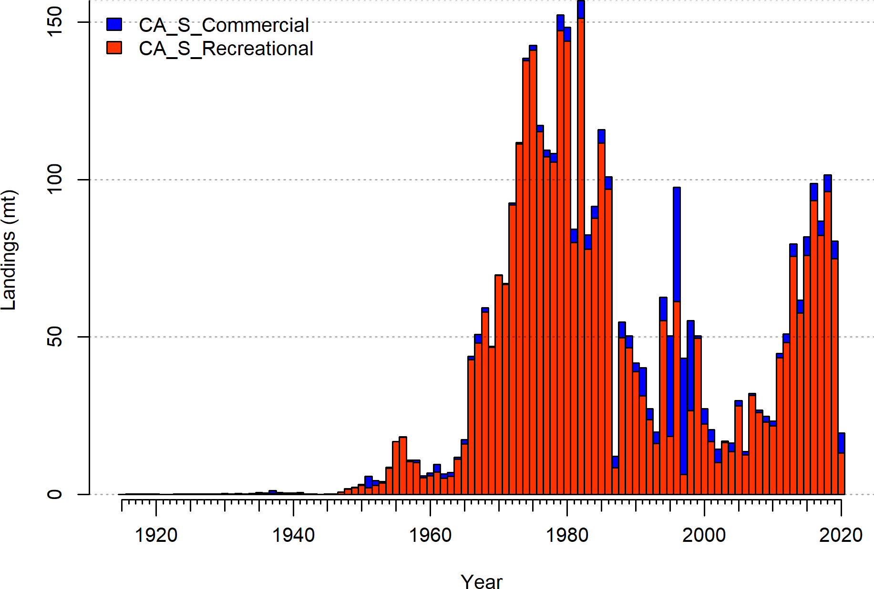

**Figure 1:** Catches by fleet used in the base model.

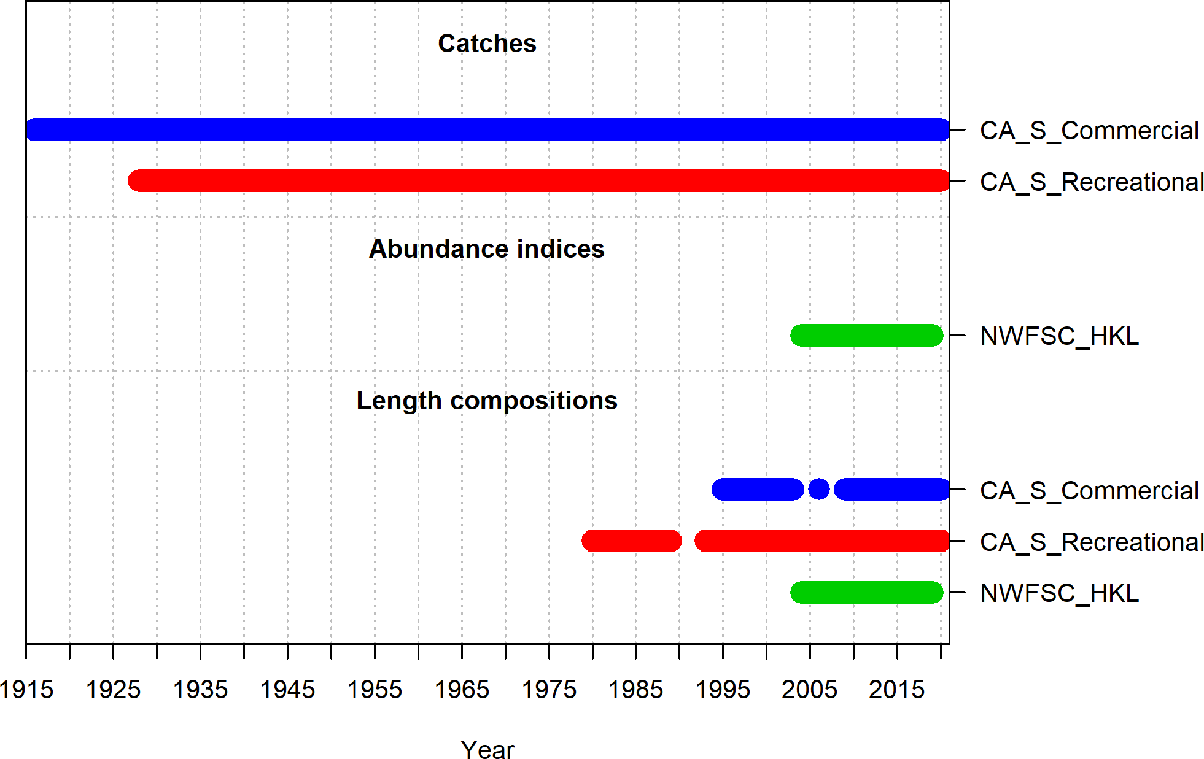

**Figure 2:** Summary of data sources used in the base model.

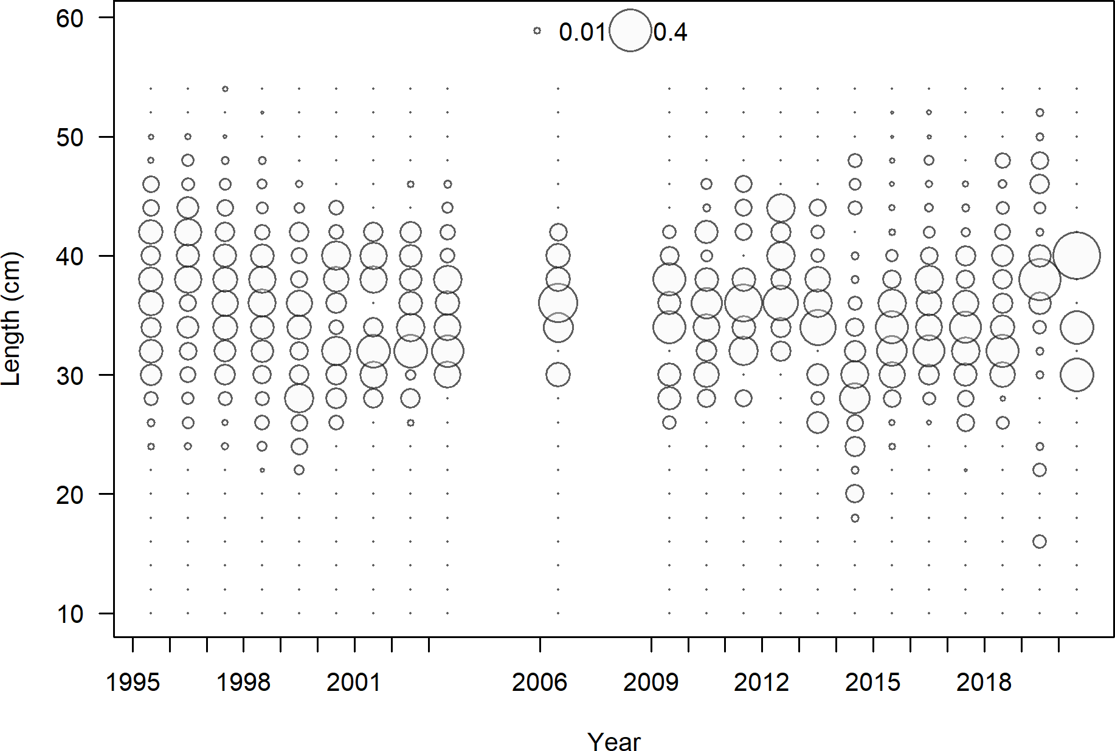

**Figure 3:** Length composition data from the commercial fleet.

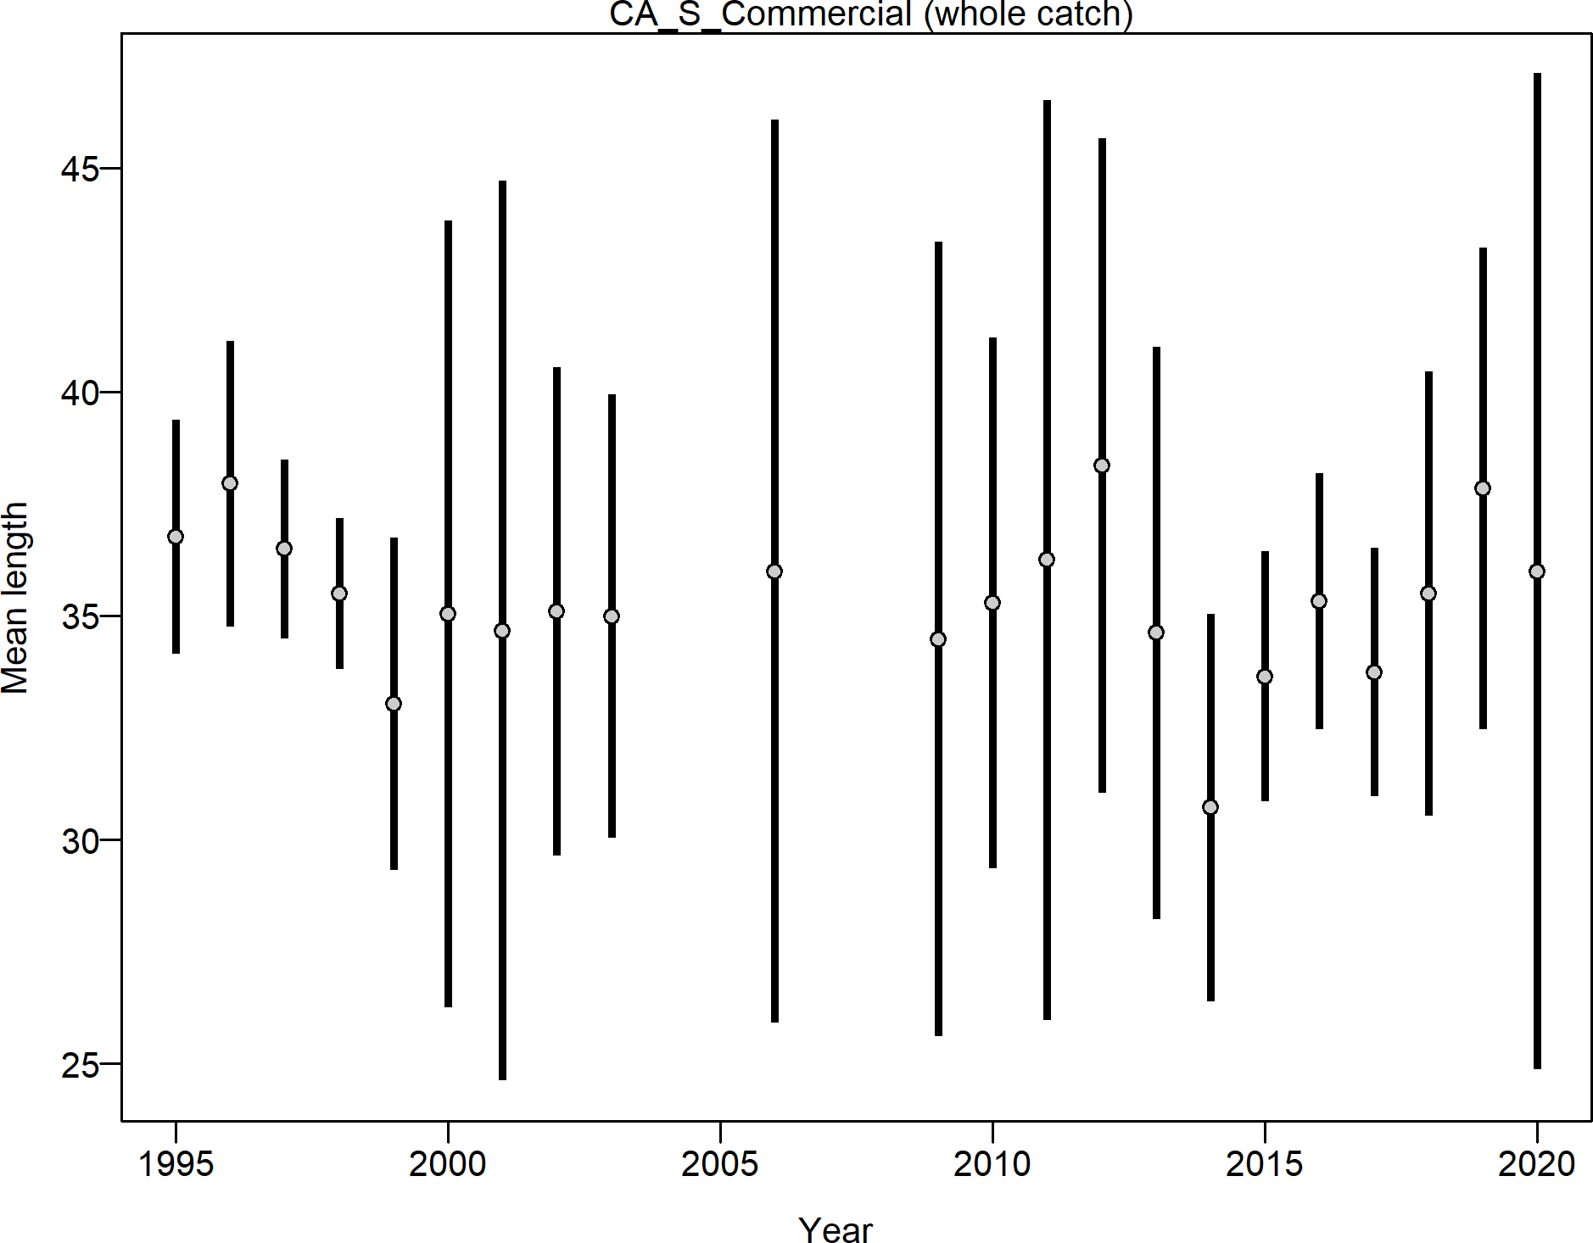

**Figure 4:** Mean length for commercial fleet with 95 percent confidence intervals.

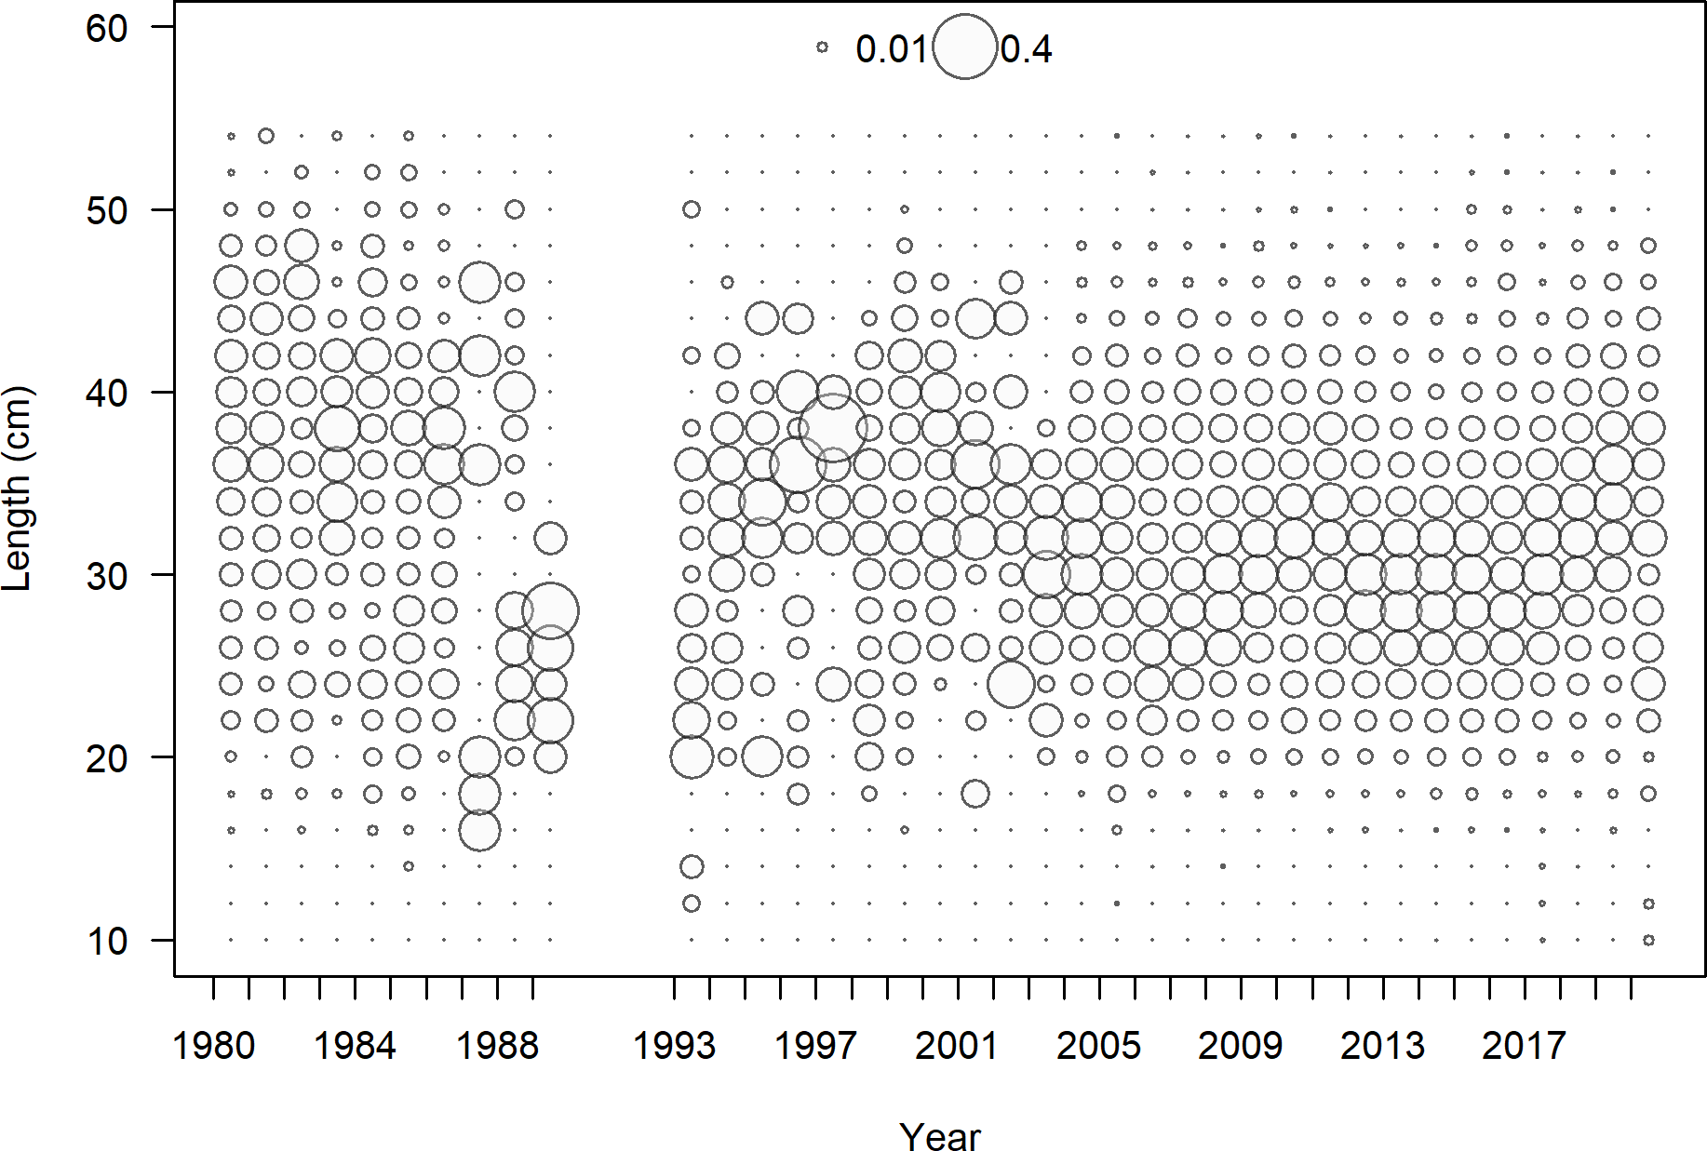

**Figure 5:** Length composition data from the recreational fleet.

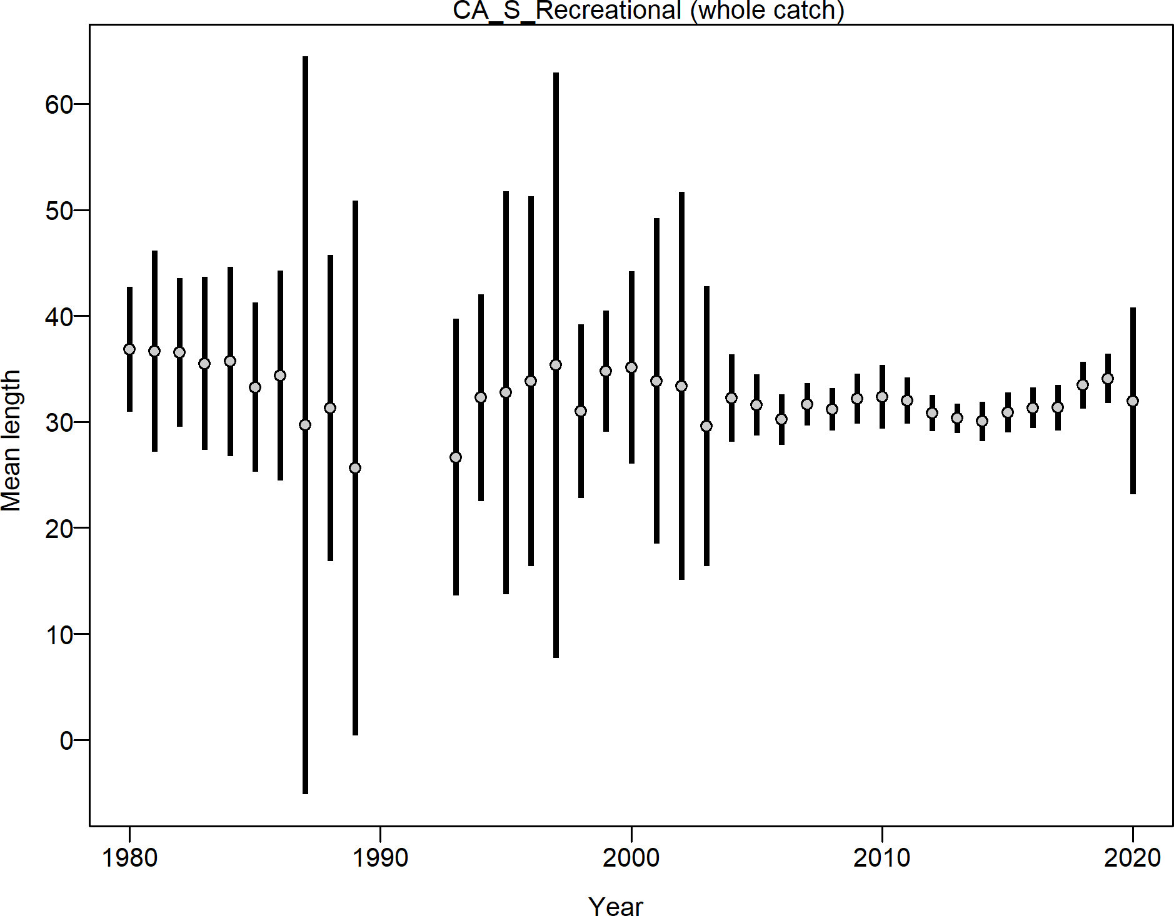

**Figure 6:** Mean length for recreational fleet with 95 percent confidence intervals.

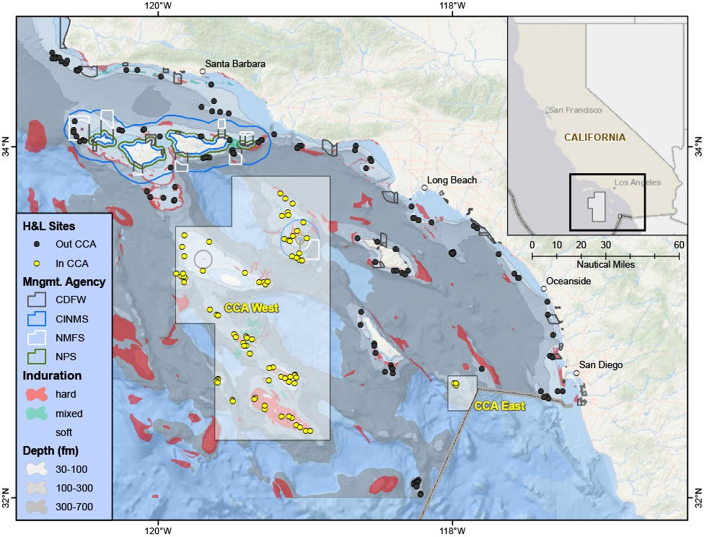

**Figure 7:** NWFSC Hook and Line sampling sites where yellow sites indicate locations inside Cowcod Conservation Areas. Additionally, known substrate structure, depths, and areas under various management regulations are shown for the area south of Point Conception.

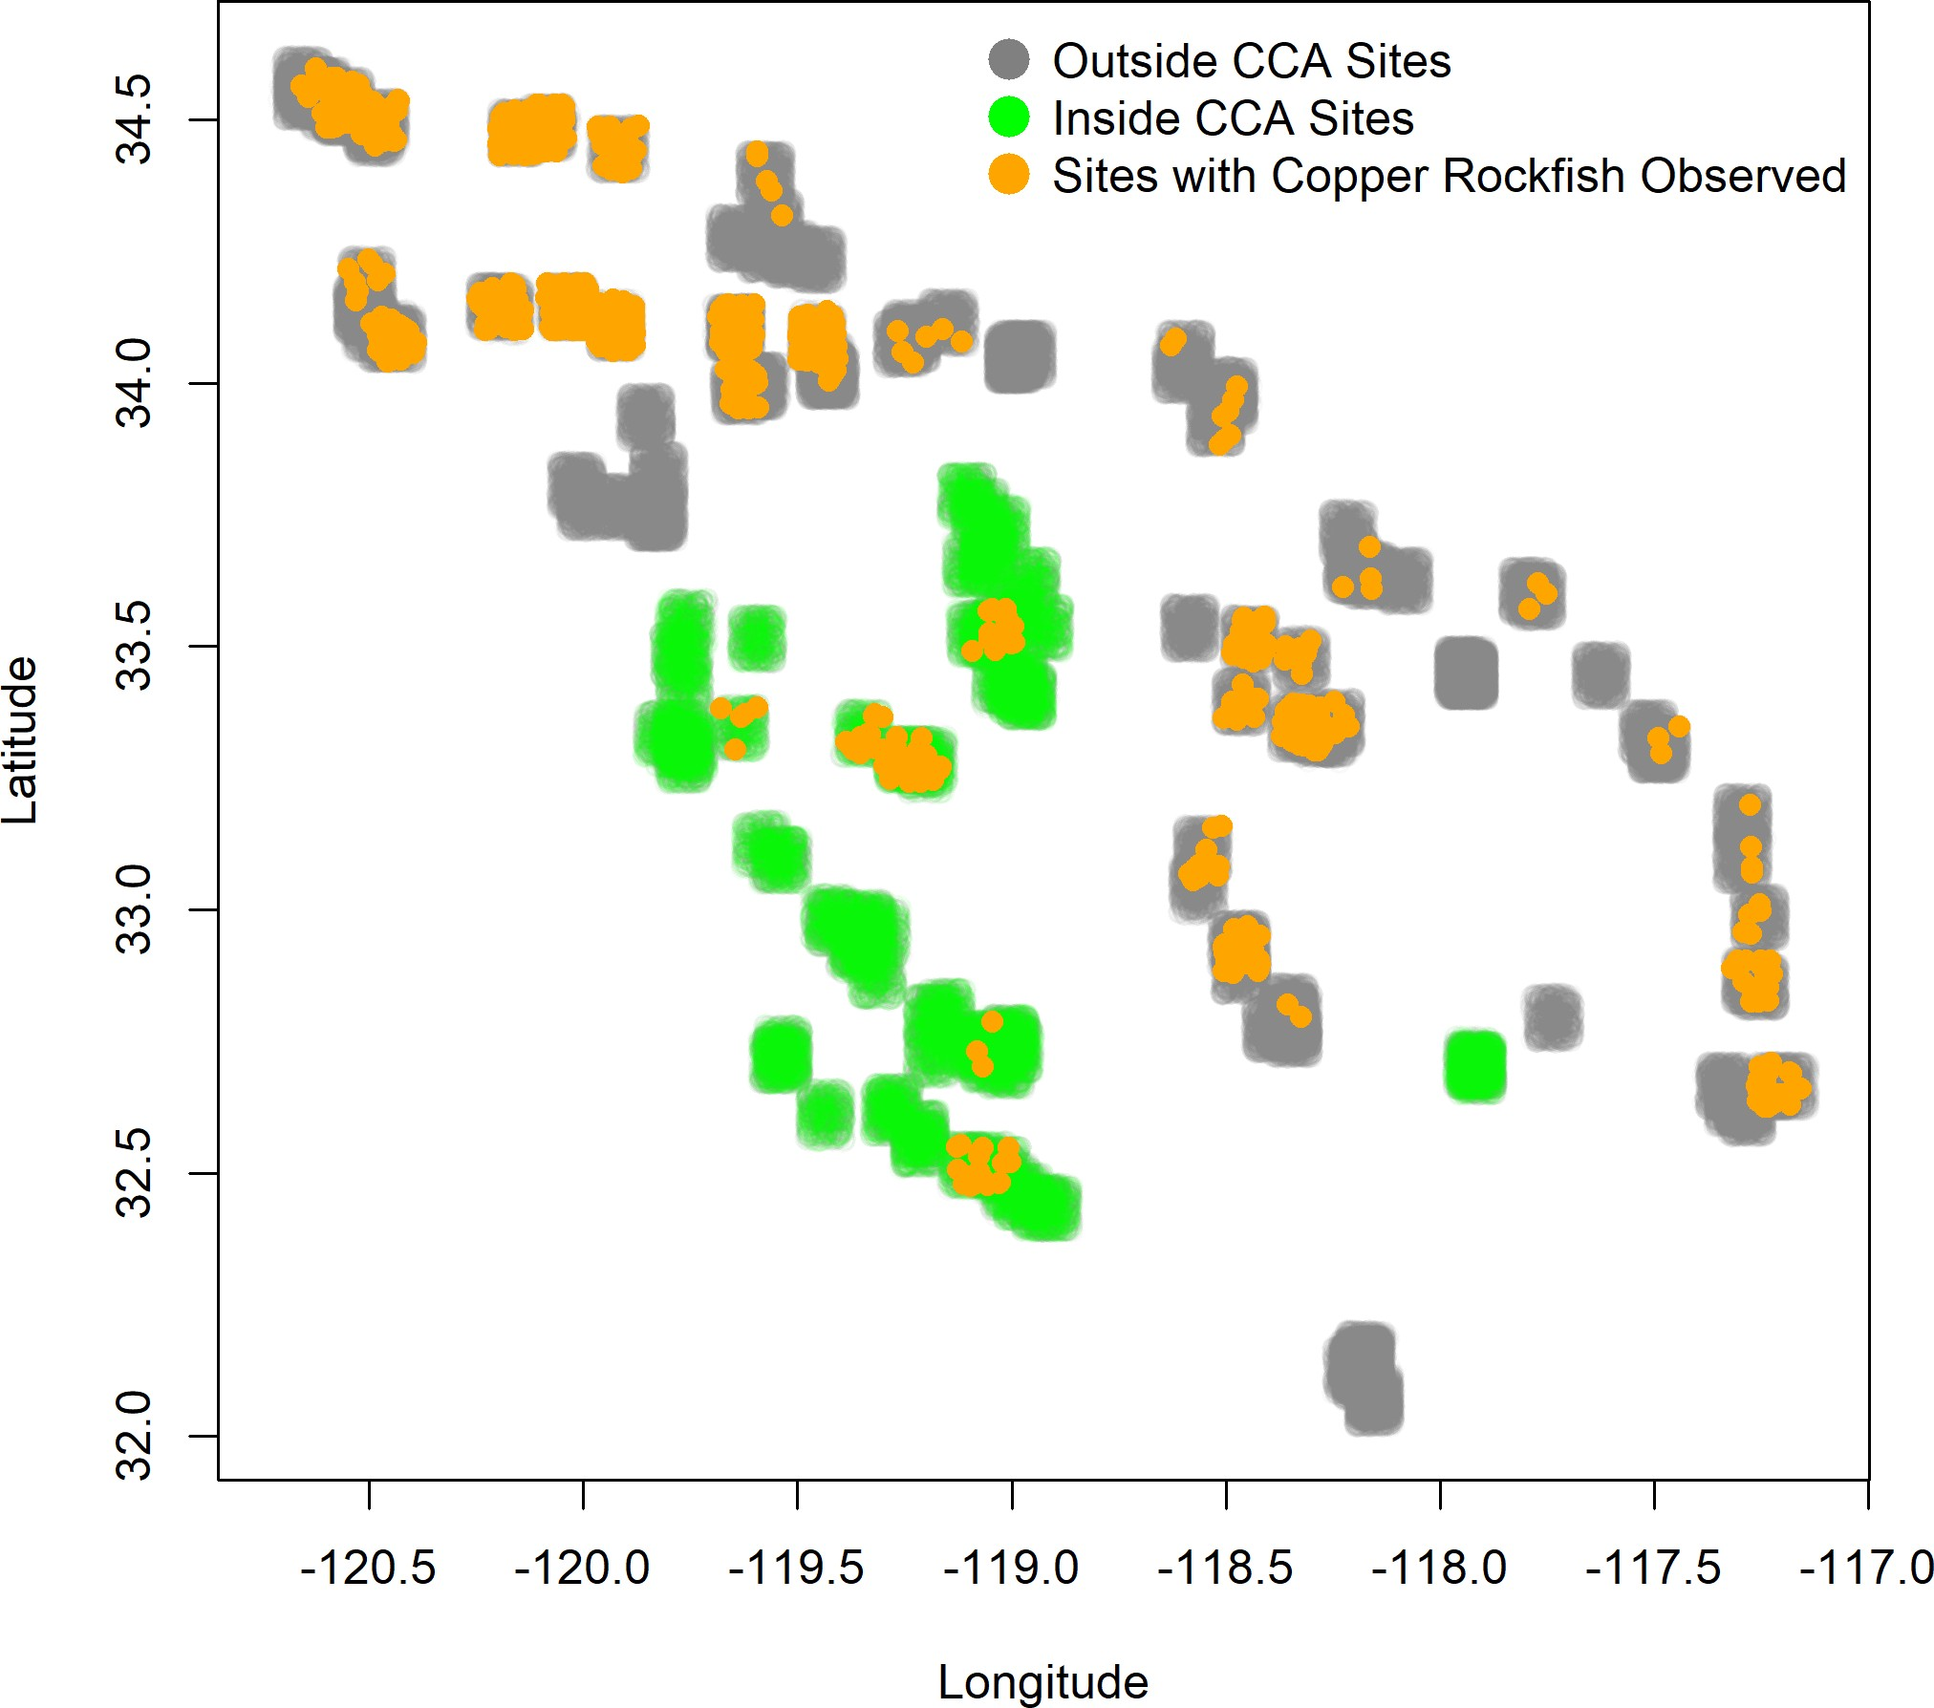

**Figure 8:** NWFSC Hook and Line sample sites inside and outside the CCA and site with observations of copper rockfish.

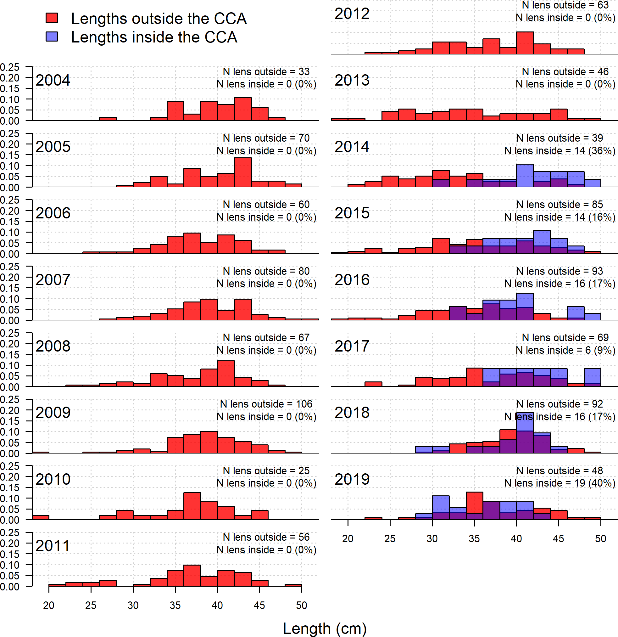

**Figure 9:** NWFSC Hook and Line observations by year outside and inside the cowcod conservation area.

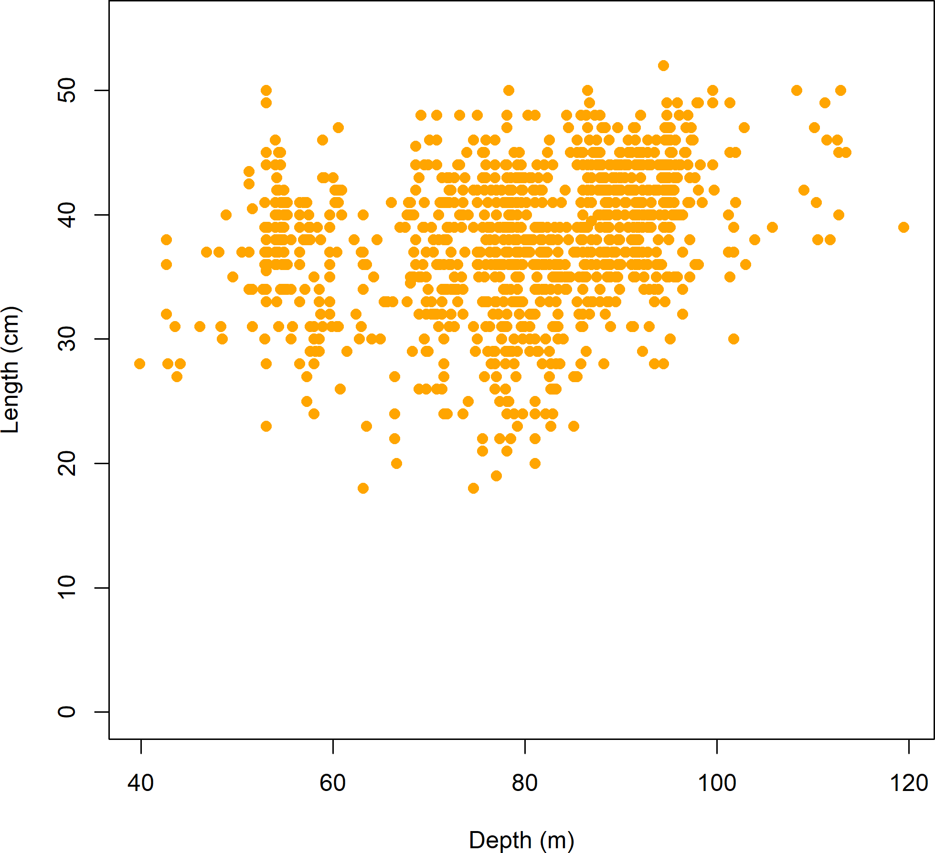

**Figure 10:** Lengths observations by depth in the NWFSC Hook and Line data.

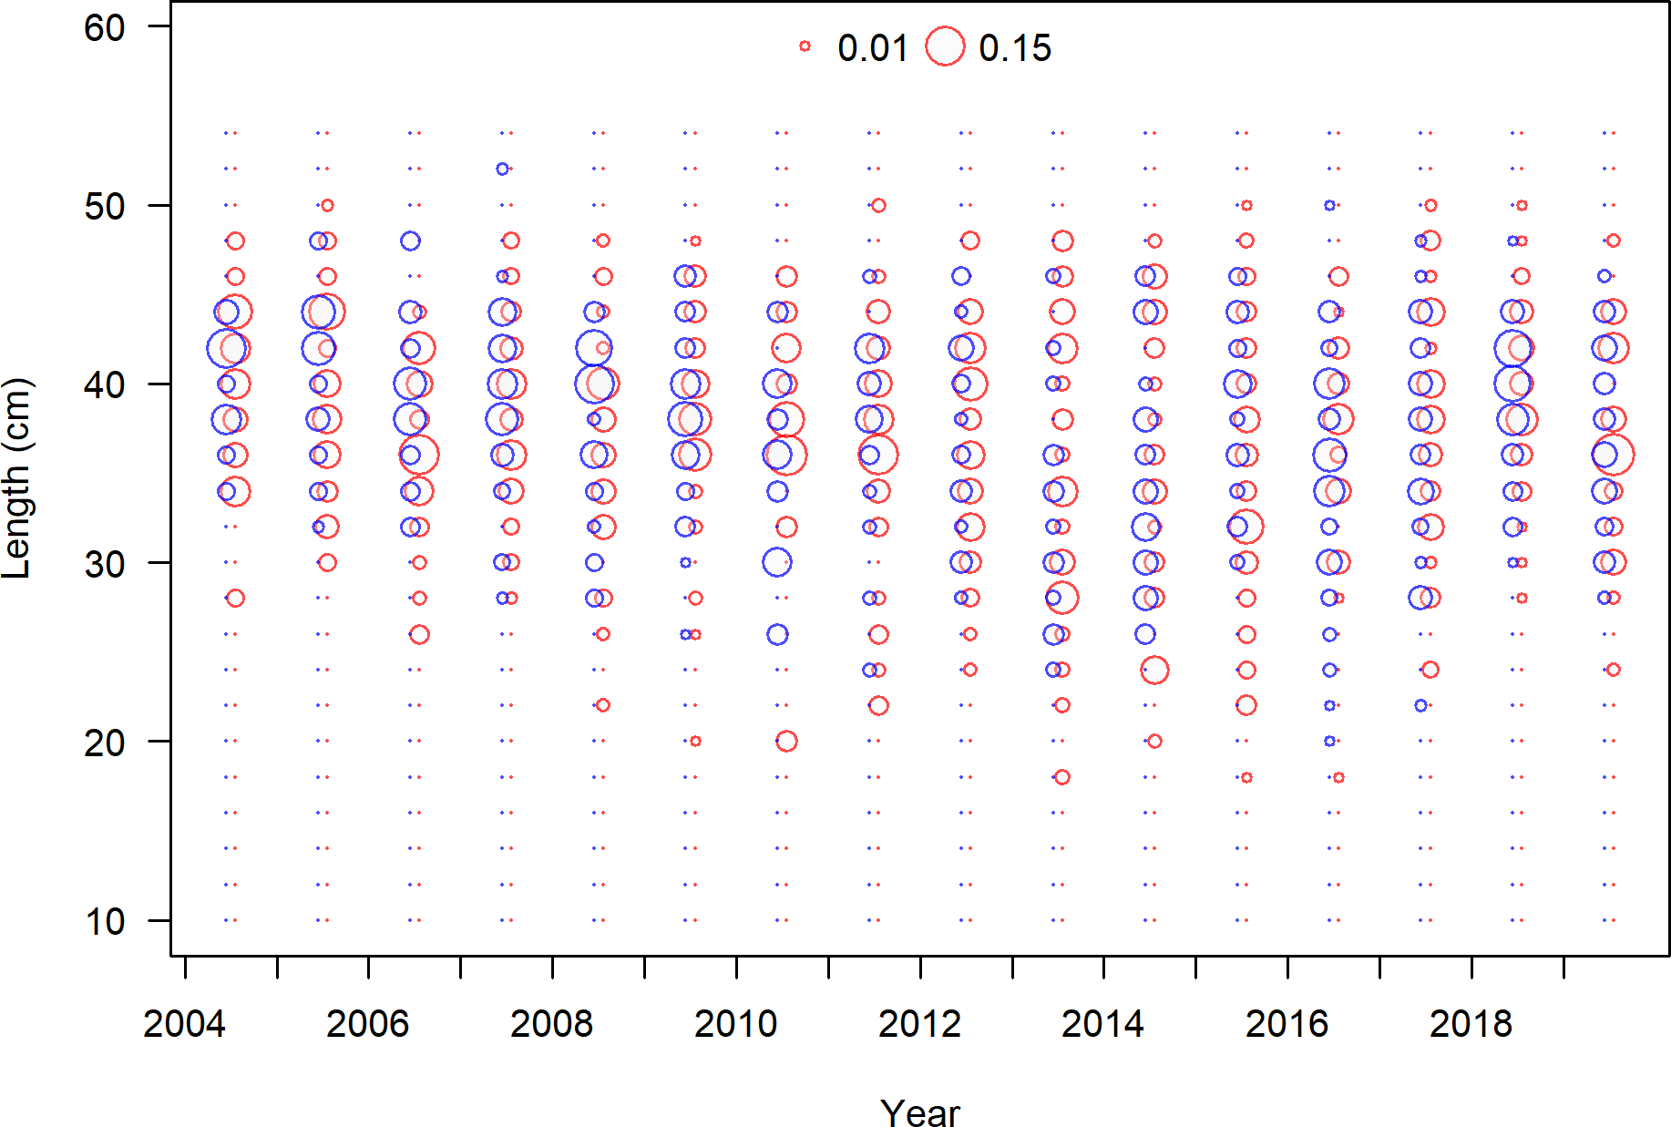

**Figure 11:** Length composition data from the NWFSC Hook and Line fleet.

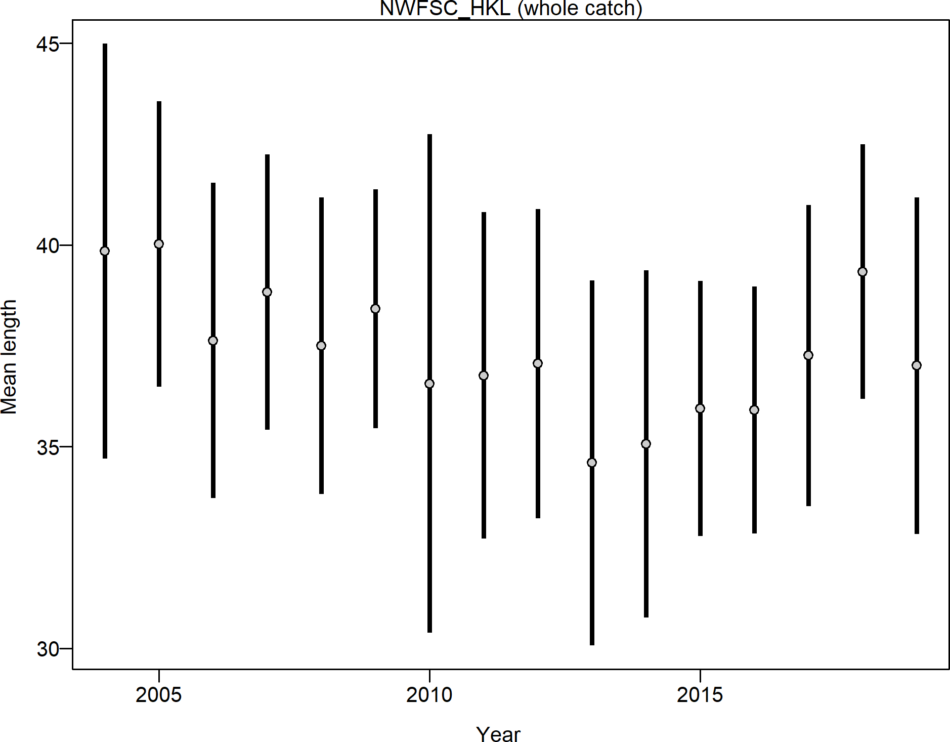

**Figure 12:** Mean length for NWFSC Hook and Line fleet with 95 percent confidence intervals.

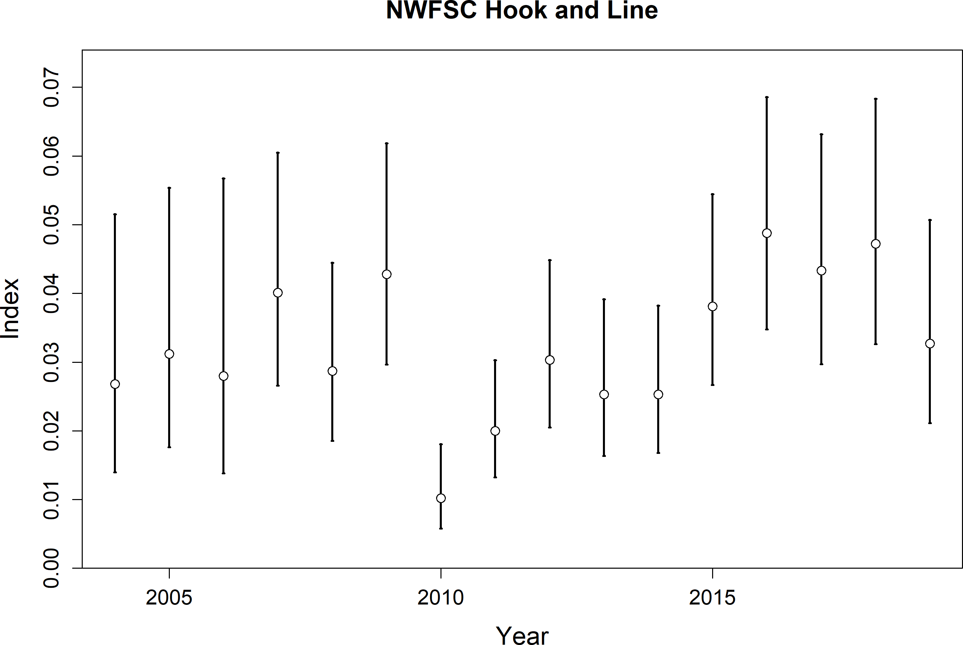

**Figure 13:** Index of abundance for the NWFSC Hook and Line survey. Lines indicate 95 percent uncertainty interval around index values based on the model assumption of lognormal error. Thicker lines indicate input uncertainty before addition of estimated additional uncertainty parameter.

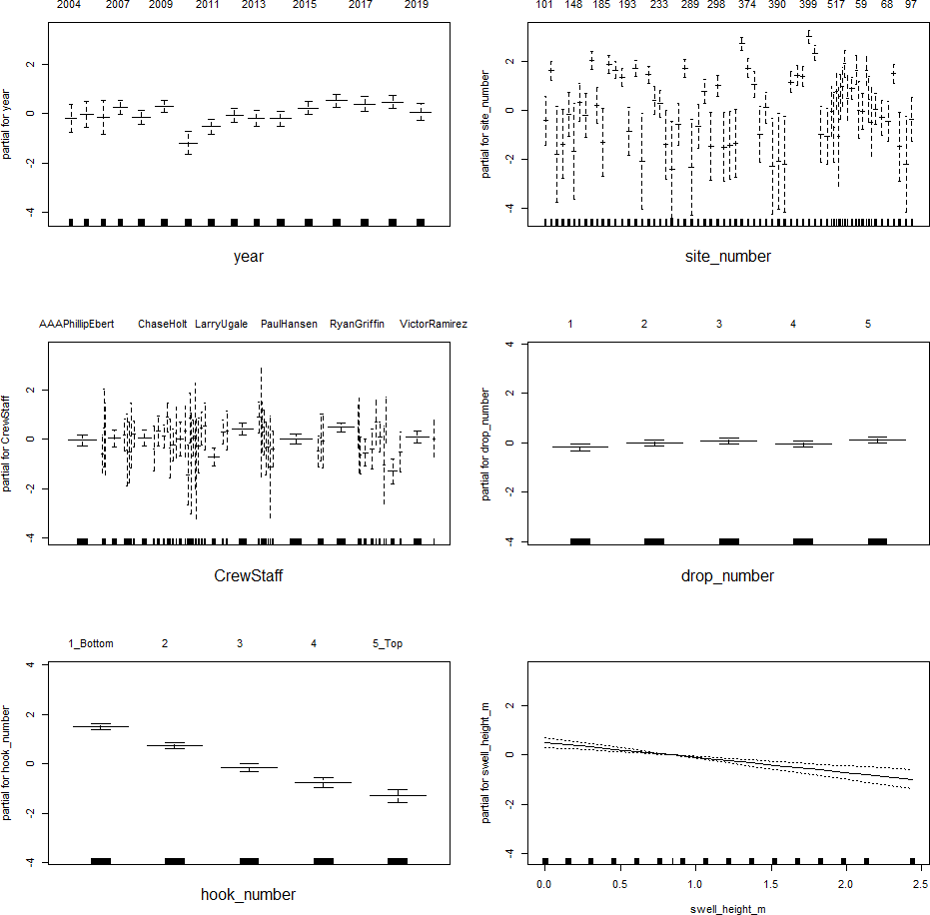

**Figure 14:** Diangostics for the binomial generalized-linear model.

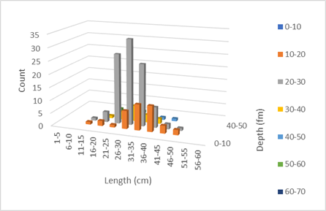

**Figure 15:** Length frequency distribution in each 10 fm depth bin for copper rockfish sampled by the ROV in reference locations open to fishing south of Point Conception.

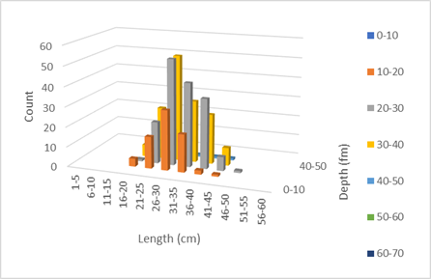

**Figure 16:** Length frequency distribution in each 10 fm depth bin for copper rockfish sampled by the ROV in marine protected areas where retention is prohibited.

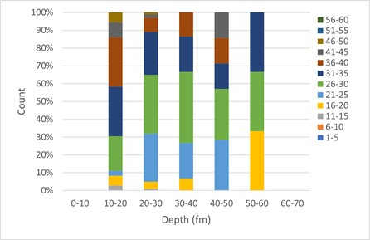

**Figure 17:** Percent composition of copper rockfish length frequency in 5 cm size classes for each 10 fm depth bin from ROV observations south of Point Conception in reference locations where retention is allowed.

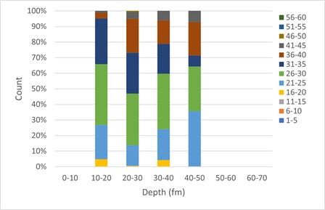

**Figure 18:** Percent composition of copper rockfish length frequency in 5 cm size classes for each 10 fm depth bin from ROV observations south of Point Conception in marine protected areas where retention is prohibited.

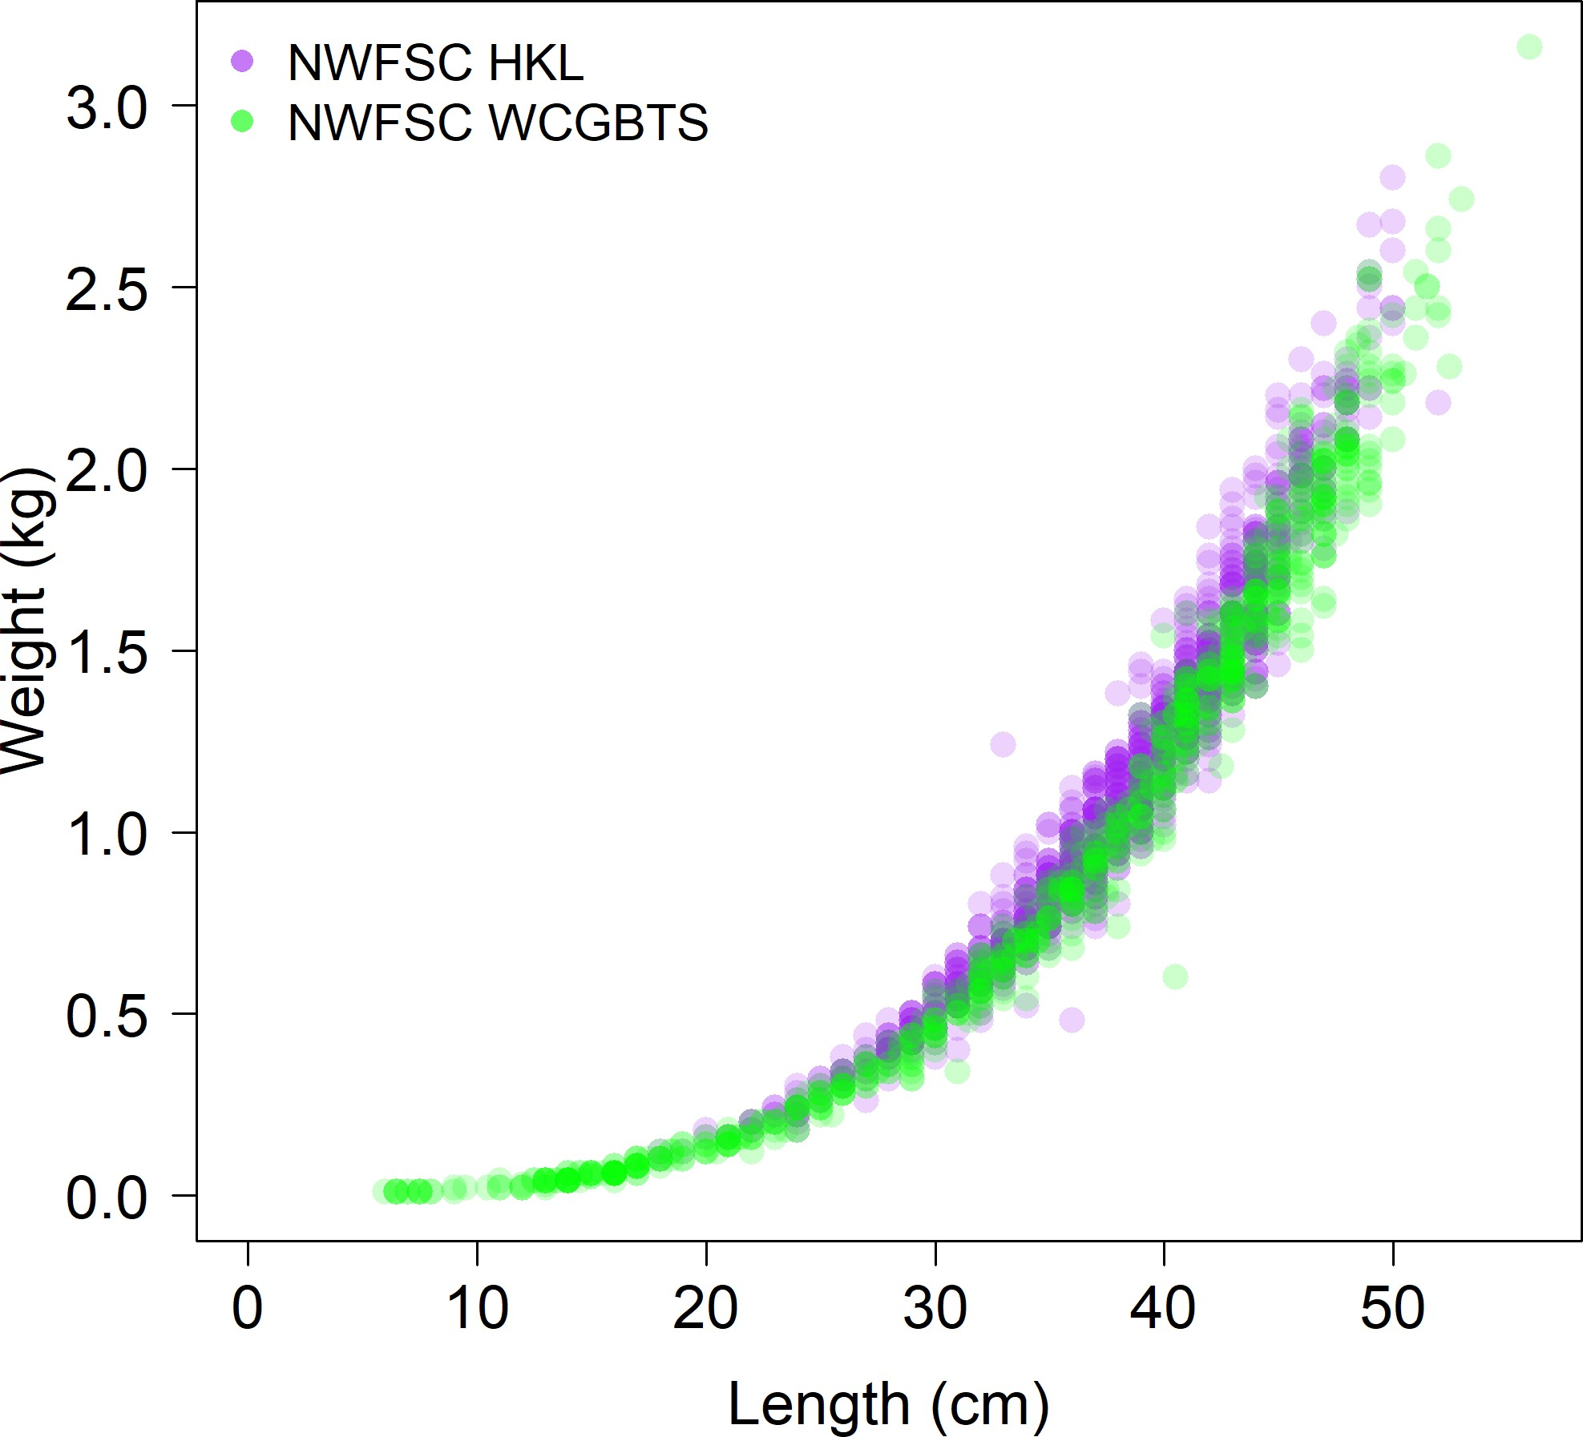

**Figure 19:** Comparison of the length-at-weight data from the NWFSC Hook and Line and the NWFSC WCGBT surveys.

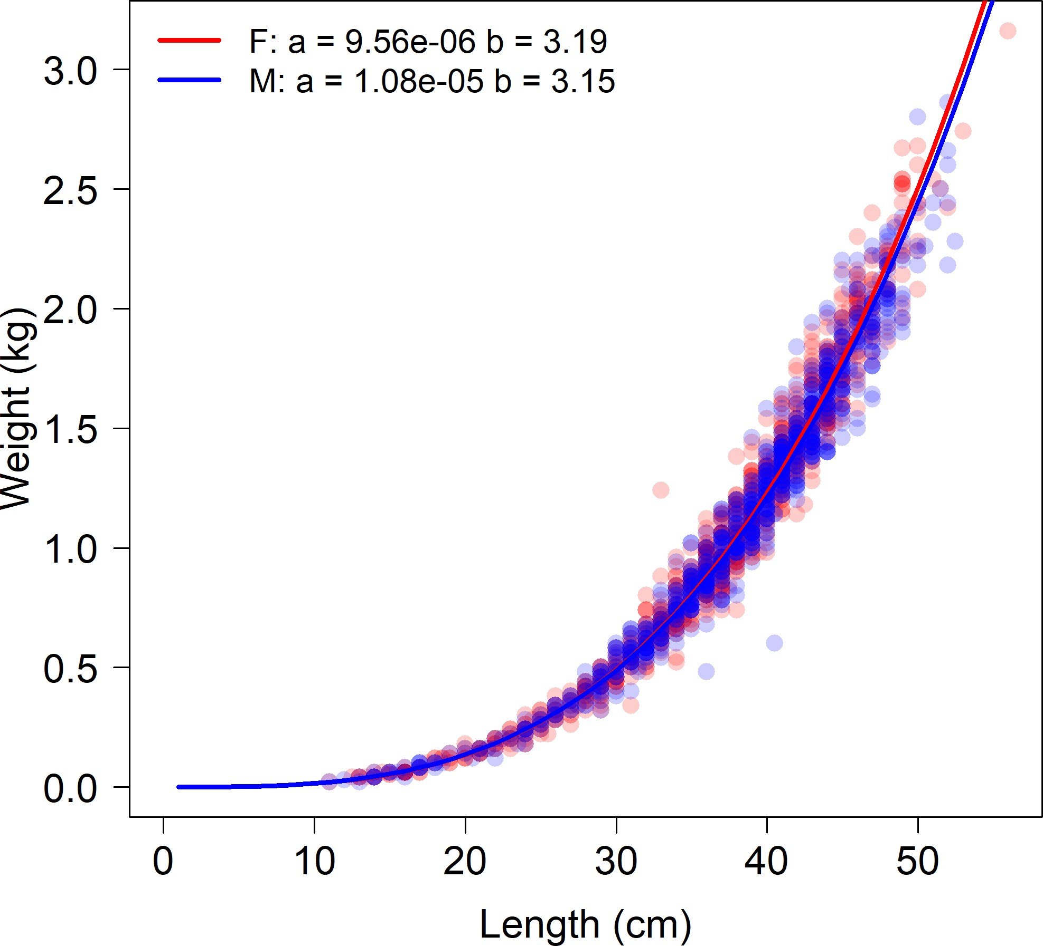

**Figure 20:** Survey length-at-weight data with sex specific estimated fits.

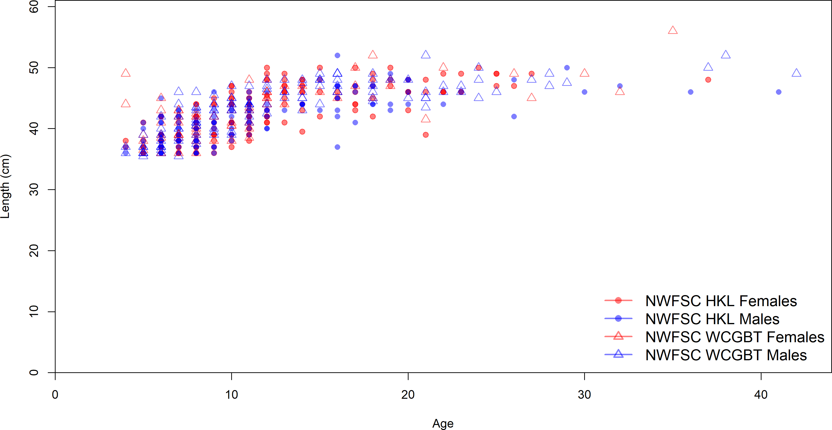

**Figure 21:** Length-at-age for non-randomly sampled larger fish observed by the NWFSC Hook and Line and WCGBT survey.

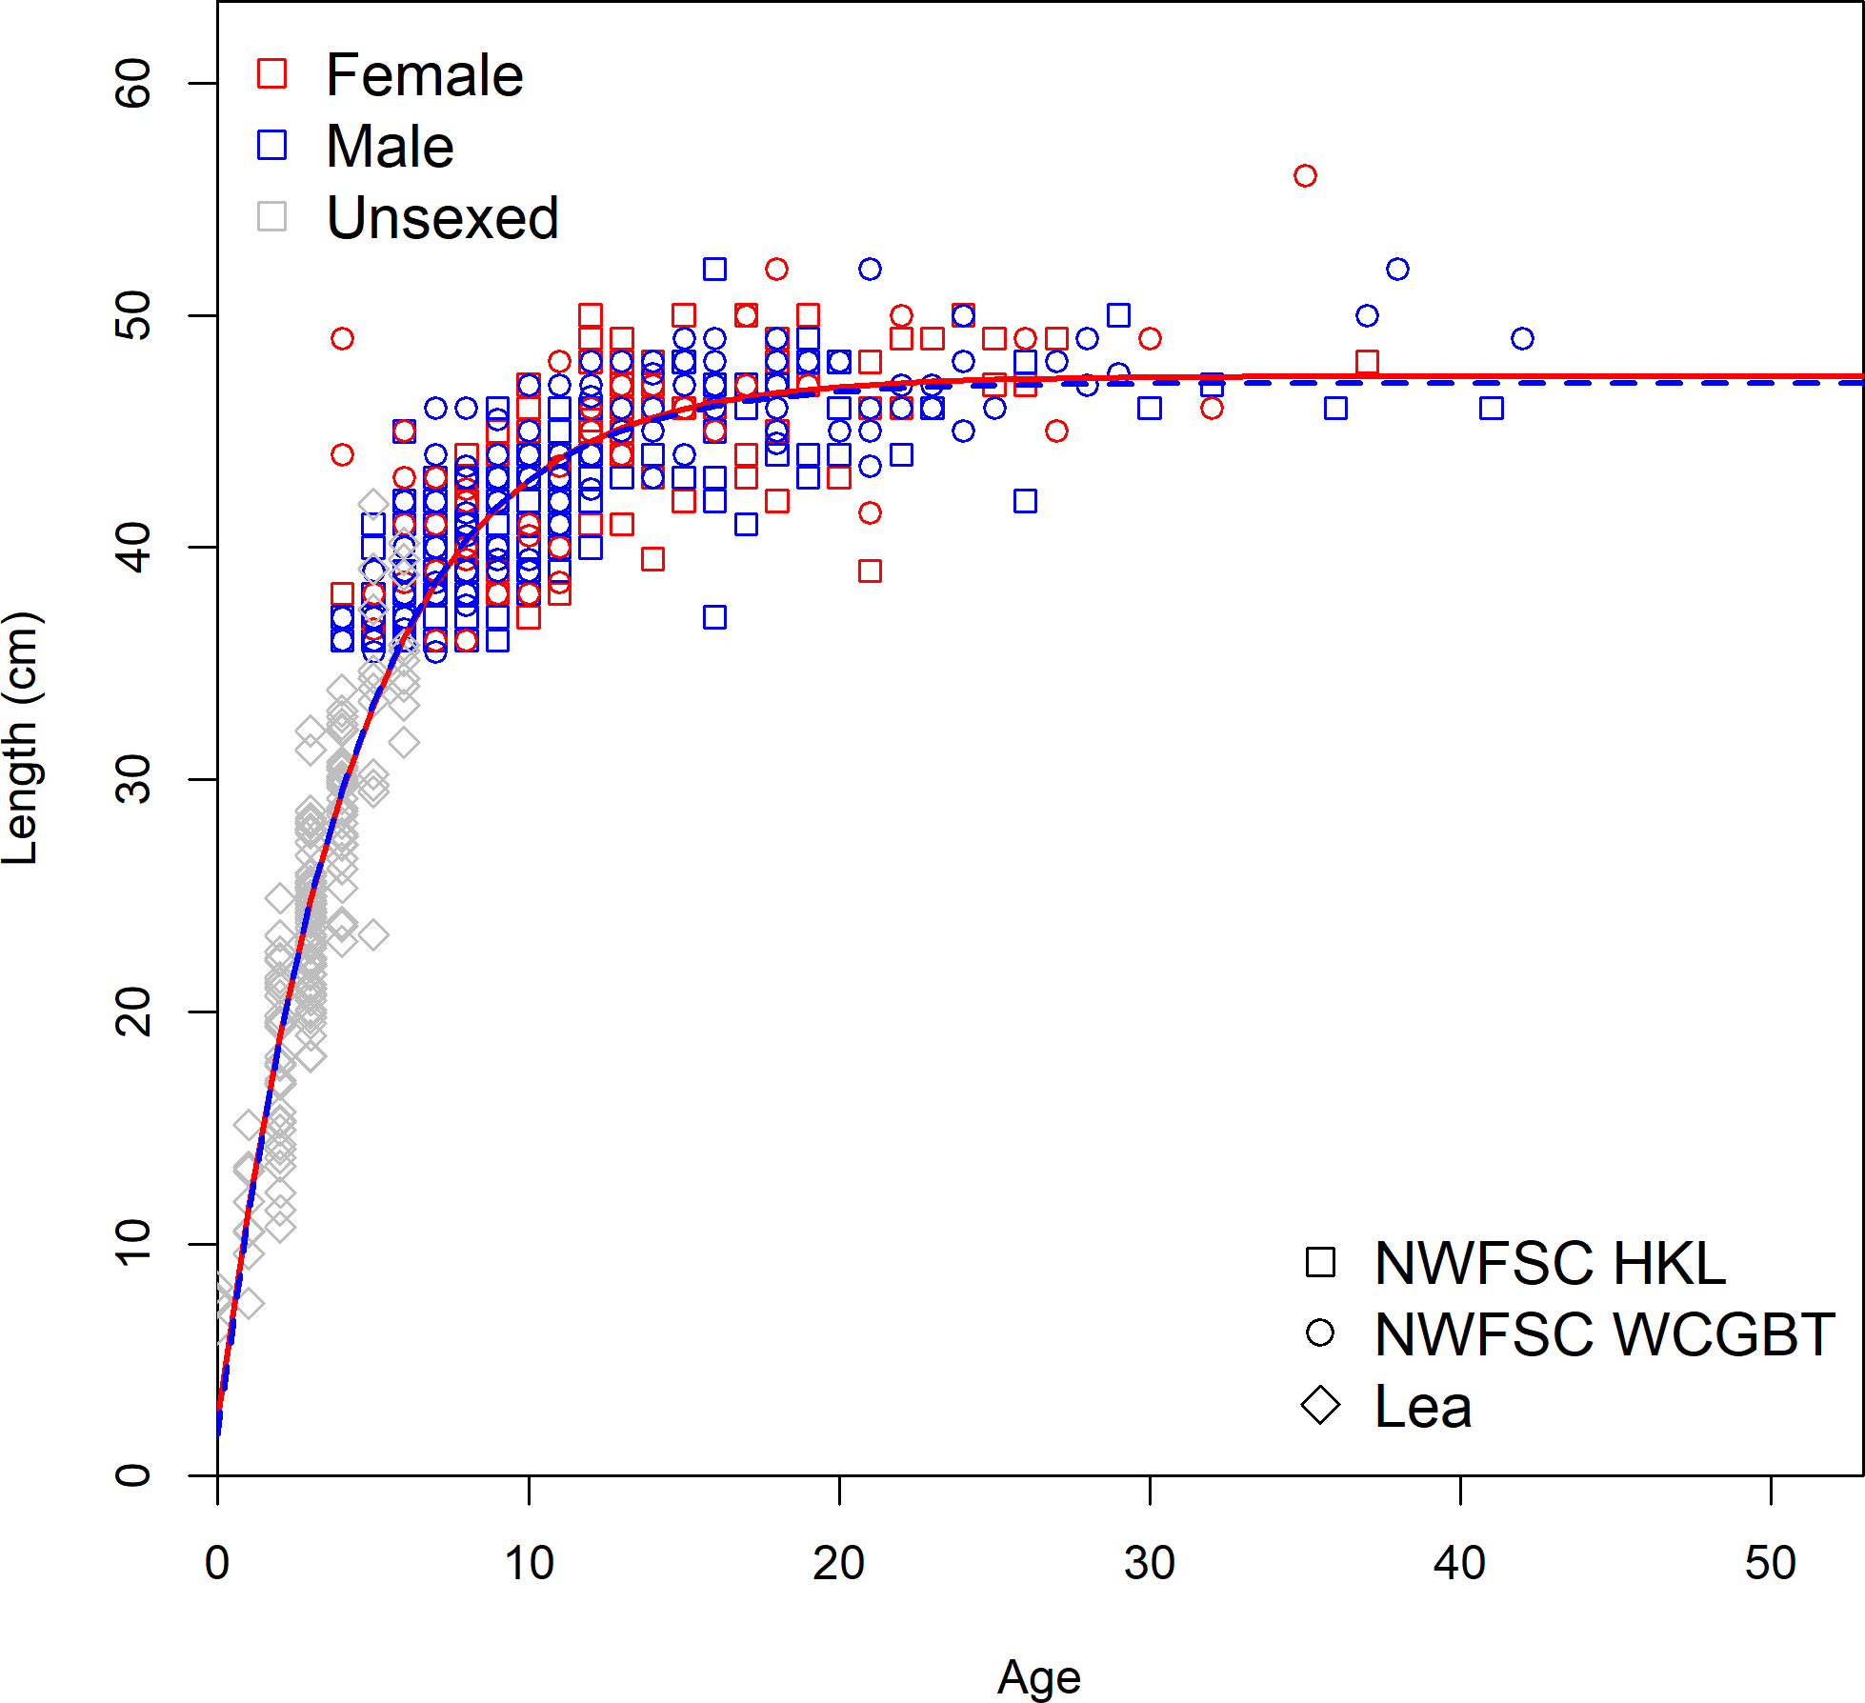

**Figure 22:** Length-at-age for non-randomly sampled larger fish observed by the NWFSC Hook and Line and WCGBT survey and young fish from Lea.

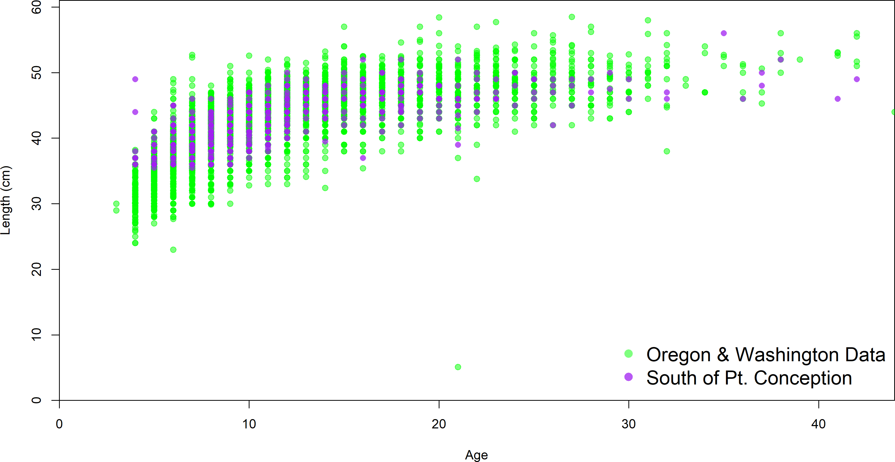

**Figure 23:** Length-at-age comparisons between survey collected fish south of Point Concep- tion and to those observed off the coast of Oregon and Washington.

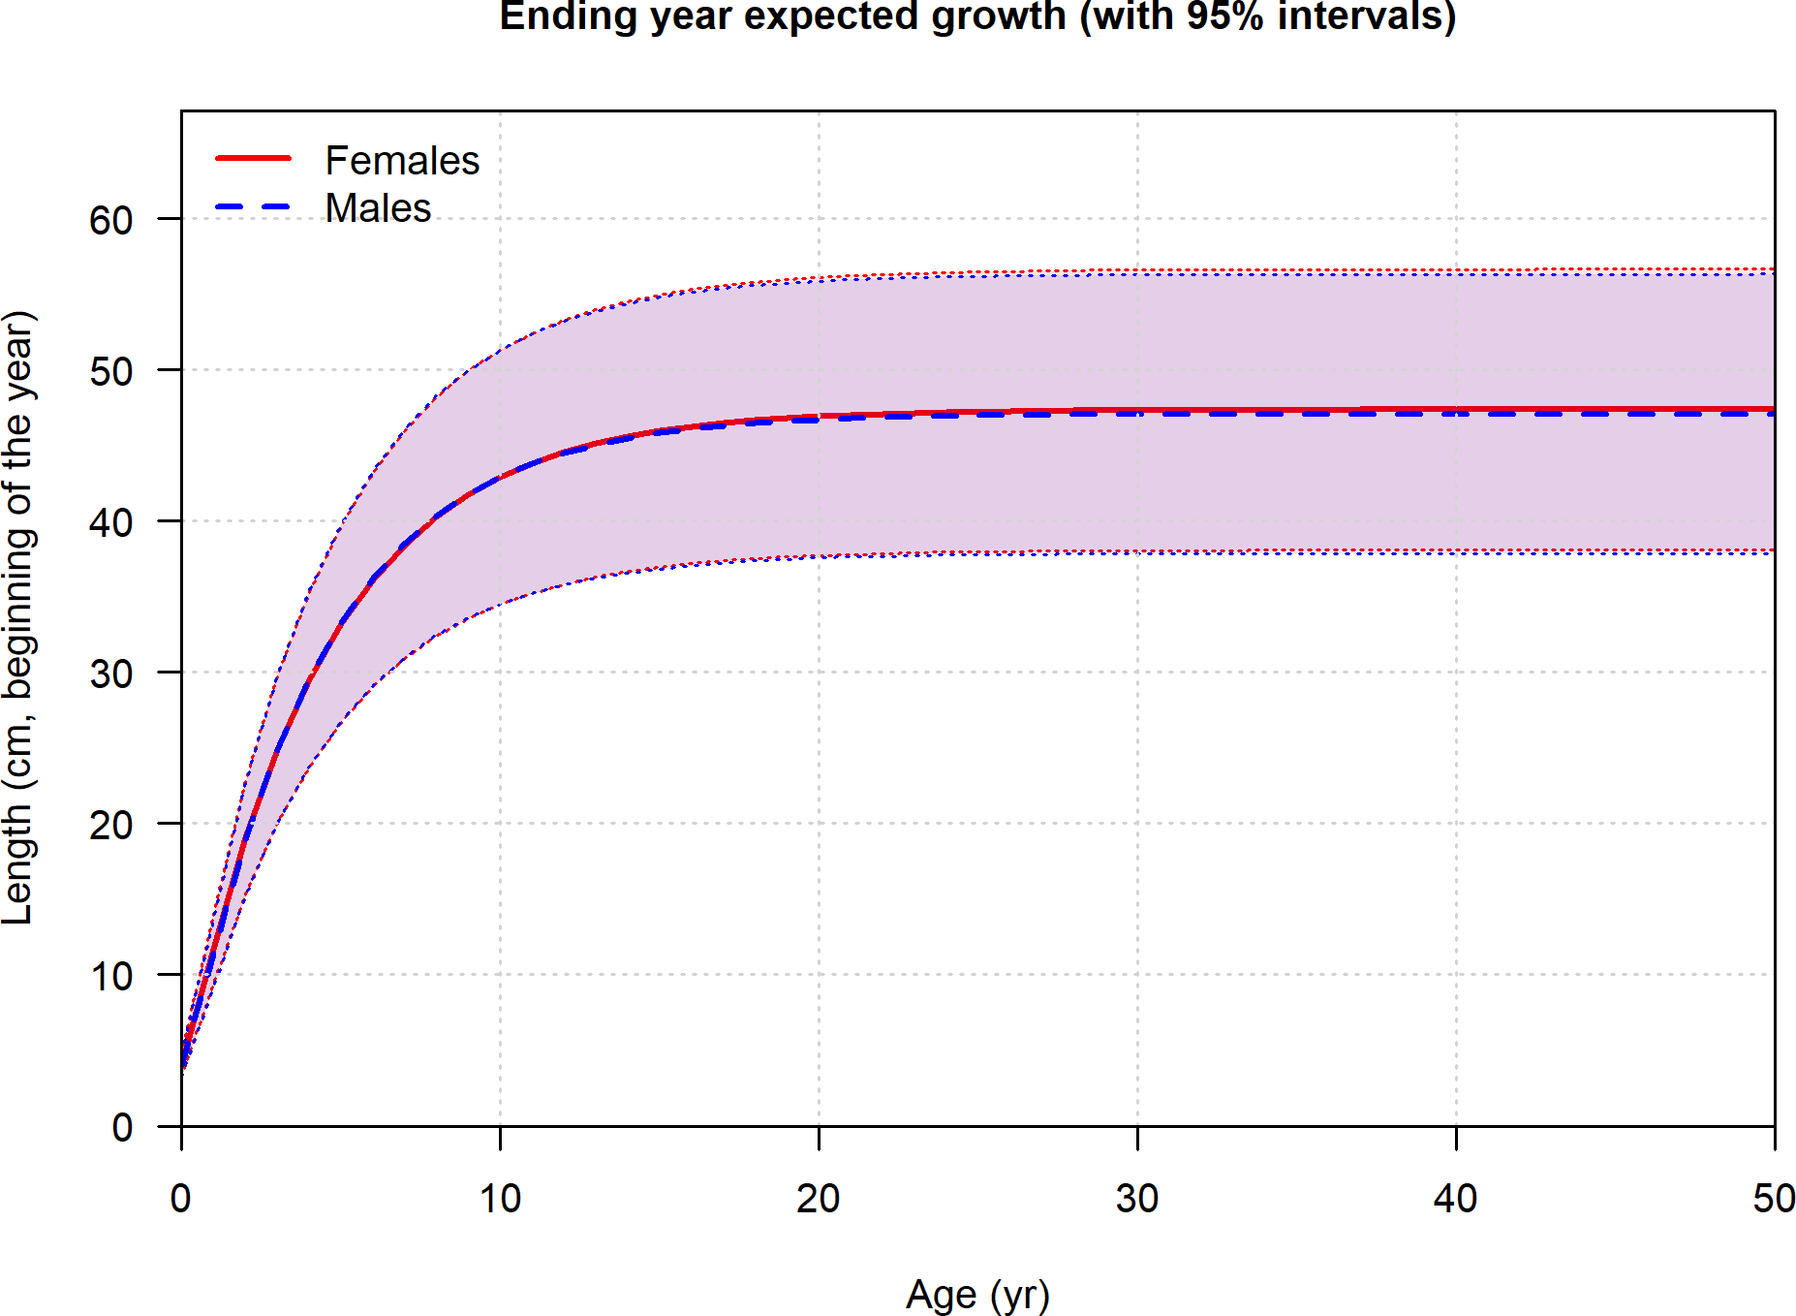

**Figure 24:** Length-at-age in the beginning of the year with the coefficient of variation by age within the model.

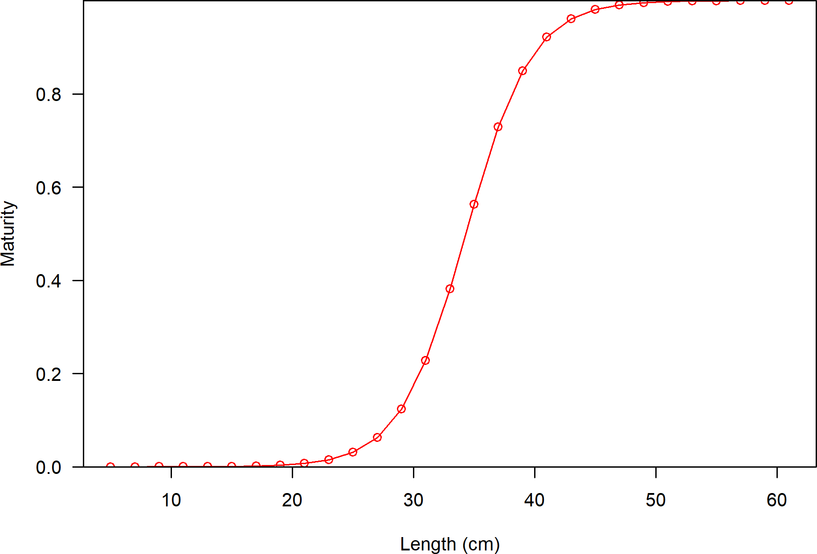

**Figure 25:** Maturity as a function of length.

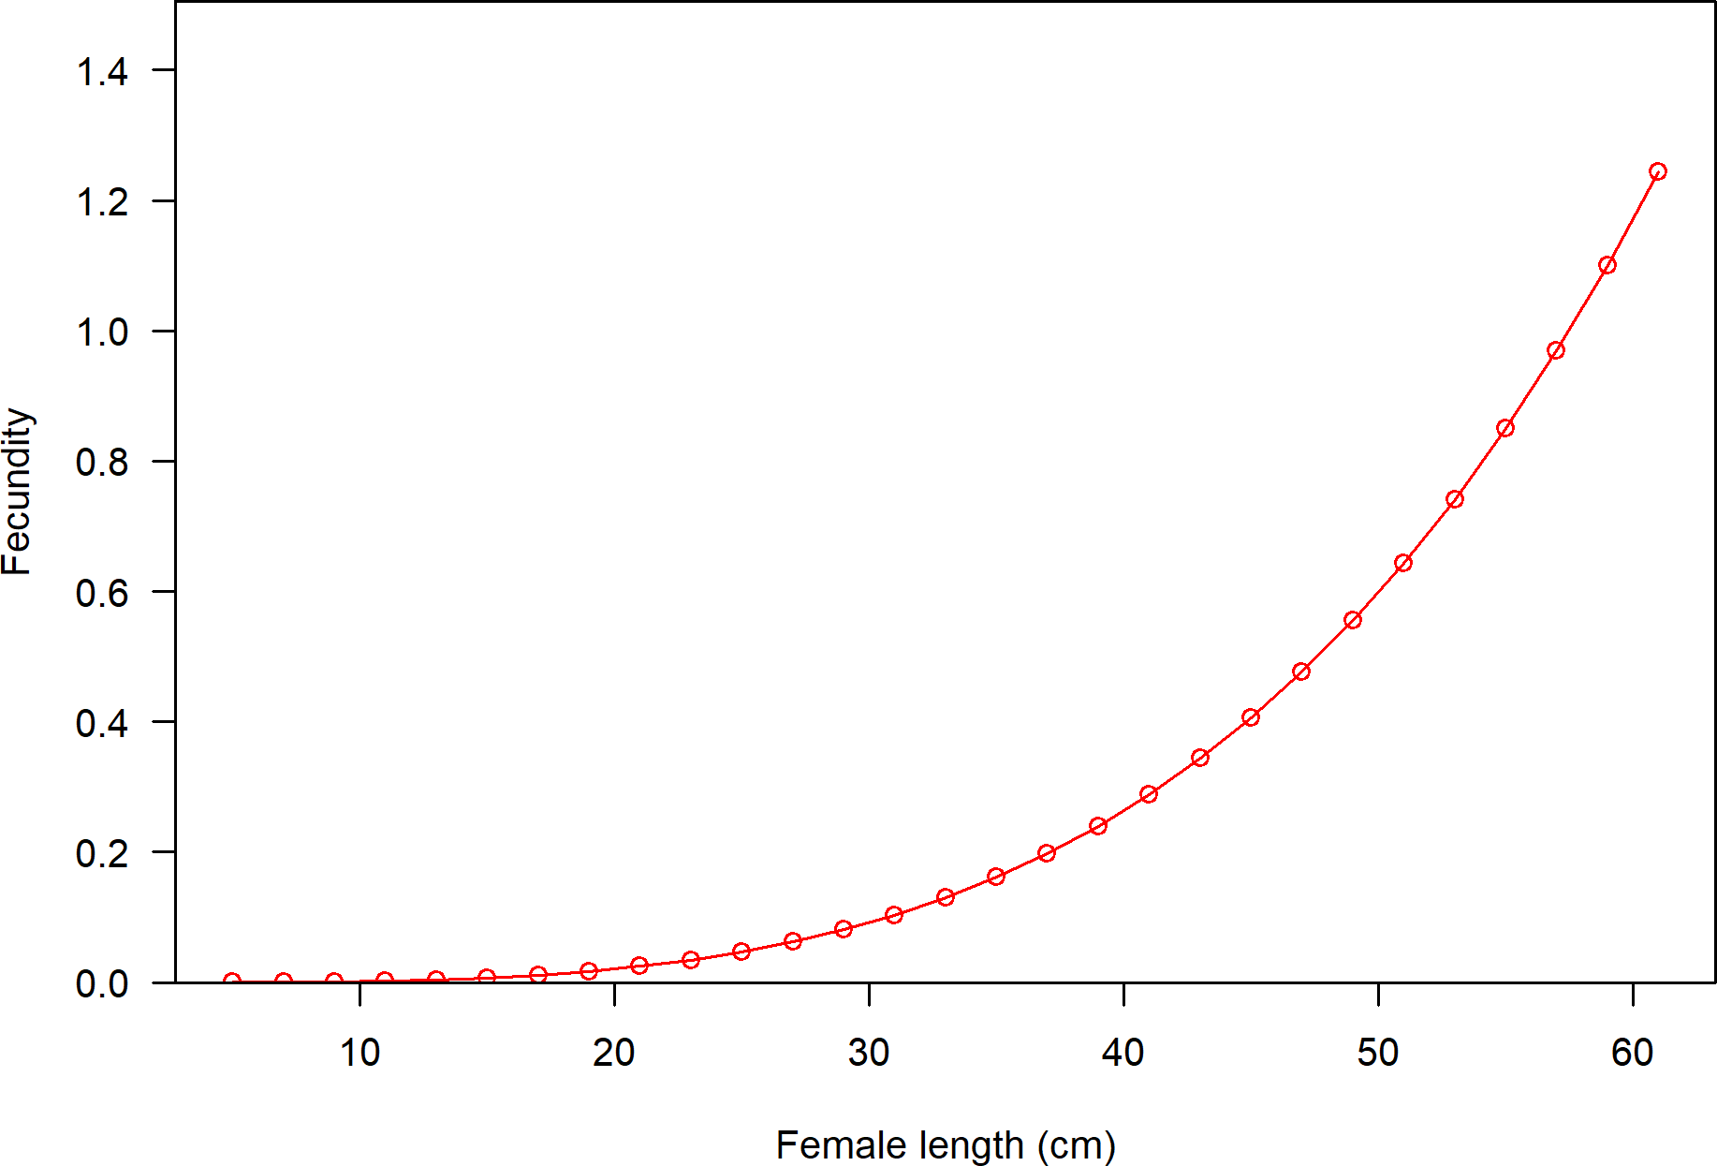

**Figure 26:** Fecundity as a function of length.

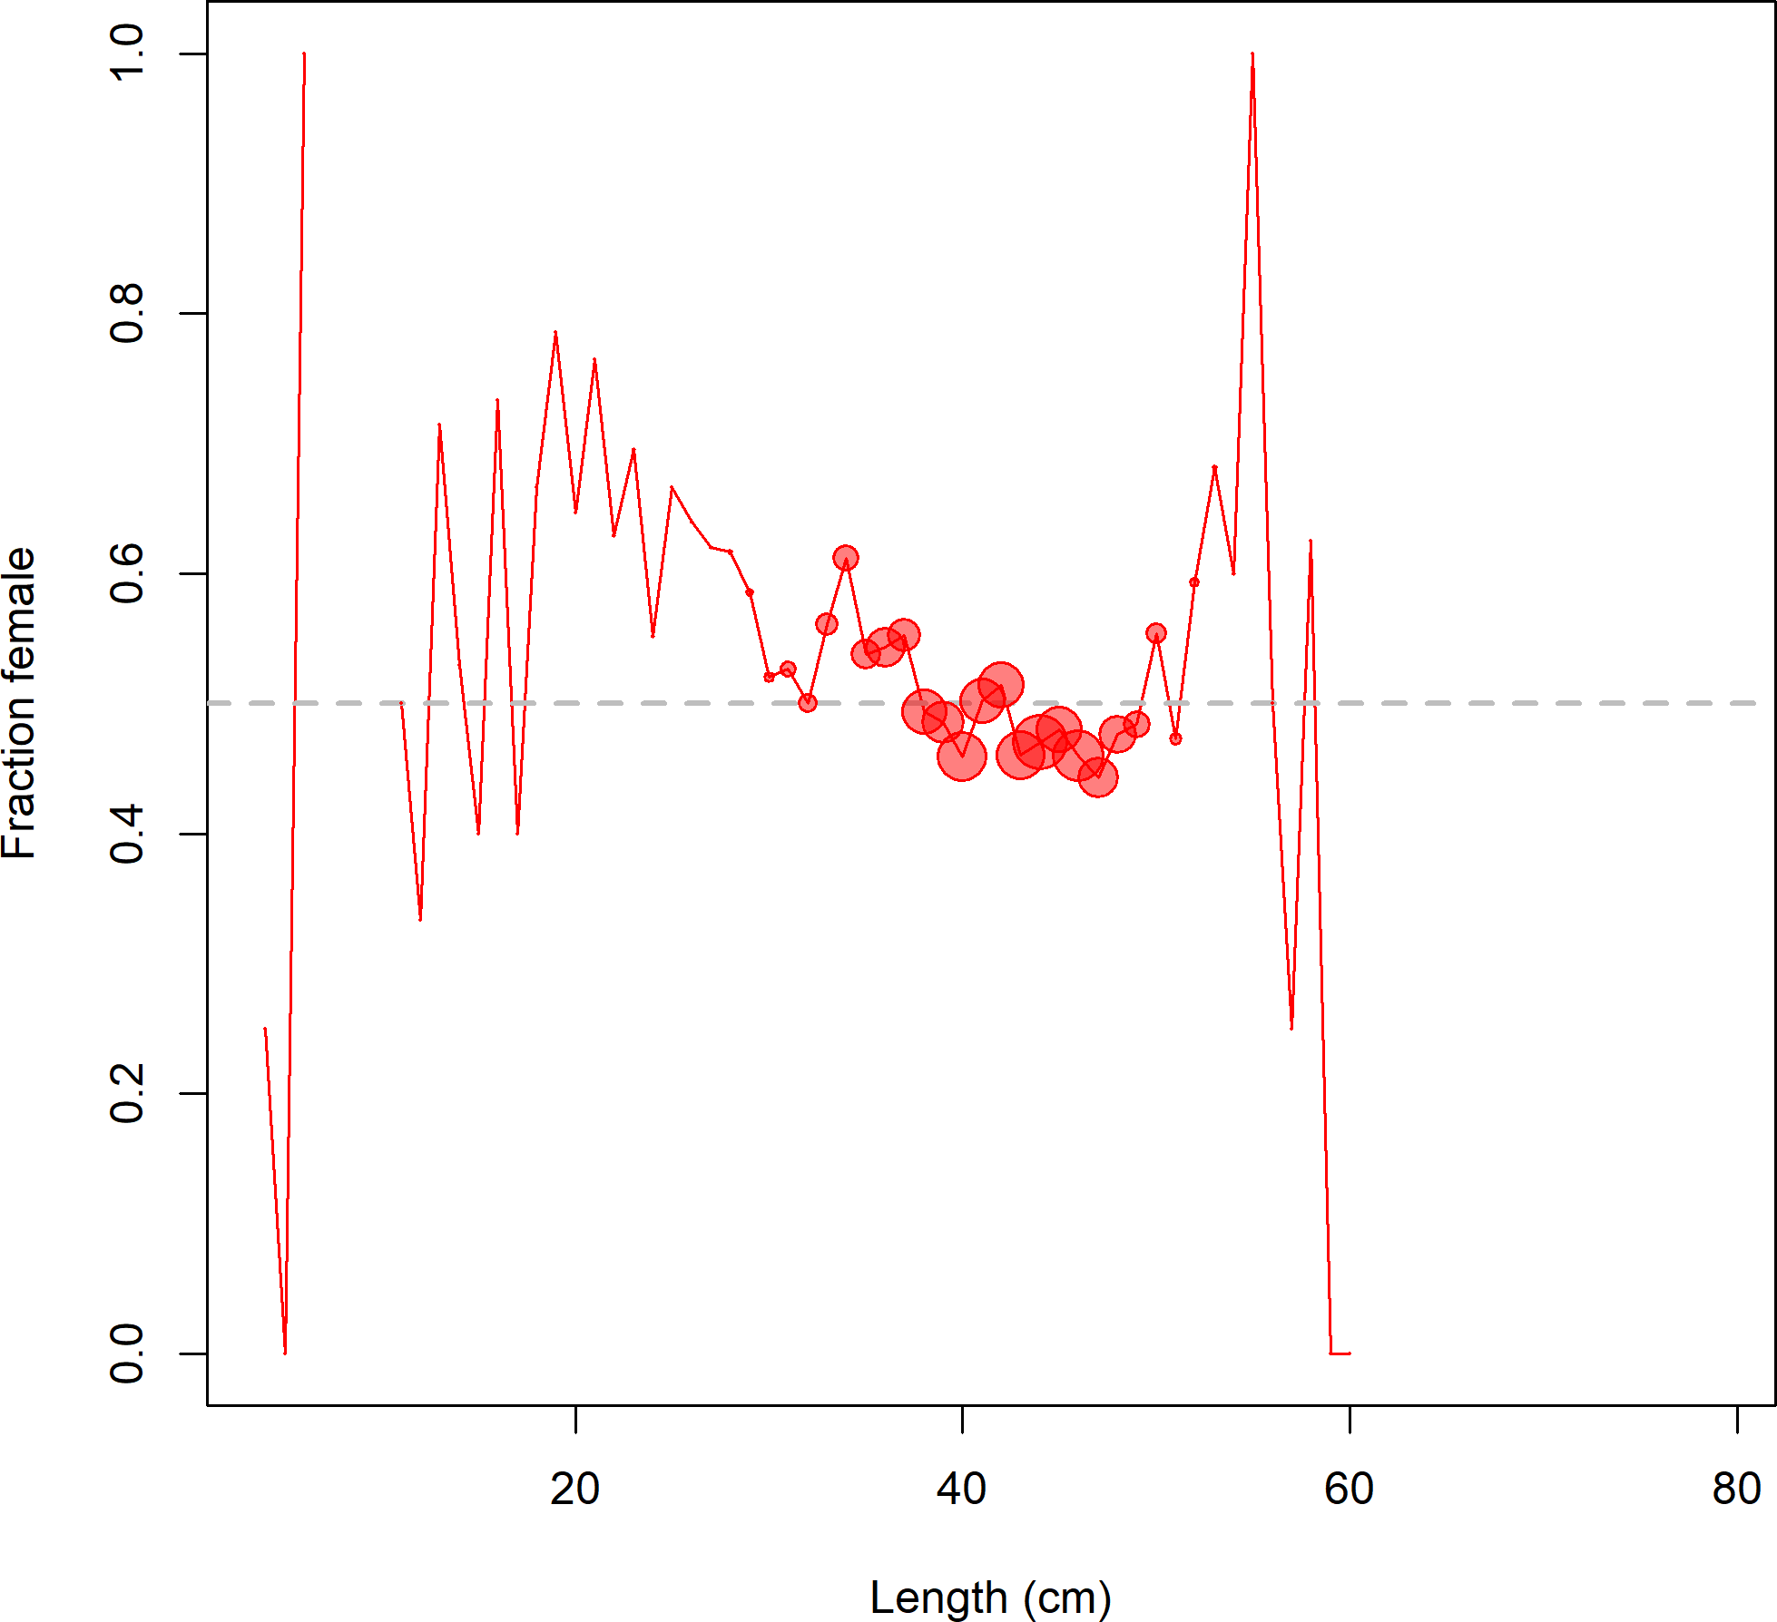

**Figure 27:** Fraction female by length across all available data sources.

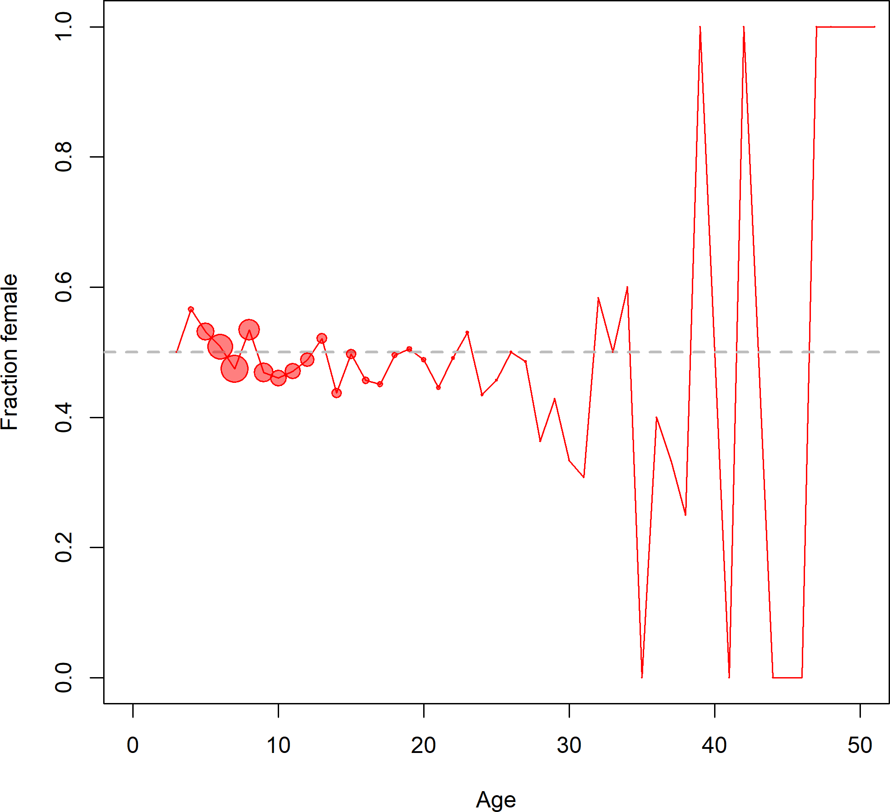

**Figure 28:** Fraction female by age across all available data sources.

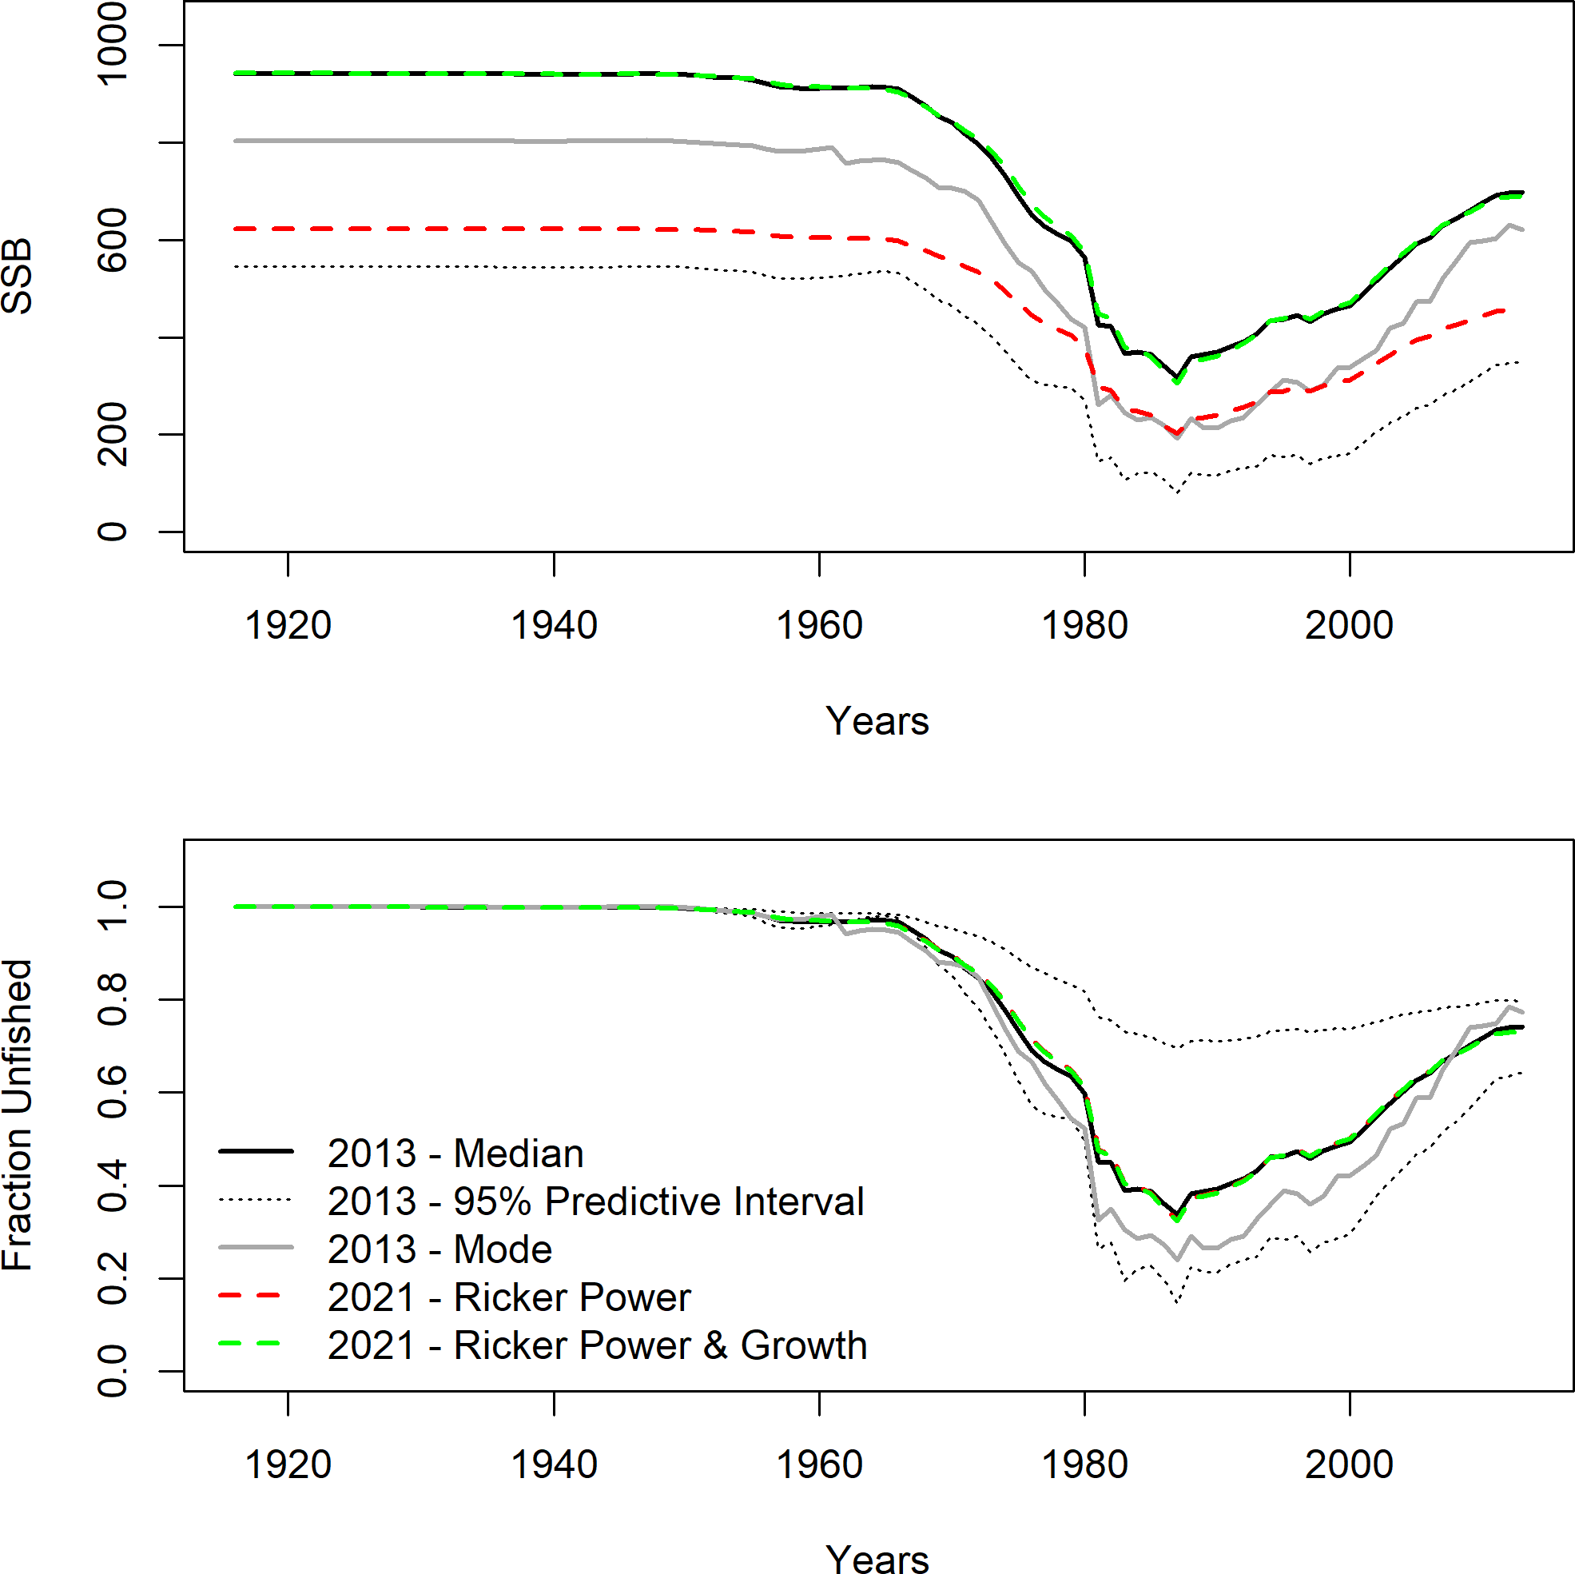

**Figure 29:** Comparison between SS bridge model and the results from the 2013 XDB-SRA model.

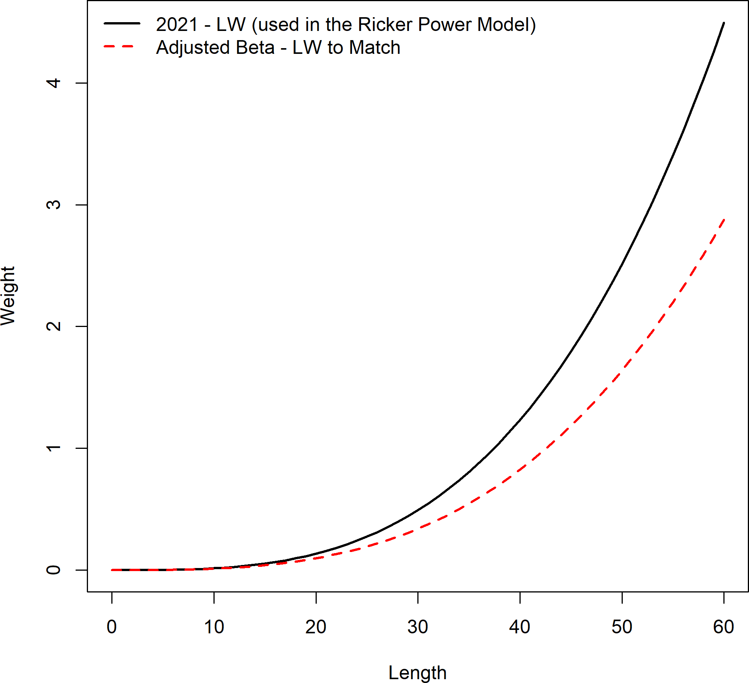

**Figure 30:** Adjustment to SS female weight-at-length curve to create a match in stock scale to XDB-SRA.

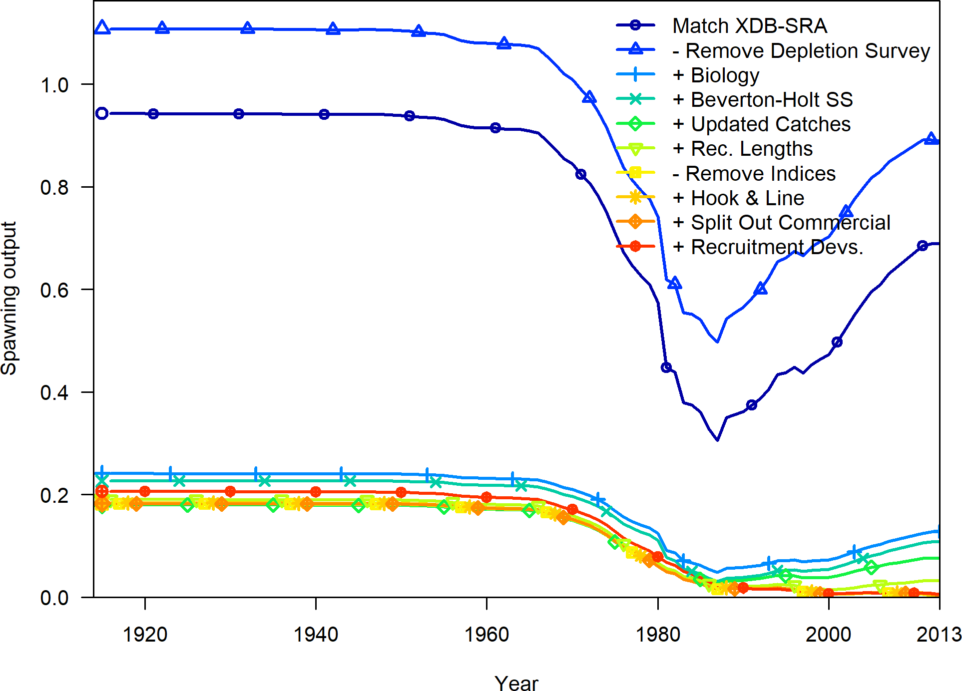

**Figure 31:** The time series of spawning biomass (or output) for updates to the 2013 model.

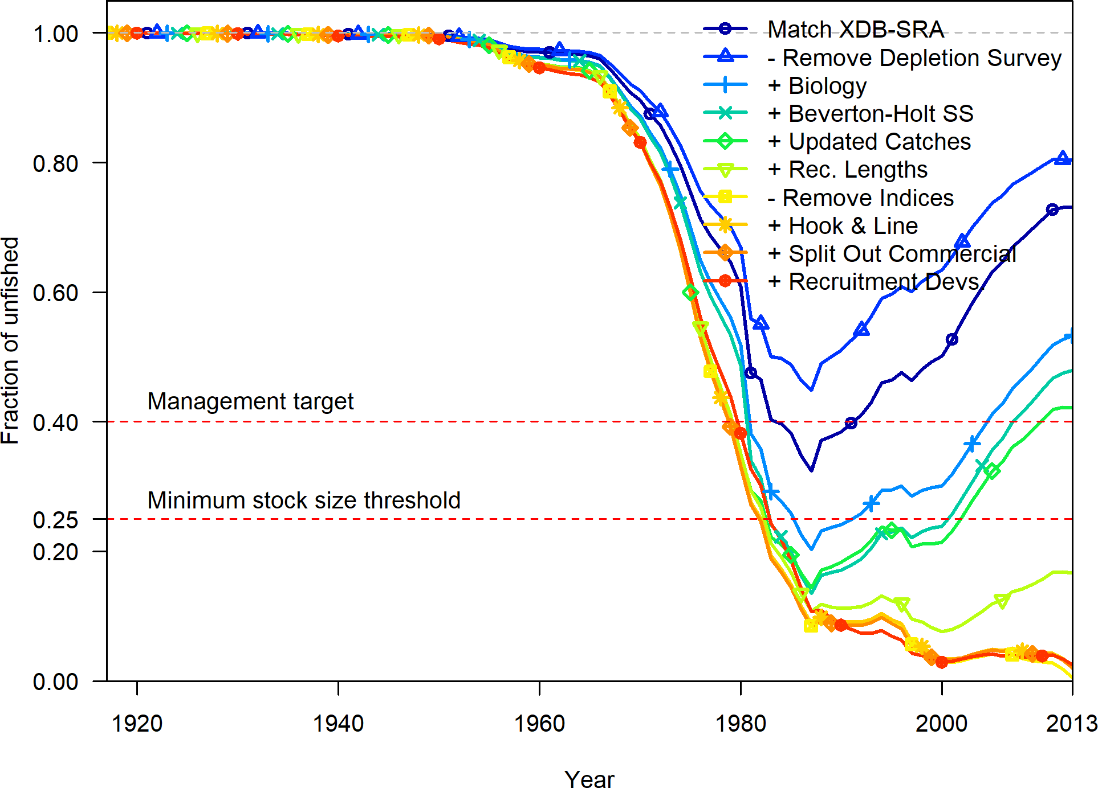

**Figure 32:** The time series of fraction unfished for updates to the 2013 model.

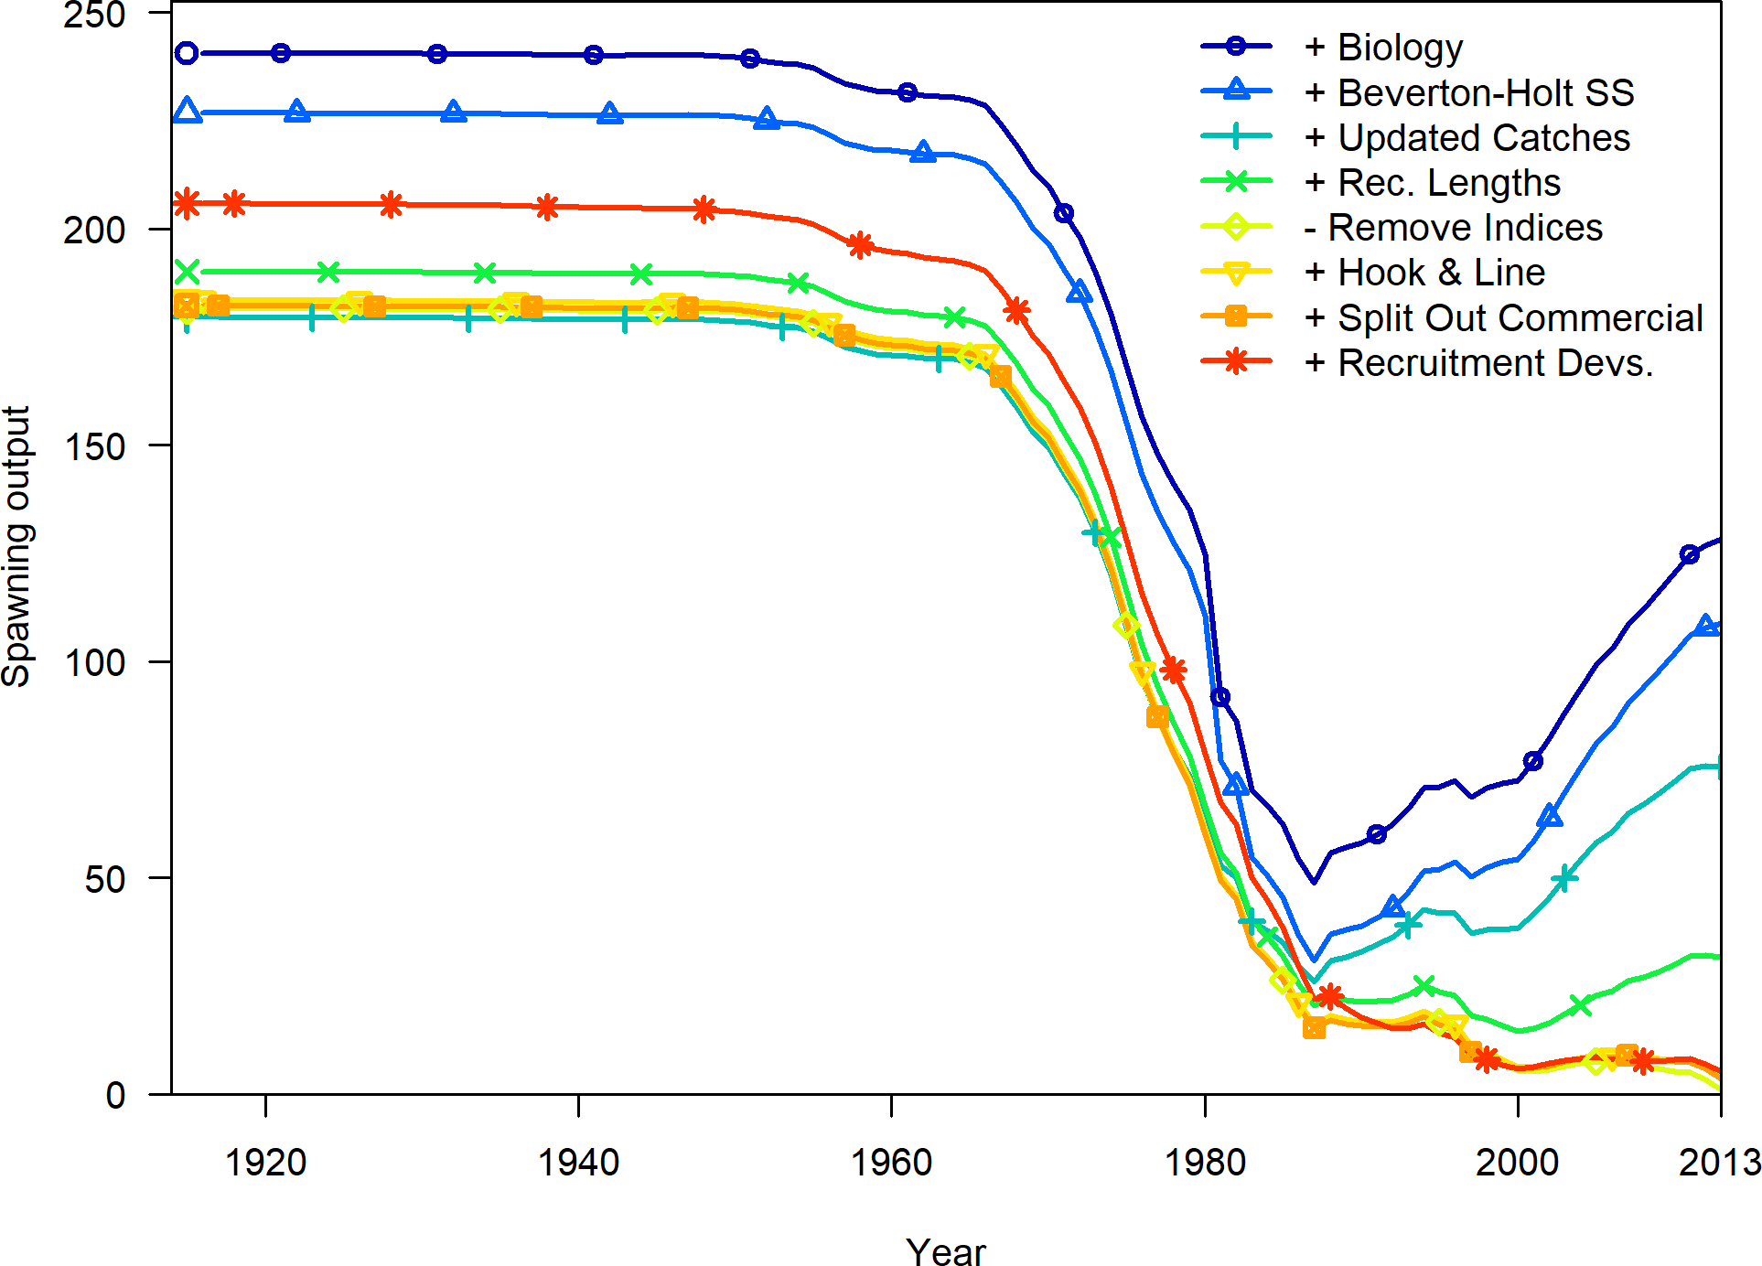

**Figure 33:** The time series of spawning output for the subset of bridge models with the updated fecundity relationship.

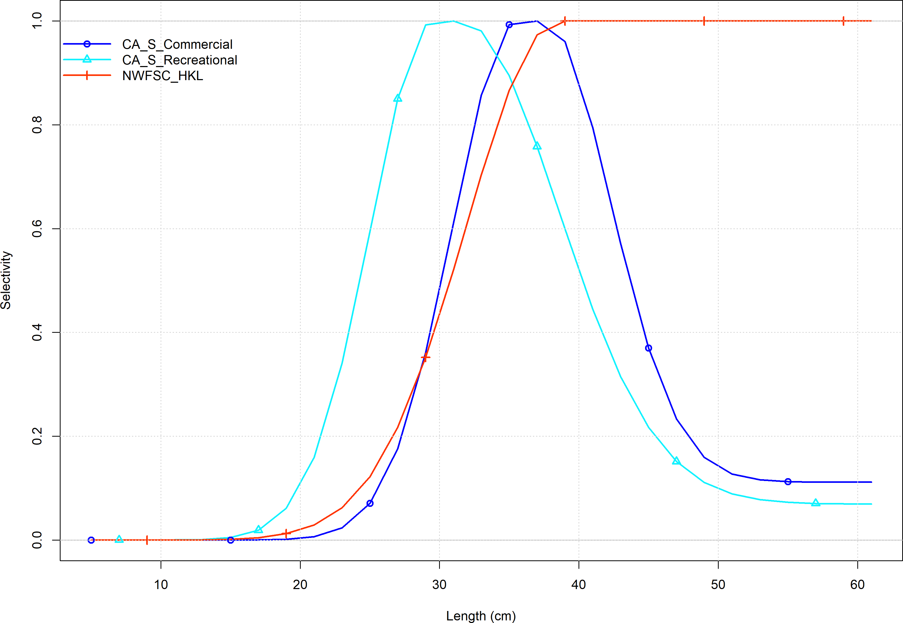

**Figure 34:** Selectivity at length by fleet.

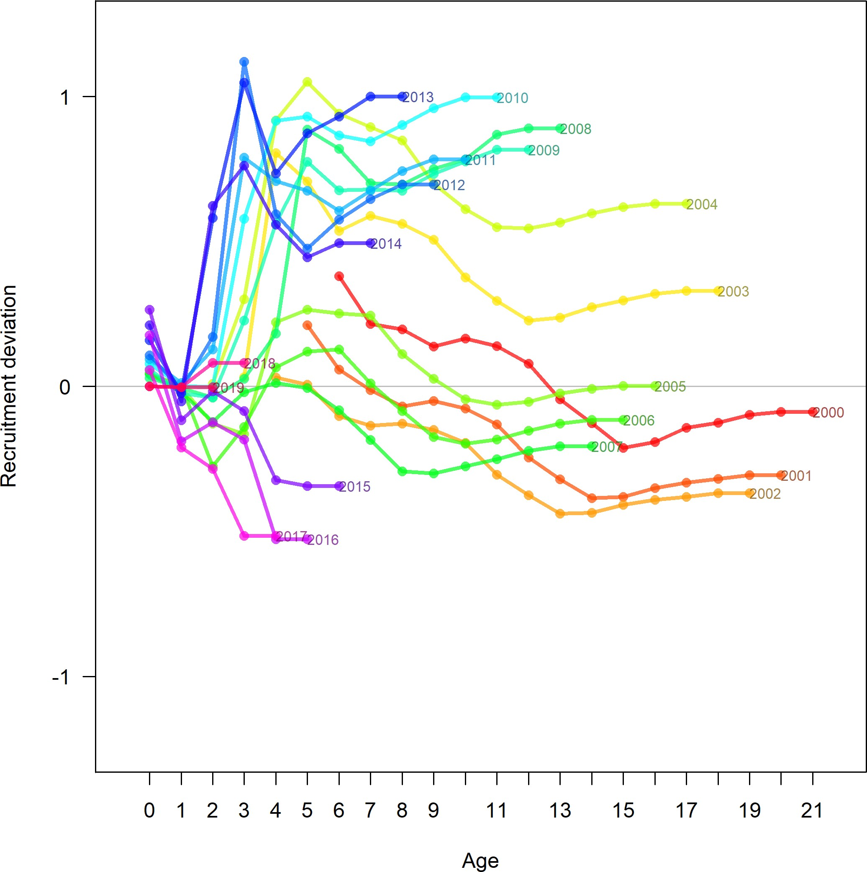

**Figure 35:** The estimated recruitment deviations as additional years of data are removed during a retrospective run. Select years of estimated recruitment deviations remain greater than 0 after all informative data are removed.

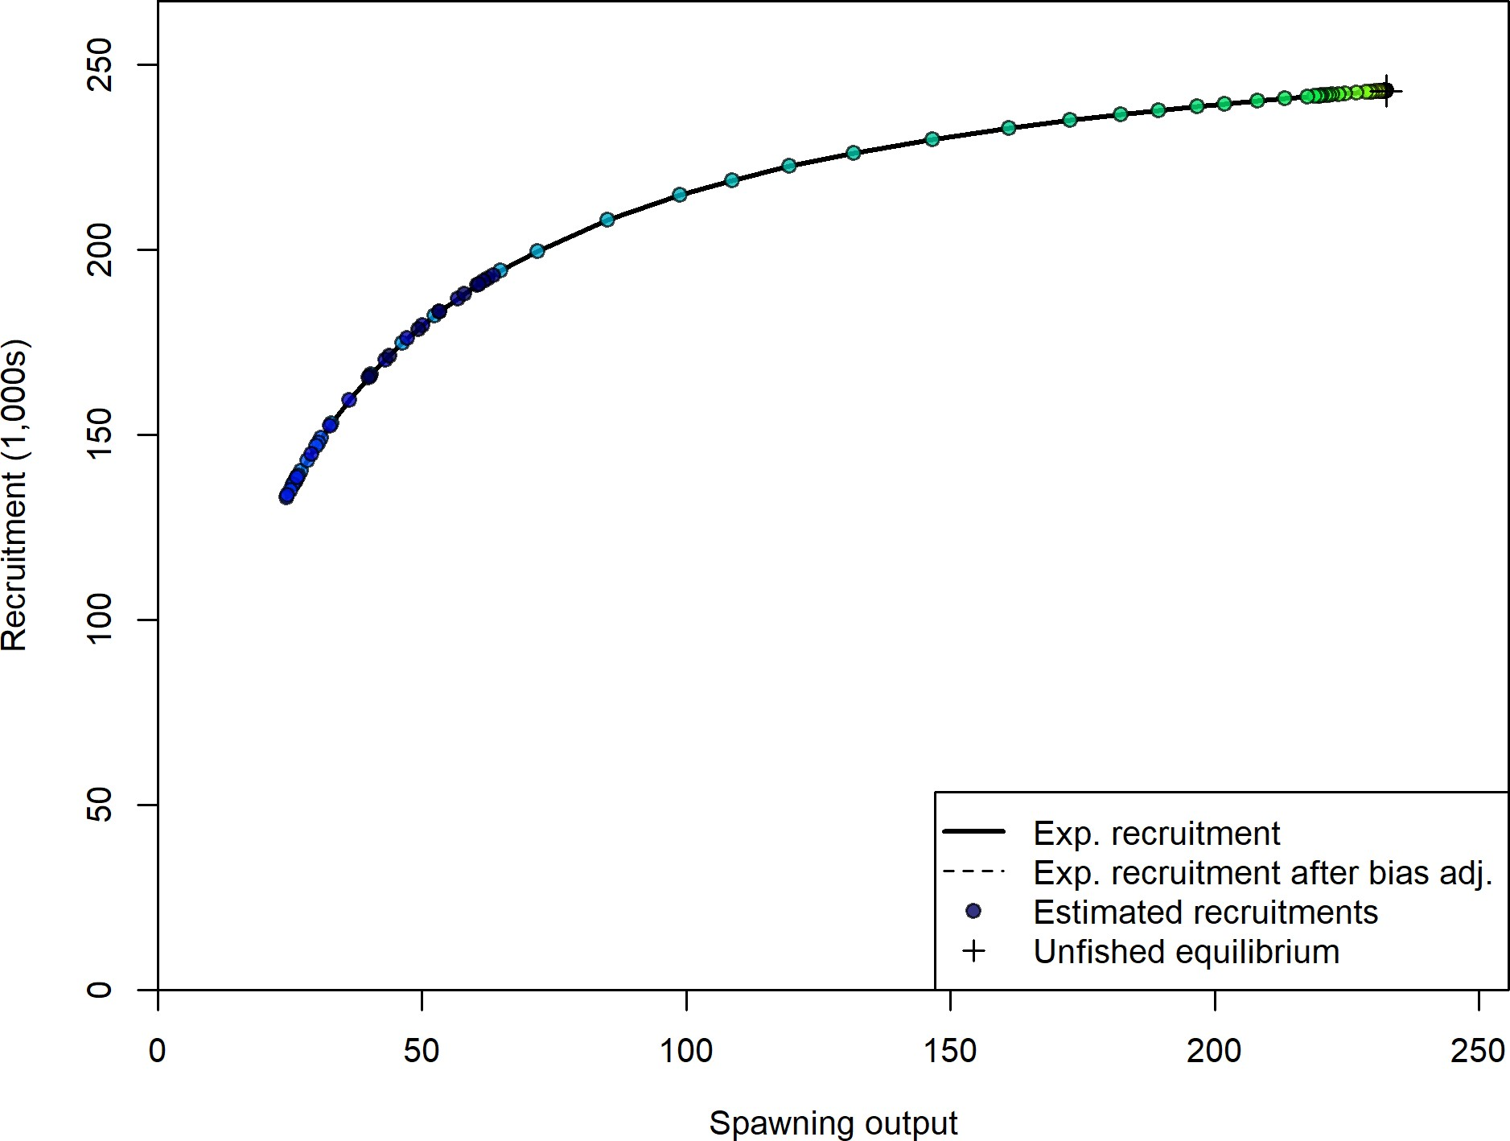

**Figure 36:** Stock-recruit curve. Point colors indicate year, with warmer colors indicating earlier years and cooler colors in showing later years.

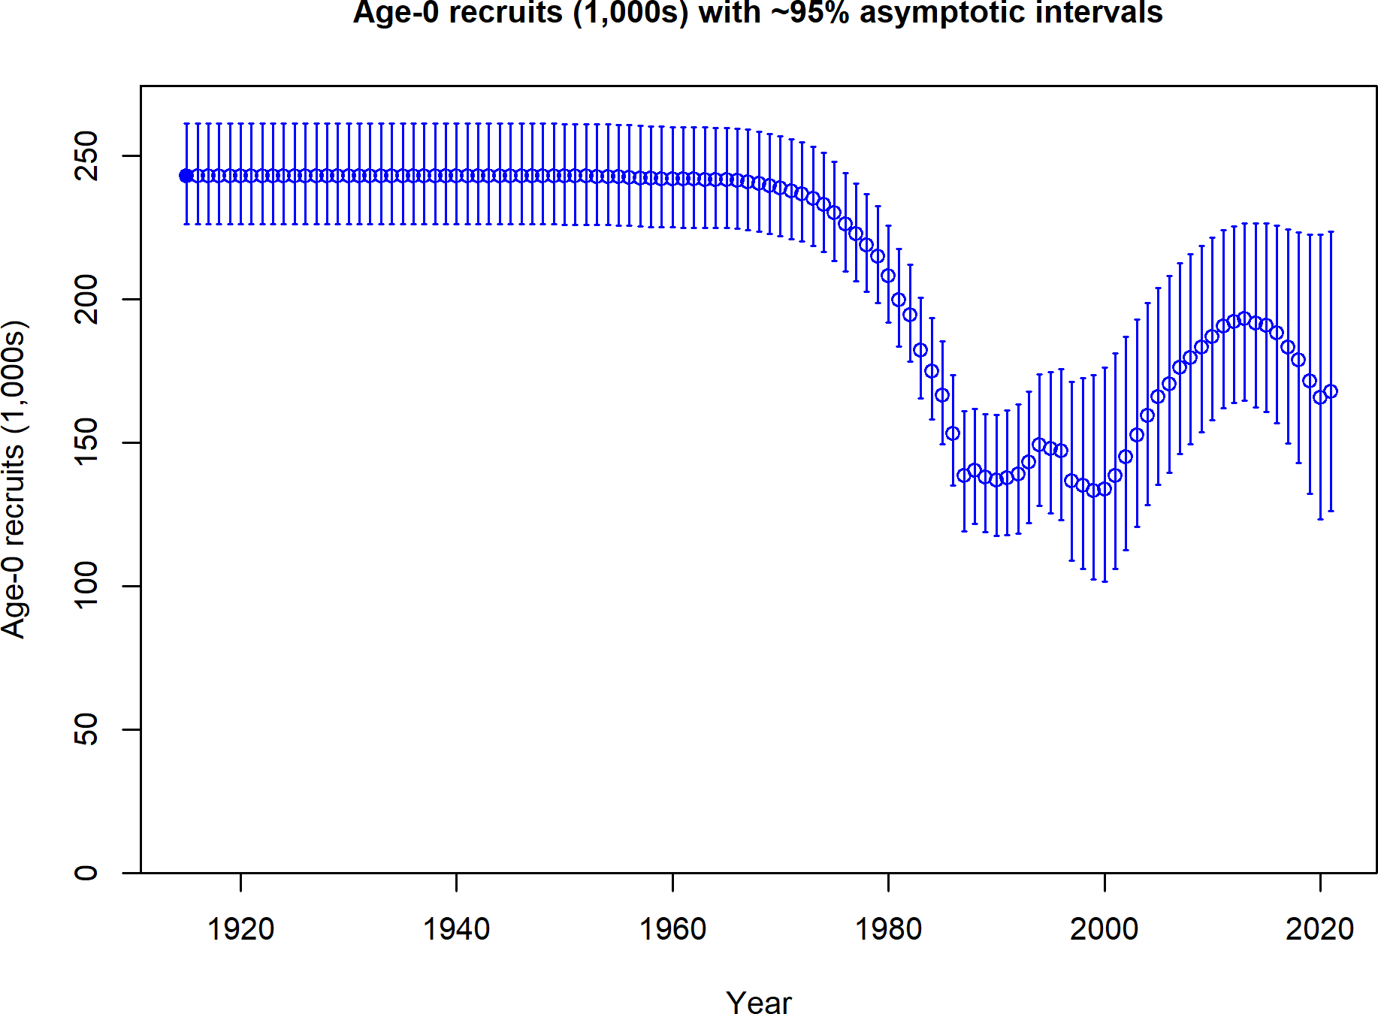

**Figure 37:** Estimated time series of age-0 recruits (1000s).

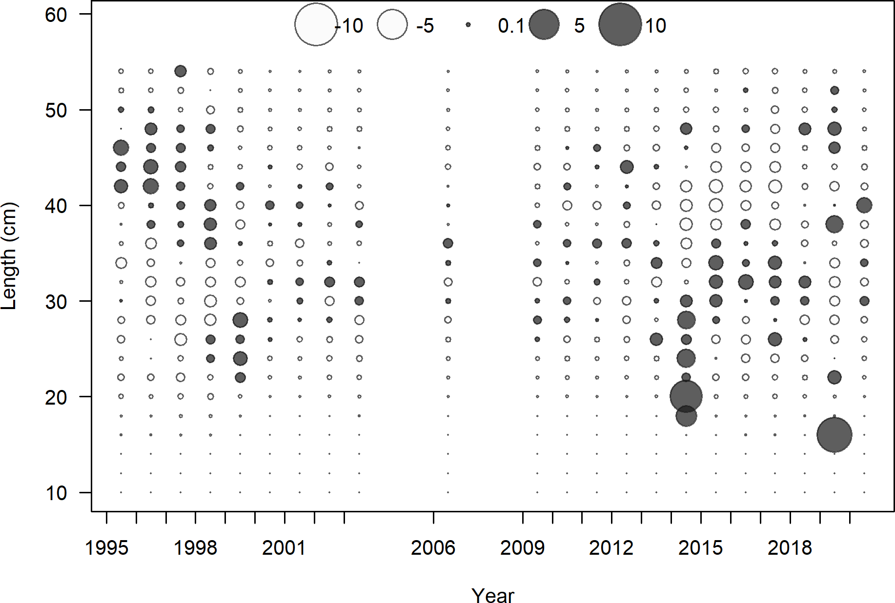

**Figure 38:** Pearson residuals for commercial fleet. Closed bubble are positive residuals (observed > expected) and open bubbles are negative residuals (observed < expected).

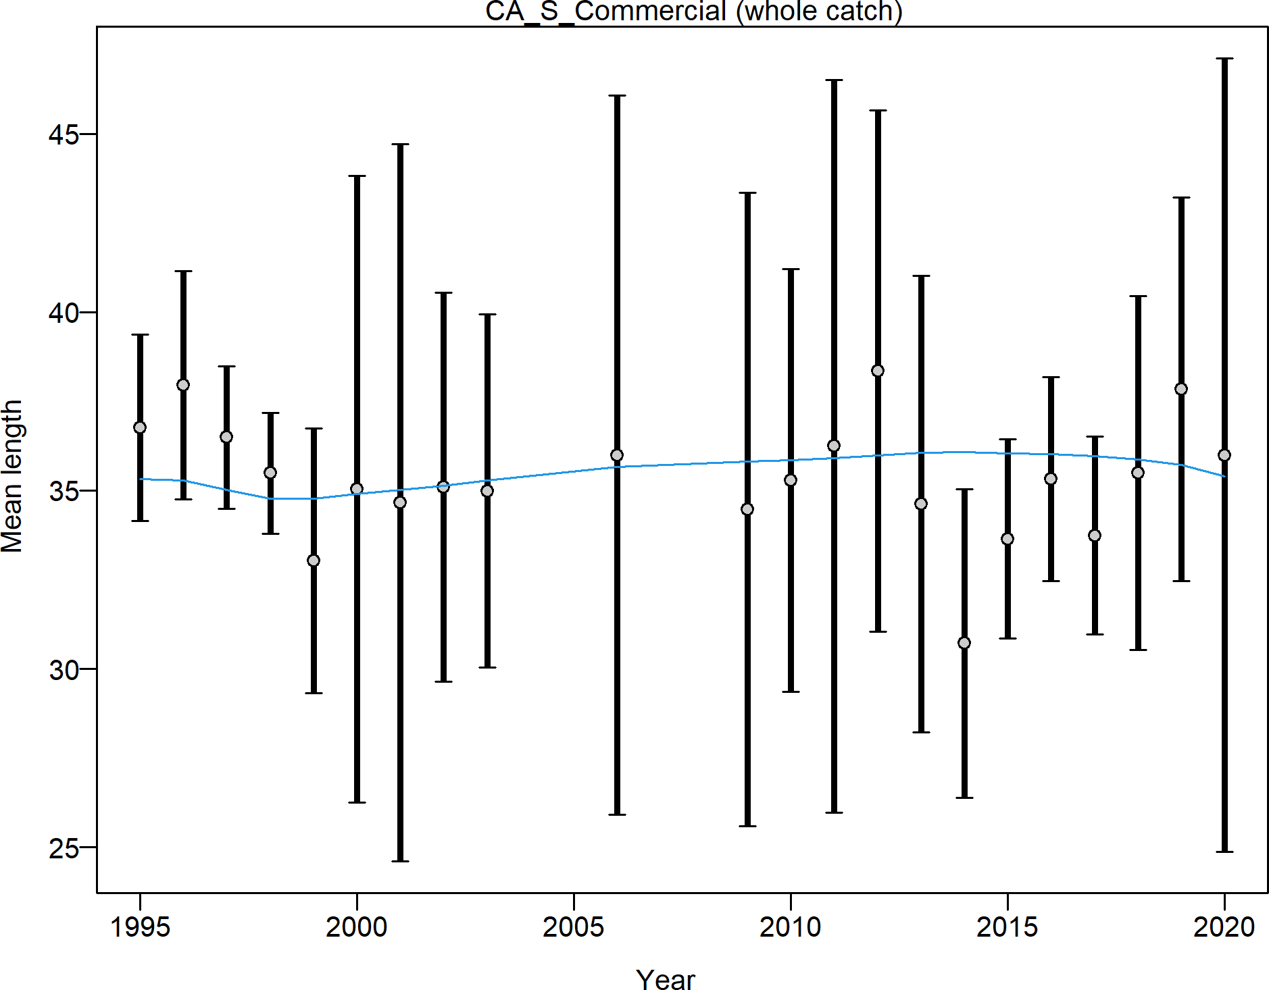

**Figure 39:** Mean length for commercial lengths with 95 percent confidence intervals based on current samples sizes.

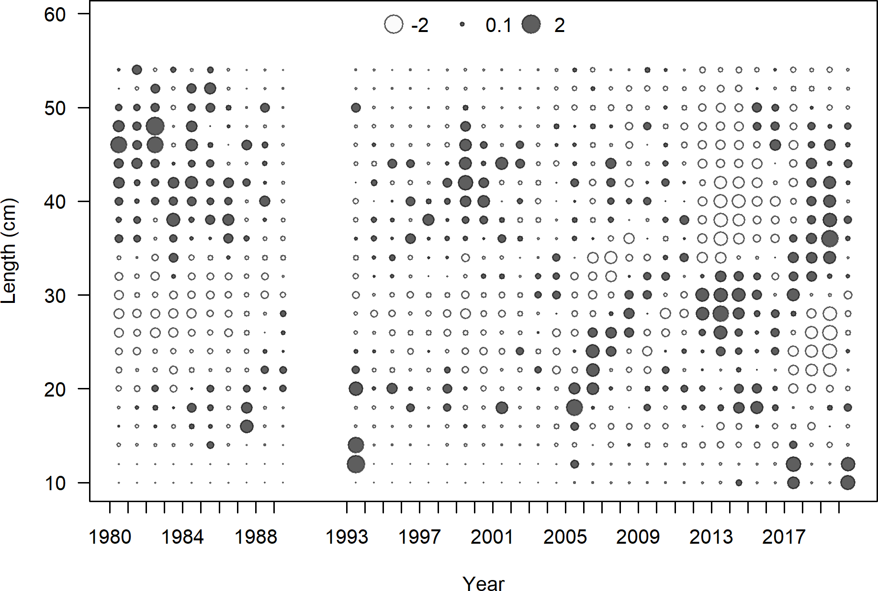

**Figure 40:** Pearson residuals for recreational fleet. Closed bubble are positive residuals (observed > expected) and open bubbles are negative residuals (observed < expected).

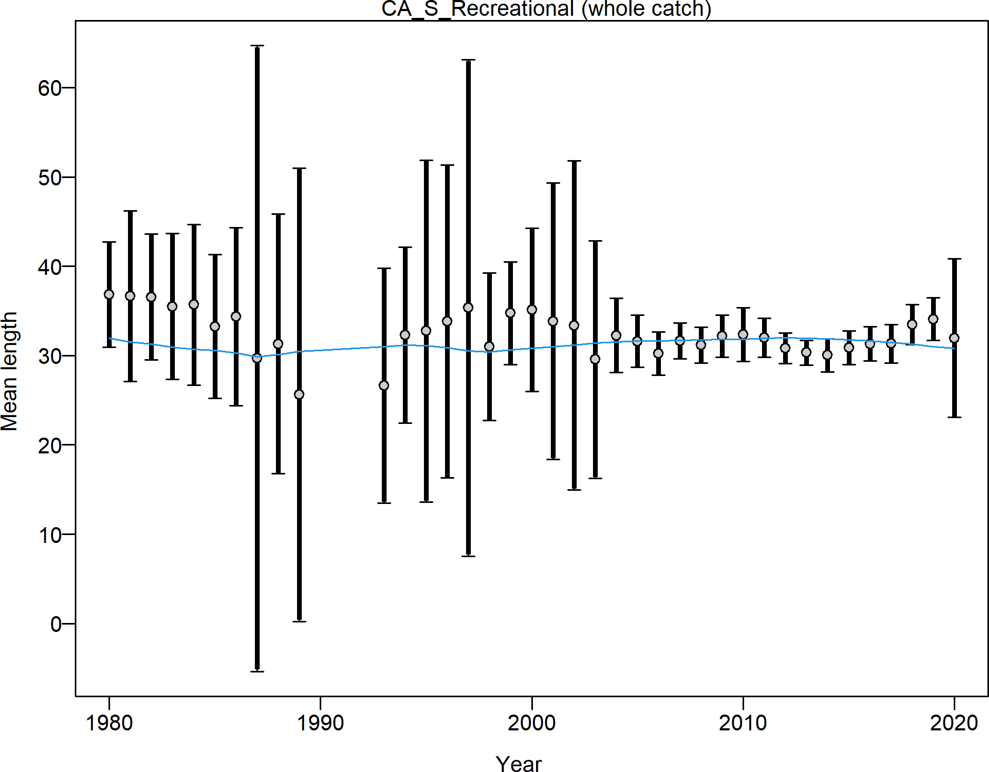

**Figure 41:** Mean length for recreational lengths with 95 percent confidence intervals based on current samples sizes.

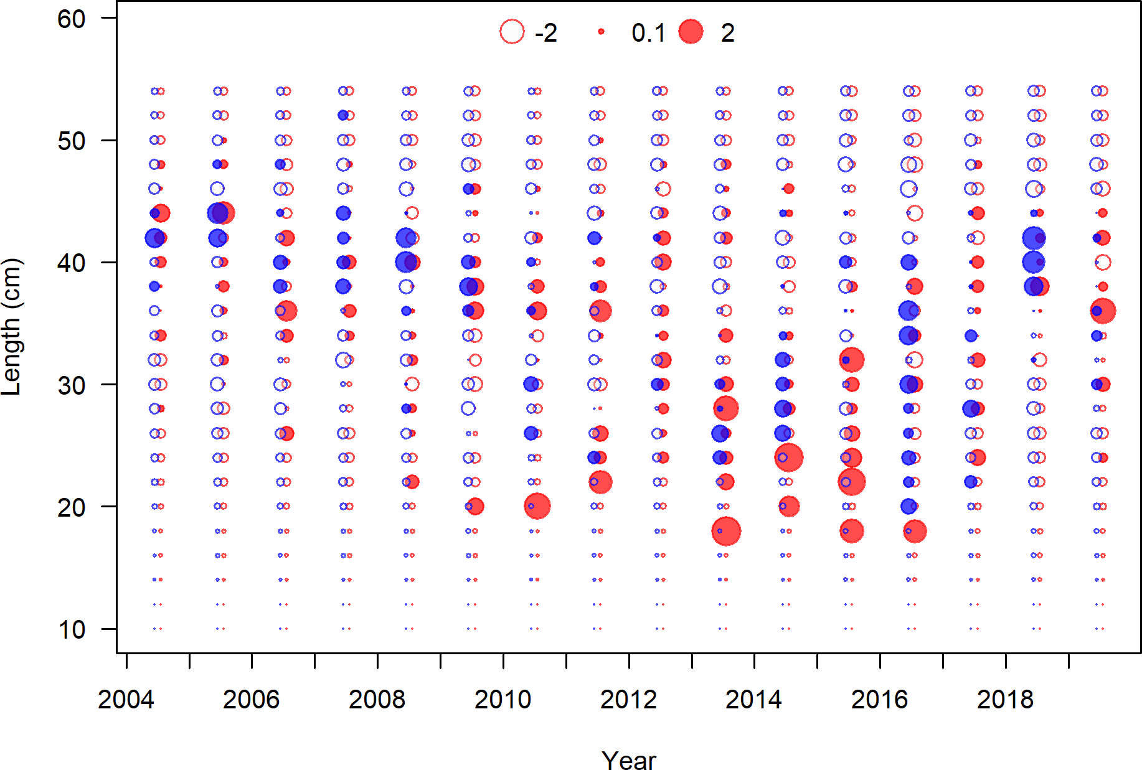

**Figure 42:** Pearson residuals for NWFSC Hook and Line survey. Closed bubble are positive residuals (observed > expected) and open bubbles are negative residuals (observed

< expected).

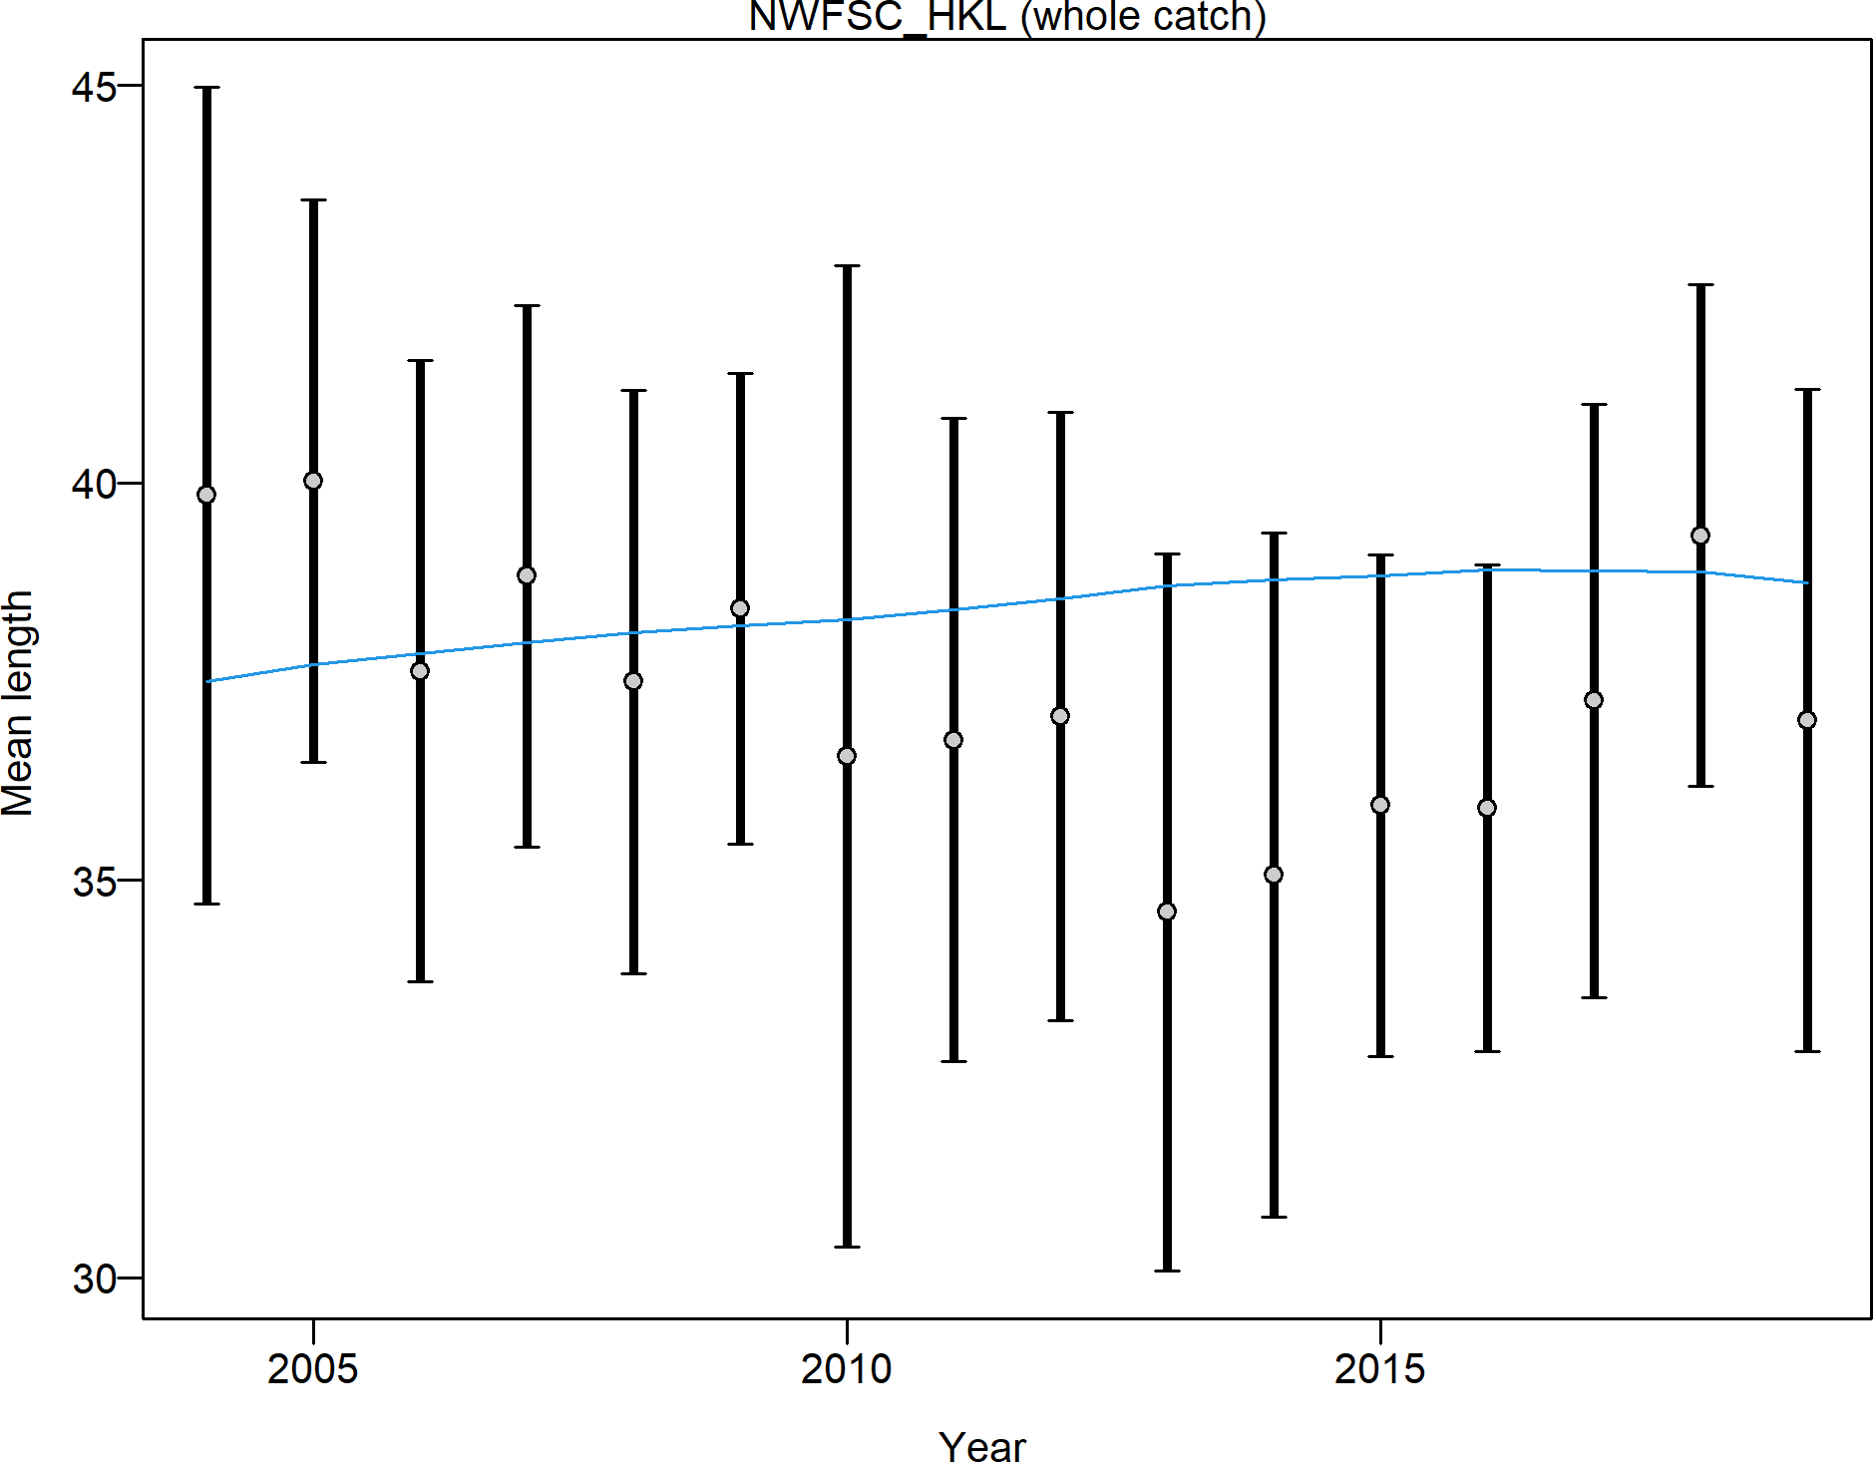

**Figure 43:** Mean length for recreational lengths with 95 percent confidence intervals based on current samples sizes.

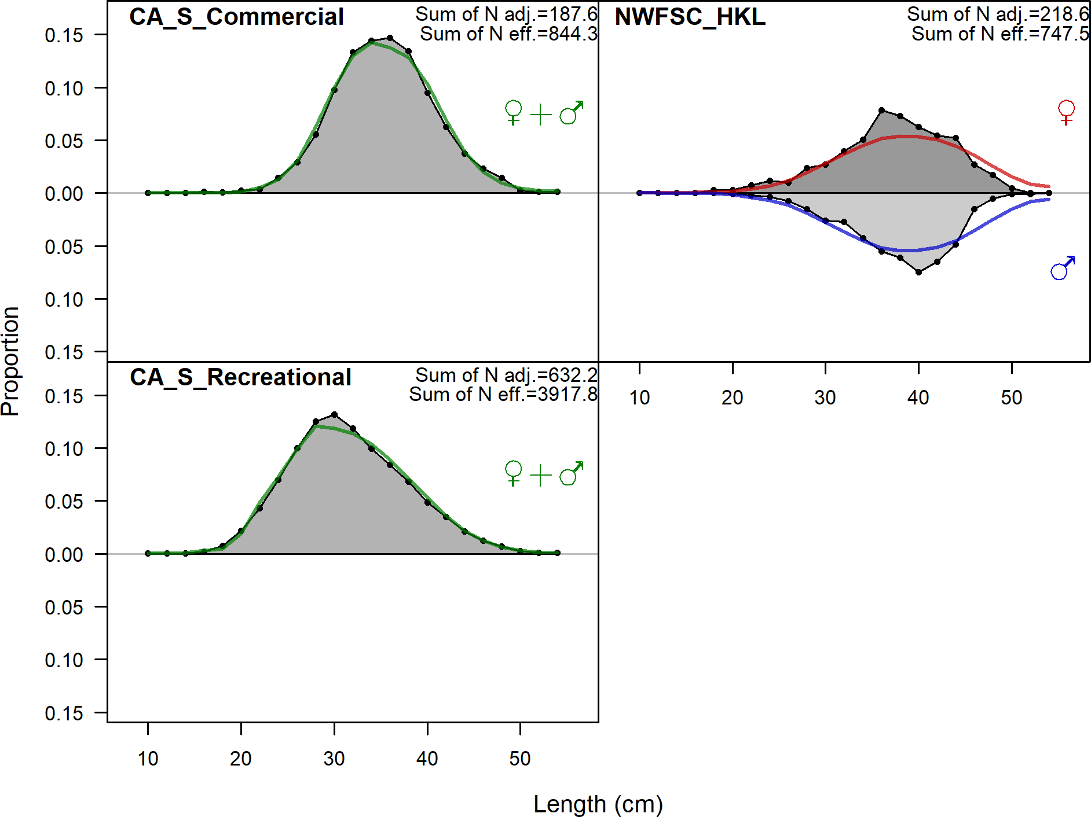

**Figure 44:** Aggregated length comps over all years.

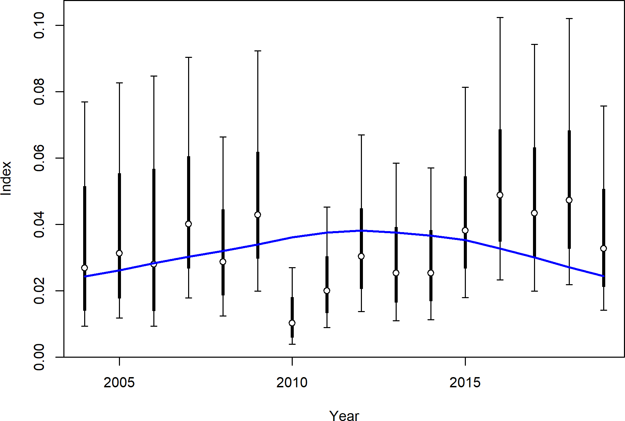

**Figure 45:** Fit to index data for the NWFSC Hook and Line survey.

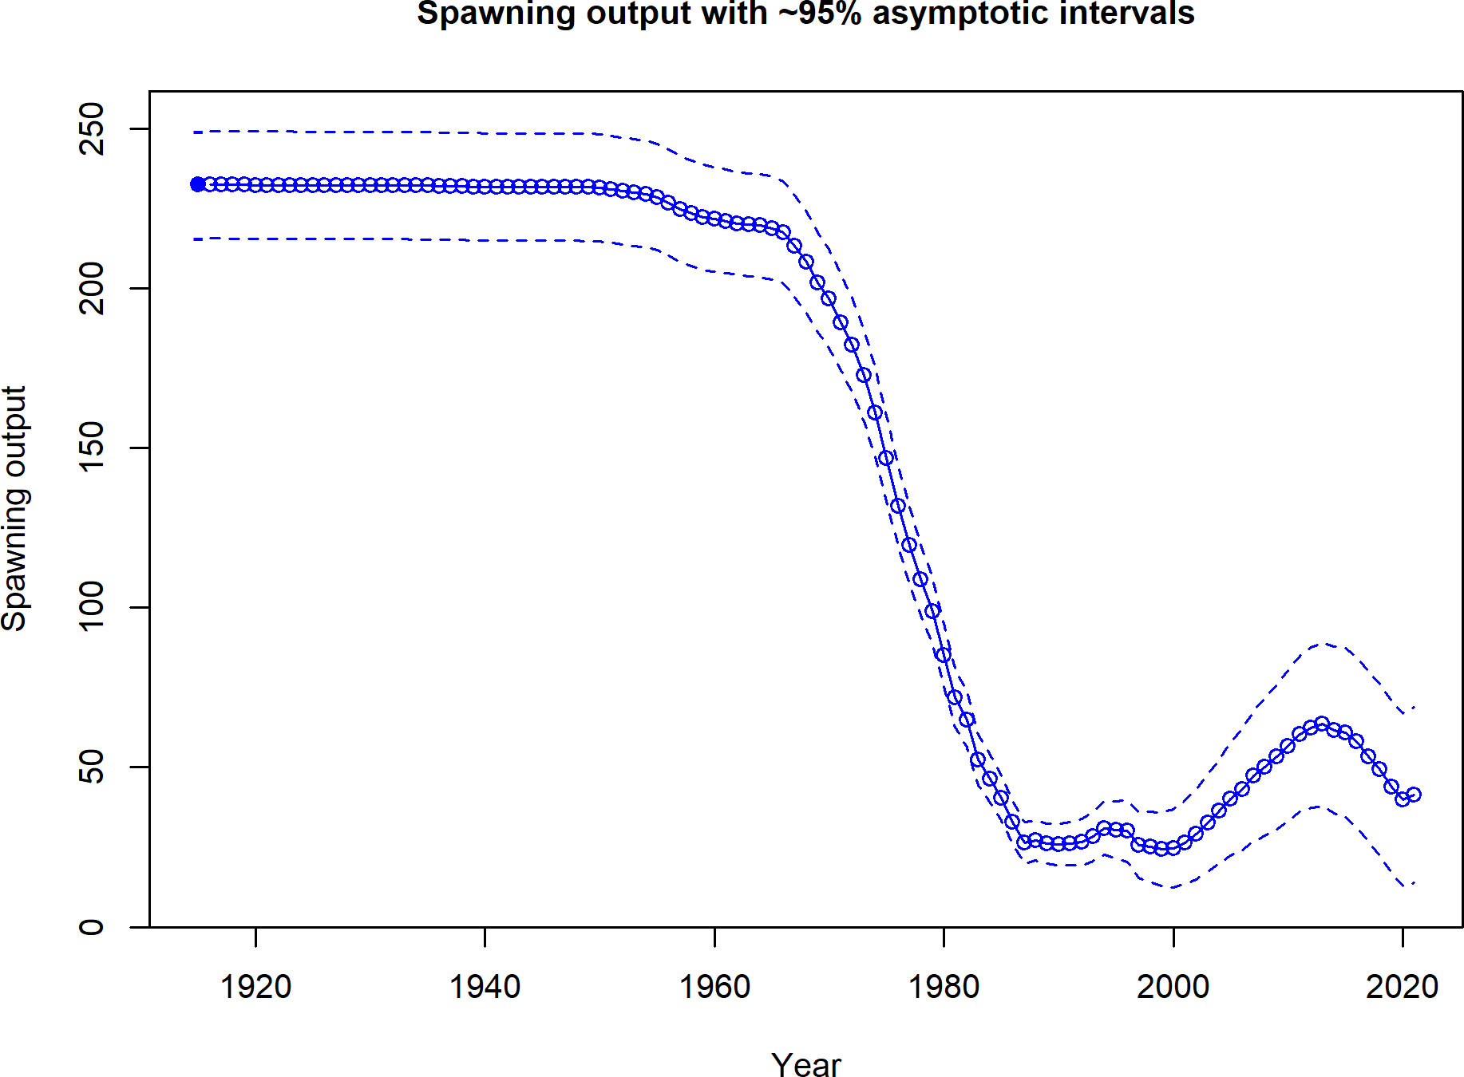

**Figure 46:** Estimated time series of spawning output.

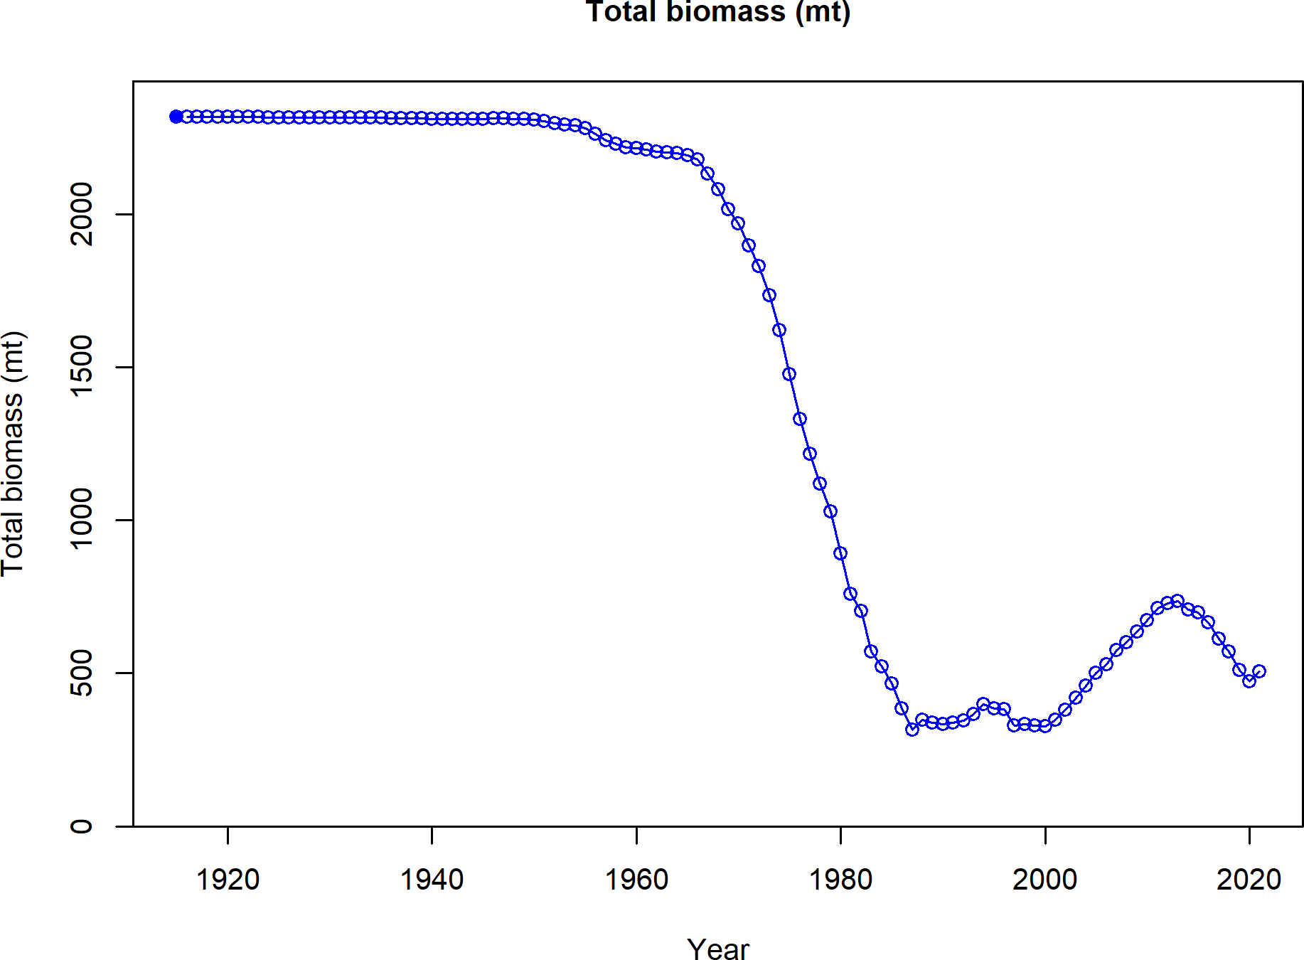

**Figure 47:** Estimated time series of total biomass.

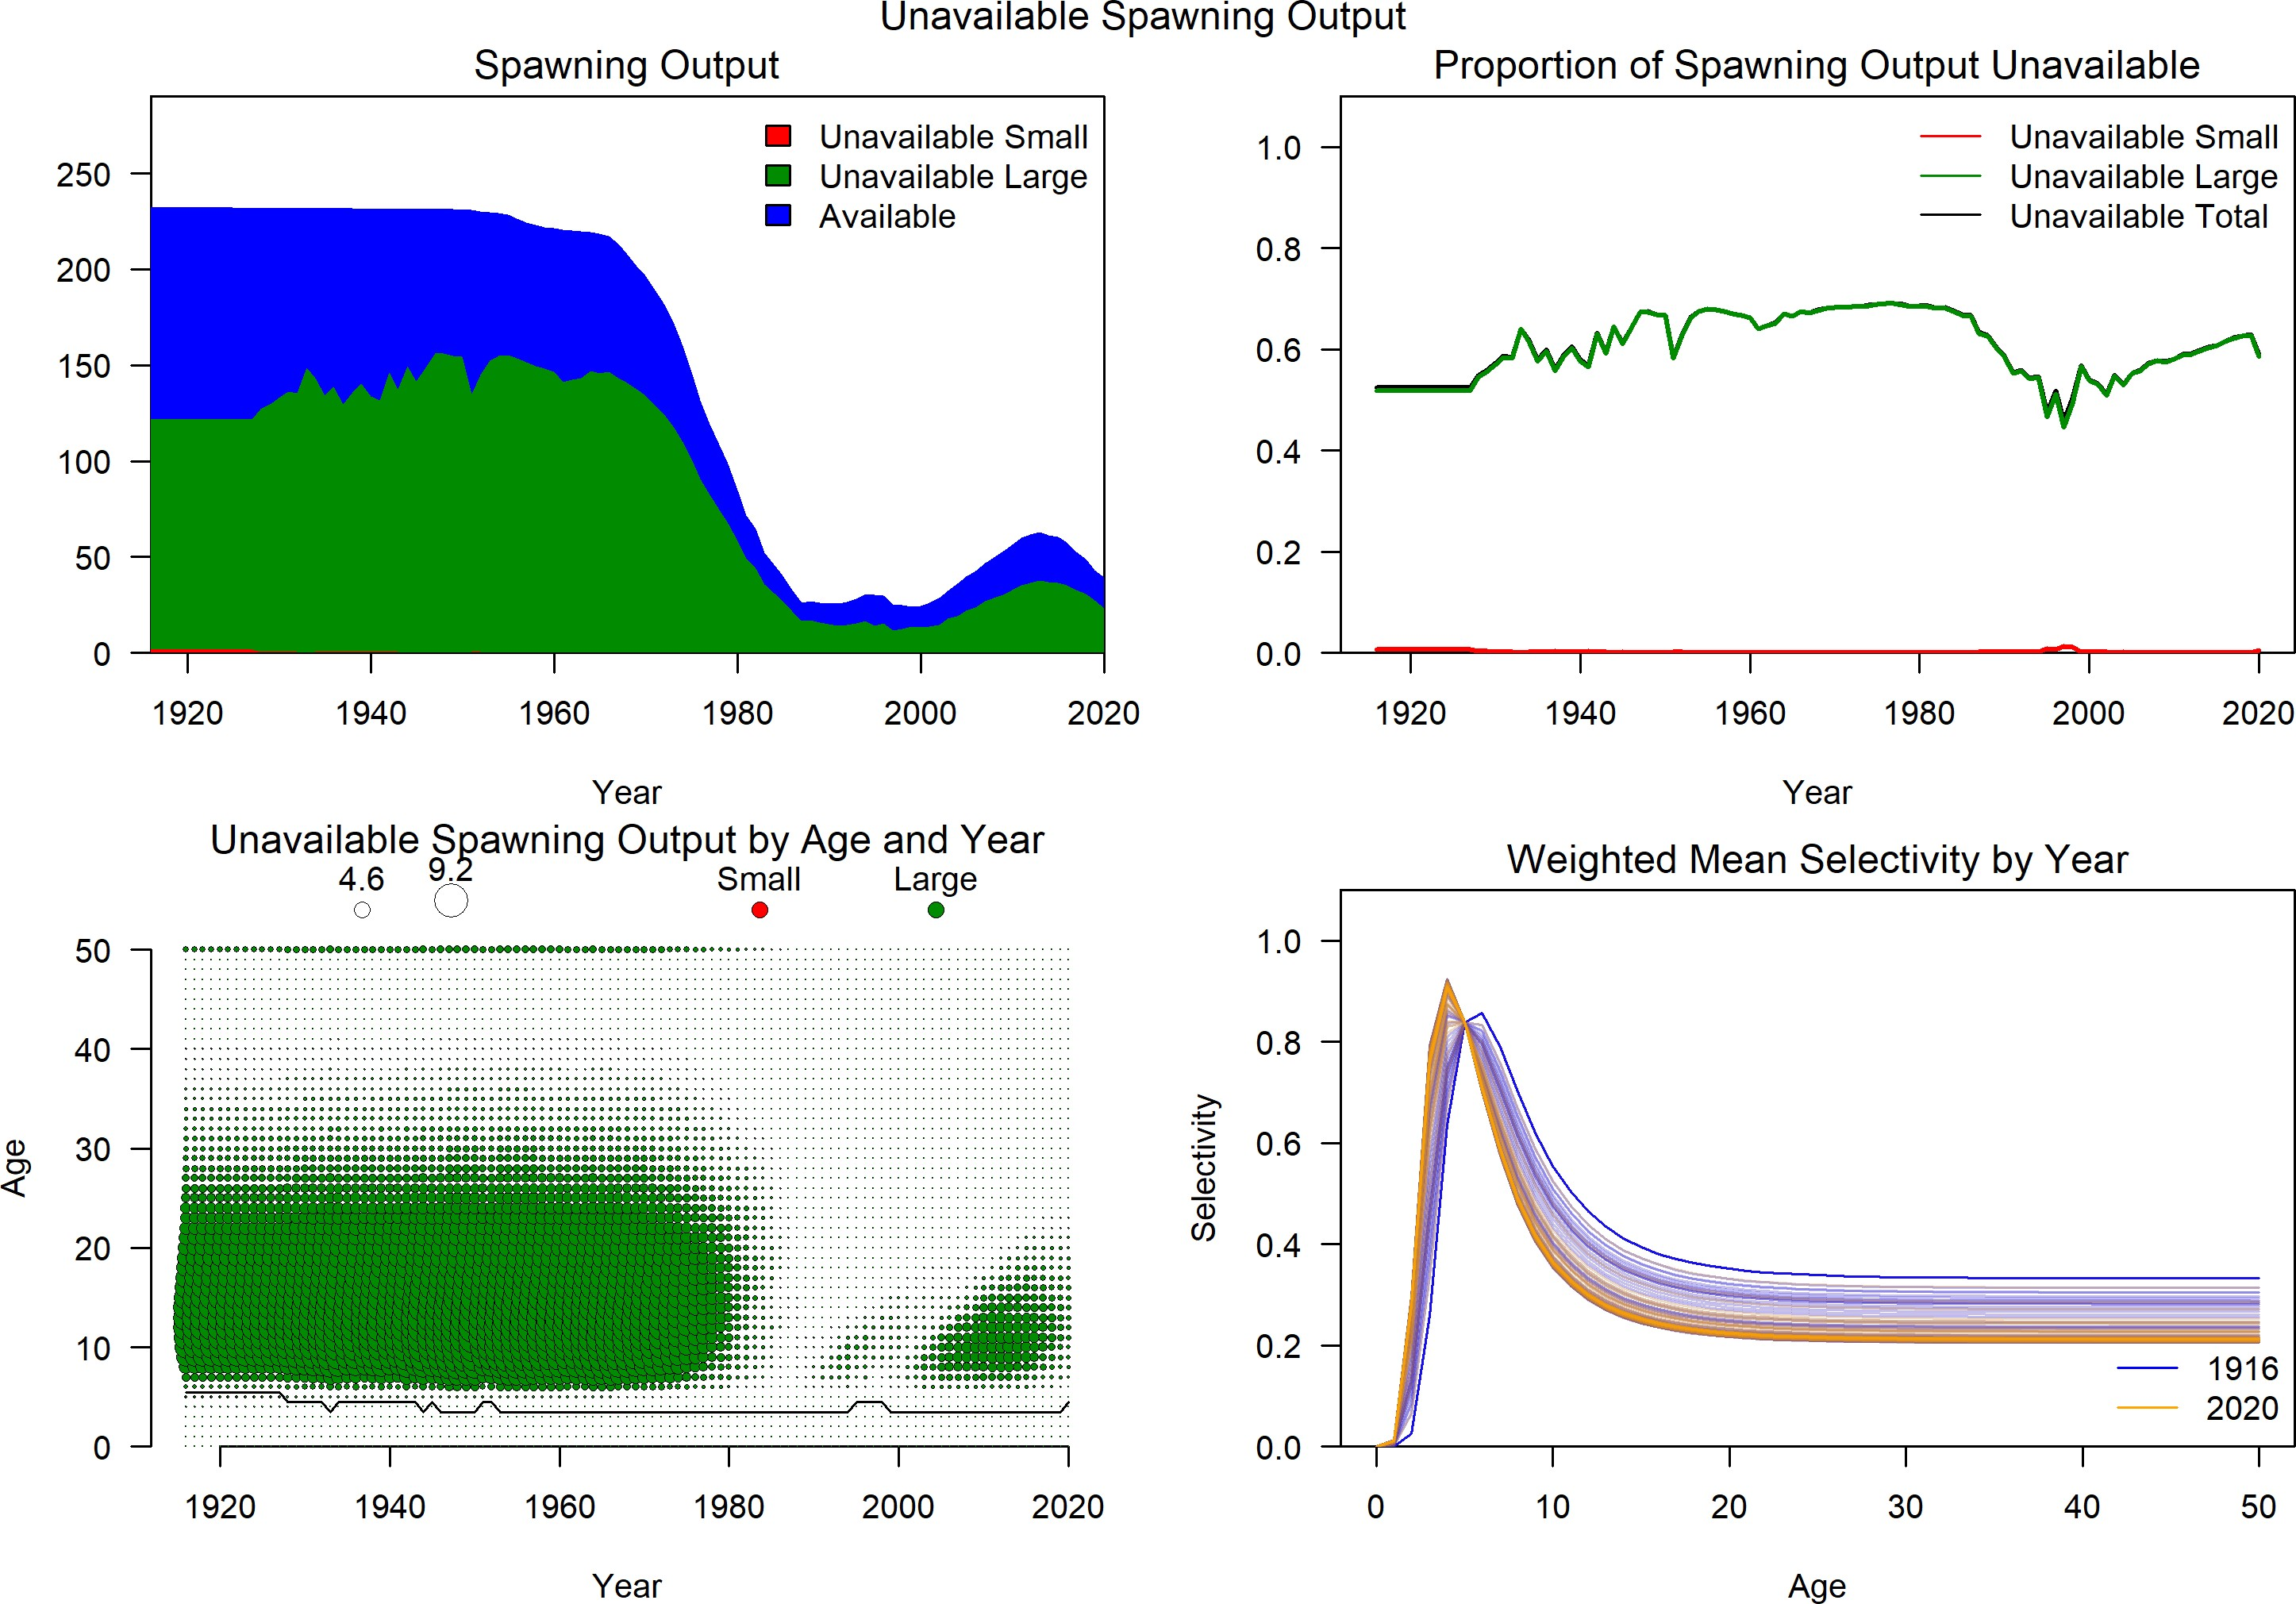

**Figure 48:** Estimated time series of unavailable spawning output.

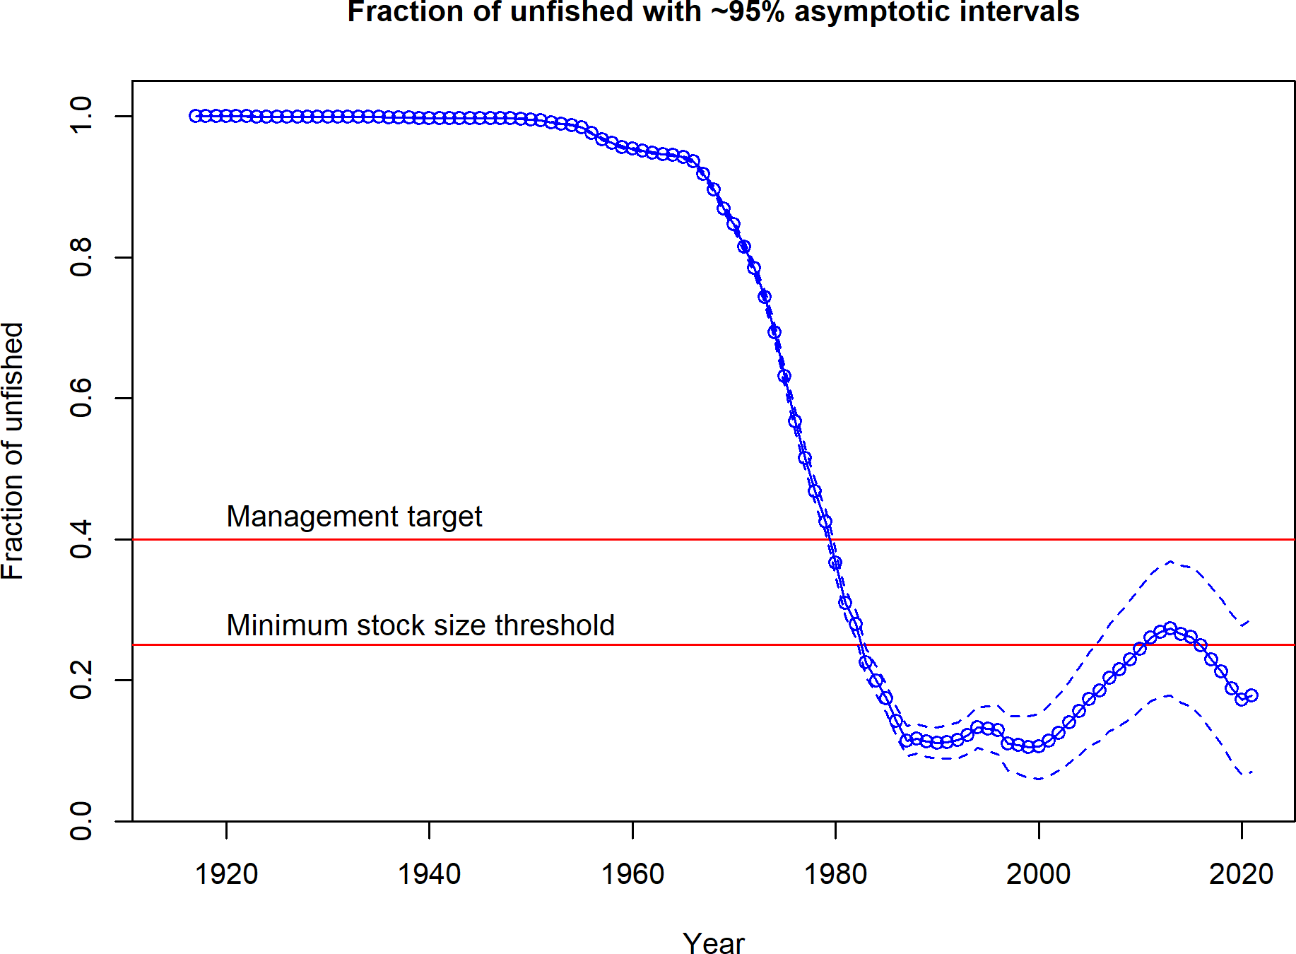

**Figure 49:** Estimated time series of fraction of unfished spawning output.

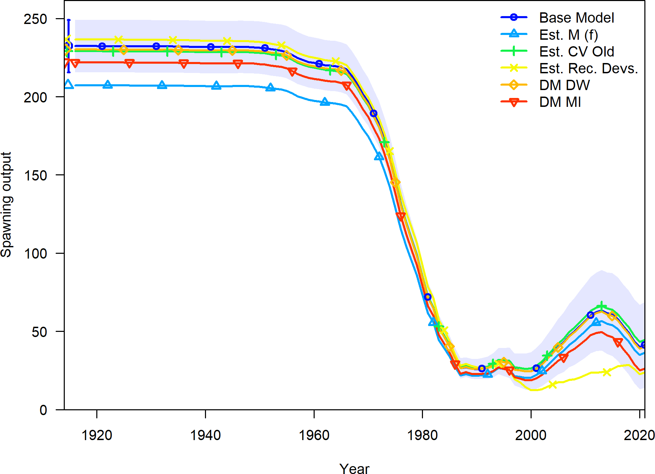

**Figure 50:** Change in estimated spawning output by sensitivity.

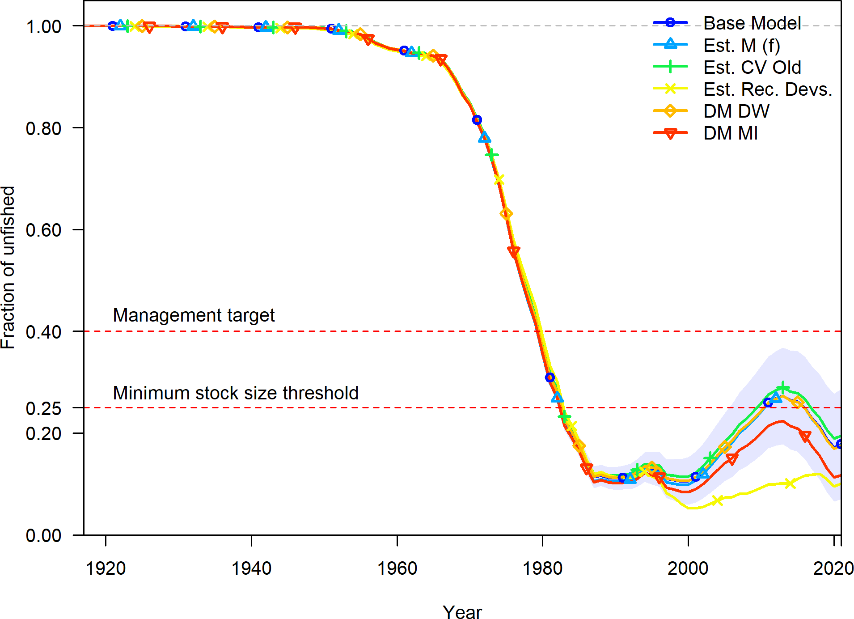

**Figure 51:** Change in estimated fraction unfished by sensitivity.

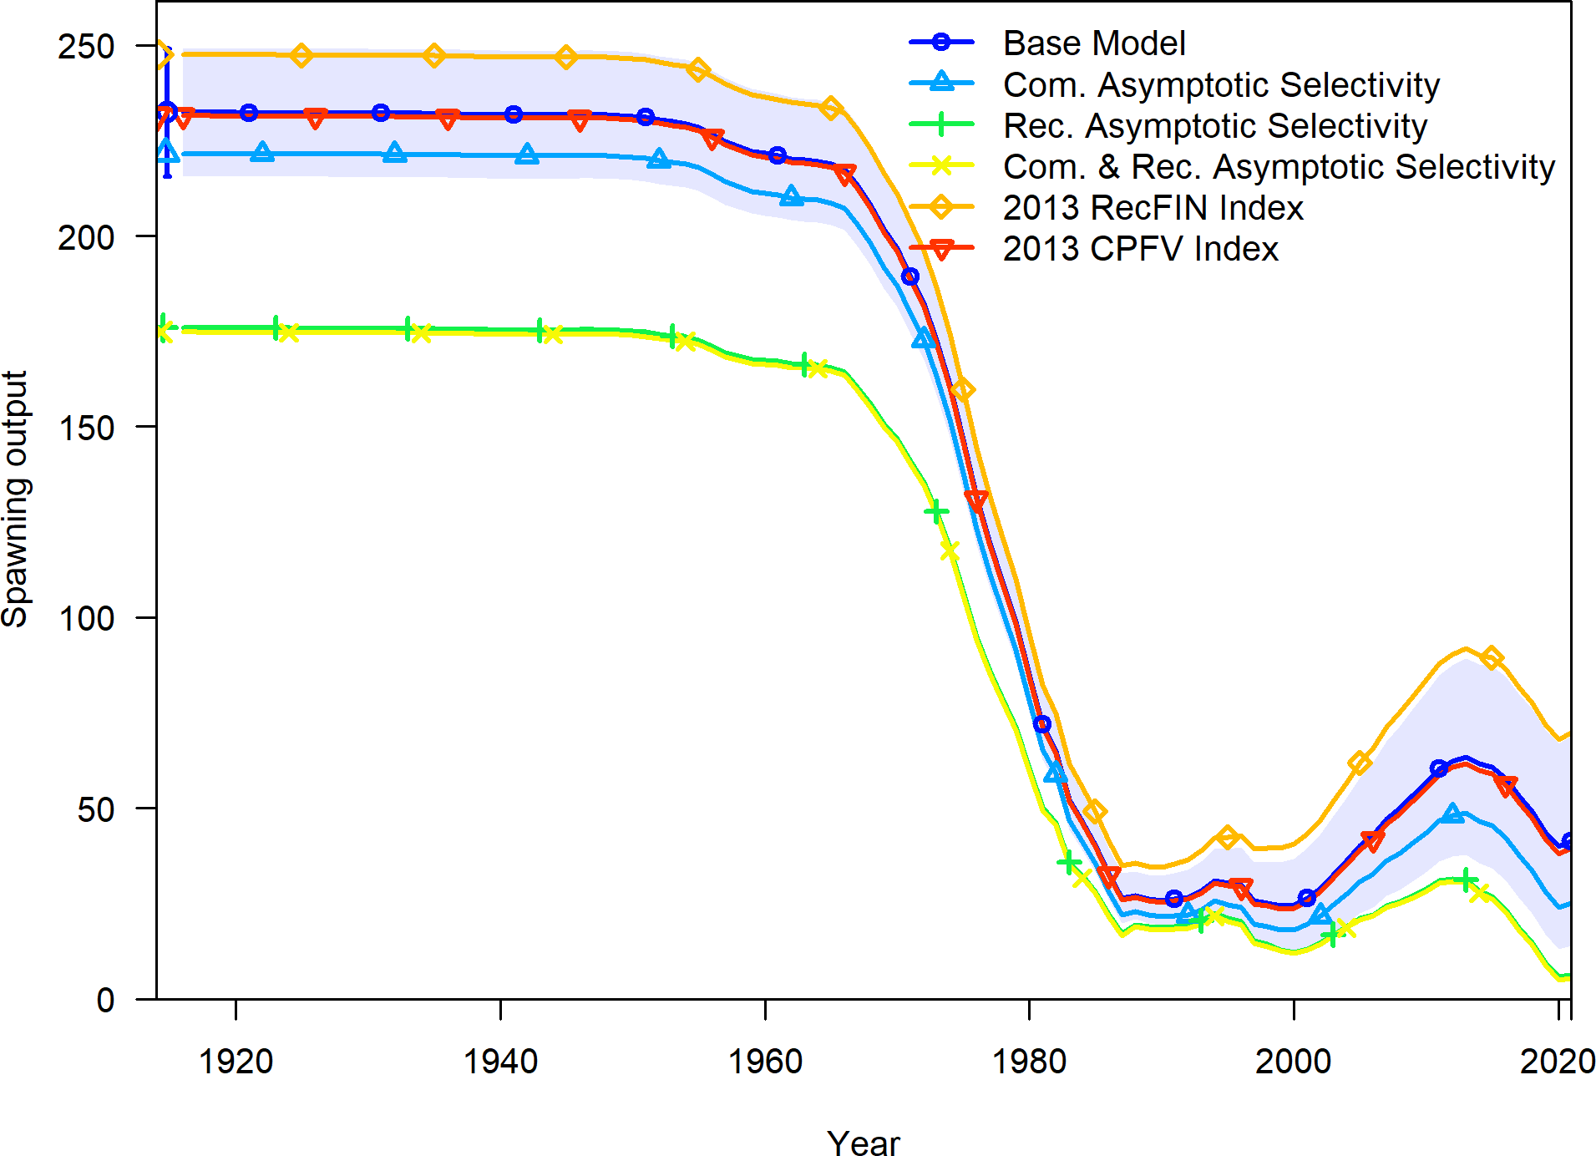

**Figure 52:** Change in estimated spawning output by sensitivity.

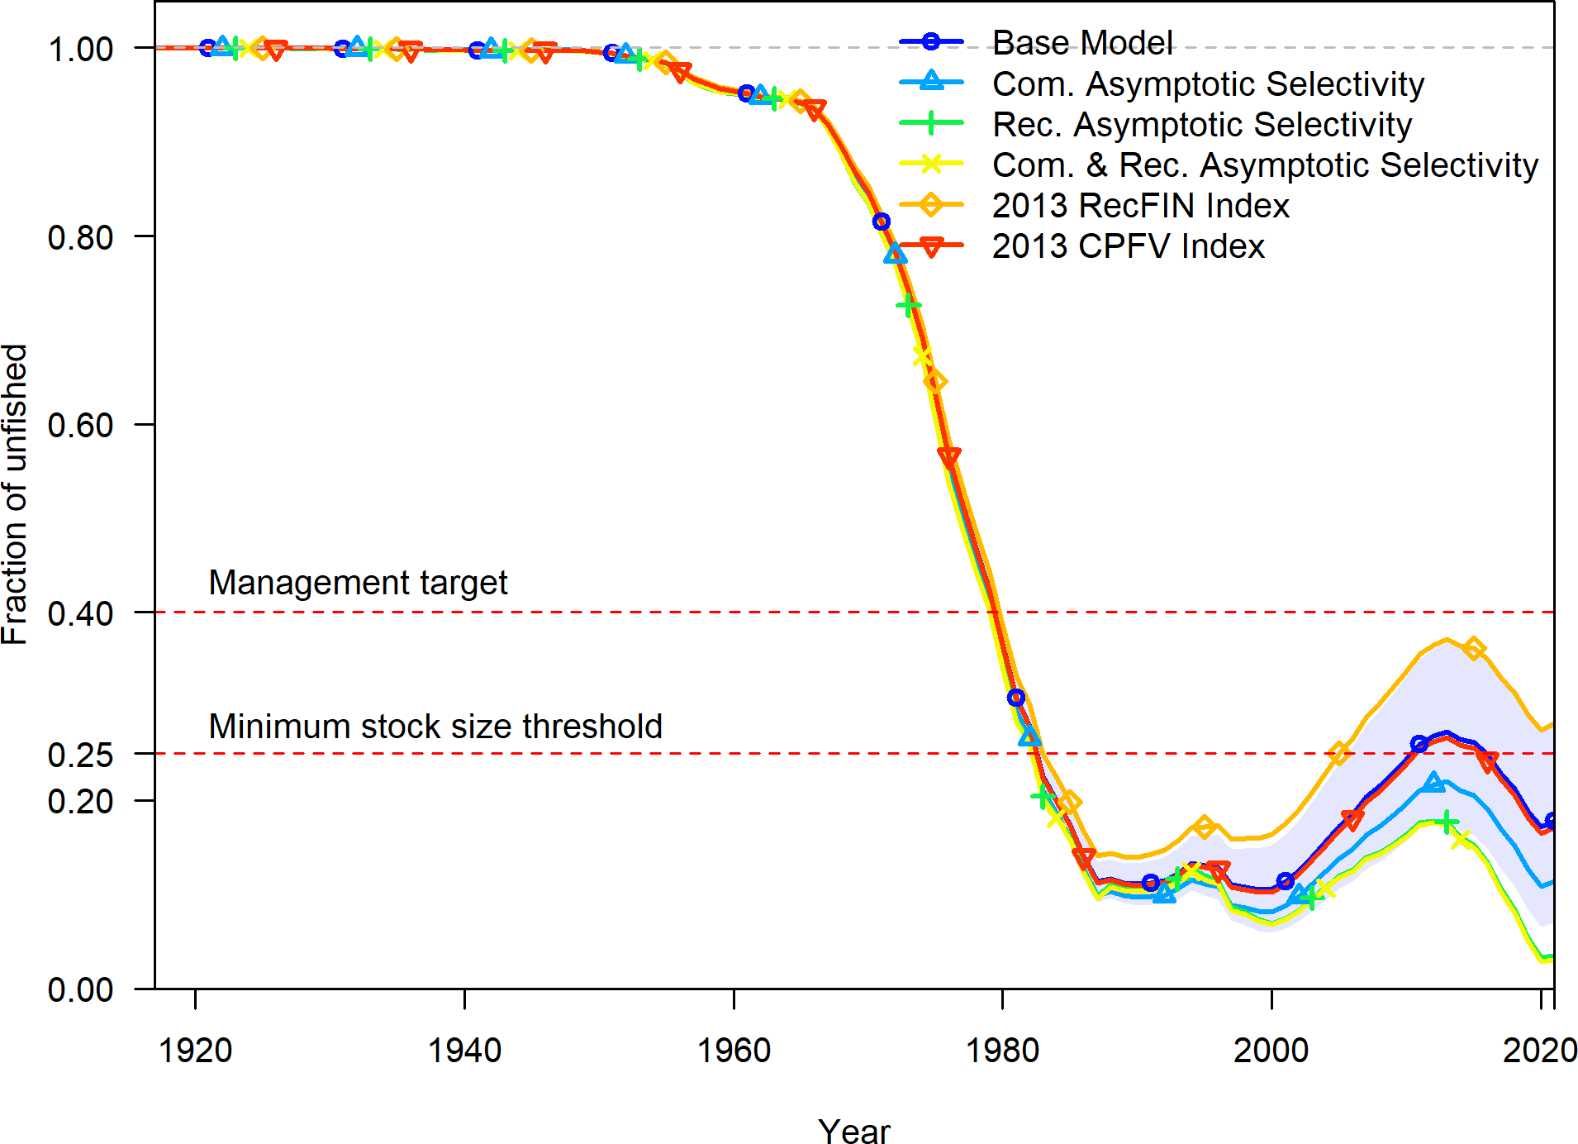

**Figure 53:** Change in estimated fraction unfished by sensitivity.

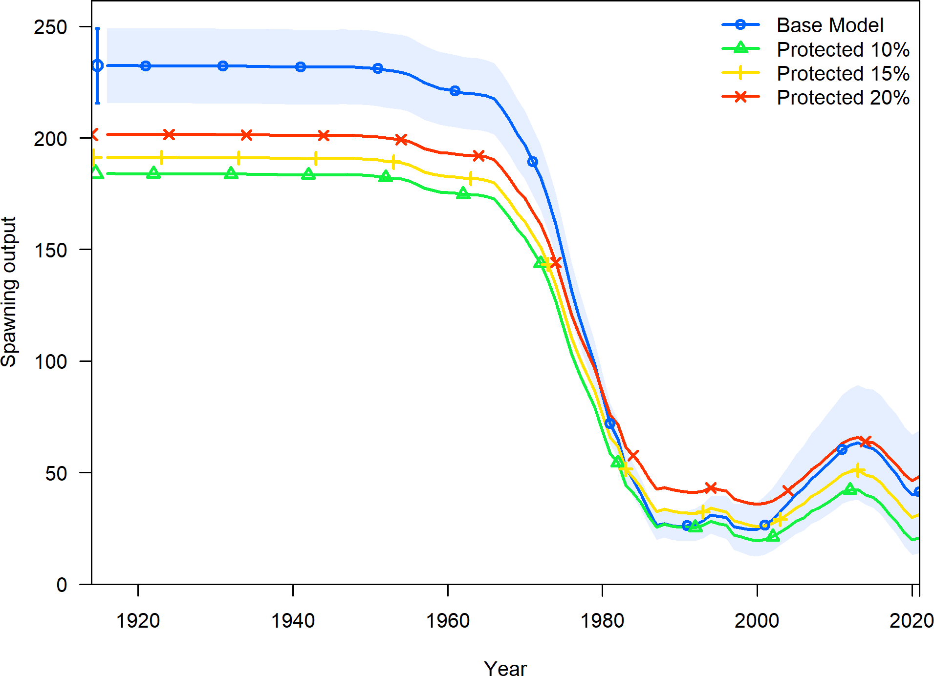

**Figure 54:** Change in estimated spawning output by sensitivity examining alternative percent of the population protected from fishing.

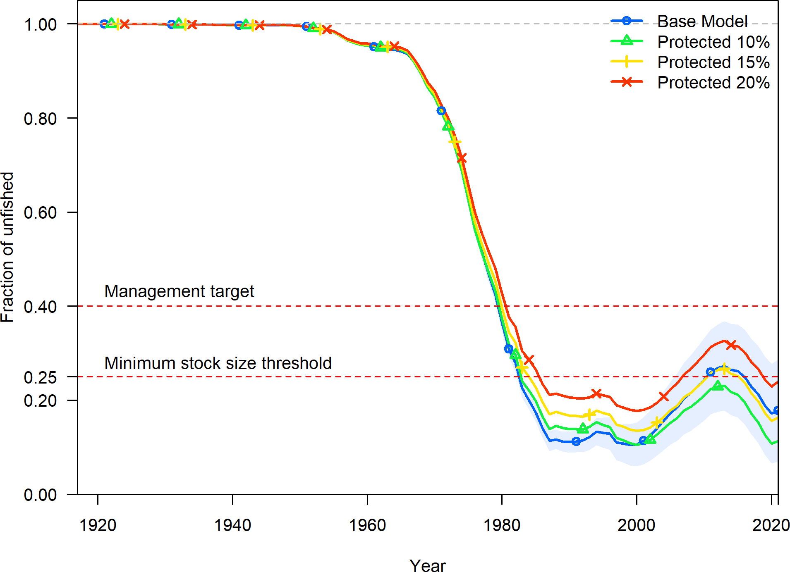

**Figure 55:** Change in estimated fraction unfished by sensitivity examining alternative percent of the population protected from fishing.

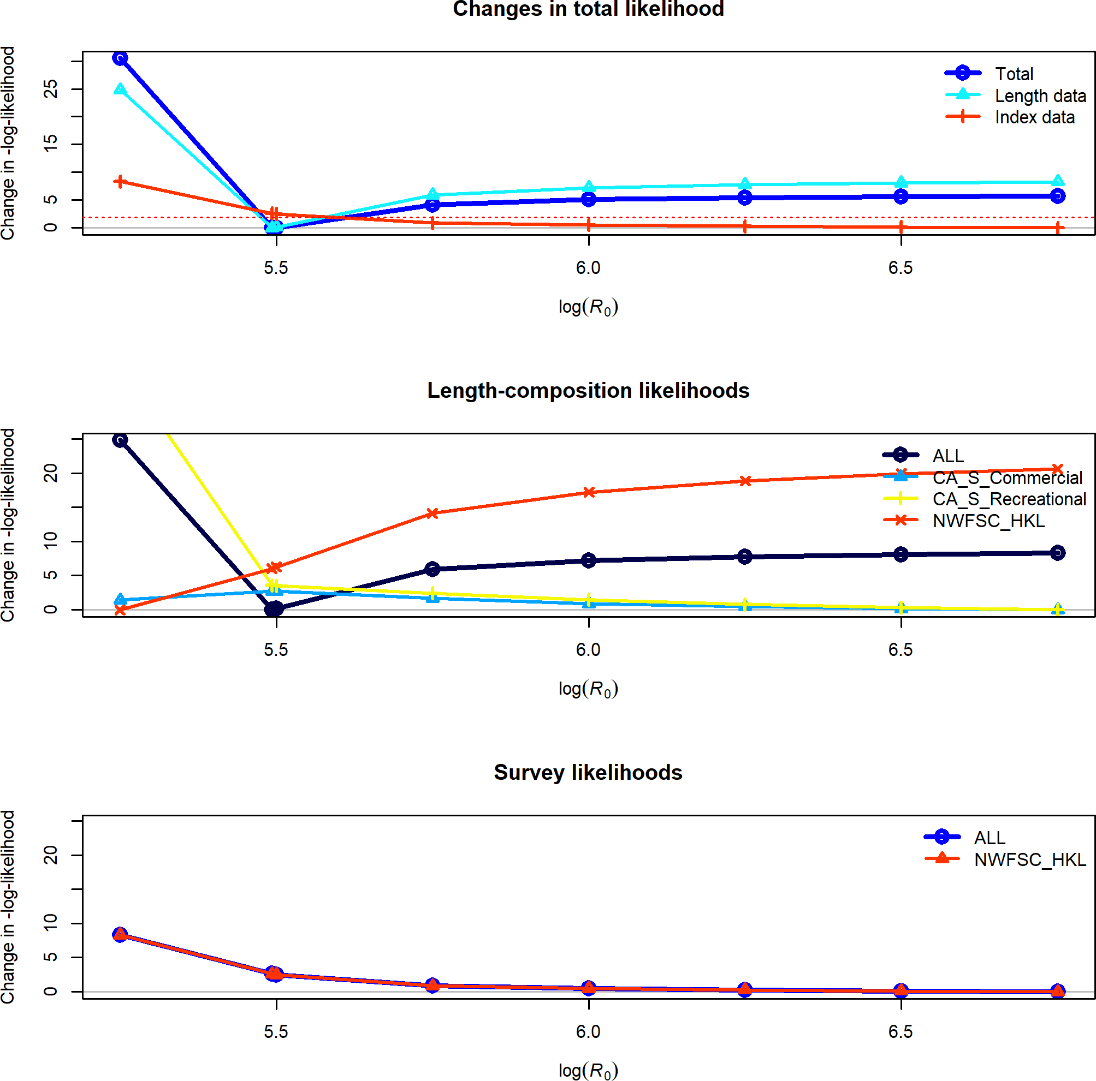

**Figure 56:** Change in the negative log-likelihood across a range of log(R0) values.

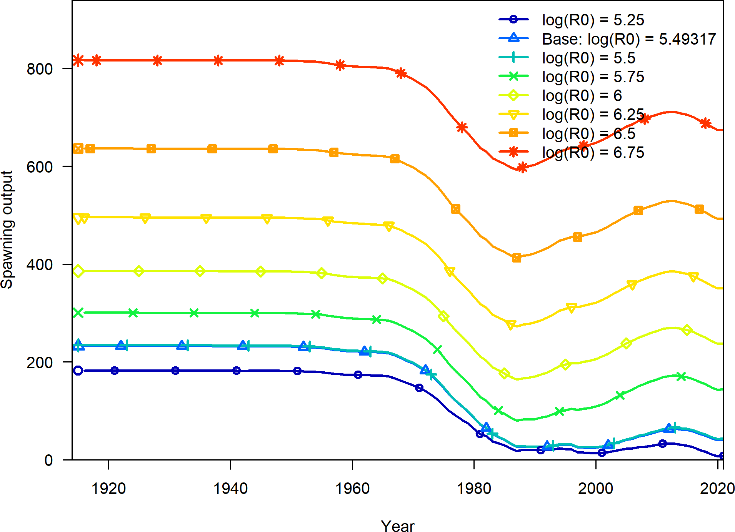

**Figure 57:** Change in the estimate of spawning output across a range of log(R0) values.

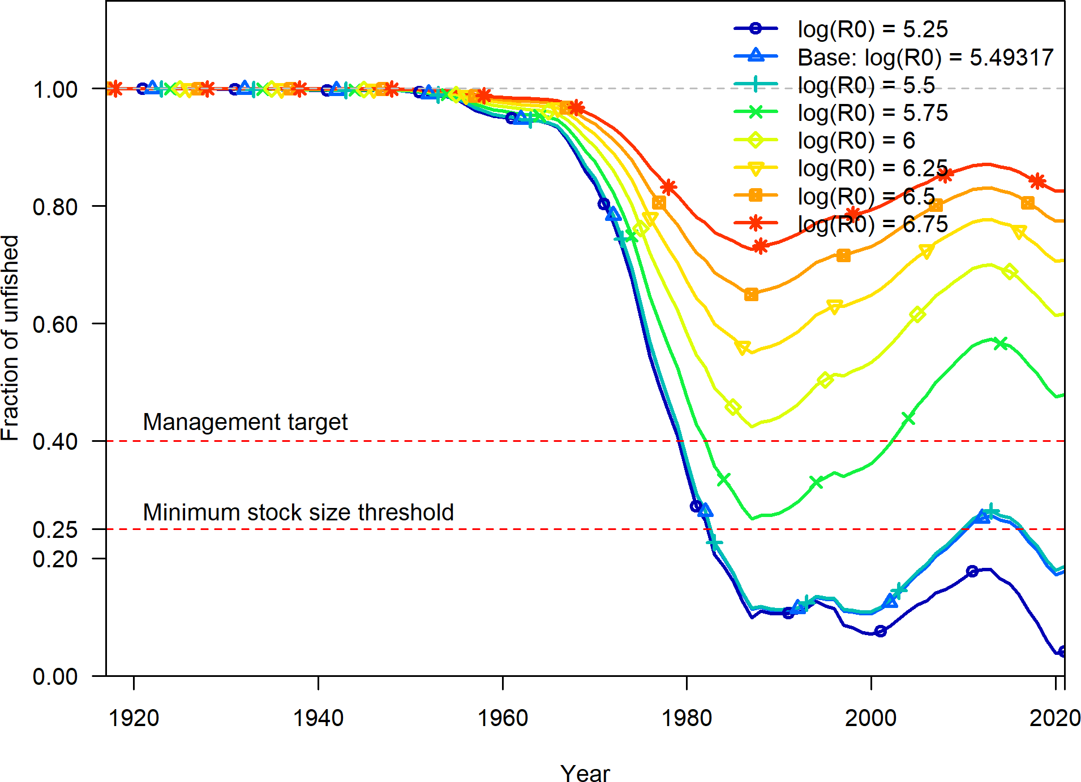

**Figure 58:** Change in the estimate of fraction unfished across a range of log(R0) values.

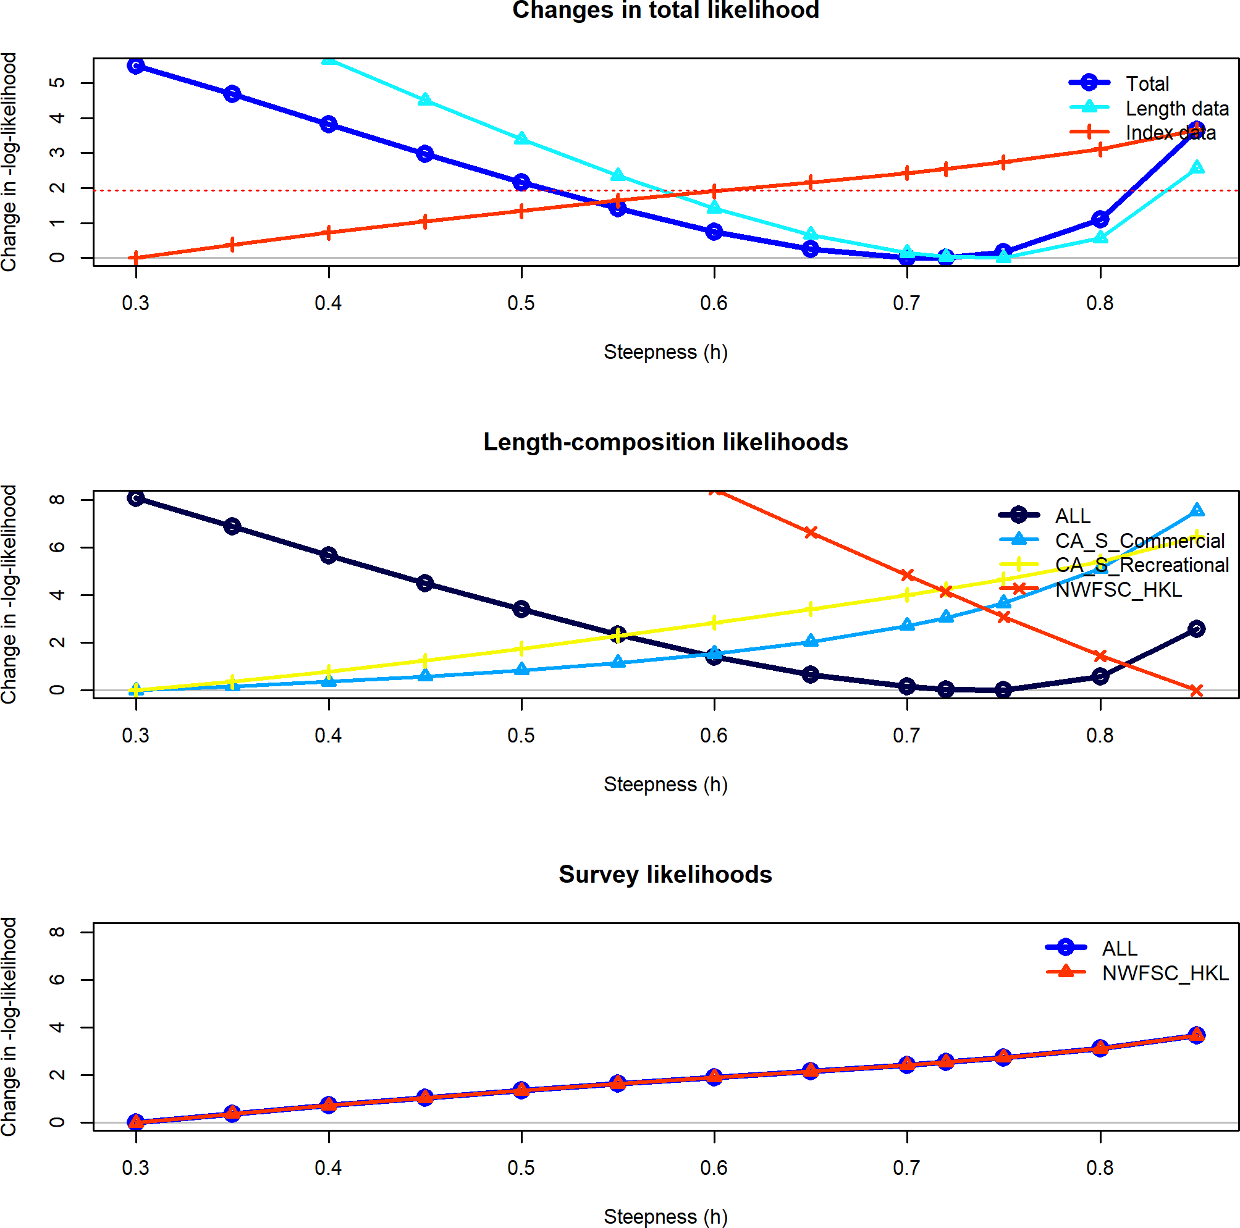

**Figure 59:** Change in the negative log-likelihood across a range of steepness values.

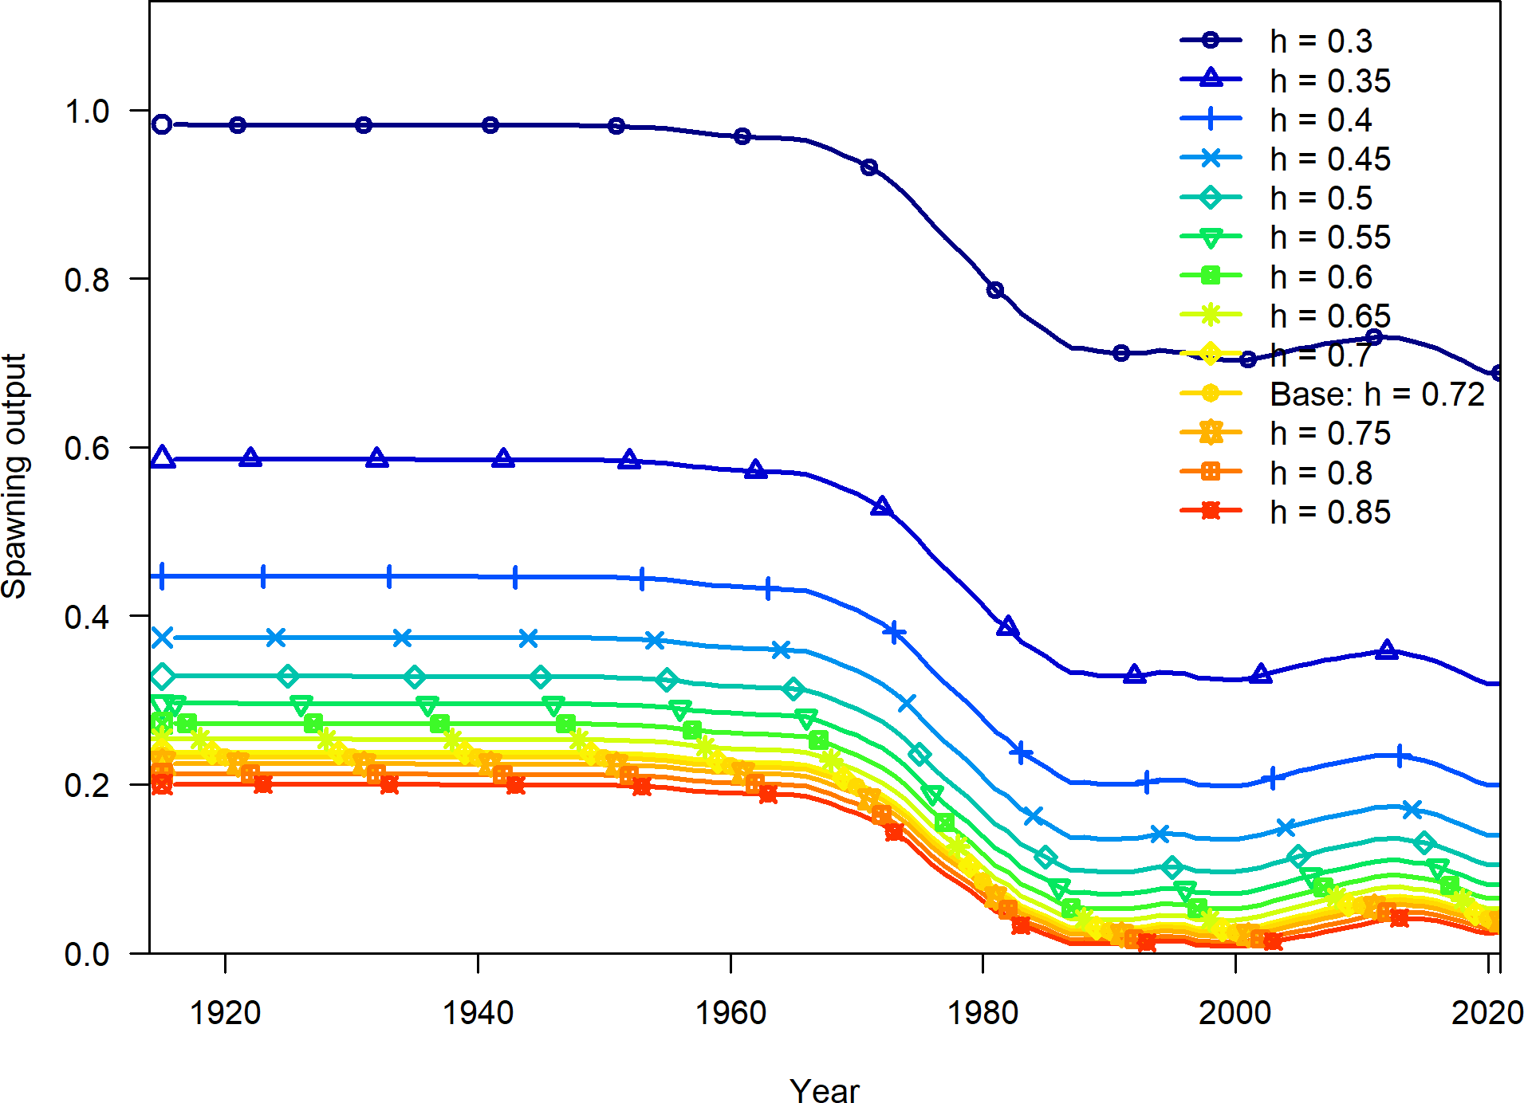

**Figure 60:** Change in the estimate of spawning output across a range of steepness values.

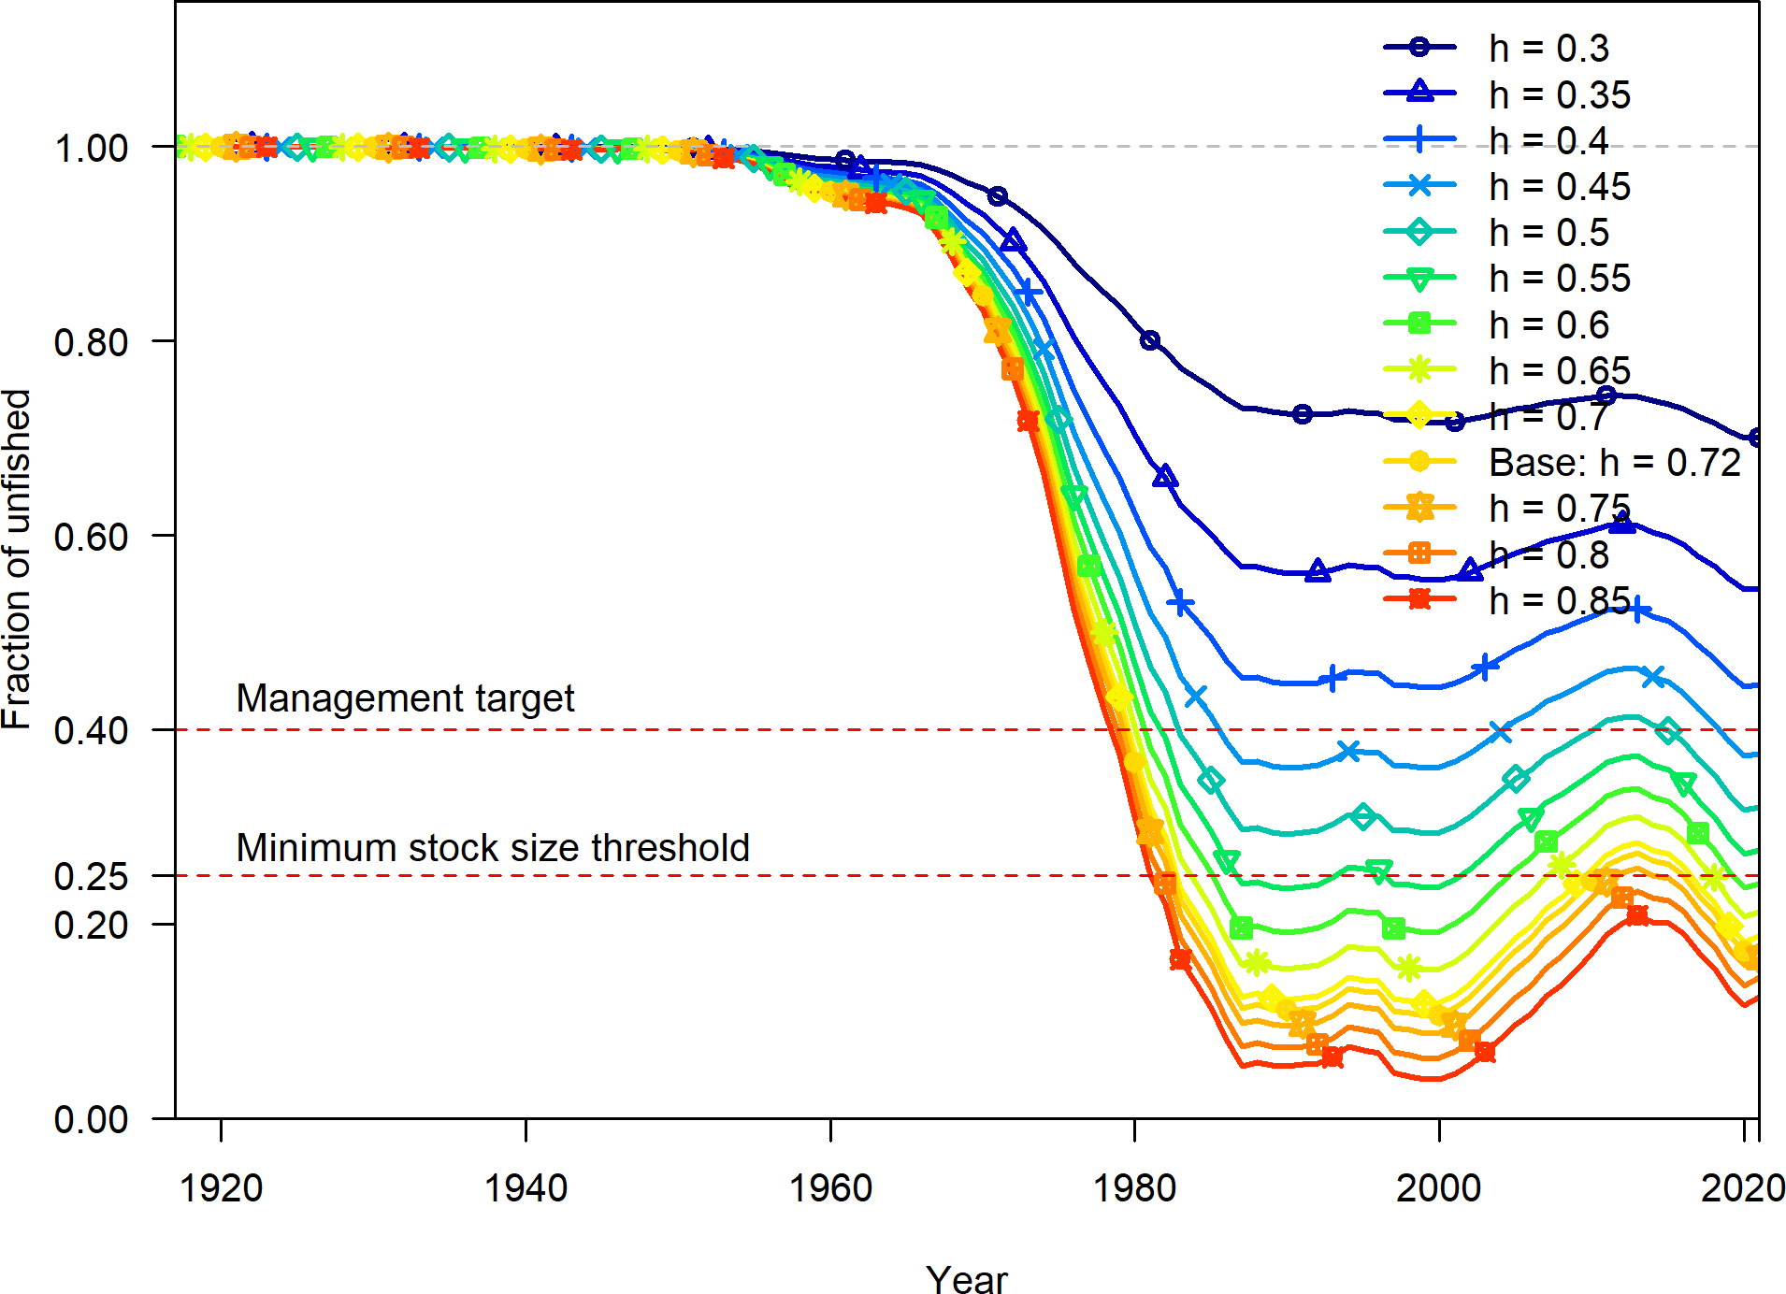

**Figure 61:** Change in the estimate of fraction unfished across a range of steepness values.

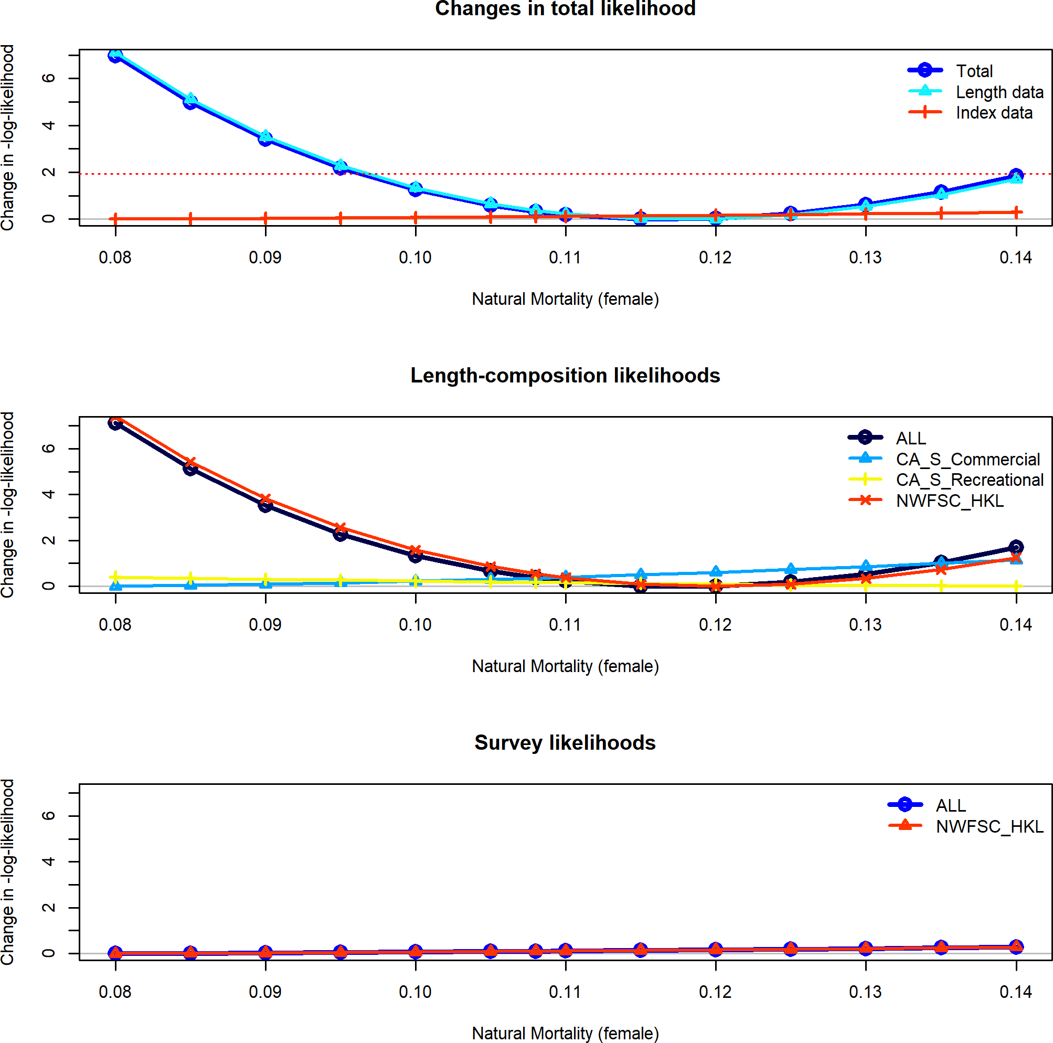

**Figure 62:** Change in the negative log-likelihood across a range of female natural mortality values.

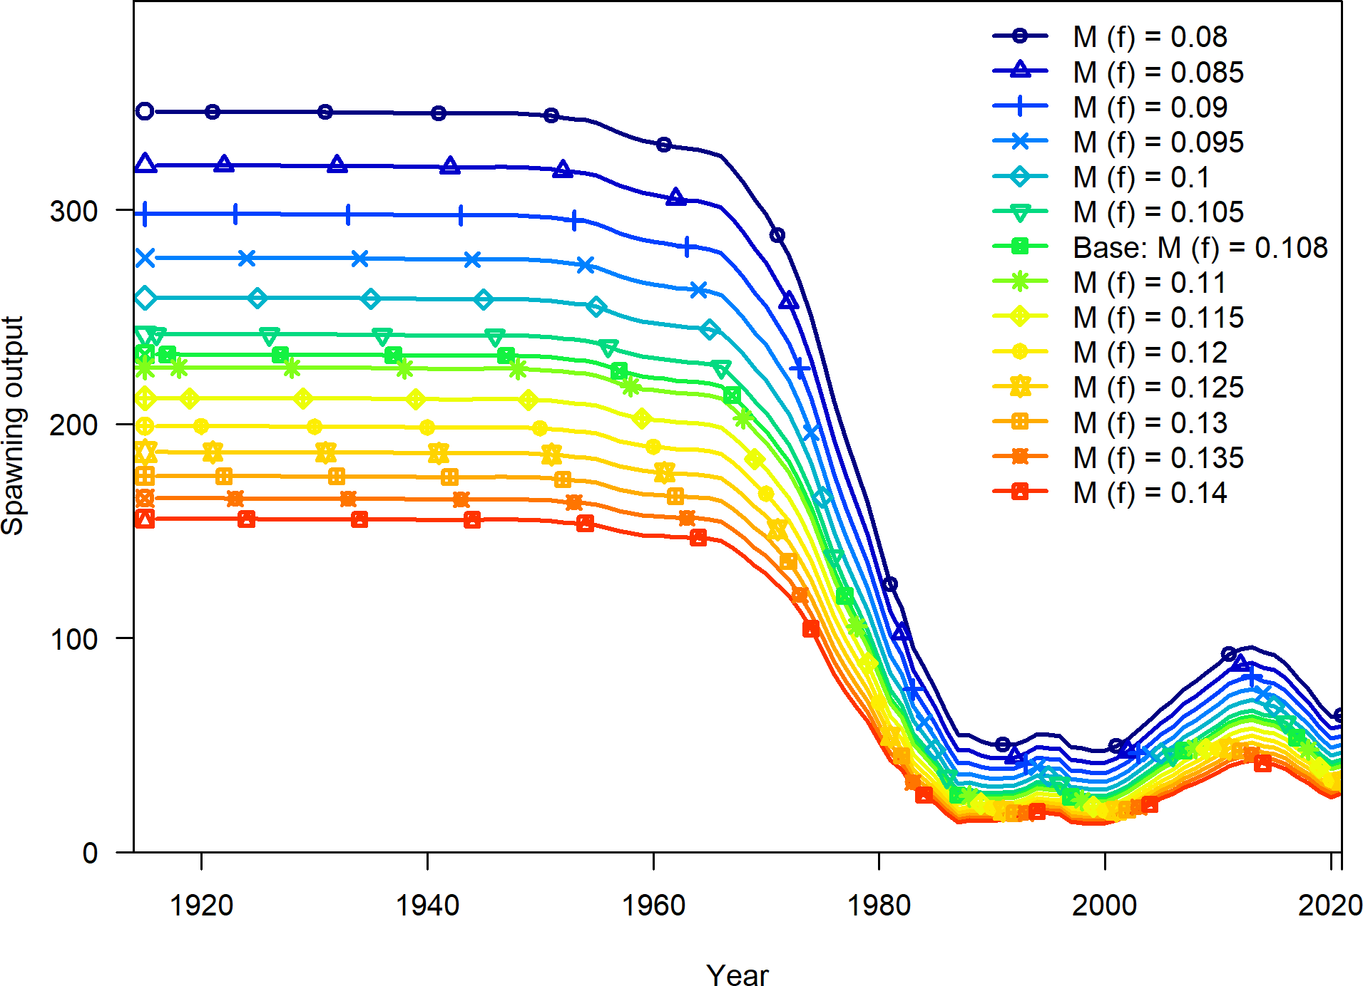

**Figure 63:** Change in the estimate of spawning output across a range of female natural mortality values.

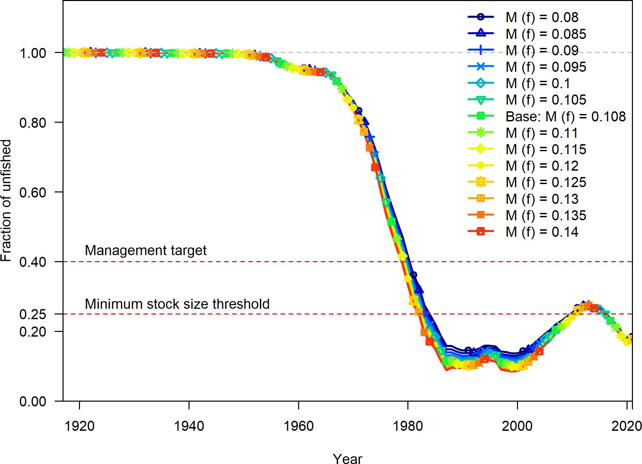

**Figure 64:** Change in the estimate of fraction unfished across a range of female natural values.

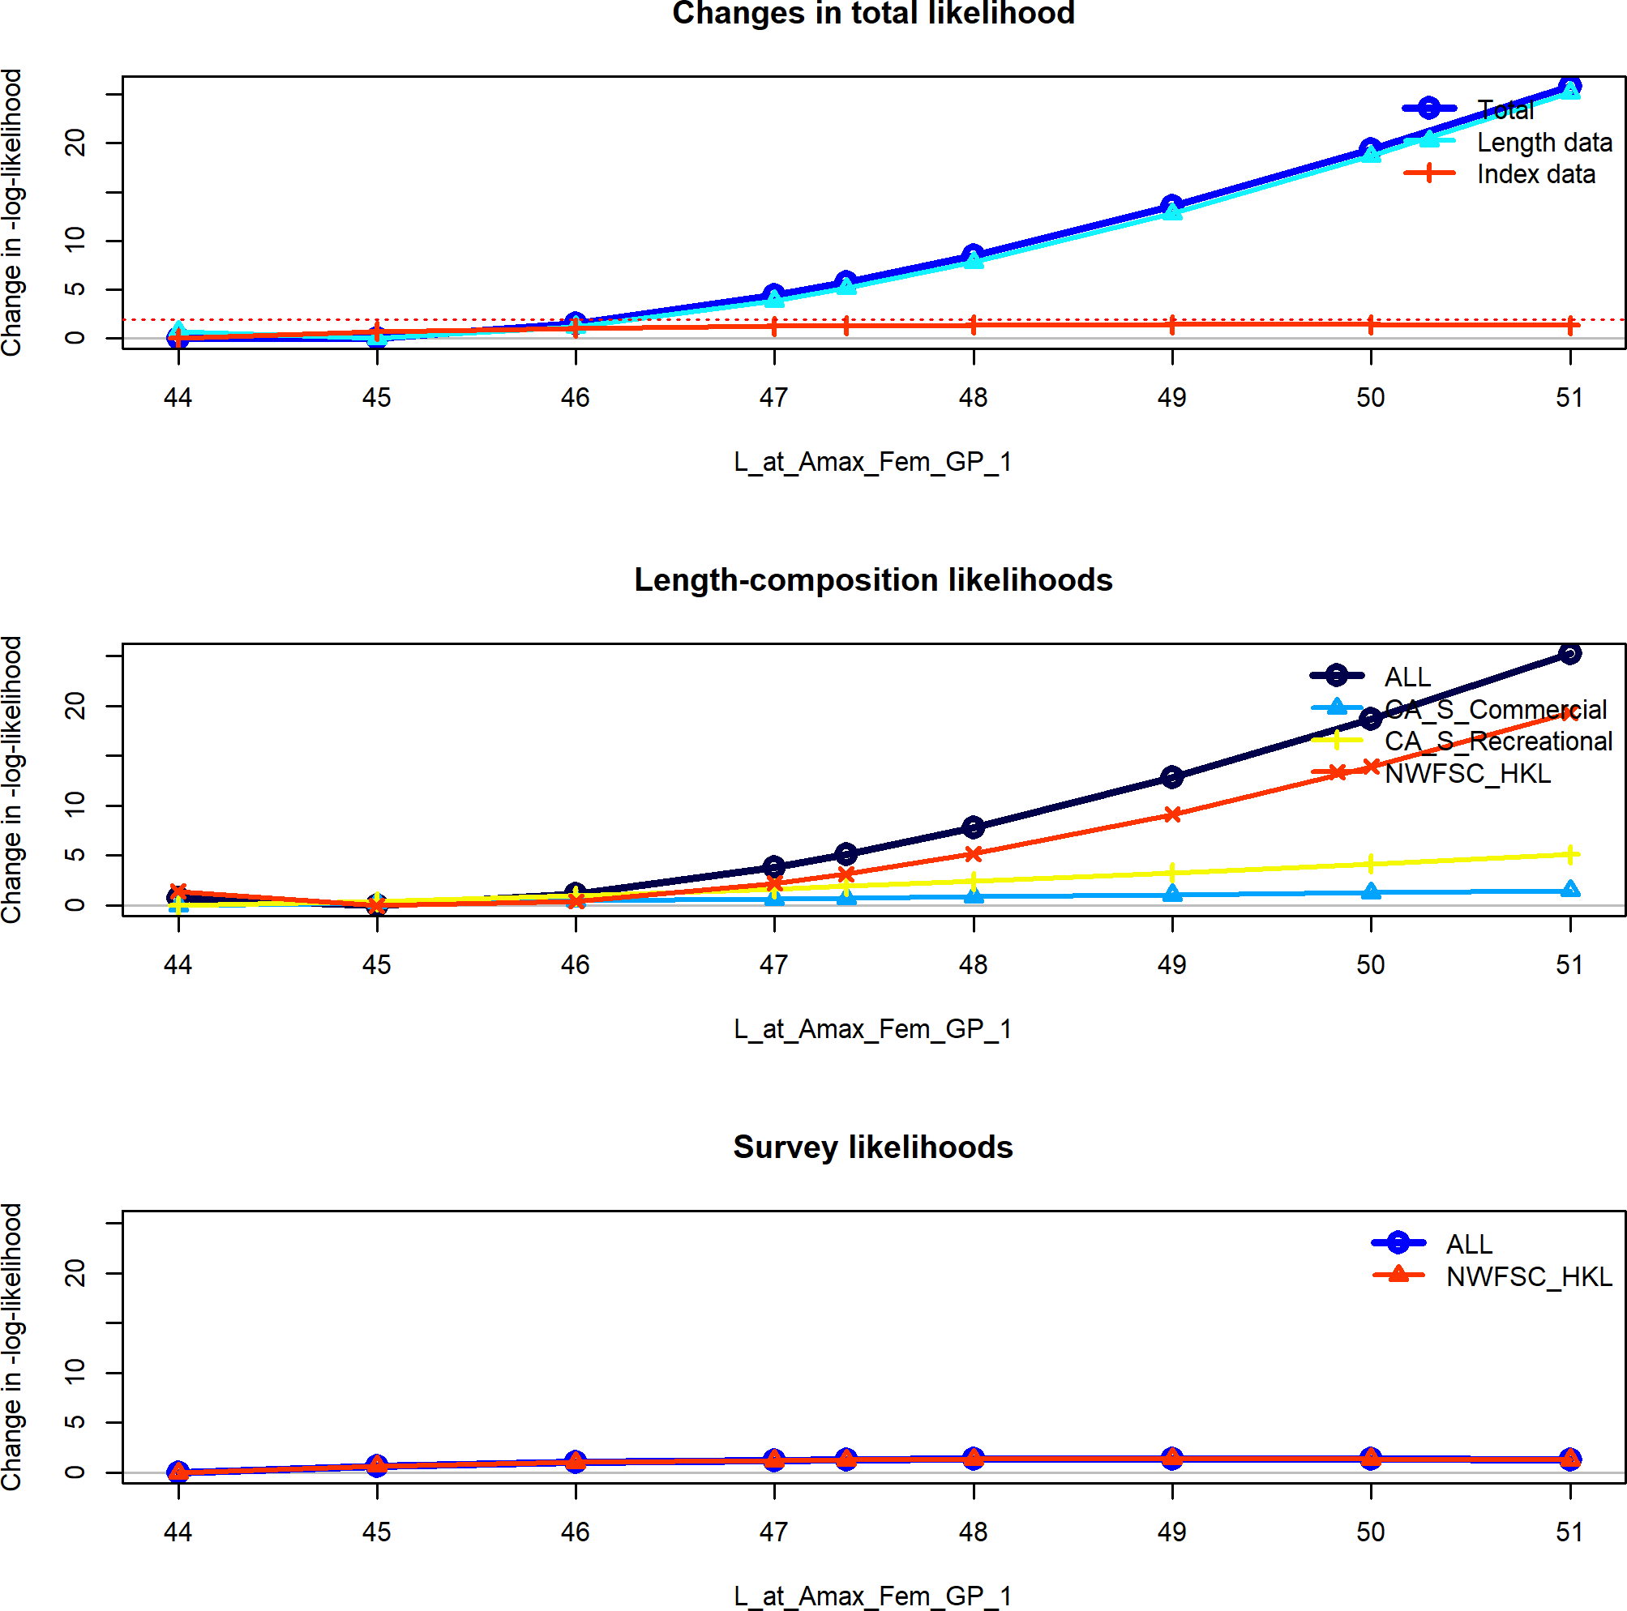

**Figure 65:** Change in the negative log-likelihood across a range of female maximum length values.

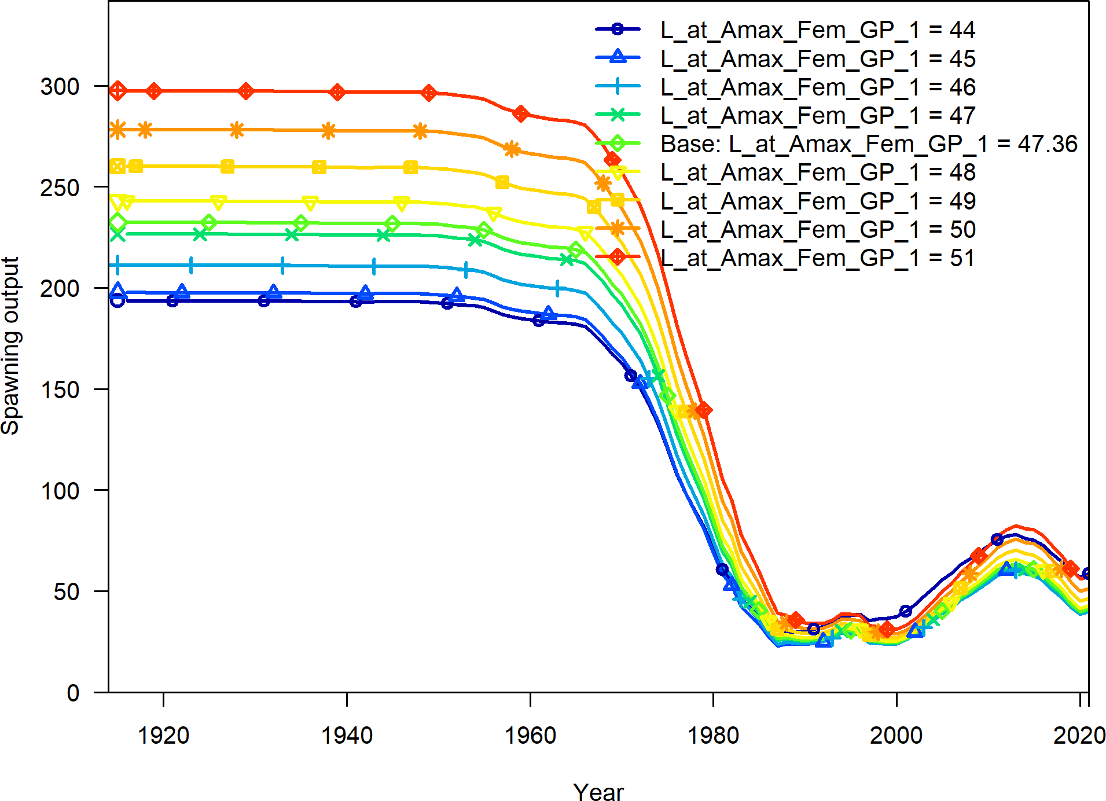

**Figure 66:** Change in the estimate of spawning output across a range of female maximum length values.

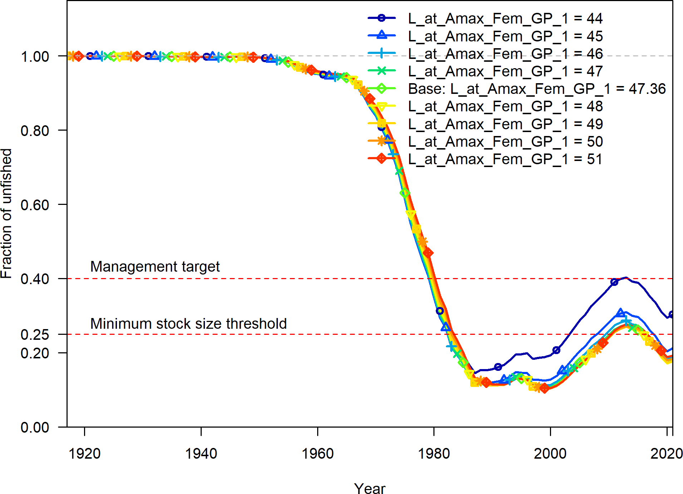

**Figure 67:** Change in the estimate of fraction unfished across a range of female maximum length values.

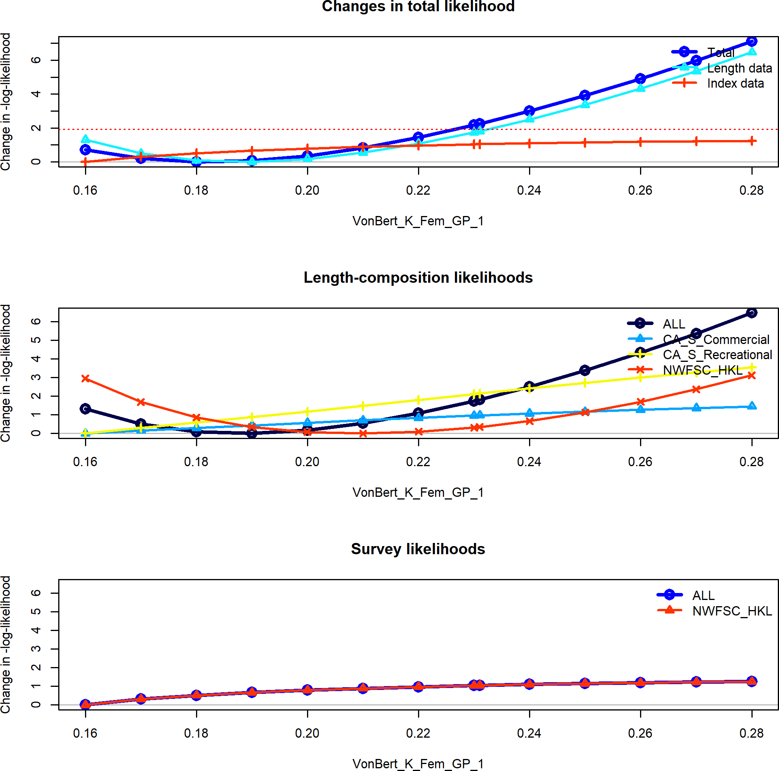

**Figure 68:** Change in the negative log-likelihood across a range of female k values.

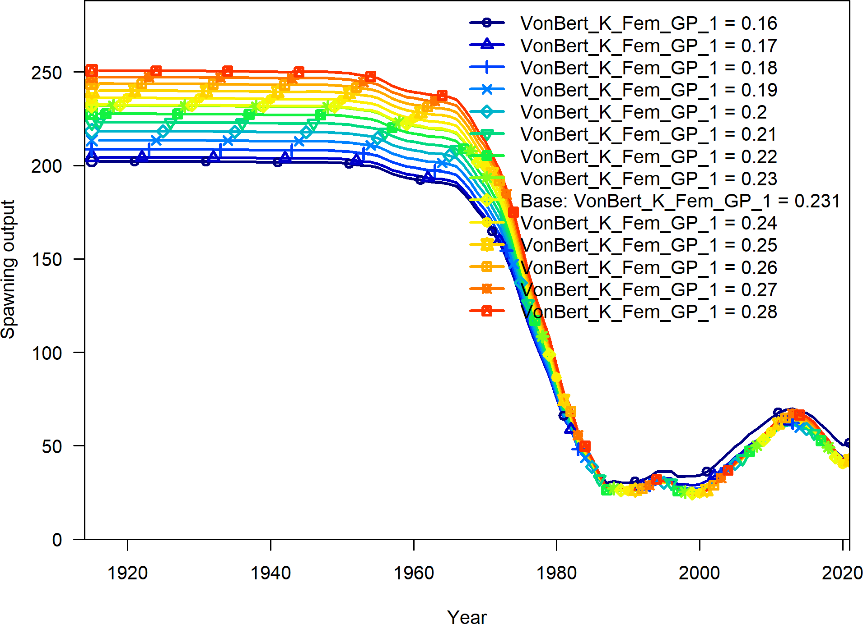

**Figure 69:** Change in the estimate of spawning output across a range of female k values.

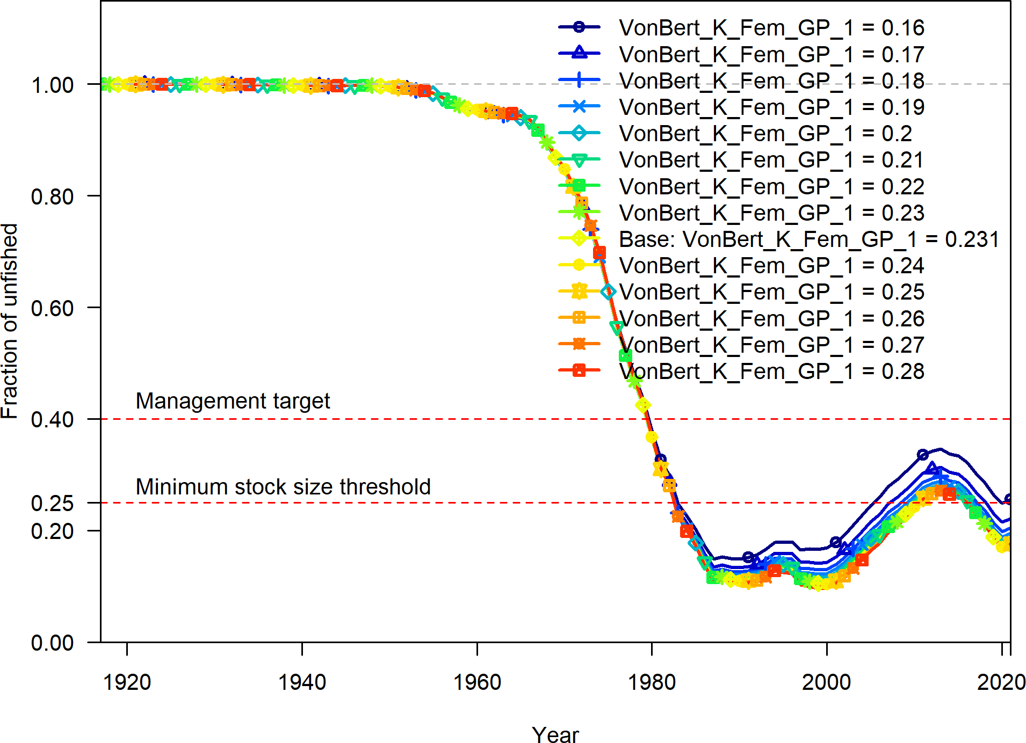

**Figure 70:** Change in the estimate of fraction unfished across a range of female k values.

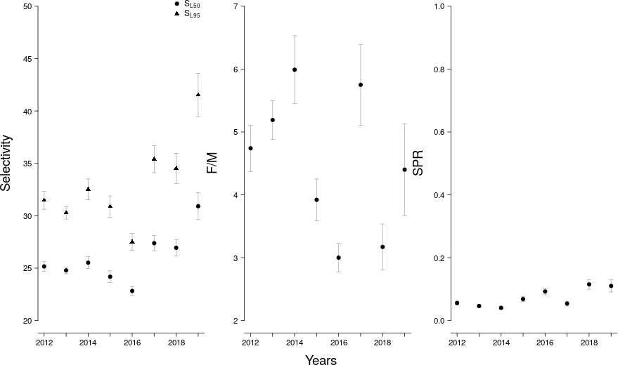

**Figure 71:** LB-SPR yearly estimates of selectivity, the ratio of fishing intensity to natural mortality (F/M), and annual spawner-per-recruit (SPR) values.

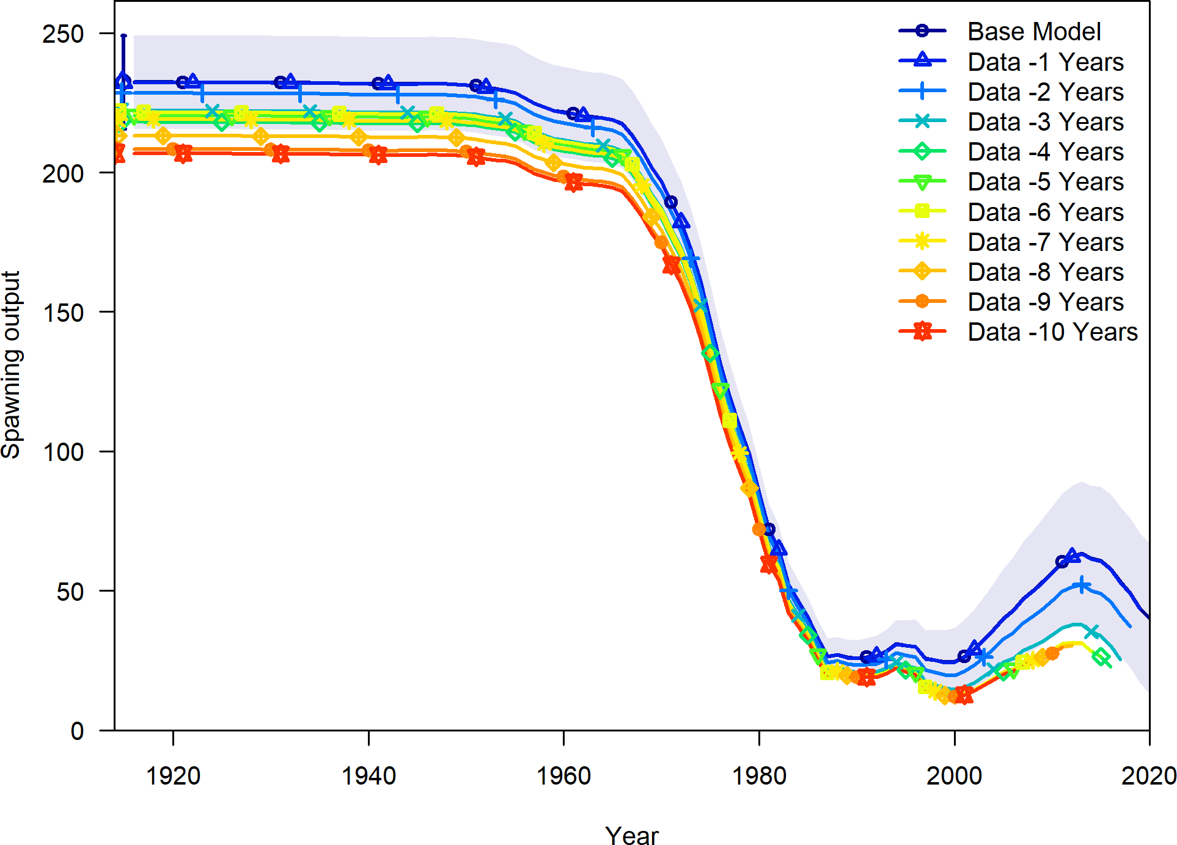

**Figure 72:** Change in the estimate of spawning output when the most recent 5 years of data area removed sequentially.

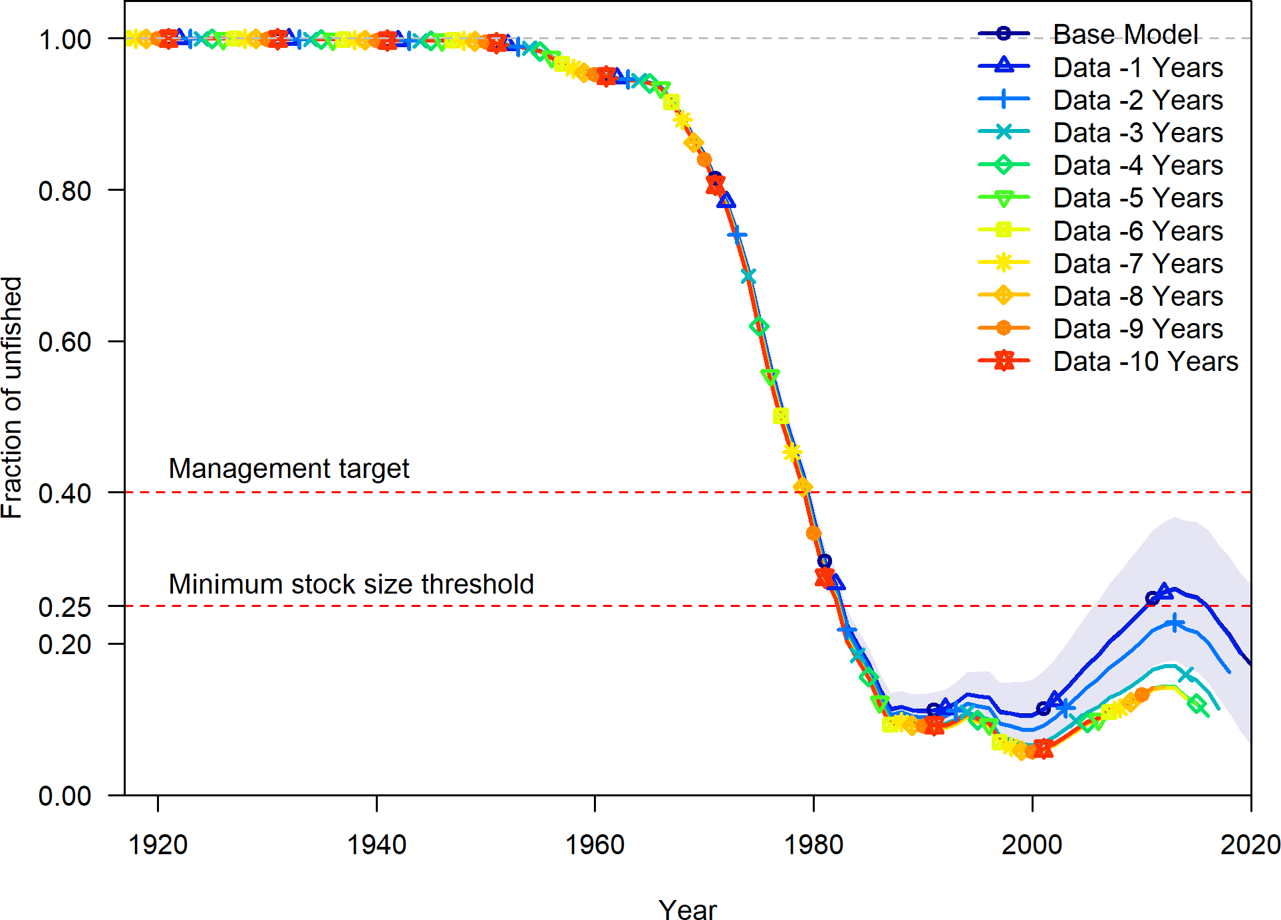

**Figure 73:** Change in the estimate of fraction unfished when the most recent 5 years of data area removed sequentially.

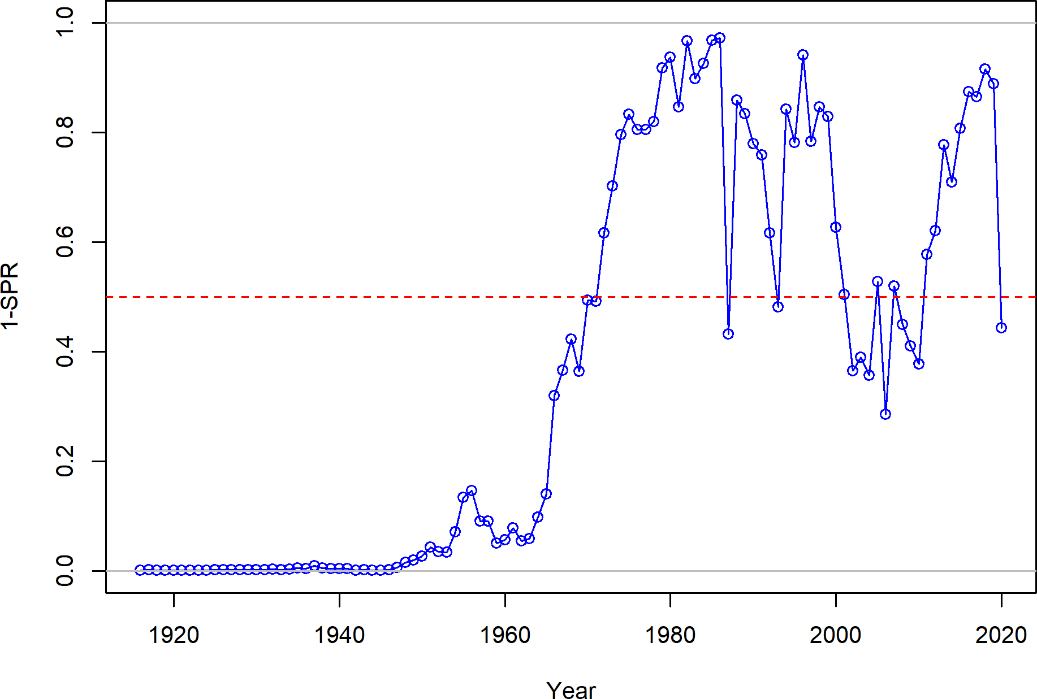

**Figure 74:** Estimated 1 - relative spawning ratio (SPR) by year.

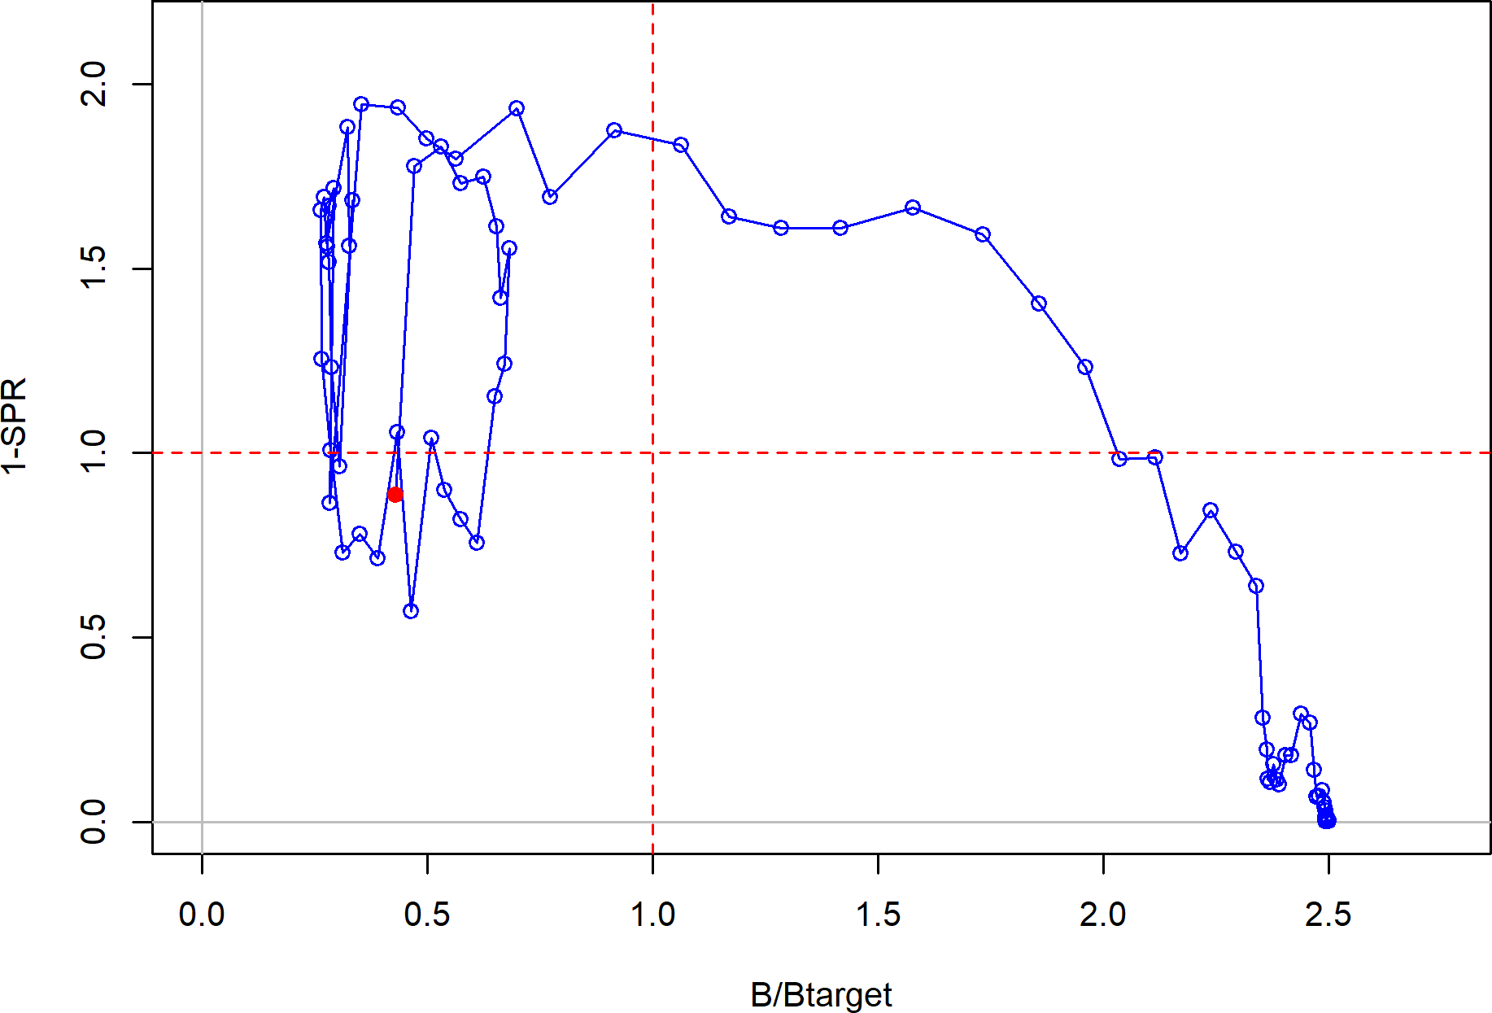

**Figure 75:** Phase plot of the relative biomass (also referred to as fraction unfished) versus the SPR ratio where each point represents the biomass ratio at the start of the year and the relative fishing intensity in that same year. Lines through the final point show the 95 percent intervals based on the asymptotic uncertainty for each dimension. The shaded ellipse is a 95 percent region which accounts for the estimated correlations between the biomass ratio and SPR ratio.

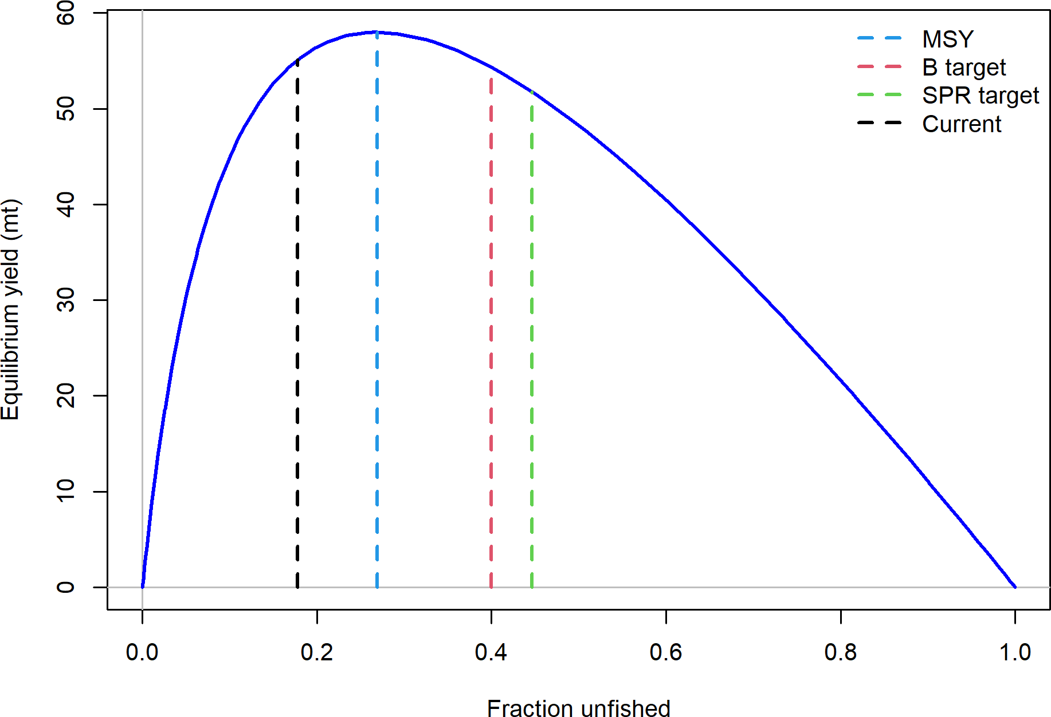

**Figure 76:** Equilibrium yield curve for the base case model. Values are based on the 2020 fishery selectivity and with steepness fixed at 0.72.

# Appendix A

## Annual Length Composition Data

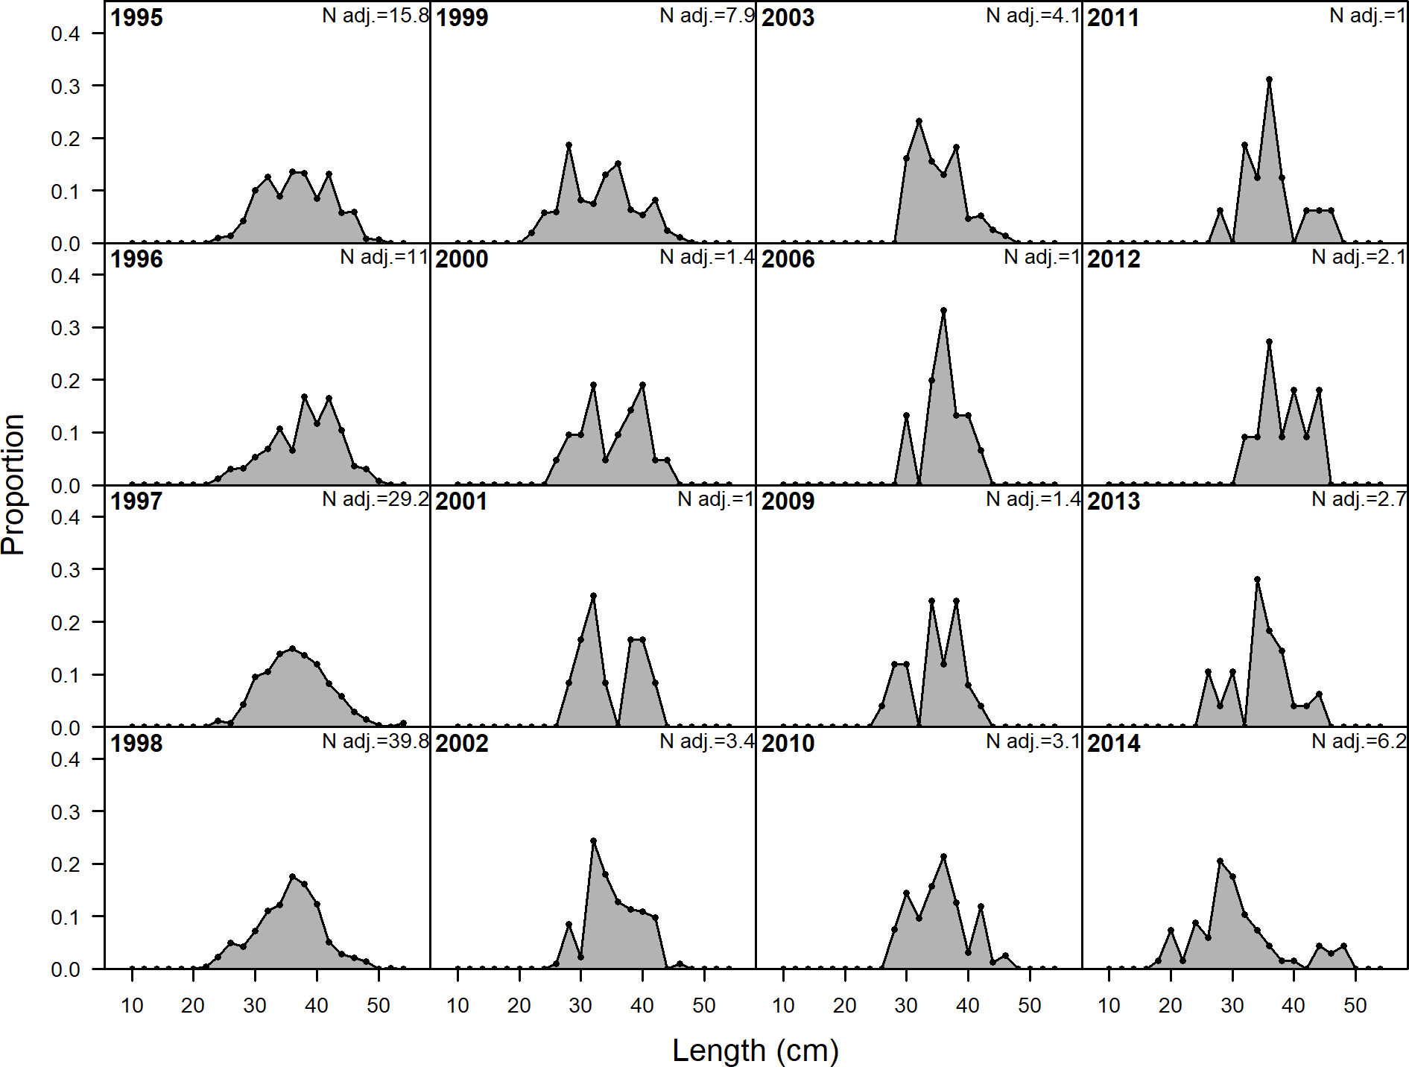

**Figure 77:** Length comp data, whole catch, CA_S_Commercial (plot 1 of 2).‘N adj.’ is the input sample size after data-weighting adjustment. N eff. is the calculated effective sample size used in the McAllister-Iannelli tuning method..

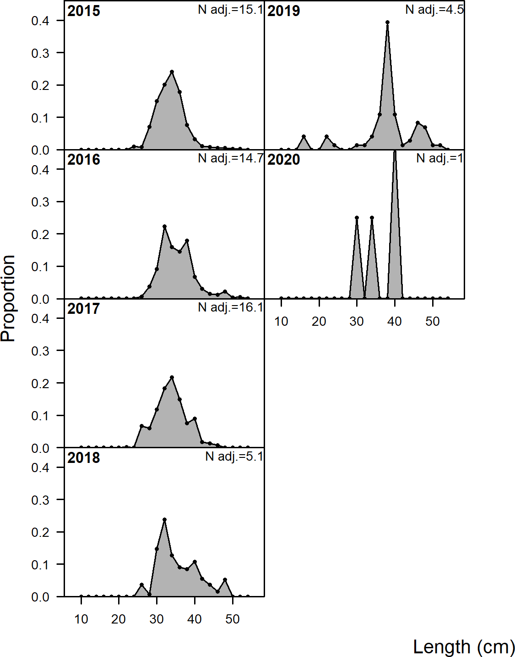

**Figure 78:** Length comp data, whole catch, CA_S_Commercial (plot 2 of 2).

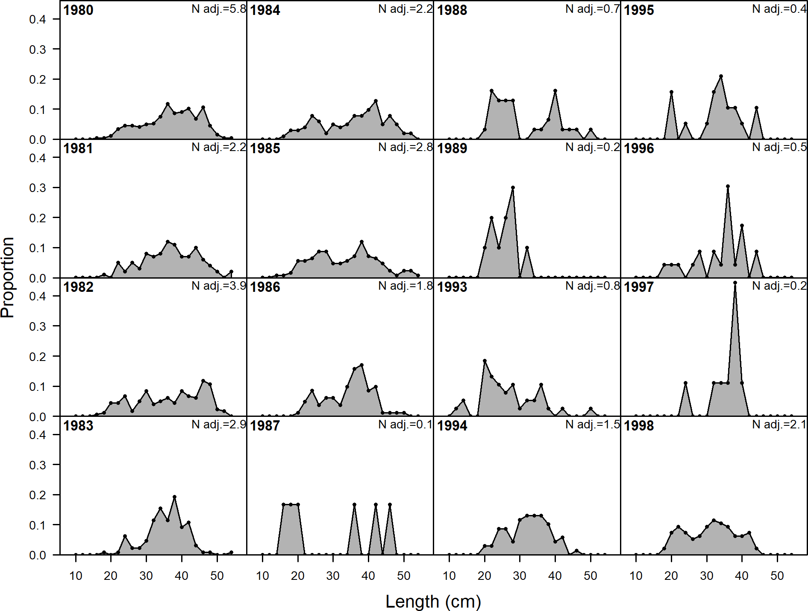

**Figure 79:** Length comp data, whole catch, CA_S_Recreational (plot 1 of 3).‘N adj.’ is the input sample size after data-weighting adjustment. N eff. is the calculated effective sample size used in the McAllister-Iannelli tuning method..

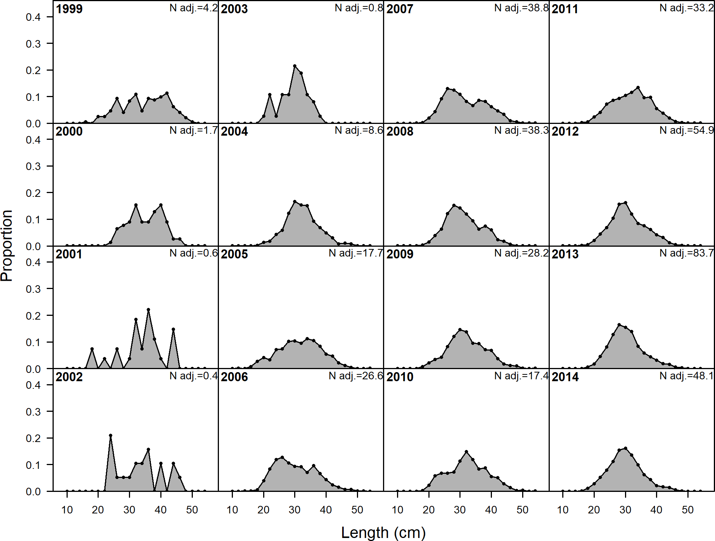

**Figure 80:** Length comp data, whole catch, CA_S_Recreational (plot 2 of 3).

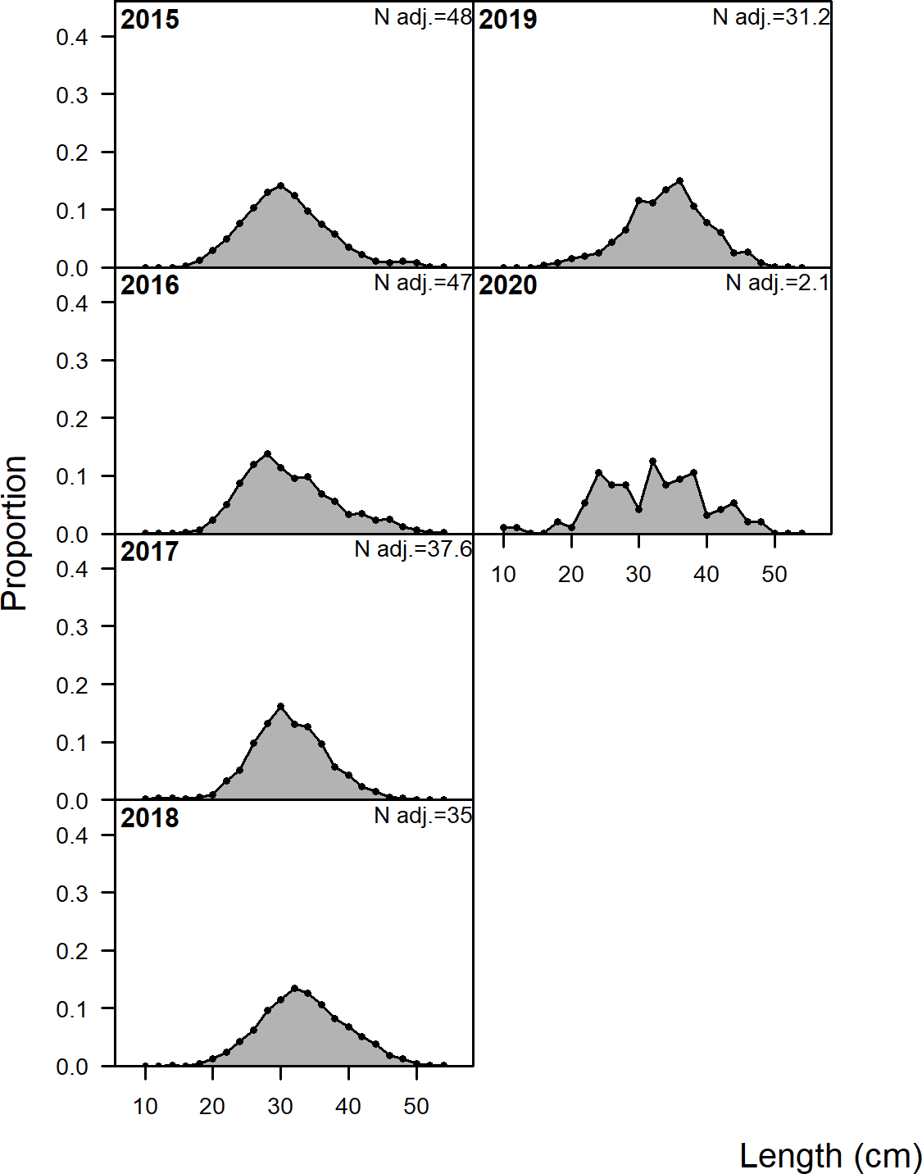

**Figure 81:** Length comp data, whole catch, CA_S_Recreational (plot 3 of 3).

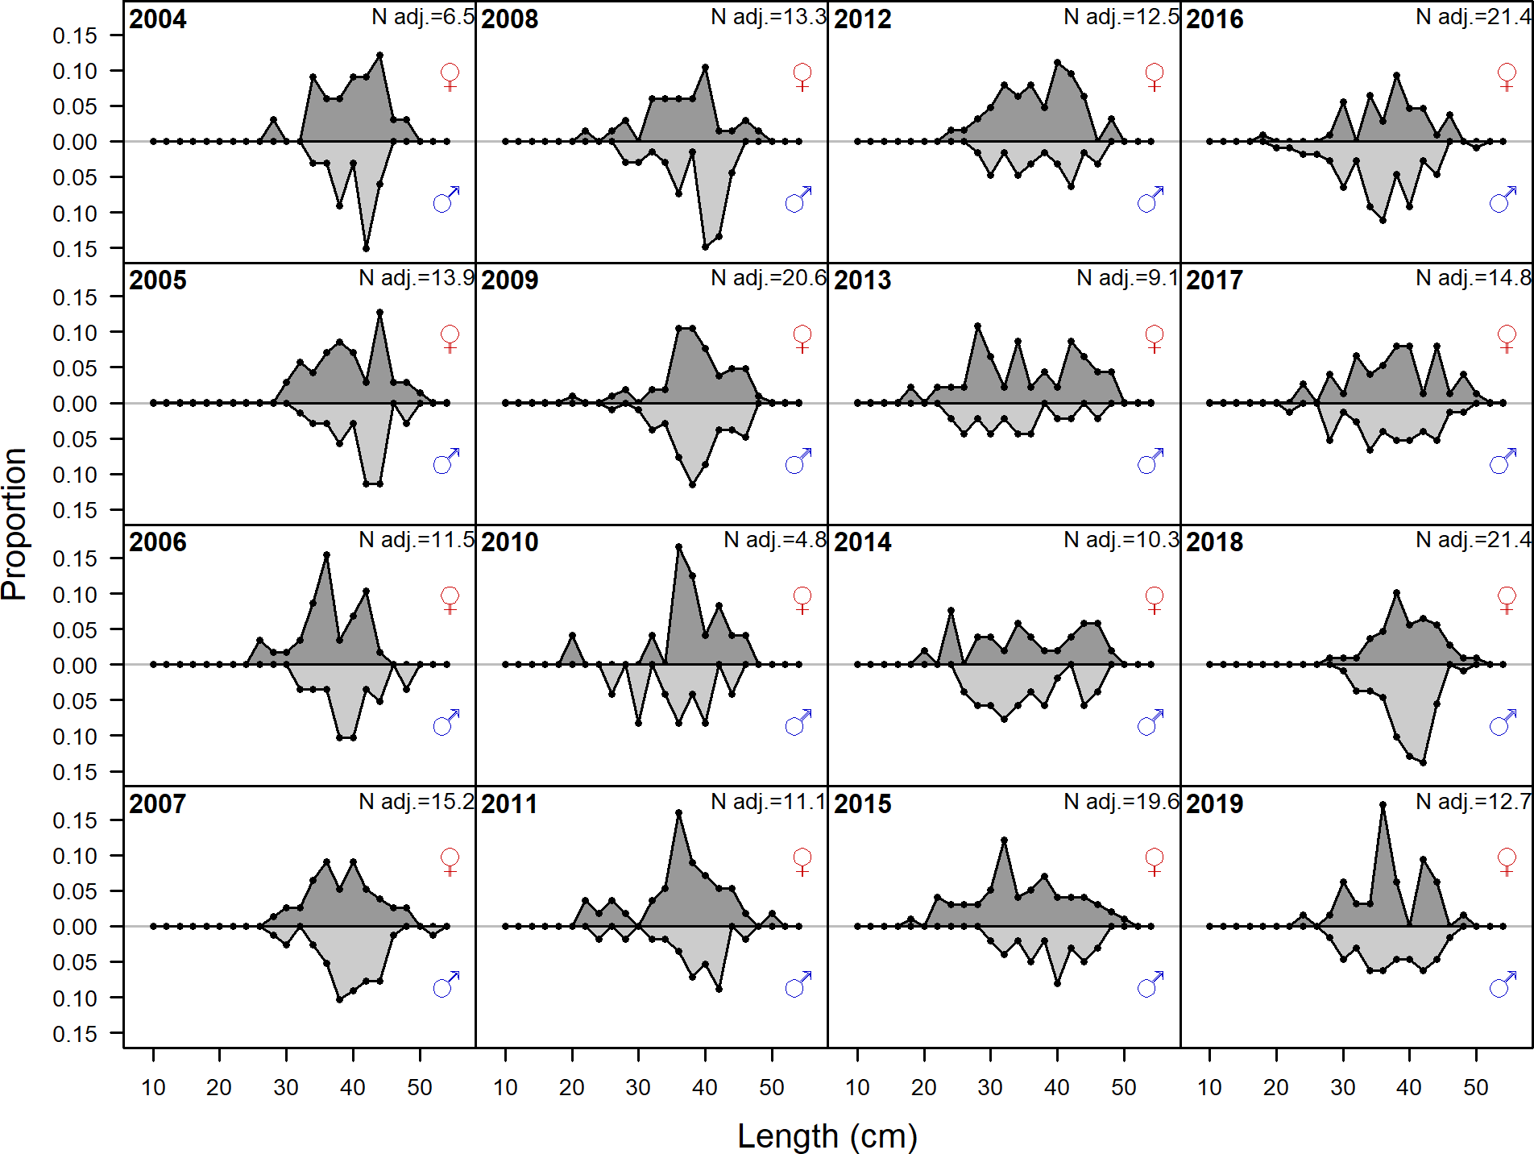

**Figure 82:** Length comp data, whole catch, NWFSC_HKL.‘N adj.’ is the input sample size after data-weighting adjustment. N eff. is the calculated effective sample size used in the McAllister-Iannelli tuning method..

## Detailed Fit to Length Composition Data

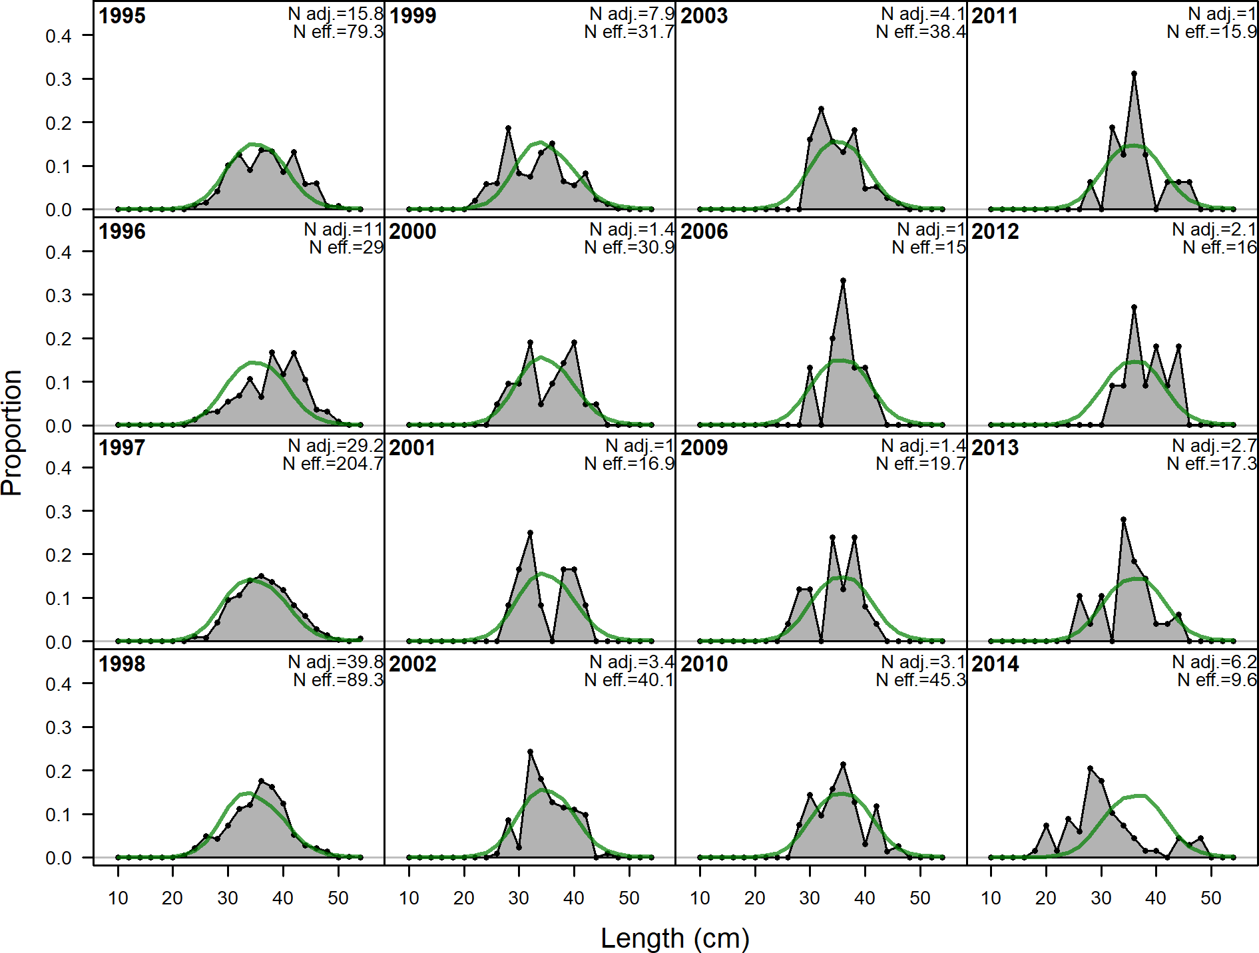

**Figure 83:** Length comps, whole catch, CA_S_Commercial (plot 1 of 2).‘N adj.’ is the input sample size after data-weighting adjustment. N eff. is the calculated effective sample size used in the McAllister-Iannelli tuning method..

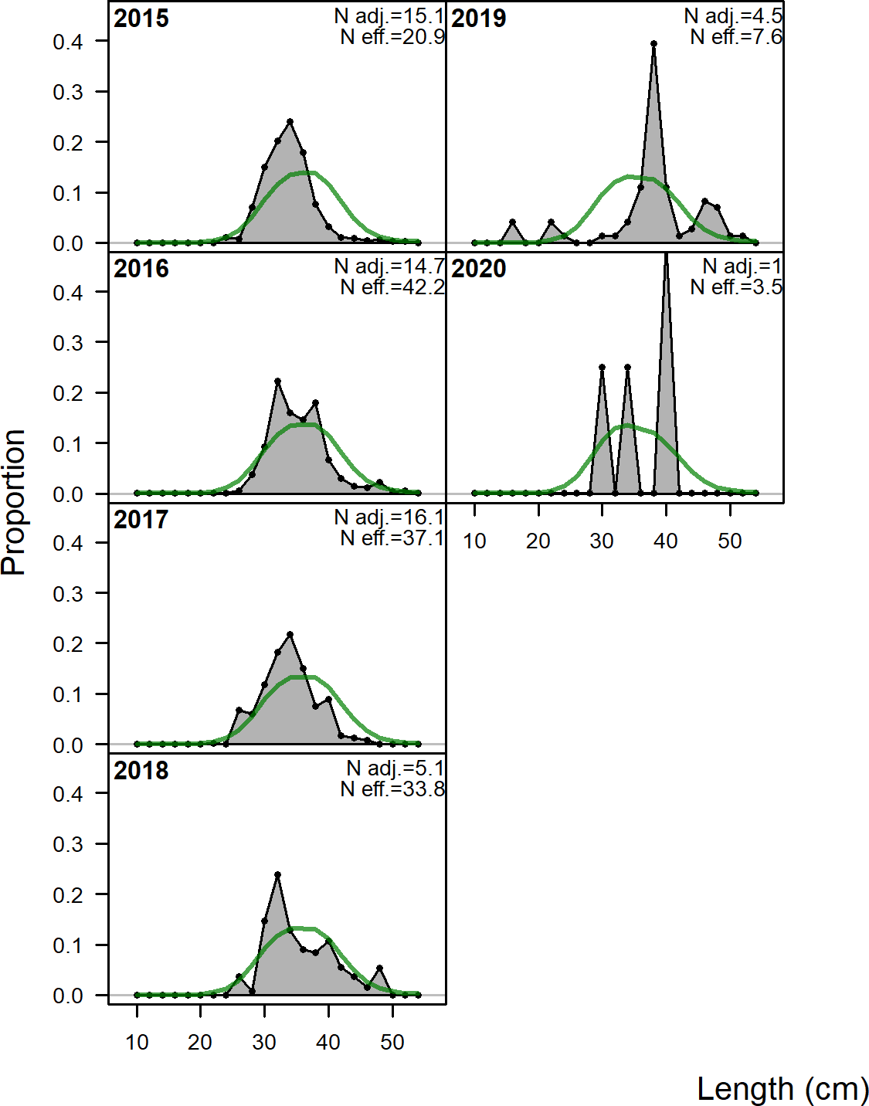

**Figure 84:** Length comps, whole catch, CA_S_Commercial (plot 2 of 2).

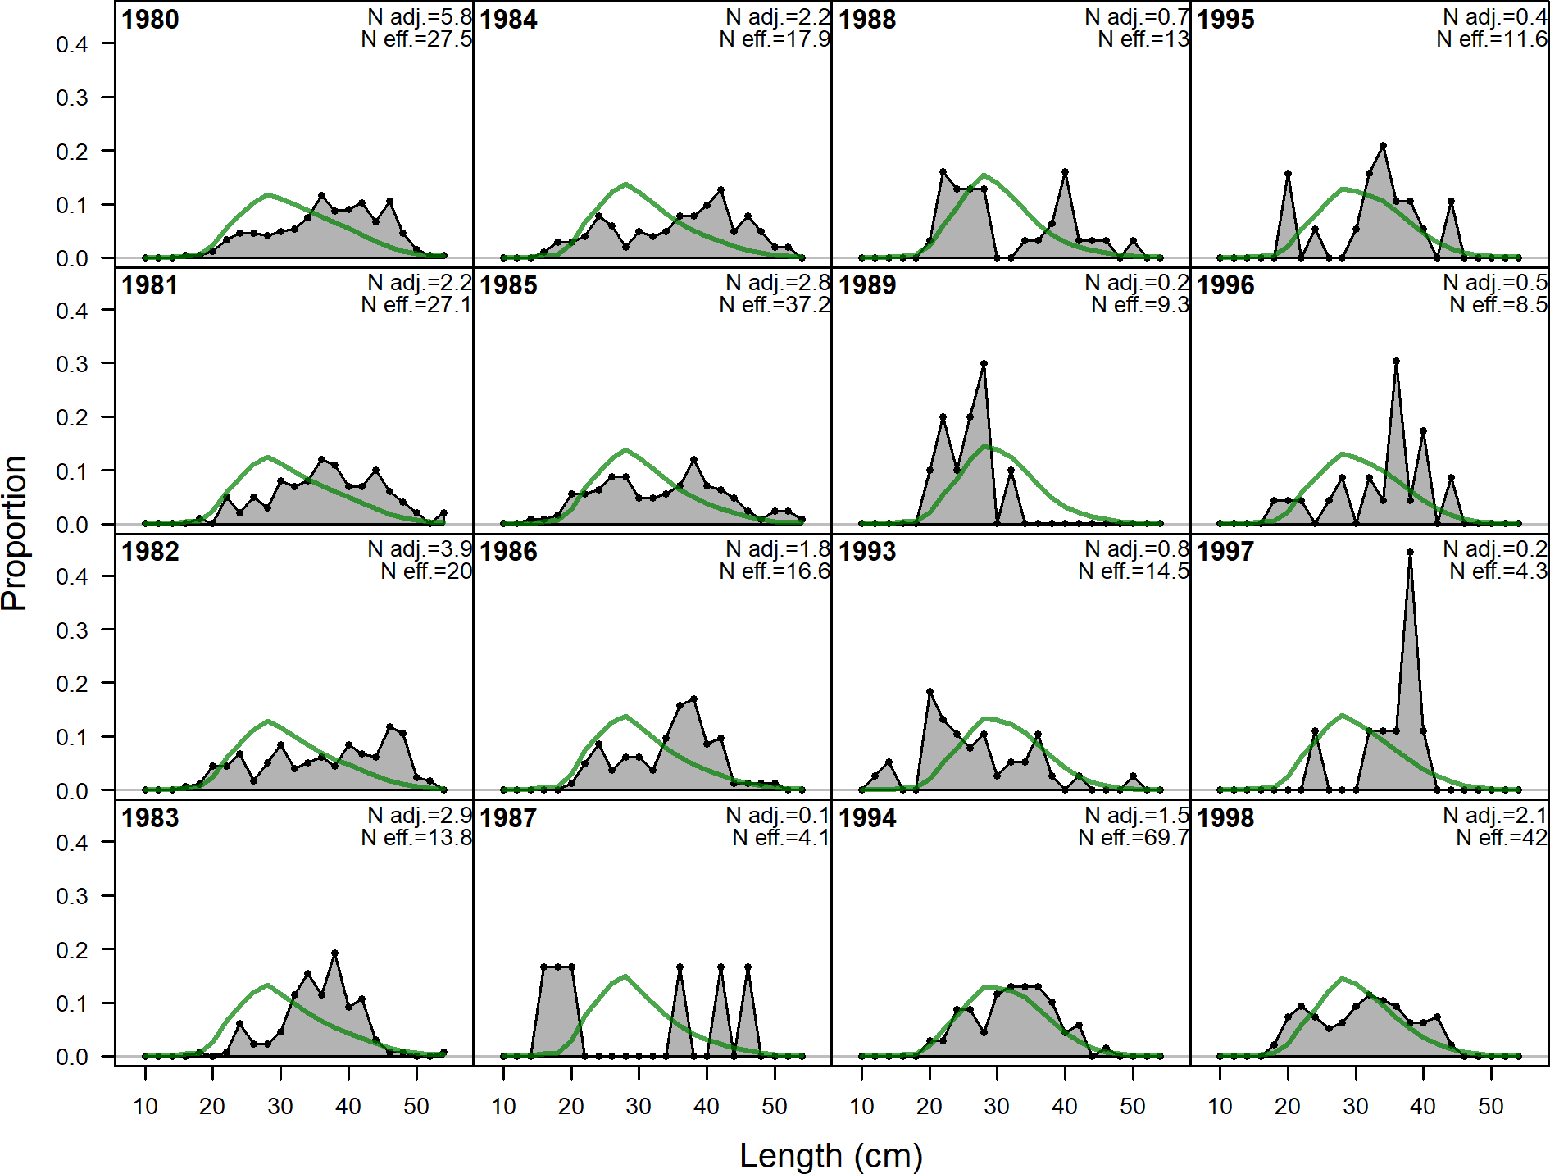

**Figure 85:** Length comps, whole catch, CA_S_Recreational (plot 1 of 3).‘N adj.’ is the input sample size after data-weighting adjustment. N eff. is the calculated effective sample size used in the McAllister-Iannelli tuning method..

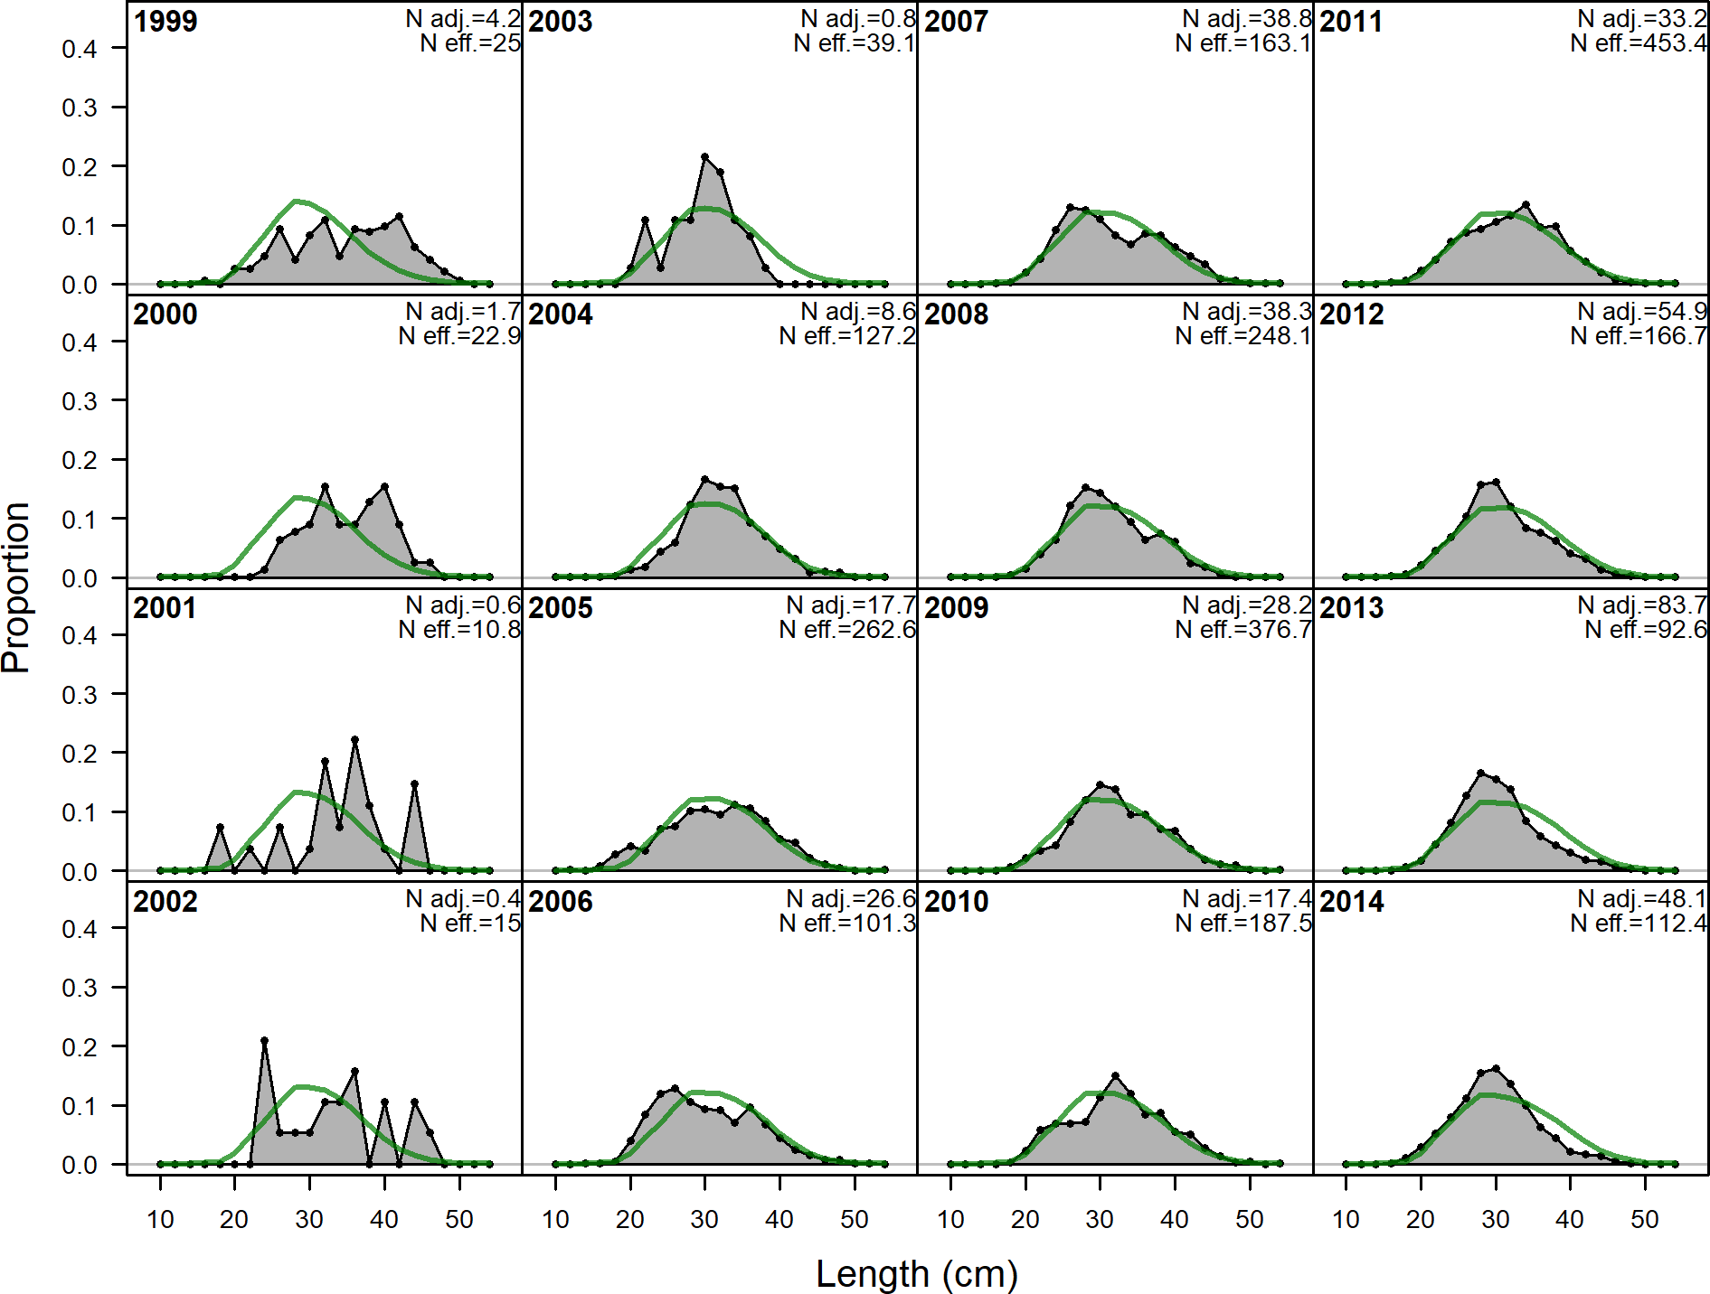

**Figure 86:** Length comps, whole catch, CA_S_Recreational (plot 2 of 3).

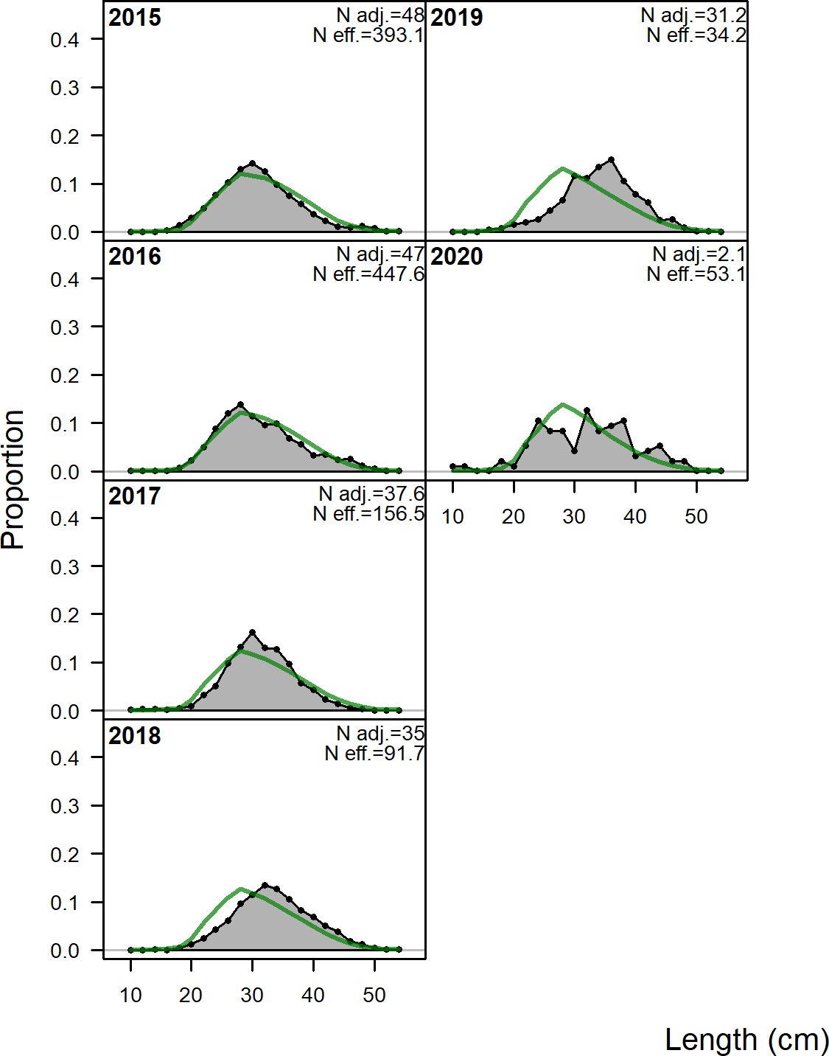

**Figure 87:** Length comps, whole catch, CA_S_Recreational (plot 3 of 3).

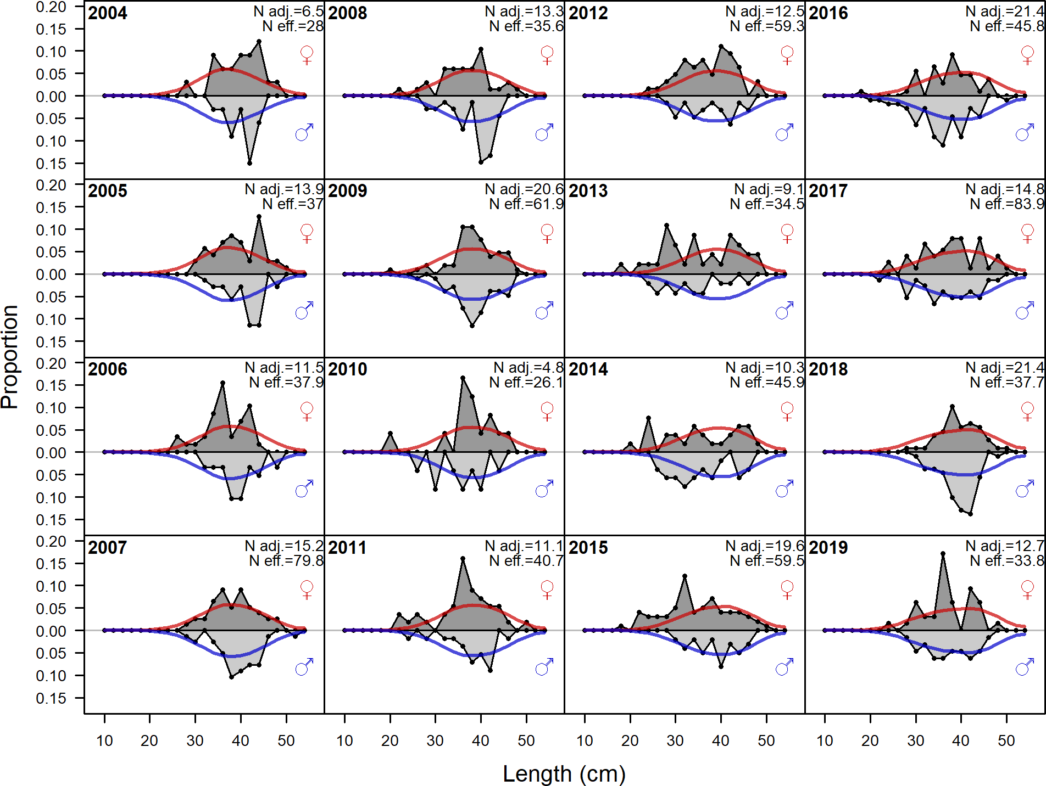

**Figure 88:** Length comps, whole catch, NWFSC_HKL.‘N adj.’ is the input sample size after data-weighting adjustment. N eff. is the calculated effective sample size used in the McAllister-Iannelli tuning method..

## Implied Fit to Commercial ‘Ghost’ Fleet Length Data

The ‘ghost’ fleet data consist of commercial length samples collected prior to 1995 which were not used in the base model due to low sample sizes which resulted in noisy length distributions.

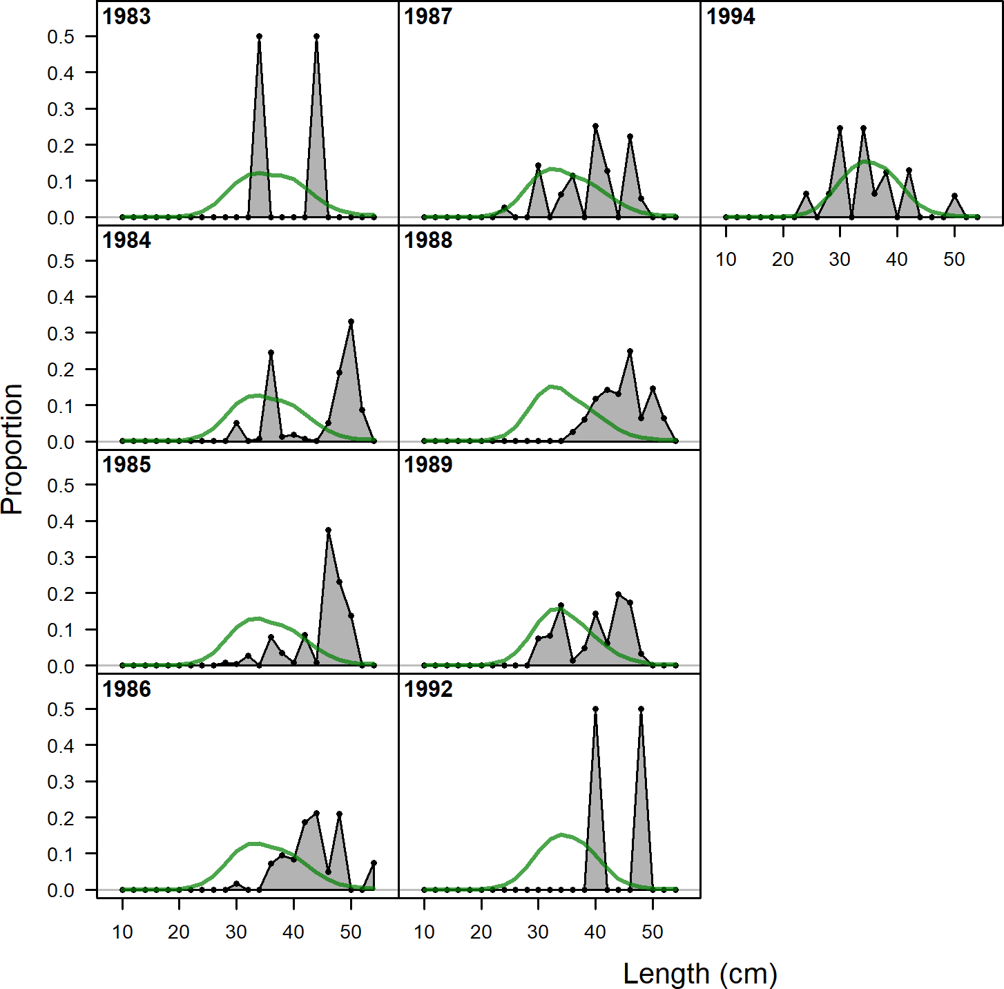

**Figure 89:** Ghost length comps, whole catch, CA_S_Commercial.‘N adj.’ is the input sample size after data-weighting adjustment. N eff. is the calculated effective sample size used in the McAllister-Iannelli tuning method..